DAX Formulas
This document brings together all the DAX formulas used to build and customize the Power BI dashboard for the Churn Abandonment Prediction project. It serves as a quick reference for how key metrics and calculations were created to track customer behavior, predict abandonment risk, and visualize performance. Each screenshot included here shows the actual DAX expressions used in the report, making it easy to understand and replicate the logic behind every insight.

Total Transaction
Predicted Abandonment Rate
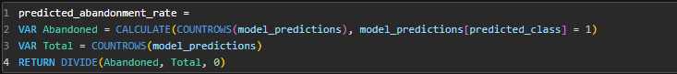
Model Accuracy
High Value Customer Share
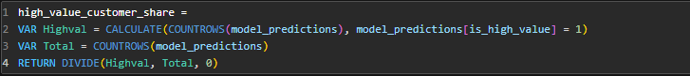
Average Abandonment Risk
Actual Abandonment Rate
