WICK REJECTION
TRADING STRATEGY
A Comprehensive Research Document

Covering All Markets | All Timeframes | Full Algorithmic Breakdown

Markets Covered:
Forex • Crypto • Stocks • Futures • Commodities

Timeframes Covered:
1min / 3min / 5min / 15min / 30min / 1H / 4H / Daily / Weekly

Compiled: 2026

TABLE OF CONTENTS

1. Introduction — What is Wick Rejection?
The Wick Rejection Strategy is one of the most widely used price action techniques in modern trading. It is built on the principle that when price violently tests a level and is pushed back, that violent rejection leaves a visible scar on the chart in the form of a long candlestick wick. This wick is not just a visual artifact — it is a direct representation of a battle between buyers and sellers, with one side overwhelming the other and snapping price back in the opposite direction.

At its core, wick rejection trading is the art of reading what markets are communicating through these wicks: where strong hands entered, where weak hands were trapped, and where the next directional move is likely to originate. When combined with context — key levels, trend alignment, volume, and confirmation — wick rejection setups become some of the highest probability entries available in any market.

KEY DEFINITION
A wick rejection occurs when the market price aggressively moves into a key support or resistance level, but buyers or sellers overwhelm the move, causing price to snap back and the candle to close far from the extreme — leaving behind a long wick (shadow) as evidence of that rejection.

This document covers the complete framework: the anatomy of the signal, the psychology behind it, the algorithmic logic required to identify and trade it systematically, risk management rules, market-specific applications, timeframe guidelines, and common pitfalls to avoid.

2. Candlestick Anatomy — Understanding the Building Block
Before mastering wick rejection, every trader must have a deep understanding of what a candlestick actually represents and how each of its components communicates market information.

2.1 The Four Components of a Candlestick
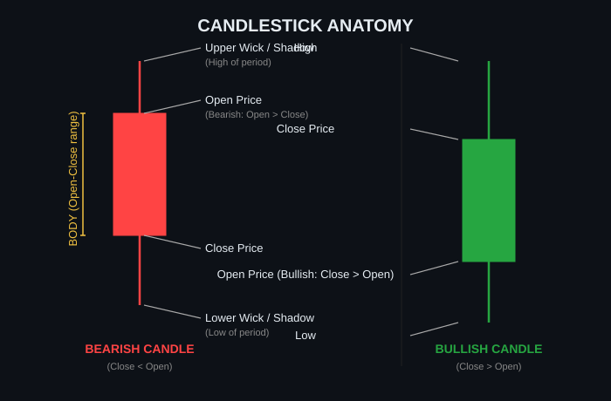
Figure 1 — Complete Candlestick Anatomy: Bullish vs. Bearish

Component | Definition
Open Price | The price at which the market opened for that time period. The starting reference point.
Close Price | The price at which the market closed at the end of that period. The most important price.
High (Upper Wick tip) | The absolute highest price reached during the period — the upper extreme of buyer/seller push.
Low (Lower Wick tip) | The absolute lowest price reached during the period — the lower extreme of buyer/seller push.
Body | The colored rectangle between Open and Close. Bullish = Close > Open. Bearish = Close < Open.
Upper Wick (Shadow) | The line extending above the body. Shows how high price went before being rejected downward.
Lower Wick (Shadow) | The line extending below the body. Shows how low price went before being rejected upward.

2.2 What the Wick Represents
The wick is market memory. It tells you exactly how far price traveled in a direction before the opposing force became too strong. A long wick means:
- Price ventured deep into a zone (often a key S/R level, liquidity pool, or psychological number)
- Sellers (for upper wick) or buyers (for lower wick) entered aggressively
- The initial push was completely overpowered — the close snapped back significantly
- Trapped traders are now on the wrong side and will fuel the move further

Think of a wick as a failed attempt. The market tried to go somewhere, failed, and the remnants of that failure are visible as a long wick on the chart.

3. Market Psychology Behind Wick Rejection
Understanding why wick rejection works requires understanding what happens at the participant level during the formation of these candles. Markets are driven by human (and algorithmic) behavior, and wick rejections are the fingerprints of institutional order flow.

3.1 The Institutional Footprint
Large institutions — hedge funds, banks, and algorithmic trading systems — cannot enter positions instantly in large size without moving the market against themselves. To solve this, they use liquidity engineering: they deliberately drive price into zones where retail traders have placed stop-loss orders or where breakout traders will pile in. This creates the liquidity pool they need to fill large orders at favorable prices.

HOW IT WORKS
1. Retail longs place stops below support. Retail shorts enter breakouts below support.
2. Institutions drive price below support — triggering all those stops and attracting new sellers.
3. Institutions absorb ALL that selling to accumulate long positions.
4. Price snaps back above support immediately — leaving a long lower wick.
5. All the breakout sellers are now trapped. Their panic buying fuels the rally.

3.2 The Psychology of Trapped Traders
When a wick rejection forms, there are always two groups of traders who got caught:

Trader Type | Their Situation After the Wick Rejection
Breakout Traders (Long Wick) | They entered in the direction of the wick, expecting a breakout. The wick snapped back against them. They are now holding losing positions and will eventually cut losses — adding fuel to the reversal.
Stop-Hunted Traders | Their stops were triggered by the wick. They were shaken out of profitable positions. They may re-enter in the original direction once price recovers, fueling more momentum.
Late-Entry Trend Traders | Entered just before the wick formed, riding what looked like momentum. Now trapped and underwater, forced to close positions as price moves against them.

The combined forced exit of all these trapped traders is what gives wick rejection moves their explosive character. You are not just following a signal — you are riding the forced liquidations of everyone on the wrong side.

3.3 The Liquidity Sweep Mechanism
The modern understanding of wick rejection is inseparable from the concept of a liquidity sweep. Price does not randomly reject from levels — it is deliberately driven to those levels to harvest the liquidity (orders) sitting there before the true directional move begins.

A liquidity sweep looks like a false breakout. Price pierces a key level, wicks dramatically into or through it, then reverses with force. This is the institution's entry point, and the long wick is the evidence of their presence. Trading the wick rejection after a liquidity sweep means aligning yourself with institutional order flow — the most powerful force in any market.

4. Types of Wick Rejection Patterns
Wick rejection manifests in multiple candlestick patterns, each with slightly different characteristics and context. Understanding all of them allows you to recognize the signal regardless of what it looks like at first glance.

4.1 Bullish Wick Rejection Patterns
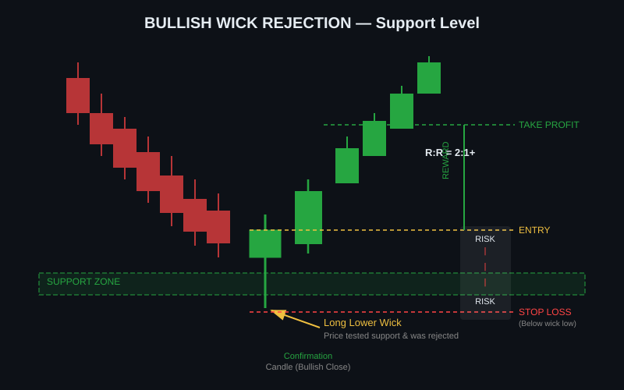
Figure 2 — Bullish Wick Rejection at Support: Entry, Stop Loss, and Target Zones

Pattern Name | Description & Characteristics
Hammer | A bullish candlestick with a small body at the top and a long lower wick (2–3x body). Forms at the bottom of a downtrend. The small body can be bullish or slightly bearish. Classic reversal signal.
Bullish Pin Bar | Similar to a hammer but emphasized in price action trading. Long lower wick, small upper wick, close near the high. One of the cleanest bullish rejection signals.
Bullish Engulfing with Wick | A bullish candle that completely engulfs the previous bearish candle, with an additional long lower wick showing intra-candle rejection.
Dragonfly Doji | Open and Close at the same level (or very close) with a very long lower wick. Extremely strong bullish rejection — shows complete dominance by buyers by end of session.
Long Lower Wick Candle | Any candle — bullish or bearish — where the lower wick is significantly longer than the body. The body color is secondary; the wick tells the story.

4.2 Bearish Wick Rejection Patterns
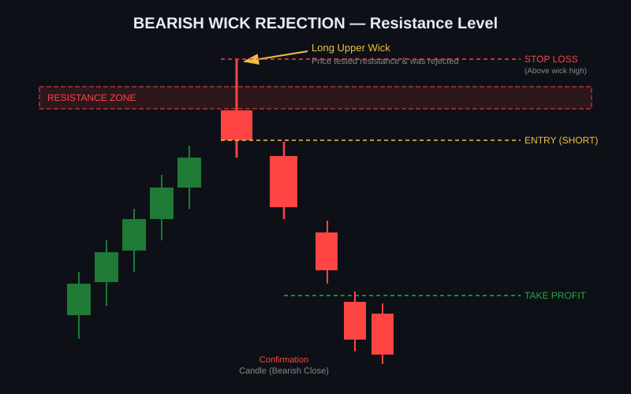
Figure 3 — Bearish Wick Rejection at Resistance: Entry, Stop Loss, and Target Zones

Pattern Name | Description & Characteristics
Shooting Star | A bearish candlestick with a small body at the bottom and a long upper wick (2–3x body). Forms at the top of an uptrend. Classic bearish reversal signal.
Bearish Pin Bar | Long upper wick, very small body, close near the low. Price aggressively tested resistance but was overwhelmed by sellers. Clean short entry signal.
Inverted Hammer (at Resistance) | At resistance context, an inverted hammer signals bearish rejection. The long upper wick shows sellers entered aggressively.
Gravestone Doji | Open and Close at the same price with a very long upper wick. Extreme bearish rejection — sellers completely dominated the session.
Long Upper Wick Candle | Any candle where the upper wick significantly exceeds the body. At resistance, this is a high-probability short signal when confirmed.

4.3 The ICT Rejection Block
In the Smart Money Concepts (SMC) and Inner Circle Trader (ICT) framework, a Rejection Block is a refined version of wick rejection. It specifically refers to the wick of a long-tailed candle that swept liquidity at a swing extreme, where the rejection wick itself becomes a re-entry zone.

ICT REJECTION BLOCK RULE
After a bullish wick sweeps a swing low and price rallies, the zone between the candle's body close and the tip of the lower wick is the Rejection Block zone. When price returns to this zone in the future, it should be treated as a high-probability long entry — institutions are re-entering the same position they built during the original sweep.

5. Wick-to-Body Ratio — Measuring Signal Strength
Not all wick rejections are created equal. The ratio between the wick length and the body size is a key indicator of signal strength. This ratio should be one of your primary filters.
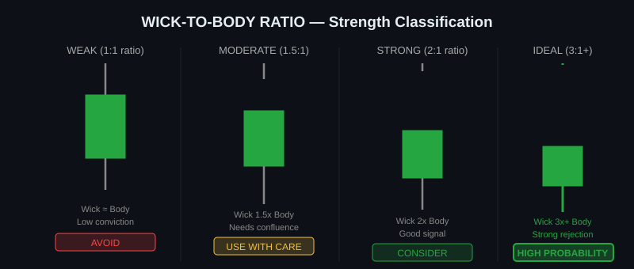
Figure 4 — Wick-to-Body Ratio Classification: From Weak to High Probability

5.1 The Ratio Formula
Wick-to-Body Ratio = Wick Length ÷ Body Length

Example: If the body of a candle is 10 pips/points and the lower wick is 25 pips/points, the ratio is 2.5:1 — a strong signal.

Ratio | Interpretation
Less than 1:1 | Weak — wick is smaller than body. Not a valid wick rejection. Skip.
1:1 to 1.5:1 | Marginal — minimal rejection. Only trade with heavy confluence (major S/R + HTF alignment + volume).
1.5:1 to 2:1 | Moderate — decent rejection. Acceptable signal when other confluence factors are present.
2:1 to 3:1 | Strong — clear rejection. High probability when at key levels with trend alignment.
3:1 and above | Ideal — extreme rejection. One of the best signals in price action. Strong institutional involvement likely.

RULE OF THUMB
A valid wick rejection requires the wick to be at least 2x the size of the body. Below this threshold, the signal is too ambiguous — the market may simply be in consolidation or noise. Always measure before acting.

6. Identification Criteria — Step-by-Step
A valid wick rejection setup requires multiple conditions to align simultaneously. Meeting one or two conditions is not sufficient. The more conditions that align, the higher the probability.

6.1 Primary Conditions (All Required)
- The wick-to-body ratio is at minimum 2:1 (ideally 3:1 or greater).
- The wick is touching or penetrating a key support or resistance level, supply/demand zone, previous swing high/low, or psychological price level.
- The candle body closes significantly away from the wick extreme — returning back into the prior range or above/below a key level.
- The wick is pointing in the direction of the level being tested (lower wick at support, upper wick at resistance).
- At least one higher timeframe is in agreement with the trade direction (HTF bias filter).

6.2 Secondary Conditions (Confluence Boosters)
- Volume is elevated on the rejection candle compared to the average of the prior 10–20 candles.
- The rejection occurs after a clear prior trend in the direction of the wick (a downtrend into support for a bullish wick).
- A Fair Value Gap (FVG) or imbalance is present near the rejection zone.
- Fibonacci retracement level (0.618, 0.786) coincides with the rejection zone.
- A moving average (20 EMA, 50 EMA, 200 EMA) acts as additional support/resistance at the wick level.
- The session timing is optimal (London open, New York open — not illiquid overnight sessions).
- Round number or psychological level (e.g., 1.1000 in EUR/USD, $50,000 in Bitcoin) coincides with the wick.
- The wick follows a liquidity sweep of obvious retail stops (equal highs/lows, previous daily high/low).

6.3 Disqualifying Conditions (Do NOT Trade)
- The wick forms in the middle of a range with no nearby key level.
- Market is in a tight sideways chop — wicks form everywhere and mean nothing.
- Session is illiquid (e.g., 3:00–6:00 AM GMT for Forex — dead hours).
- Major news event is imminent within 15–30 minutes (pre-news wicks are manipulated and unpredictable).
- The wick-to-body ratio is below 1.5:1.
- The higher timeframe trend is strongly opposed to your trade direction with no clear structure shift.
- Price has recently repeatedly tested and failed to hold the same level (worn out level).

7. Algorithmic Breakdown — Input, Logic, Output
The wick rejection strategy can be codified into a systematic algorithm. The following section breaks it down as an engineering specification — inputs, processing logic, decision rules, and outputs. This framework can be used manually or as the basis for building an automated trading system.
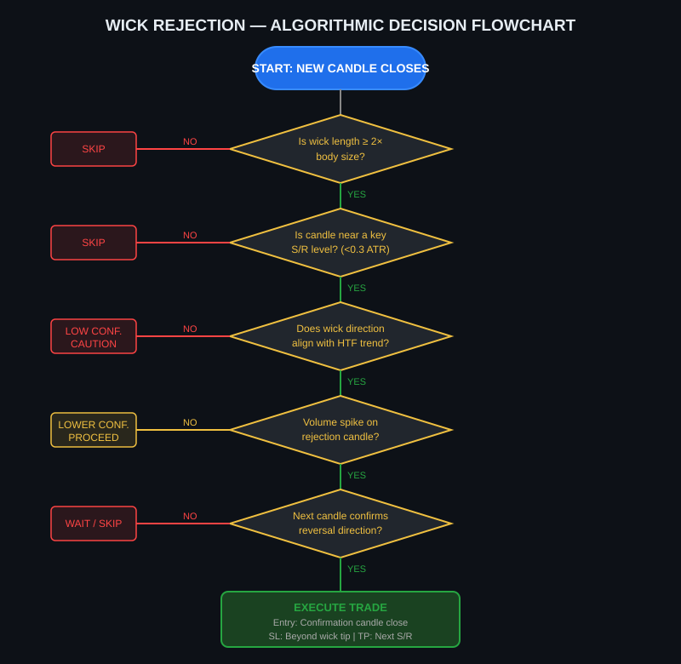
Figure 5 — Algorithmic Decision Flowchart for Wick Rejection Strategy

7.1 Inputs Required

7.1.1 Price Data Inputs
Input Variable | Description
OHLCV[current] | Open, High, Low, Close, Volume of the current candle (fully closed).
OHLCV[n] | OHLCV of the prior n candles (typically last 50–200 candles needed).
HTF_OHLCV[n] | Higher timeframe OHLCV data — minimum 1 TF above current. E.g., if on 15min, need 1H or 4H.
ATR(14) | Average True Range over 14 periods. Used to normalize wick size and set stop distances.
Volume_MA(20) | 20-period moving average of volume. Baseline to compare current candle's volume against.

7.1.2 Level Inputs (Key Areas)
Level Type | How to Define It
Support / Resistance | Previous swing highs and lows. At minimum last 50 candles. Best if tested 2+ times.
Supply / Demand Zones | Areas where price previously spent little time and moved sharply away from (imbalances).
Psychological Levels | Round numbers: $100, $1000, 1.1000 EUR/USD, etc. Always in play.
Moving Averages | 20 EMA, 50 EMA, 200 SMA on current and higher timeframes.
Fibonacci Levels | Drawn from last swing high to swing low (or vice versa). 0.618 and 0.786 are primary.
Session Highs/Lows | Prior day's high and low, prior week's high and low — major liquidity targets.

7.1.3 Context Inputs (Filters)
Context Variable | Purpose
Trend_Direction[HTF] | Bullish or Bearish on higher timeframe. Primary filter for trade direction.
Session_Time | Current trading session (Asia, London, New York). Filter for liquidity conditions.
News_Calendar | High-impact news events within next 30 min. Hard exclusion filter.
Market_Type | Trending, ranging, or volatile. Changes strategy application.

7.2 Processing Logic (The Algorithm)

Step 1 — Candle Measurement
When a new candle closes, run the following calculations:

Body_Size = |Close - Open|
Upper_Wick = High - max(Open, Close)
Lower_Wick = min(Open, Close) - Low
Wick_Ratio = max(Upper_Wick, Lower_Wick) / Body_Size
Dominant_Wick = 'LOWER' if Lower_Wick > Upper_Wick else 'UPPER'

Step 2 — Wick Ratio Filter
Check the primary filter:
IF Wick_Ratio < 2.0: DISCARD — Not a valid wick rejection.
IF Wick_Ratio >= 2.0: PROCEED to next step.

Step 3 — Key Level Proximity Check
Identify if the wick tip is within acceptable distance of a key level:
Level_Distance = abs(Wick_Tip - Nearest_Key_Level)
IF Level_Distance > 0.3 * ATR(14): DISCARD — Wick not at a meaningful level.

Step 4 — Higher Timeframe Bias Check
Confirm the trade direction aligns with the higher timeframe trend:
IF Dominant_Wick == 'LOWER' AND HTF_Trend == 'BEARISH': LOW_CONFIDENCE (downgrade)
IF Dominant_Wick == 'LOWER' AND HTF_Trend == 'BULLISH': HIGH_CONFIDENCE (upgrade)
IF Dominant_Wick == 'UPPER' AND HTF_Trend == 'BULLISH': LOW_CONFIDENCE (downgrade)
IF Dominant_Wick == 'UPPER' AND HTF_Trend == 'BEARISH': HIGH_CONFIDENCE (upgrade)

Step 5 — Volume Filter
IF Volume[current] > 1.5 * Volume_MA(20): Volume spike confirmed — add confluence point.

Step 6 — Confirmation Candle Check
Wait for the candle AFTER the rejection candle to close in the reversal direction:
IF Dominant_Wick == 'LOWER' AND Next_Candle_Close > Rejection_Candle_Close: CONFIRMED
IF Dominant_Wick == 'UPPER' AND Next_Candle_Close < Rejection_Candle_Close: CONFIRMED
IF No confirmation: WAIT or SKIP — reduce to alert mode.

7.3 Confidence Scoring System
To make the algorithm more objective, assign a score to each signal:

Condition | Score if MET | Score if NOT Met
Wick Ratio >= 2:1 | +2 points | DISQUALIFY
Wick Ratio >= 3:1 | +1 bonus point | 0
Wick at key S/R level | +2 points | DISQUALIFY
HTF trend alignment | +2 points | -1 point
Volume spike (1.5x MA) | +2 points | 0
Confirmation candle | +2 points | Skip trade
Fibonacci confluence | +1 point | 0
Session timing (London/NY) | +1 point | 0
Liquidity sweep present | +1 point | 0

SCORING THRESHOLDS
Score 8+: High-confidence setup. Full position size. Risk up to 1.5% of account.
Score 6–7: Moderate setup. Reduced position (0.5–1% risk).
Score 4–5: Low-confidence. Avoid or paper-trade only.
Score Below 4: Do not trade. Insufficient confluence.

7.4 Outputs Generated
Output Parameter | How to Calculate
Trade Direction | LONG if Dominant_Wick = LOWER at Support. SHORT if Dominant_Wick = UPPER at Resistance.
Entry Price | Aggressive: Close of rejection candle. Conservative: Close of confirmation candle.
Stop Loss Price | LONG: Wick_Low - (0.1 * ATR). SHORT: Wick_High + (0.1 * ATR). Buffer of 10% of ATR to avoid wick hunts.
Risk Amount ($) | Entry_Price - Stop_Loss (for longs). Stop_Loss - Entry_Price (for shorts).
Target 1 (TP1) | Next logical S/R level in the trade direction. Minimum R:R of 1.5:1.
Target 2 (TP2) | Second key level beyond TP1. Minimum R:R of 2.5:1. Move stop to breakeven after TP1 hit.
Target 3 (TP3) | Major structural target. R:R of 4:1 or above. Trail stop after TP2 hit.
Position Size | (Account_Value * Risk%) / Risk_Amount. Never exceed 2% account risk per trade.
Signal Quality Score | Numerical score from the confidence scoring system (max 14 points).
Trade Valid Until | Valid for 3–5 candles after the rejection. If not triggered, signal expires.

8. Entry and Exit Rules

8.1 Entry Methods
Entry Method | Description & Risk/Benefit
Aggressive Entry (Market Order) | Enter at the close of the rejection candle itself — before confirmation. Faster fill, better price. Higher risk of false signal. Best for experienced traders who can read context quickly.
Standard Entry (After Confirmation) | Enter at the close of the next candle that closes in the reversal direction. Slightly worse price but much higher confirmation. Recommended for most traders.
Limit Order Entry (Wick Re-test) | Place a limit order at the 50%–75% retracement of the wick — within the Rejection Block zone. Best risk/reward. Price doesn't always re-test. Best for ICT/SMC practitioners.
Break of Structure Entry | Wait for price to break a minor swing high/low in the reversal direction after the rejection. Most conservative. Fewest false entries but late fills.

8.2 Stop Loss Placement
Stop loss placement is a science, not a guess. For wick rejection trades, the stop must go BEYOND the wick tip, not at it:

Scenario | Stop Loss Placement
Bullish wick rejection (Long trade) | Stop Loss = Candle Low - buffer. Buffer = 0.1 × ATR(14) or 5–10 pips/points minimum.
Bearish wick rejection (Short trade) | Stop Loss = Candle High + buffer. Buffer = 0.1 × ATR(14) or 5–10 pips/points minimum.
ICT Rejection Block re-entry | Stop Loss = Beyond the original wick extreme, not just the zone boundary.
Volatile markets (Crypto) | Use wider buffer: 0.25 × ATR. Crypto wicks can be extreme and trap stop-tight traders.

CRITICAL RULE
Never place a stop at a round number or at the exact wick tip. The market has a tendency to sweep just beyond obvious stop levels before reversing. Always add a buffer. A stop that is too tight is worse than no trade at all.

8.3 Profit Target Setting
Target Level | Description
TP1 — 1:1.5 R:R | First key level — swing high/low or nearest S/R. Partial profit (30–50% of position). Move stop to breakeven.
TP2 — 1:2.5 R:R | Second structural level. Take additional profits (30%). Trail stop to just below TP1.
TP3 — 1:4+ R:R | Major structural target — prior week high/low, major S/R, HTF target. Let 20% ride with trailing stop.
Time-Based Exit | If price has not moved significantly in 3–5 candles after entry, exit at breakeven. Time decay signals the setup is failing.

9. Timeframe Application Guide
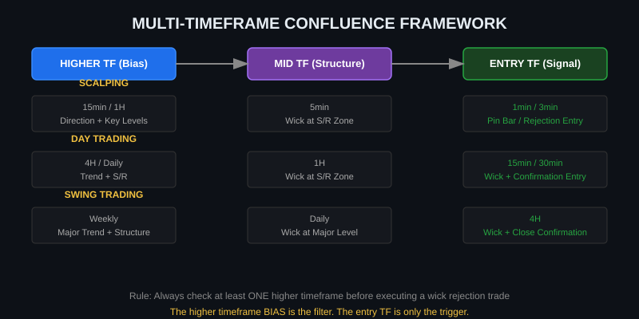
Figure 6 — Multi-Timeframe Confluence Framework
The wick rejection strategy works across all timeframes, but the rules of application shift depending on the timeframe. The key principle is always the same: use a higher timeframe for context and a lower timeframe for the actual entry signal.

9.1 Timeframe-Specific Guidelines
Timeframe | Role in System | Specific Considerations
Weekly Chart | Major bias only | Wick rejections here define month-long moves. Very rare but extremely powerful. Swing/position traders only.
Daily Chart | HTF bias + major levels | Identify dominant trend and key structural levels. A wick here can set up 4H and 1H trades.
4H Chart | Swing trade entries | Primary timeframe for swing traders. Wick at daily S/R on 4H = high-quality setup. Holds 1–5 days.
1H Chart | Day trade entries | Core timeframe for day traders. Wick at 4H level on 1H = solid intraday setup. Holds hours to 1 day.
30min / 15min | Scalp & day trade overlap | Useful for refining entries from higher TF signals. Can be noisy in ranging markets.
5min | Scalp entries | Only use with 15min/1H bias confirmed. Valid wicks at key levels. Holds minutes to 1 hour.
1min / 3min | Execution only | Never use as standalone signal. Used ONLY for fine-tuning entry on a confirmed higher TF setup. Ultra-fast trades.

9.2 The Top-Down Analysis Framework
Before entering any wick rejection trade, complete this analysis sequence:

- Daily/Weekly: What is the dominant trend? Where are the major S/R levels? Is the market in a trending or ranging phase?
- 4H/1H: Where is price relative to the higher timeframe structure? Has it retraced to a meaningful zone? Is a wick forming at a confluence area?
- Entry TF (15min/5min/1min): Wait for the wick rejection candle to close. Wait for confirmation. Execute with defined SL and TP.

TOP-DOWN RULE
Never skip the top-down analysis. A 5-minute chart setup that looks perfect but contradicts the daily trend is a low-probability trade. The higher timeframe is the judge — the lower timeframe is only the executioner.

10. Market-Specific Applications
While the core logic of wick rejection is universal, each market has unique characteristics that influence how the strategy should be applied.

10.1 Forex (FX)
Factor | Forex-Specific Notes
Best Pairs | Major pairs: EUR/USD, GBP/USD, USD/JPY, AUD/USD. Higher liquidity = cleaner wick formations.
Best Sessions | London Open (8:00–10:00 GMT) and New York Open (13:00–15:00 GMT) for highest quality wicks.
Key Levels | Round numbers (1.1000, 1.2000), daily/weekly opens, prior day high/low, session high/low.
Volume Caveat | Forex has no centralized volume. Use tick volume as a proxy — it correlates well with actual volume.
Wick Quality | EUR/USD on 1H at London Open hitting a round number is among the highest quality setups available.

10.2 Cryptocurrency
Factor | Crypto-Specific Notes
Market Hours | 24/7 trading. Most significant wicks form during NYSE/Nasdaq overlap hours (13:00–20:00 GMT).
Wick Extremity | Crypto wicks are often extreme (3x-10x body ratio) due to leverage cascades and thin liquidity. Wide stops needed.
Key Levels | Previous ATH/ATL, round numbers ($50K, $100K BTC), exchange-specific liquidation clusters.
Volume | Real volume available on crypto exchanges. A wick with 5x average volume is a very strong signal.
Leverage Factor | Liquidation cascades create artificial wicks that can fail. Always confirm on 2 or more exchanges.

10.3 Stocks & Equities
Factor | Stocks-Specific Notes
Market Hours | NYSE/NASDAQ: 9:30–16:00 ET. Avoid pre-market and after-hours wicks — low liquidity, unreliable.
Opening Wicks | The first 5–30 minutes often produce wicks as price finds fair value after overnight gap. These are high-quality rejection setups.
Key Levels | Prior day high/low, 52-week high/low, earnings-related levels, round dollar figures.
Earnings Season | Avoid wick rejection trades around earnings announcements — gaps invalidate the pattern.
Best Candidates | Large-cap, high-volume stocks (AAPL, TSLA, NVDA, SPY, QQQ). Low-cap stocks have erratic wicks.

10.4 Futures
Factor | Futures-Specific Notes
Instruments | ES (S&P 500), NQ (Nasdaq), GC (Gold), CL (Crude Oil), ZB (Bonds), 6E (EUR/USD Futures).
Session Times | RTH (Regular Trading Hours) only for cleanest signals. Overnight session wicks are less reliable.
Volume | Futures have actual volume data. Use Volume Profile and Delta to confirm institutional participation.
Key Levels | VWAP, POC (Point of Control), overnight high/low, globex high/low. These are institutional reference points.
Order Flow Tools | Footprint charts and order flow indicators are most powerful here — use them to confirm wick rejections.

11. Risk Management Framework
No matter how perfect the wick rejection setup looks, risk management determines whether you survive long enough to profit from the strategy. Professional traders understand that any single trade can fail — the edge comes from consistency over many trades.

11.1 Position Sizing Formula
Position Size = (Account Balance × Risk%) ÷ (Entry Price - Stop Loss Price)

Setup Quality (Confidence Score) | Maximum Risk % Per Trade
High Confidence (Score 10+) | 1.0% to 1.5% of account balance
Moderate Confidence (Score 7–9) | 0.5% to 1.0% of account balance
Low Confidence (Score 4–6) | 0.25% or skip entirely
Below Threshold (Score < 4) | DO NOT TRADE

11.2 Risk Rules to Follow Unconditionally
- Maximum 2% risk per trade, regardless of conviction.
- Maximum 5–6% total account risk across all open positions simultaneously.
- After 3 consecutive losses, reduce position size by 50% for the next 5 trades.
- Daily loss limit: Stop trading for the day if drawdown reaches 3–4% of account.
- Weekly loss limit: If week is down 6–8%, reduce size and review strategy.
- Never move stop loss in the direction of a losing trade. Only move it to breakeven after TP1.
- Always set stop loss BEFORE entering a trade, never after.

11.3 Win Rate and Expectancy
The wick rejection strategy, when applied with proper confluence, typically produces:

Metric | Expected Range
Win Rate (strict execution) | 55% to 65% of trades profitable
Average Risk-to-Reward | 1:2 to 1:3 per trade
Mathematical Expectancy | Positive: Even at 50% win rate with 1:2 R:R = +50 per 100 trades
Drawdown Periods | Expected 5–15% drawdown phases — this is normal, not a strategy failure

EXPECTANCY FORMULA
Expectancy = (Win Rate × Average Win) - (Loss Rate × Average Loss)
Example at 60% win rate and 1:2 R:R: (0.60 × 2) - (0.40 × 1) = 1.20 - 0.40 = +0.80R per trade
This means over 100 trades, you gain approximately 80 times your average risk — a strong positive edge.

12. False Signals, Pitfalls, and Failure Modes
Understanding why the strategy fails is as important as understanding why it works. Avoiding these mistakes is the difference between a profitable and an unprofitable wick rejection trader.

12.1 Common False Signal Scenarios
Scenario | Why It Fails and How to Avoid It
Wick in low liquidity market | During off-hours or on illiquid instruments, wicks form randomly without institutional meaning. Use volume to filter — low volume wick = skip.
Wick against strong momentum | When a major macro event or news release creates strong directional momentum, wick rejections often fail. Avoid trading against clear momentum during news.
Repeated tests of same level | A support or resistance level that has been tested 5+ times is weakened. The more a level is tested, the less reliable a wick rejection at that level becomes.
Pre-news wick manipulation | Smart money creates false wicks before major announcements to collect liquidity. Never trade wicks that form 15–30 minutes before high-impact news.
Wick in choppy/ranging market | In tight ranges, both upper and lower wicks appear frequently. They signal indecision, not rejection. Requires a clearly defined range and key level to be valid.
Wick on wrong side of trend | A lower wick in a powerful downtrend is often just a brief pause, not a reversal. Without HTF alignment, counter-trend wicks have much lower success rates.

12.2 Psychological Pitfalls
- FOMO Entry: Entering too late because you missed the rejection candle. The setup has expired — wait for the next one.
- Stop Widening: Moving your stop further away when price is going against you. This is the fastest way to blow an account.
- Revenge Trading: After a failed wick rejection, immediately taking another marginal setup. Take a break.
- Overtrading: Seeing wick rejections everywhere. Only trade the obvious, clean setups with full confluence.
- Ignoring HTF: Tunnel vision on a beautiful-looking 5-minute setup without checking the daily trend. This is the most common mistake among retail traders.

13. Advanced Confluence — Stacking the Edge
The highest probability wick rejection setups arise when multiple independent technical factors coincide at the same price level. The more factors that stack, the stronger the setup.

13.1 Confluence Factor Combinations
Confluence Factor | Adds to Signal Because | Application
Fibonacci 0.618 / 0.786 | Golden ratio levels attract institutional orders | Draw Fib from last major swing. Wick at 0.618/0.786 = very strong
Fair Value Gap (FVG) | Price imbalances pull price back for mitigation | Wick into an unmitigated FVG = high probability reversal zone
VWAP / POC | Volume-weighted levels show where most business was done | Wick rejection at VWAP on intraday = institutional reference rejection
Moving Average Confluence | 20/50/200 EMA act as dynamic support/resistance | Wick at key EMA + static S/R = double confirmation
Demand/Supply Zone | Areas of prior institutional accumulation/distribution | Wick into fresh supply/demand zone = first test = highest probability
Liquidity Sweep | Confirms institutional stop hunt before real move | Wick that sweeps equal highs/lows then reverses = ICT-style entry
Previous Day High/Low | Major retail reference levels = natural liquidity pools | Wick sweep of PDH or PDL followed by immediate reversal

13.2 The Ideal Setup — All Factors Aligned
The absolute best wick rejection trade looks like this:

- Daily chart is in a clear uptrend. Price has pulled back to a previous swing high (now turned support).
- On the 4H chart, a key Fibonacci 0.618 retracement level coincides exactly with the daily support.
- On the 1H chart, there is an unmitigated Fair Value Gap from a previous strong move.
- Price wicks below all three of these levels in a single candle, sweeping equal lows (liquidity), triggering all retail stops.
- Volume on the rejection candle is 2.5x the 20-period average.
- The next 1H candle closes strongly bullish, above all three confluence levels.
- Confidence Score: 13+/14. Maximum position size. Enter long with stop below the wick, target prior swing high.

14. Backtesting and Implementation

14.1 How to Backtest Wick Rejection
- Choose a single market and timeframe to begin (e.g., EUR/USD 1H).
- Go back 6–12 months of historical data.
- Mark all key support and resistance levels on the chart.
- Identify every candle where the wick-to-body ratio was 2:1 or greater at a key level.
- For each: record entry price, stop loss, and maximum adverse excursion.
- Note whether confirmation appeared and what the outcome was at TP1, TP2, TP3.
- Track win rate, average R:R, maximum drawdown, and consecutive loss streaks.
- Apply the confidence scoring system retrospectively and filter results by score threshold.
- Compare results: full dataset vs. score >= 8 only. You should see clear improvement.

14.2 Recommended Platforms and Tools
Platform / Tool | Purpose
TradingView | Chart analysis, alerts, backtesting (PineScript). Best for multi-market analysis.
NinjaTrader | Futures trading, automated strategy execution, advanced order flow tools.
MetaTrader 4/5 | Forex and CFD trading. Expert Advisors can automate the algorithm.
Bookmap / Sierra Chart | Order flow and footprint chart analysis for futures — confirms institutional volume.
Excel / Google Sheets | Trade journal for tracking results, calculating metrics, refining the scoring system.
Python + Pandas | Full algorithmic backtesting with OHLCV data from Yahoo Finance, Binance API, etc.

14.3 Basic Python Pseudocode
# Wick Rejection Scanner (Pseudocode)
for candle in price_data:
body = abs(candle.close - candle.open)
upper_wick = candle.high - max(candle.open, candle.close)
lower_wick = min(candle.open, candle.close) - candle.low
dominant_wick = max(upper_wick, lower_wick)
if body == 0: continue # Doji-like — skip
wick_ratio = dominant_wick / body
if wick_ratio < 2.0: continue # Filter 1
nearest_level = find_nearest_level(candle, key_levels)
distance = abs(candle.low if lower_wick > upper_wick else candle.high) - nearest_level
if distance > 0.3 * ATR(14, candle): continue # Filter 2
htf_trend = get_htf_trend(candle)
direction = 'LONG' if lower_wick > upper_wick else 'SHORT'
score = calculate_score(wick_ratio, distance, htf_trend,
volume_ratio, session_time)
if score >= 8:
generate_signal(direction, candle, score)

15. Quick Reference Cheat Sheet

WICK REJECTION — COMPLETE CHECKLIST
[ ] 1. Wick-to-body ratio >= 2:1 (ideally 3:1+)
[ ] 2. Wick tip at or within 0.3 × ATR of a key S/R level
[ ] 3. Higher timeframe bias confirms trade direction
[ ] 4. Volume elevated on rejection candle (1.5x MA minimum)
[ ] 5. Confirmation candle closes in reversal direction
[ ] 6. No major news event within 30 minutes
[ ] 7. Confidence score >= 8/14
[ ] 8. Position size calculated (max 1.5% risk)
[ ] 9. Stop loss set BELOW wick low (long) or ABOVE wick high (short) + buffer
[ ] 10. TP1, TP2, TP3 levels identified before entry

COMMON MISTAKES TO AVOID
✗ Trading wicks in illiquid sessions or pre-news
✗ Skipping higher timeframe bias check
✗ Stop loss too tight — at the wick tip with no buffer
✗ Entering without a confirmation candle (aggressive entries for beginners only)
✗ Trading wicks in choppy, trendless markets with no clear key levels
✗ Widening stop when trade goes against you
✗ Ignoring volume — a wick with no volume expansion is far weaker

16. Conclusion
The Wick Rejection Strategy is not simply a candlestick pattern to memorize — it is a complete framework for reading the psychological battle between buyers and sellers at critical price levels. When mastered, it reveals the footprints of institutional order flow and allows retail traders to position themselves alongside the most powerful forces in the market.

Success with this strategy requires three things working together: technical precision (the algorithm), contextual judgment (reading market conditions), and disciplined execution (risk management). Remove any one of these three pillars and the strategy fails.

Begin by mastering the pattern on one market, one timeframe. Backtest rigorously. Build your confidence score system. Only then scale up to multiple markets and timeframes. The edge is real — but it only reveals itself through consistent, disciplined, rule-based application.

Master the wick. Read the rejection. Follow the institutional footprint.

