BREAKOUT TRADING
MASTER STRATEGY GUIDE

All Markets • All Timeframes • Algorithmic Understanding
FOREX | STOCKS | CRYPTO | FUTURES | COMMODITIES

Compiled 2025 | Comprehensive Research Edition

1. WHAT IS BREAKOUT TRADING?
Breakout trading is one of the most powerful and widely used strategies across all financial markets. It is built on a simple but profound concept: when price breaks through a significant level of support or resistance with sufficient momentum and volume, it tends to continue in that direction — often explosively.
A breakout occurs when price escapes a defined consolidation zone, trendline boundary, or key structural level. The breakout signals a fundamental shift in market equilibrium — supply and demand are no longer balanced at that price, and a new directional move begins. Energy that has been compressed during consolidation releases outward like a spring.

1.1 The Core Mechanics
Markets spend most of their time in consolidation — periods of relative price equilibrium where buyers and sellers are balanced. This creates zones of support (floors where buying dominates) and resistance (ceilings where selling dominates). Over time, energy builds inside these zones. The longer and tighter the consolidation, the more powerful the eventual breakout.
When one side finally overwhelms the other, price escapes the zone. This event is precisely what breakout traders identify and trade. The move is typically sharp, sustained, and disproportionate to the consolidation range that preceded it.
Key Insight: The longer the consolidation before a breakout, the stronger and more sustained the resulting move tends to be — energy compresses before it explodes.

1.2 Market Psychology Behind Breakouts
- Fear of Missing Out (FOMO): Once a breakout begins, sidelined traders rush in, creating a self-fulfilling momentum cascade that amplifies the move
- Short Covering: Traders who bet against the move are forced to exit positions, adding significant fuel to the breakout momentum
- Stop Hunt Reversals: Market makers deliberately push price through levels to trigger retail stop orders, then may reverse — creating false breakouts
- Institutional Participation: Large players (banks, funds, institutions) often initiate or join breakouts at key structural levels with massive order flow
- Liquidity Events: Breakouts release trapped liquidity from the stop orders accumulated at key levels by thousands of retail traders

1.3 Types of Breakouts by Structure
Breakout Type | Structure | Direction Bias | Reliability
Horizontal Range | Rectangle / Range | Neutral | ★★★★☆
Ascending Triangle | Converging (flat top) | Bullish | ★★★★☆
Descending Triangle | Converging (flat bottom) | Bearish | ★★★★☆
Symmetrical Triangle | Both sides converging | Neutral | ★★★☆☆
Bull Flag | Down-channel after rally | Bullish continuation | ★★★★★
Bear Flag | Up-channel after decline | Bearish continuation | ★★★★★
Pennant | Tiny triangle after surge | Continuation | ★★★★☆
Rising Wedge | Upward-sloping channel | Bearish reversal | ★★★☆☆
Falling Wedge | Downward-sloping channel | Bullish reversal | ★★★☆☆
Cup & Handle | Rounded base + pullback | Bullish | ★★★★☆
Head & Shoulders | 3 peaks, middle highest | Bearish reversal | ★★★★☆
Double Top / Bottom | Two equal highs or lows | Reversal | ★★★☆☆

2. BREAKOUT ANATOMY — VISUAL BREAKDOWN
The diagram below shows the essential components of a valid breakout setup. Each element plays a critical role in determining whether the breakout is real or a trap. Study this structure until it becomes second nature.
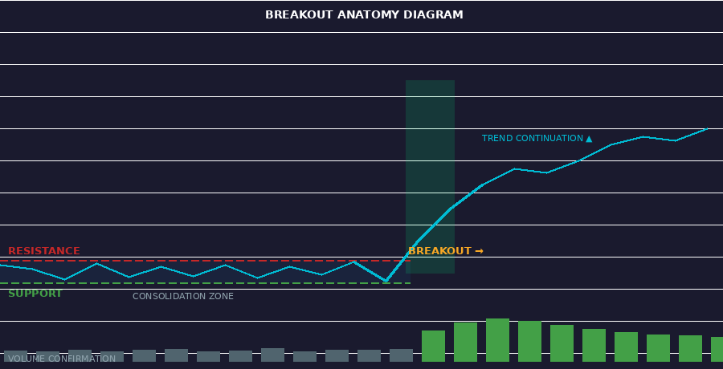
Figure 1: Complete Breakout Anatomy — Consolidation zone, resistance, volume surge, and trend continuation

2.1 The Six Key Components
- CONSOLIDATION ZONE (Blue shade): Price oscillates between support and resistance. Volume decreases during this phase as the market 'coils' before the move. The more touches on each boundary, the stronger the eventual break.
- RESISTANCE LINE (Red dashed): The upper boundary that sellers have defended repeatedly. This becomes the breakout trigger level. Previous resistance becomes new support post-breakout.
- SUPPORT LINE (Green dashed): The lower boundary where buyers have stepped in repeatedly. In a bullish breakout, this level holds while resistance breaks.
- BREAKOUT CANDLE (Highlighted zone): The specific candle that closes decisively above/below the level. The body of the candle must close beyond the level — a wick penetration alone does NOT constitute a valid breakout.
- VOLUME SURGE (Green bars): The single most critical confirmation. Volume must expand significantly — at minimum 1.5x the 20-period average, ideally 2x or more. This confirms institutional participation and genuine momentum.
- TREND CONTINUATION: After the break, price should continue in the breakout direction. A healthy pullback (retest) to the broken level is normal and provides the best secondary entry opportunity.
Critical Rule: A breakout without volume expansion is NOT a valid breakout. It is a potential false move. Volume is the fingerprint of institutional participation — never trade a breakout without it.

2.2 Step-by-Step Breakout Process
- Price consolidates between defined support and resistance for a sustained period
- Volume contracts during consolidation — the market is 'coiling' (energy building)
- Price tests the resistance level multiple times (minimum 2 touches to validate the level)
- A strong breakout candle forms and CLOSES above the resistance with high volume
- Volume on breakout candle is at least 1.5x (preferably 2x+) the 20-period average
- Price may pull back to retest the broken level — this is the conservative secondary entry
- Trend continuation begins — target equals the height of the prior range projected upward

3. BREAKOUT PATTERNS — IN DEPTH
Each breakout pattern has distinct formation requirements, statistical characteristics, and optimal trading approaches. Understanding the nuances of each pattern dramatically improves trade selection and timing.

3.1 Flags & Pennants — The Highest Probability Patterns
Flags and pennants are consistently the most reliable continuation patterns in technical analysis, appearing on all markets and all timeframes. They form after a strong impulsive move (the flagpole), followed by a brief consolidation, then a breakout that typically mirrors the flagpole height.
Feature | Bull/Bear Flag | Pennant
Shape | Rectangular channel (parallel lines) | Small converging triangle
Slope | Counter-trend (against the pole) | Neutral / slight counter-trend
Duration | 5-20 bars typically | 5-15 bars, often shorter
Volume | Declines in pattern, surges at breakout | Declines in pattern, surges at breakout
Target | Flagpole height from breakout point | Flagpole height from breakout point
Reliability | Very High (★★★★★) | High (★★★★☆)
Best Timeframes | 1H, 4H, Daily | 15M, 1H, 4H
Ideal Markets | All — especially Stocks, Crypto | All — especially Futures, Forex

3.2 Triangles — Compressed Energy
Triangles form as price makes lower highs and higher lows simultaneously, converging toward an apex. The tension between buyers and sellers builds until one side overwhelms the other in a decisive breakout.
- ASCENDING TRIANGLE: Flat horizontal resistance + rising support. Strong bullish bias. Volume typically quiet before the break, then explosive. Breakout target = triangle height projected upward. Failure rate: ~20%.
- DESCENDING TRIANGLE: Flat horizontal support + falling resistance. Strong bearish bias. Mirror image of ascending. Watch for false upside breaks as a trap before the real downward move.
- SYMMETRICAL TRIANGLE: Both trendlines converging at equal angles. No directional bias — the breakout direction determines the trade. Measure the widest height of the triangle; project that distance from the breakout point. Minimum 5 contact points required (2 on one side, 3 on the other).
Triangle Rule: Breakout ideally occurs at 50-75% of the distance to the apex. Breakouts too early (below 50%) lack conviction; breakouts at the apex often lack momentum.

3.3 Wedges — Countertrend Power
Wedges differ from triangles in that both trendlines slope in the same direction. This gives them a strong directional bias — rising wedges are bearish, falling wedges are bullish.
- RISING WEDGE: Higher highs and higher lows, but both lines slope upward and converge. Bearish reversal setup. Volume typically declining as price rises (weakening conviction). Breaks down through lower trendline. Common in late-stage uptrends.
- FALLING WEDGE: Lower lows and lower highs, both sloping downward. One of the most powerful bullish setups — falling wedges break upward explosively after being compressed. Excellent in crypto corrections and stock market pullbacks.

3.4 Rectangle / Range Breakouts
The simplest and most common breakout pattern. Price oscillates between two parallel horizontal support and resistance levels. Breakout above resistance or below support signals the end of the range. Target = range height projected in the breakout direction. These are highly reliable on Daily and Weekly charts due to cleaner structure.

3.5 Cup & Handle
Predominantly seen in stocks but applicable to all markets. A larger rounded base (the cup) forms over weeks or months as the market digests a prior decline, followed by a smaller consolidation pullback (the handle). The handle breakout above its resistance is the entry signal. Target = cup depth projected from the breakout. One of William O'Neil's (CANSLIM) core patterns.

4. ALL TIMEFRAMES — COMPLETE BREAKDOWN
Breakout strategies work on every timeframe, from 1-minute scalping charts to monthly position charts. Each timeframe exhibits unique characteristics in signal quality, noise, and reliability. The fundamental key is matching your timeframe to your trading style, personality, and available time.
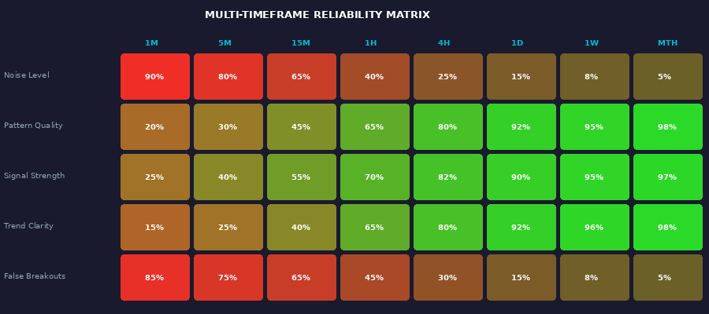
Figure 2: Multi-Timeframe Reliability Matrix — Signal quality, noise levels, and false breakout rates across all timeframes

4.1 Scalping Timeframes (1M – 5M)
Ultra-short timeframes require lightning-fast execution and extremely tight risk management. Noise levels are highest here, and false breakouts are very common. These timeframes demand full-time attention and advanced infrastructure.
- Best for: Market makers, HFT traders, experienced discretionary scalpers with low-latency execution
- Breakout focus: Opening Range Breakouts (ORB) at session opens, momentum spikes on level 2 data
- Volume: Use tick volume or order flow / footprint charts for granular confirmation
- Risk per trade: Maximum 0.25-0.5% of capital. Stop losses 3-5 pips / 2-5 ticks
- Key filter: Only trade during first 30 minutes of London or New York opens. Avoid lunch hours.

4.2 Intraday Timeframes (15M – 1H)
The sweet spot for most active day traders. Sufficient bar data to form reliable patterns while still allowing multiple trades per session. The 15M and 1H are the most widely traded timeframes by retail traders globally.
- Best for: Day traders, active professionals, experienced part-time traders
- Breakout focus: Triangles, flags, pennants, horizontal breakouts, previous day high/low breaks
- Volume confirmation: 1.5x-2x the 20-period average is the minimum required
- Risk per trade: 0.5-1% of capital. Stop loss positioned 1-1.5 ATR beyond the pattern
- Multi-TF approach: Use 4H for trend direction, 1H for pattern identification, 15M for precise entry

4.3 Swing Timeframes (4H – Daily)
The highest probability timeframes for breakout trading, consistently producing the best risk-adjusted returns. Patterns form over days to weeks, institutional participation is higher, market noise is significantly reduced, and false breakouts occur far less frequently.
- Best for: Swing traders, part-time traders with careers, patient systematic traders
- Breakout focus: All major patterns — cup & handle, large triangles, bull/bear flags, rectangles
- Volume: Compare to 20-day average volume. Look for 2x+ expansion on the breakout day
- Risk per trade: 1-2% of capital. Stop loss placed at 1.5-2x ATR from entry
- Key advantage: Fewer screen hours required, higher signal quality, overnight position holding

4.4 Position Timeframes (Weekly – Monthly)
The highest conviction timeframes used by institutional traders, fund managers, and long-term position traders. Breakouts on these charts signal major macro structural shifts that can sustain for months or years. These require patience, capital, and the ability to withstand drawdowns.
- Best for: Long-term investors, portfolio managers, macro traders, hedge funds
- Breakout focus: Multi-month ranges, massive cup & handle formations, secular trend breakouts
- Volume: Monthly/weekly volume trend. Watch for volume climax patterns at the breakout
- Risk per trade: 2-5% of capital. Allow wide stops — noise is low but moves require room
- Examples: Bitcoin breaking $69K to ATH (2024), S&P 500 breaking decade-long resistance (2013, 2020)
Timeframe | Trade Duration | Trades/Day | Stop Loss Range | Typical Win Rate | R:R Target
1M | Seconds to minutes | 10-50+ | 3-8 pips | 35-45% | 1:1.5
5M | 5-30 minutes | 5-15 | 5-12 pips | 38-48% | 1:2
15M | 15-90 minutes | 2-6 | 10-20 pips | 40-50% | 1:2-3
1H | 1-8 hours | 1-3 | 20-40 pips | 42-52% | 1:2-3
4H | 4-24 hours | 0-2 | 40-80 pips | 45-55% | 1:3
Daily | 1-5 days | 0-1 | 80-200 pips | 48-58% | 1:3-5
Weekly | 1-4 weeks | 0-1/wk | 200-500 pips | 50-60% | 1:5-8
Monthly | 1-3 months | 0-1/mo | 500+ pips | 55-65% | 1:8+

5. ALL MARKETS — COMPLETE COVERAGE
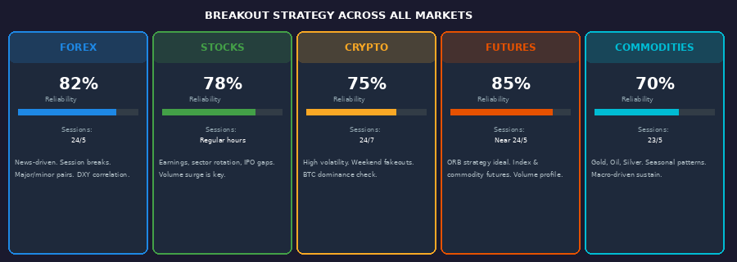
Figure 3: Breakout Strategy Reliability and Session Coverage Across All Major Financial Markets

5.1 Forex (FX) Market
The Forex market is the world's largest financial market, trading over $7.5 trillion daily across 170+ currency pairs. Breakouts in FX are driven by macroeconomic events, central bank decisions, geopolitical developments, and technical levels accumulated from years of price history.
- Top pairs for breakout trading: EUR/USD, GBP/USD, USD/JPY, GBP/JPY, AUD/USD, USD/CHF
- Best breakout times: London Open (08:00 GMT), New York Open (13:00 GMT), London-NY overlap (13:00-17:00 GMT)
- Key catalysts: CPI inflation data, Non-Farm Payrolls (NFP), FOMC/ECB/BOE/BOJ decisions, GDP releases
- False breakout risk: Medium-High. Asian session frequently creates false breaks that London reverses or confirms
- Unique consideration: Currency pairs are interconnected — always check DXY (Dollar Index) to confirm USD-pair directional bias

5.2 Stock Market (Equities)
Stock market breakouts are particularly powerful because they combine technical structure with fundamental catalysts. The best breakouts occur when a technically perfect setup aligns with a fundamental reason to move.
- Individual stocks: Earnings surprises, product launches, M&A announcements, FDA approvals, sector rotations
- Indices (SPY, QQQ, DIA, IWM): Macro breakouts driven by Fed policy, economic data, earnings seasons, and risk sentiment shifts
- Volume is king: Stock volume surges of 200-500% above average on the breakout day are extremely powerful bullish signals
- Pre-market/After-hours: Gap breakouts from earnings can be traded with reduced size — high risk but high reward
- Relative Strength: Always focus on stocks breaking out in the strongest sectors during broader market breakouts

5.3 Cryptocurrency
Crypto markets operate 24/7/365 and exhibit the most volatile breakout behavior of any mainstream asset class. Breakouts on altcoins can produce 50-500%+ gains, but false breakouts are also the most frequent, making rigorous filtering essential.
- Bitcoin dominance: BTC breakouts typically trigger altcoin season. Always check BTC.D (dominance chart) before altcoin trades
- Weekend risk: Low-liquidity weekends create elevated false breakout risk. Wait for Monday open confirmation for major levels
- Volume confirmation: Use aggregated volume from multiple major exchanges (Binance, Coinbase, Bybit, OKX)
- On-chain data: Large wallet (whale) movements, exchange inflows/outflows, and funding rates add powerful confirmation layers
- Best crypto breakout filter: Weekly candle close above the level AND funding rates neutral/negative (not overheated)

5.4 Futures Markets
Futures offer some of the cleanest breakout signals due to standardized contracts, exceptional liquidity, and high-quality volume data. The Opening Range Breakout (ORB) strategy was specifically developed for futures markets and remains highly effective.
- Index futures (ES, NQ, YM, RTY): ORB on 5-30 minute opening range is the gold standard day trading strategy
- Commodity futures (CL crude oil, GC gold, SI silver, ZC corn, ZW wheat): Seasonal patterns + technical breakouts
- Overnight range: Mark the overnight high and low. A break above/below at the open triggers the directional bias
- Volume profile: Point of Control (POC), Value Area High (VAH), and Value Area Low (VAL) are natural breakout magnets

5.5 Commodities
Gold, Silver, Oil, natural gas, and agricultural commodities exhibit powerful multi-week and multi-month breakouts. These are often tied to macro themes — inflation, geopolitics, weather — that sustain the move far longer than purely technical markets.
- Gold (XAU/USD): Multi-year range breakouts are the most powerful. The 2024 breakout above $2,100 confirmed a secular bull market that continued aggressively higher
- Oil (WTI/Brent): OPEC+ decisions, geopolitical events (Middle East, Russia), and seasonal demand cycles drive major breakouts
- Agricultural commodities: Weather-driven supply shocks create violent breakouts in corn, wheat, and soybean futures
- Key consideration: Fundamental macro drivers sustain commodity breakouts much longer than purely technical assets

6. ALGORITHMIC UNDERSTANDING
Translating the breakout strategy into a rigorous algorithmic framework is essential for systematic trading, backtesting, automation, and removing emotional bias. Below is the complete specification for a production-grade breakout algorithm.
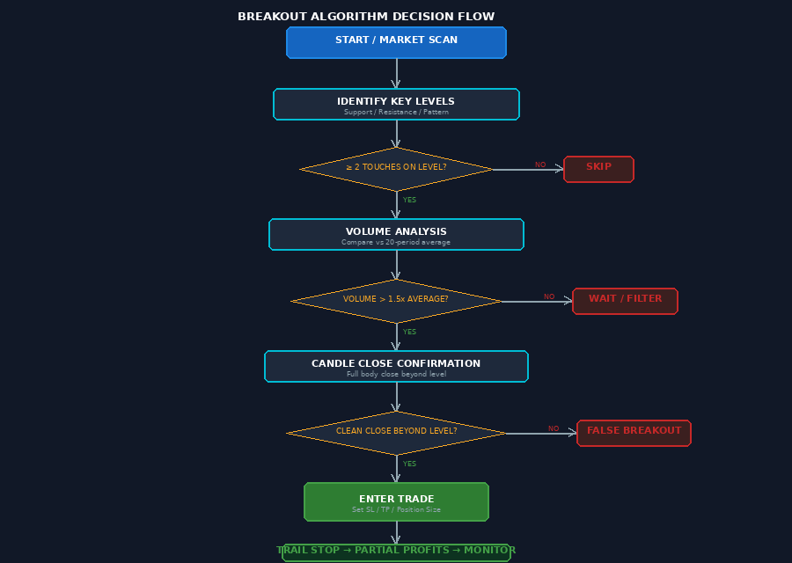
Figure 4: Complete Breakout Algorithm Decision Flow — From market scan to trade entry, stop loss, and exit management

6.1 Inputs — Raw Data Required
Input Variable | Description | Data Type | Default Value
OHLCV Data | Open, High, Low, Close, Volume per bar | Float array | Required
Timeframe | Chart period being analyzed | Enum (1M,5M,15M,1H,4H,1D,1W) | User config
Lookback Period | Bars to analyze for level detection | Integer | 50-200
ATR Period | Period for Average True Range | Integer | 14
Volume MA Period | Period for volume moving average | Integer | 20
Min Level Touches | Min touches to validate a level | Integer | 2
Breakout Buffer | Price buffer beyond level | Float (ATR mult) | 0.5 × ATR
Volume Threshold | Min volume ratio for confirmation | Float | 1.5
Risk % Per Trade | Account capital at risk per trade | Float (%) | 1.0%
Min R:R Ratio | Minimum reward-to-risk required | Float | 2.0
Session Filter | Approved trading sessions | Enum | LONDON, NY
Higher TF Trend | Trend from higher timeframe | Enum (BULL/BEAR/NEUTRAL) | Calculated
News Filter | Block trades near economic events | Boolean | TRUE
Max Daily Losses | Stop trading after N daily losses | Integer | 2

6.2 Processing Logic — Core Algorithm
The algorithm executes the following sequence of calculations on every new bar close:
- LEVEL DETECTION: Scan the last N bars. Identify swing highs as resistance and swing lows as support using a zigzag or fractal algorithm. Count the number of price touches on each level. Flag levels with ≥ 2 touches as validated breakout candidates.
- VOLUME CALCULATION: Compute the 20-period Simple Moving Average (SMA) of volume. Calculate the current volume ratio: current_volume ÷ volume_SMA_20. Flag if ratio ≥ 1.5 (configurable threshold).
- ATR CALCULATION: Compute the 14-period ATR. Use ATR to set the buffer zone: valid_breakout_price = resistance_level + (ATR × buffer_multiplier). This filters wick-only false penetrations.
- BREAKOUT DETECTION: On each bar close, evaluate: IF close > resistance + ATR_buffer → potential_bullish_breakout = TRUE. IF close < support - ATR_buffer → potential_bearish_breakout = TRUE.
- CONFIRMATION STACK: Run all filters simultaneously in parallel. ALL conditions must be TRUE for a valid signal: volume_ratio ≥ threshold AND ATR expanding AND body_ratio ≥ 0.5 AND session_filter AND htf_trend_aligned AND no_news_imminent.
- SIGNAL GENERATION: If confirmation stack passes → generate LONG or SHORT signal with calculated entry price, stop loss, take profit levels, and position size.
- TRADE MANAGEMENT: Monitor the open position each bar. Trail stop using ATR multiplier. Flag partial profit exits at 1.5R and 3R. Invalidation exit if price closes back inside the broken level.

6.3 Entry Conditions — Full Logic
BULLISH BREAKOUT — ALL conditions must evaluate to TRUE:
- C1: close[0] > highest_resistance + (ATR_14 × buffer_multiplier)
- C2: volume[0] >= volume_sma_20 × volume_threshold
- C3: ATR_14[0] > ATR_14[5] (ATR expanding — genuine volatility breakout)
- C4: close[0] > EMA_200[0] (price above 200 EMA — trading with macro trend)
- C5: RSI_14[0] > 50 (momentum positive for long trades)
- C6: candle_body_size / candle_range > 0.50 (no doji — rejection candle filter)
- C7: session_active == TRUE (within configured high-probability hours)
- C8: bars_until_news > 4 (no major news event within next 4 bars)
BEARISH BREAKOUT — Mirror logic (all conditions inverted where applicable):
- close[0] < lowest_support - (ATR_14 × buffer) AND volume ≥ threshold AND ATR expanding AND close < EMA_200 AND RSI < 50 AND body > 50% AND session active AND no news

6.4 Outputs — Generated Trade Parameters
Output | Formula / Logic | Example Value
Entry Price | Close of breakout candle (market order) OR limit at retest | $100.00
Stop Loss | entry - (ATR_14 × 1.5) for LONG / entry + (ATR_14 × 1.5) for SHORT | $97.75
Take Profit 1 | entry + (stop_distance × 1.5) — exit 50% position here | $103.37
Take Profit 2 | entry + (stop_distance × 3.0) — exit remaining 50% here | $106.75
Position Size | (account × risk_pct) ÷ abs(entry - stop_loss) | 100 shares
Risk Amount $ | account_balance × risk_percent | $200
Signal Type | Detected pattern: FLAG / TRIANGLE / RECTANGLE / PENNANT... | BULL_FLAG
Confidence Score | Composite 0-100 based on all filter conditions passing | 87/100
Invalidation Level | Price at which setup logic is wrong — immediate exit | $95.50
Pattern Height | Height of pattern (range), used for target projection | $8.25
Alert Triggered | Push notification sent with trade details | TRUE
Journal Entry | Automated log: date, pair, TF, pattern, entry, SL, TP, notes | Generated

7. RISK MANAGEMENT & POSITION SIZING
Risk management is the foundation that separates consistently profitable traders from those who eventually blow their accounts. No breakout strategy — regardless of its win rate — survives without disciplined risk management. This section covers the mathematical reality, position sizing, stop placement, and trade management rules.

7.1 The Mathematical Reality of Breakout Trading
Breakout strategies statistically win between 40-50% of all trades. Many traders abandon breakout strategies because of this low win rate, not understanding that the MATH still works powerfully in their favor:
40% Win Rate + 1:3 R:R = (0.40 × 3R) - (0.60 × 1R) = +1.2R - 0.6R = +0.6R per trade (PROFITABLE over 100 trades)
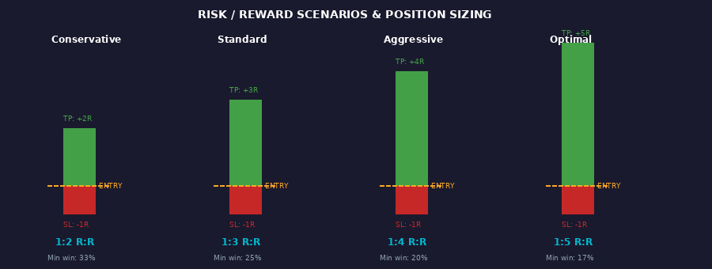
Figure 5: Risk/Reward Scenarios — Comparing 1:2 through 1:5 R:R profiles with minimum win rates needed for profitability

7.2 Universal Position Sizing Formula
Position Size = (Account Balance × Risk %) ÷ Stop Loss Distance (in price terms)
Worked Example — Forex: $10,000 account, 1% risk, 50 pip stop on EUR/USD:
- Step 1: Risk Amount = $10,000 × 1% = $100 per trade
- Step 2: Stop loss = 50 pips. For 0.10 lot (mini): 50 pips × $1/pip = $50 per mini lot
- Step 3: Position Size = $100 ÷ $50 = 0.20 lot (2 mini lots)
Worked Example — Stocks: $50,000 account, 1% risk, $2.50 stop on a $100 stock:
- Step 1: Risk Amount = $50,000 × 1% = $500 per trade
- Step 2: Stop loss = $2.50 per share
- Step 3: Position Size = $500 ÷ $2.50 = 200 shares

7.3 Stop Loss Placement Methods
Method | Placement Logic | Best Applied To
ATR-Based Stop | Entry ± (1.5-2.0 × 14-period ATR) | All markets and all timeframes — universal
Structure Stop | Below pattern swing low (long) / above swing high (short) | Chart pattern breakouts — most logical
Candle Stop | Below breakout candle low / above breakout candle high | Tight entries on high-conviction setups
Zone Stop | Below support zone bottom / above resistance zone top | Range and rectangle breakouts
Volatility Stop | Entry ± (Bollinger Band width × 0.5) | High-volatility crypto and indices
Percentage Stop | Fixed % below entry (e.g. 1.5% for stocks) | Beginners, algorithmic systems

7.4 The 7 Cardinal Rules of Breakout Risk Management
- NEVER risk more than 1-2% of total trading capital on a single breakout trade — account survival comes first
- Take partial profits (50%) at 1.5R-2R — reduce risk, keep opportunity open with the remaining position
- Move stop loss to breakeven when the trade reaches 1R in profit — free trade from this point
- Trail remaining 50% position using ATR-based trailing stop — capture extended breakout moves
- If stopped out 2 times in the same session, STOP trading for the day — avoid revenge trading
- Reduce position size by 50% during low-volume periods (pre-holiday, Asian session, Friday close)
- NEVER add to a losing breakout position — averaging down on failed breakouts destroys accounts

8. FALSE BREAKOUTS — DETECTION & AVOIDANCE
False breakouts, also known as fakeouts, are the primary challenge and cost center in breakout trading. Studies of price behavior across equities, futures, and forex consistently show that approximately 50% of all breakout attempts ultimately fail. Understanding why they occur and how to filter them is what defines professional traders.

8.1 Why False Breakouts Occur
- Stop Hunt Manipulation: Large institutional players deliberately push price through key levels to trigger retail stop orders and buy at better prices, then reverse the move sharply
- Low Liquidity Environments: During quiet sessions (Asia session, pre-holiday, overnight), small order sizes can push price through levels without institutional backing — no follow-through
- News-Driven Spikes: Surprise economic releases cause momentary price spikes that penetrate technical levels but reverse equally fast as the market digests the news
- Thin Market Hours: End of month, quarter-end rebalancing, and holiday periods reduce participation and increase manipulation probability
- Crypto Market Manipulation: Whale wallets deliberately push price to trigger cascading stop losses and liquidations on leveraged positions, then buy the resulting dip
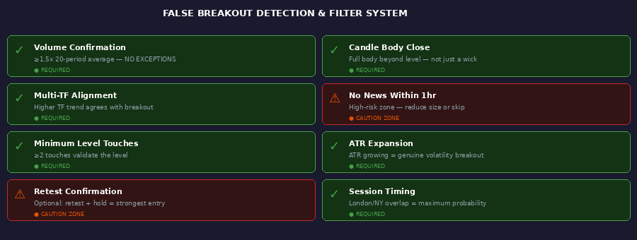
Figure 6: False Breakout Detection System — Required confirmations (green) and high-risk caution zones (orange)

8.2 The Complete False Breakout Filter
- ✅ REQUIRED — Volume ≥ 1.5x the 20-period average: Zero exceptions. Low-volume breakouts fail 70%+ of the time.
- ✅ REQUIRED — Candle body closes beyond level: Body must close beyond the level. A wick-only penetration is NOT a breakout.
- ✅ REQUIRED — Higher timeframe trend alignment: Trading breakouts against the major trend adds significant failure risk.
- ✅ REQUIRED — Minimum 2 level touches before breakout: Unvalidated levels can be random noise — not true support/resistance.
- ✅ REQUIRED — ATR expanding at time of breakout: Contracting ATR on a breakout suggests fading, not genuine momentum.
- ✅ REQUIRED — No major news event within 30-60 minutes: News invalidates all technical levels temporarily.
- ⚠️ OPTIONAL — Retest and hold confirmation: Price returns to the broken level, holds, and resumes — most powerful secondary confirmation.
- ⚠️ ADVISED — Correct session timing: London and New York opens produce the highest probability, most sustained breakouts.

8.3 Trading the False Breakout (Fade Strategy)
When you identify a confirmed false breakout, it creates an excellent counter-directional trade opportunity. This is the breakout fade strategy:
- IDENTIFY: Price breaks a key level but volume is LOW and/or candle closes back inside the range (long upper/lower wick)
- CONFIRM: The next 1-2 candles confirm the reversal — price is back inside the range and moving away from the level
- ENTRY: Enter in the direction OPPOSITE to the failed breakout, near the broken level that is now acting as resistance/support
- STOP LOSS: Place stop just beyond the false breakout candle high (for bearish fade) or low (for bullish fade)
- TARGET: The opposite side of the range, the next structural support/resistance level
Pro Tip: False breakouts on Weekly or Daily timeframes followed by a strong reversal candle (pinbar, engulfing) on LOW volume are among the highest-probability trading setups available to any trader.

9. INDICATORS & CONFIRMATION TOOLS
No single indicator should be used in isolation for breakout confirmation. The most effective and robust systems use a layered, multi-indicator approach that combines price action analysis, volume data, momentum measurement, and trend identification. Each layer adds probability — not certainty.
Indicator | Primary Function | Breakout Application | Optimal Settings
Volume | Measures market participation | Primary confirmation — must be ≥1.5x 20-period SMA | Raw volume + SMA(20)
ATR (Avg True Range) | Measures volatility | Stop placement, breakout buffer, position sizing | Period: 14
RSI | Momentum oscillator 0-100 | >50 confirms bullish momentum; <50 bearish | Period: 14
MACD | Trend and momentum | MACD crossover confirms breakout direction and strength | 12 / 26 / 9
Bollinger Bands | Volatility channels | Squeeze = imminent breakout. Price outside band = confirmed | Period: 20, 2σ
EMA 8/21/50/200 | Layered trend direction | Price above all EMAs = aligned bullish trend. EMA stack order matters | 8, 21, 50, 200
VWAP | Volume-weighted average price | Breakout above VWAP confirms institutional buying activity | Daily reset anchor
Donchian Channels | N-period high/low channel | Breakout above N-period high is primary Turtle Trading signal | Period: 20 or 55
ADX | Trend strength measurement | ADX >25 = trending market. Breakout in strong ADX trend = higher prob | Period: 14
OBV | Cumulative volume trend | OBV making new highs before price breaks = anticipatory bullish signal | Cumulative
Keltner Channels | ATR-based channel | BB inside KC = squeeze active. Expansion = imminent breakout | Period: 20, ATR 1.5
Ichimoku Cloud | Multi-dimensional trend | Break through cloud = major structural change signal | 9 / 26 / 52

9.1 The Recommended 5-Layer Indicator Stack
Layer 1 — TREND: EMA 50 + EMA 200. Only trade breakouts in the direction of the trend. Price above both EMAs = bullish bias only.
Layer 2 — MOMENTUM: RSI 14 must be above 50 for longs / below 50 for shorts. MACD crossover as secondary momentum confirmation.
Layer 3 — VOLUME: Current volume vs SMA(20). Must be ≥1.5x. OBV trend should slope in the breakout direction.
Layer 4 — VOLATILITY: ATR(14) must be expanding. Bollinger Band squeeze before the breakout = maximum compression setup.
Layer 5 — PRICE ACTION: Breakout candle body must exceed 50% of total candle range. No indecision candles (doji, spinning tops) on the breakout bar.

9.2 The Bollinger Band Squeeze — Breakout Anticipation
The Bollinger Band Squeeze is one of the most powerful leading indicators of an imminent breakout. When Bollinger Bands contract tightly, volatility has compressed — the market is coiling before an explosive move. This is the John Bollinger squeeze signal:
- Bands contracting to their narrowest point in N bars = SQUEEZE ACTIVE — maximum compression
- The squeeze does NOT predict direction — it predicts magnitude. Use trend/momentum tools for direction.
- Advanced: When Bollinger Bands contract INSIDE Keltner Channels, the squeeze is at maximum compression (John Carter TTM Squeeze method)
- Entry strategy: Wait for BB to begin expanding AND direction confirmed by momentum → enter the breakout

10. STRATEGY VARIATIONS & IMPLEMENTATIONS

10.1 Classic Aggressive Breakout
Enter immediately on the closing price of the breakout candle. Market order on close. Maximum capture of the opening move. Highest reward potential but also the highest false breakout exposure. Best applied on Daily/Weekly charts or when volume is extreme (3x+ average).

10.2 Conservative Retest Entry
Wait for price to break the level, then pull back to retest the formerly broken level as new support/resistance, then enter when it holds. This is the highest probability entry method — lower risk, better R:R, significantly fewer false entries, but some fast-moving breakouts are missed entirely.
Retest Confirmation: Look for a bullish engulfing, pinbar, or inside bar at the retest level before entering. This adds powerful price action confirmation to the volume and structure analysis.

10.3 Opening Range Breakout (ORB)
Mark the high and low of the first 5, 15, or 30 minutes of the trading session. Enter on a candle close above the range high (long) or below the range low (short). Extremely effective on index futures (ES, NQ), individual stocks at open, and FX during the London or New York opens.
- 5-Minute ORB: Very aggressive. Multiple trades possible. Best for experienced scalpers.
- 15-Minute ORB: Balanced approach. Popular with day traders on futures and stocks.
- 30-Minute ORB: Conservative. Highest probability per trade. Best risk-adjusted approach.
- Filter: Only take ORB breakouts that align with the previous day's closing trend direction

10.4 Donchian / Turtle Breakout System
Enter when price makes a new N-period high (Donchian Channel breakout). The 20-period channel for entries and the 10-period for exits (or 55-period for longer timeframes) — this is the Turtle Trading system developed by Richard Dennis and William Eckhardt in the 1980s. It generated hundreds of millions in returns and still works today on futures, commodities, and trending FX pairs.

10.5 Multi-Timeframe Confluence Breakout
The highest conviction and highest probability breakout setup: a breakout that simultaneously aligns across THREE separate timeframes. Each alignment adds probability. When all three align, position size can be increased to 1.5x-2x normal.
- Level 1: Weekly chart breaks major resistance — macro structural breakout confirmed
- Level 2: Daily chart forms bull flag or triangle — continuation setup on intermediate timeframe
- Level 3: 4H chart triggers breakout with volume — entry timing precision on execution timeframe
The Maximum Conviction Setup: Weekly structural breakout + Daily bull flag + 4H volume surge + RSI > 50 all timeframes + price above EMA 50/200. This multi-confluence setup represents the highest probability breakout configuration available.

11. QUICK REFERENCE — TRADER'S CHECKLIST
Use this pre-trade checklist before entering ANY breakout trade on ANY market on ANY timeframe. No exceptions. Discipline at this stage is what separates consistently profitable traders from those who gamble:
# | Checkpoint | Priority | Status
1 | Identified clear S/R level with minimum 2 validated touches | REQUIRED | □
2 | Volume ≥ 1.5x the 20-period average on breakout candle | REQUIRED | □
3 | Candle BODY closes beyond the level — not just a wick | REQUIRED | □
4 | ATR is expanding relative to the prior 5 bars | REQUIRED | □
5 | Higher timeframe trend aligned with breakout direction | REQUIRED | □
6 | No major news event within next 30-60 minutes | STRONGLY ADVISED | □
7 | Stop loss calculated and positioned at ATR or structure level | REQUIRED | □
8 | Position size calculated — risk does not exceed 1-2% of account | REQUIRED | □
9 | Minimum 1:2 R:R ratio confirmed before entry | REQUIRED | □
10 | RSI above 50 (longs) / below 50 (shorts) — momentum confirmation | ADVISED | □
11 | Price above EMA 50 and EMA 200 (for bullish breakouts) | ADVISED | □
12 | Retest confirmation received (for conservative entry method) | OPTIONAL | □

11.1 The 8 Most Common Breakout Trading Mistakes
- Entering before candle close: A candle actively breaking a level does NOT count. ALWAYS wait for the bar to close before entering.
- Ignoring volume: Low-volume breakouts fail 70%+ of the time. Volume confirmation is not optional under any circumstances.
- Trading against higher timeframe trend: Breakouts against the dominant trend fail at 2-3x the normal rate.
- Chasing price: If you missed the entry and price is 2-3 ATRs extended from the level, do NOT chase. Wait for the retest.
- Over-leveraging: The number one account killer. Strict 1-2% risk per trade is non-negotiable for long-term survival.
- No plan before entry: Know your stop loss, take profit, and position size BEFORE the trade is entered, not after.
- Trading through news: Major economic releases invalidate technical setups. Check economic calendars every morning.
- Ignoring execution costs: In forex and crypto especially, wide spreads and commissions erode breakout edge. Account for all transaction costs.

11.2 Backtesting Requirements Before Live Trading
Before trading any breakout configuration with real capital, rigorous backtesting across varied historical conditions is mandatory:
- Minimum sample size: 100+ trades across different market conditions and at least 2 full market cycles
- Include all market phases in the test: strong trending, ranging/choppy, high-volatility, low-volatility, and crisis periods
- Slippage modeling: Add 1-2 pips or 0.1% slippage to all entries and exits for realistic simulation
- Walk-forward validation: Always test on out-of-sample (unseen) data to confirm true robustness vs curve-fitting
- Required performance metrics: Win rate, average win/average loss ratio, maximum drawdown, Sharpe ratio, and profit factor
Minimum viable profit factor for live trading deployment: 1.5 or higher. A profit factor below 1.3 requires further optimization, additional filters, or market/timeframe selection changes before going live.

— END OF BREAKOUT MASTER STRATEGY GUIDE —
Research Compiled 2025 | All Markets — All Timeframes | For Educational Purposes Only

