**Project Task: Deployment of Vagrant Ubuntu Cluster with LAMP Stack**

1. Open your virtual machine.
2. Create a new directory called deploy_cluster using the mkdir command.
3. Create and enter your bash script with the command: nano deploy_cluster.sh
4. Enter the following commands into your bash script: 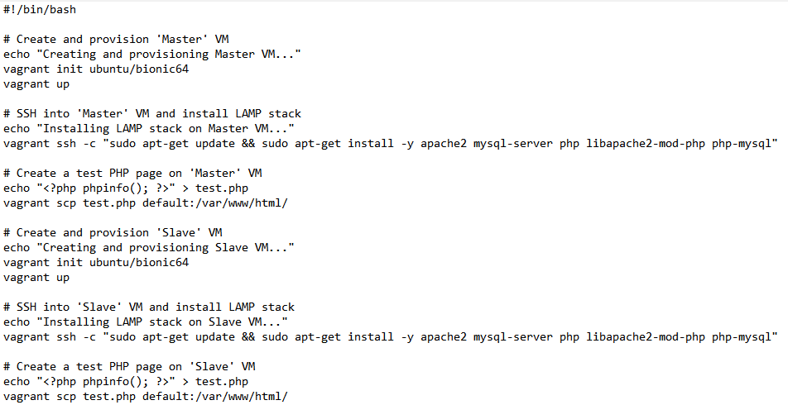 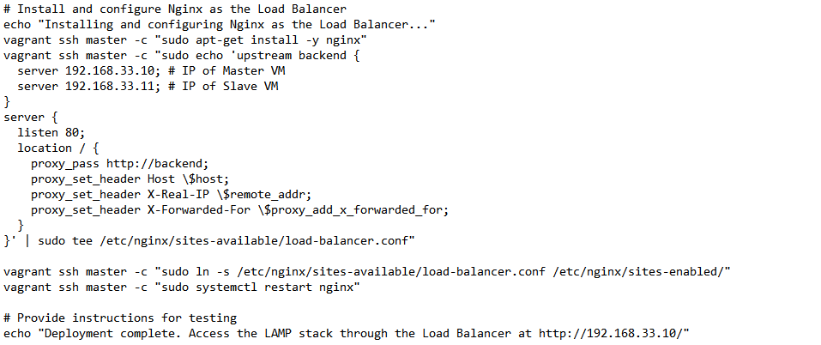
5. Save and close the bash script with the Ctrl+O and Ctrl+X keyboard shortcuts respectively.
6. Before the script can be run, it must have executable permissions. To do that, issue the command: chmod u+x deploy_cluster.sh
7. Run your bash script with the command: ./deploy_cluster.sh
8. Access the LAMP stack through the Load Balancer at <http://192.168.33.10/>.
9. Access the test PHP page by visiting http://192.168.33.10/test.php or htpp://192.168.33.11/test.php.