90 Forestry Road,

Benin City.

19th September, 2022.

The Dean,

Faculty of Physical Sciences,

Through The Head of Department,

Computer Sciences,

University of Benin,

Benin City,

Edo State.

Dear Sir,

**REQUEST FOR RESULT**

I, Osazee Isere hereby write to request for the result of my Master of Science programme that I did in department of Computer Science, University of Benin, Benin City. Below are my other details:

MatNo: PG/PSC1714883

Start session: 2017/2018

End session: 2018/2019

Thanks for your anticipated cooperation and understanding in this regard.

Yours faithfully,

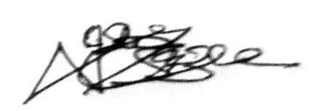

OSAZEE ISERE

08078987313; 08163775990