Digital Logic and Design

CMPS4252

Final Project

Osborn Collins and Mark Pascual

15th November 2022

INSTRUCTIONS

=============

NOTE: This project can be done in PAIRS (both persons must present) or individually.

DUE DATE: November 21, 2022, by 11:30 pm

Note: Provide a link to your YouTube video and a link to your PowerPoint slides on GitHub

QUESTION:

You have been enlisted to design a soda machine dispenser for the IT

department students' lounge. Sodas are partially subsidized by the student chapter of the

ACM, so they cost only 25 cents each. The machine accepts 5 cents, 10 cents, and shillings.

When enough coins have been inserted, it dispenses the soda and returns any

necessary change. Design an FSM controller for the soda machine. The FSM inputs

are 5 cents, 10 cents, and shilling, indicating which coin was inserted. Assume that

exactly ONE coin is inserted on each cycle. The outputs are Dispense, Return5Cents,

Return10Cents, and ReturnTwo10Cents. When the FSM reaches 25 cents, it asserts

Dispense and the necessary Return outputs required to deliver the appropriate

change. Then it should be ready to start accepting coins for another soda.

NOTE: I have given you the FSM except that it uses nickels (5), dimes (10), and quarters (25).

TASKS:

-------

PART 1

-------

Provide:

0. The modified FSM (showing 5 cents, 10 cents and shillings instead of nickels, dimes, and quarters)

1. The State Encoding table

[HINT: Use 10 bits to represent each of the 10 states (S0 - S45).

Use a one-hot encoding scheme with S0 = 0000000001 and S45 = 1000000000

2. The State Transition table and the resulting simplified equations

3. The Output table and the resulting simplified equations

4. The circuit

-------

PART 2

-------

Provide:

0. A PowerPoint presentation (between 25 - 30 minutes). This presentation will

explain how the FSM works, how you arrived at the state transition equations, how

you arrived at the output equations, and how the circuit works.

GRADING CRITERIA

=================

1. Clarity of explanation (conciseness)

2. Length of presentation (between 25 - 30 minutes)

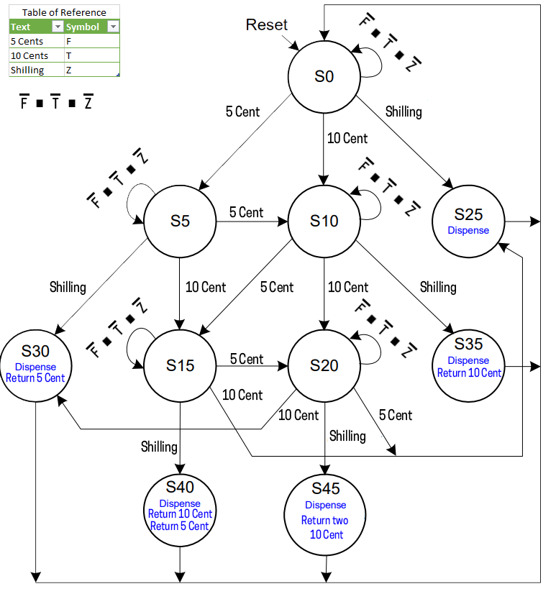**FSM**

**State encoding**

|  |  |
| --- | --- |
| **State** | **Encoding S9:0** |
| S0 | 0000000001 |
| S5 | 0000000010 |
| S10 | 0000000100 |
| S25 | 0000001000 |
| S30 | 0000010000 |
| S15 | 0000100000 |
| S20 | 0001000000 |
| S35 | 0010000000 |
| S40 | 0100000000 |
| S45 | 1000000000 |

**Definitions:**

5 cents – F

10 cents ­– T

Shilling ­– Z

**State transition table**

|  |  |  |  |  |
| --- | --- | --- | --- | --- |
| **Current state** | **Inputs** | | | **Next state** |
| **S** | **F (five cent)** | **T (ten cent)** | **Z (shilling)** | **S’** |
| S0 | 0 | 0 | 0 | S0 |
| S0 | 0 | 0 | 1 | S25 |
| S0 | 0 | 1 | 0 | S10 |
| S0 | 1 | 0 | 0 | S5 |
| S5 | 0 | 0 | 0 | S5 |
| S5 | 0 | 0 | 1 | S30 |
| S5 | 0 | 1 | 0 | S15 |
| S5 | 1 | 0 | 0 | S10 |
| S10 | 0 | 0 | 0 | S10 |
| S10 | 0 | 0 | 1 | S35 |
| S10 | 0 | 1 | 0 | S20 |
| S10 | 1 | 0 | 0 | S15 |
| S25 | X | X | X | S0 |
| S30 | X | X | X | S0 |
| S15 | 0 | 0 | 0 | S15 |
| S15 | 0 | 0 | 1 | S40 |
| S15 | 0 | 1 | 0 | S25 |
| S15 | 1 | 0 | 0 | S20 |
| S20 | 0 | 0 | 0 | S20 |
| S20 | 0 | 0 | 1 | S45 |
| S20 | 0 | 1 | 0 | S30 |
| S20 | 1 | 0 | 0 | S25 |
| S35 | X | X | X | S0 |
| S40 | X | X | X | S0 |
| S45 | X | X | X | S0 |

**State transition table with encoding**

|  |  |  |  |  |  |  |  |  |  |  |  |  |  |  |  |  |  |  |  |  |  |  |
| --- | --- | --- | --- | --- | --- | --- | --- | --- | --- | --- | --- | --- | --- | --- | --- | --- | --- | --- | --- | --- | --- | --- |
| Current State  S | | | | | | | | | | Inputs | | | Next State  S’ | | | | | | | | | |
| **S9** | **S8** | **S7** | **S6** | **S5** | **S4** | **S3** | **S2** | **S1** | **S0** | **F** | **T** | **Z** | **S’9** | **S’8** | **S’7** | **S’6** | **S’5** | **S’4** | **S’3** | **S’2** | **S’1** | **S’0** |
| 0 | 0 | 0 | 0 | 0 | 0 | 0 | 0 | 0 | 1 | 0 | 0 | 0 | 0 | 0 | 0 | 0 | 0 | 0 | 0 | 0 | 0 | 1 |
| 0 | 0 | 0 | 0 | 0 | 0 | 0 | 0 | 0 | 1 | 0 | 0 | 1 | 0 | 0 | 0 | 0 | 0 | 0 | 1 | 0 | 0 | 0 |
| 0 | 0 | 0 | 0 | 0 | 0 | 0 | 0 | 0 | 1 | 0 | 1 | 0 | 0 | 0 | 0 | 0 | 0 | 0 | 0 | 1 | 0 | 0 |
| 0 | 0 | 0 | 0 | 0 | 0 | 0 | 0 | 0 | 1 | 1 | 0 | 0 | 0 | 0 | 0 | 0 | 0 | 0 | 0 | 0 | 1 | 0 |
| 0 | 0 | 0 | 0 | 0 | 0 | 0 | 0 | 1 | 0 | 0 | 0 | 0 | 0 | 0 | 0 | 0 | 0 | 0 | 0 | 0 | 1 | 0 |
| 0 | 0 | 0 | 0 | 0 | 0 | 0 | 0 | 1 | 0 | 0 | 0 | 1 | 0 | 0 | 0 | 0 | 0 | 1 | 0 | 0 | 0 | 0 |
| 0 | 0 | 0 | 0 | 0 | 0 | 0 | 0 | 1 | 0 | 0 | 1 | 0 | 0 | 0 | 0 | 0 | 1 | 0 | 0 | 0 | 0 | 0 |
| 0 | 0 | 0 | 0 | 0 | 0 | 0 | 0 | 1 | 0 | 1 | 0 | 0 | 0 | 0 | 0 | 0 | 0 | 0 | 0 | 1 | 0 | 0 |
| 0 | 0 | 0 | 0 | 0 | 0 | 0 | 1 | 0 | 0 | 0 | 0 | 0 | 0 | 0 | 0 | 0 | 0 | 0 | 0 | 1 | 0 | 0 |
| 0 | 0 | 0 | 0 | 0 | 0 | 0 | 1 | 0 | 0 | 0 | 0 | 1 | 0 | 0 | 1 | 0 | 0 | 0 | 0 | 0 | 0 | 0 |
| 0 | 0 | 0 | 0 | 0 | 0 | 0 | 1 | 0 | 0 | 0 | 1 | 0 | 0 | 0 | 0 | 1 | 0 | 0 | 0 | 0 | 0 | 0 |
| 0 | 0 | 0 | 0 | 0 | 0 | 0 | 1 | 0 | 0 | 1 | 0 | 0 | 0 | 0 | 0 | 0 | 1 | 0 | 0 | 0 | 0 | 0 |
| 0 | 0 | 0 | 0 | 0 | 0 | 1 | 0 | 0 | 0 | X | X | X | 0 | 0 | 0 | 0 | 0 | 0 | 0 | 0 | 0 | 1 |
| 0 | 0 | 0 | 0 | 0 | 1 | 0 | 0 | 0 | 0 | X | X | X | 0 | 0 | 0 | 0 | 0 | 0 | 0 | 0 | 0 | 1 |
| 0 | 0 | 0 | 0 | 1 | 0 | 0 | 0 | 0 | 0 | 0 | 0 | 0 | 0 | 0 | 0 | 0 | 1 | 0 | 0 | 0 | 0 | 0 |
| 0 | 0 | 0 | 0 | 1 | 0 | 0 | 0 | 0 | 0 | 0 | 0 | 1 | 0 | 1 | 0 | 0 | 0 | 0 | 0 | 0 | 0 | 0 |
| 0 | 0 | 0 | 0 | 1 | 0 | 0 | 0 | 0 | 0 | 0 | 1 | 0 | 0 | 0 | 0 | 0 | 0 | 0 | 1 | 0 | 0 | 0 |
| 0 | 0 | 0 | 0 | 1 | 0 | 0 | 0 | 0 | 0 | 1 | 0 | 0 | 0 | 0 | 0 | 1 | 0 | 0 | 0 | 0 | 0 | 0 |
| 0 | 0 | 0 | 1 | 0 | 0 | 0 | 0 | 0 | 0 | 0 | 0 | 0 | 0 | 0 | 0 | 1 | 0 | 0 | 0 | 0 | 0 | 0 |
| 0 | 0 | 0 | 1 | 0 | 0 | 0 | 0 | 0 | 0 | 0 | 0 | 1 | 1 | 0 | 0 | 0 | 0 | 0 | 0 | 0 | 0 | 0 |
| 0 | 0 | 0 | 1 | 0 | 0 | 0 | 0 | 0 | 0 | 0 | 1 | 0 | 0 | 0 | 0 | 0 | 0 | 1 | 0 | 0 | 0 | 0 |
| 0 | 0 | 0 | 1 | 0 | 0 | 0 | 0 | 0 | 0 | 1 | 0 | 0 | 0 | 0 | 0 | 0 | 0 | 0 | 1 | 0 | 0 | 0 |
| 0 | 0 | 1 | 0 | 0 | 0 | 0 | 0 | 0 | 0 | X | X | X | 0 | 0 | 0 | 0 | 0 | 0 | 0 | 0 | 0 | 1 |
| 0 | 1 | 0 | 0 | 0 | 0 | 0 | 0 | 0 | 0 | X | X | X | 0 | 0 | 0 | 0 | 0 | 0 | 0 | 0 | 0 | 1 |
| 1 | 0 | 0 | 0 | 0 | 0 | 0 | 0 | 0 | 0 | X | X | X | 0 | 0 | 0 | 0 | 0 | 0 | 0 | 0 | 0 | 1 |

**Boolean Equations**

S’9 = S6Z

S’8 = S5Z

S’7 = S2Z

S’6 = S2T + S5F + S6

S’5 = S1T + S2F + S5

S’4 = S1Z + S6T

S’3 = S0Z + S5T + S6F

S’2 = S0T + S1F + S2

S’1 = S0F + S1

S’0 = S1 + S3 + S4 + S7 + S8 + S9

**Definitions:**

rF – Return 5 Cent

rT – Return 10 Cent

r2T – Return two 10 Cent

**Output Table**

|  |  |  |  |  |
| --- | --- | --- | --- | --- |
| **Current State** | **Dispense** | **rF** | **rT** | **r2T** |
| S25 | 1 | X | X | X |
| S30 | 1 | 1 | X | X |
| S35 | 1 | X | 1 | X |
| S40 | 1 | 1 | 1 | X |
| S45 | 1 | X | X | 1 |

**Output Table with Encoding**

|  |  |  |  |  |  |  |  |  |  |  |  |  |  |
| --- | --- | --- | --- | --- | --- | --- | --- | --- | --- | --- | --- | --- | --- |
| Current State | | | | | | | | | | Output | | | |
| S9 | S8 | S7 | S6 | S5 | S4 | S3 | S2 | S1 | S0 | Dispense | rF | rT | r2T |
| 0 | 0 | 0 | 0 | 0 | 0 | 1 | 0 | 0 | 0 | 1 | X | X | X |
| 0 | 0 | 0 | 0 | 0 | 1 | 0 | 0 | 0 | 0 | 1 | 1 | X | X |
| 0 | 0 | 1 | 0 | 0 | 0 | 0 | 0 | 0 | 0 | 1 | X | 1 | X |
| 0 | 1 | 0 | 0 | 0 | 0 | 0 | 0 | 0 | 0 | 1 | 1 | 1 | X |
| 1 | 0 | 0 | 0 | 0 | 0 | 0 | 0 | 0 | 0 | 1 | X | X | 1 |

**Boolean Equations for the Output**

Dispense = S3 + S4 + S7 + S8 + S9

rF = S4 + S8

rT = S7 + S8

r2T = S9

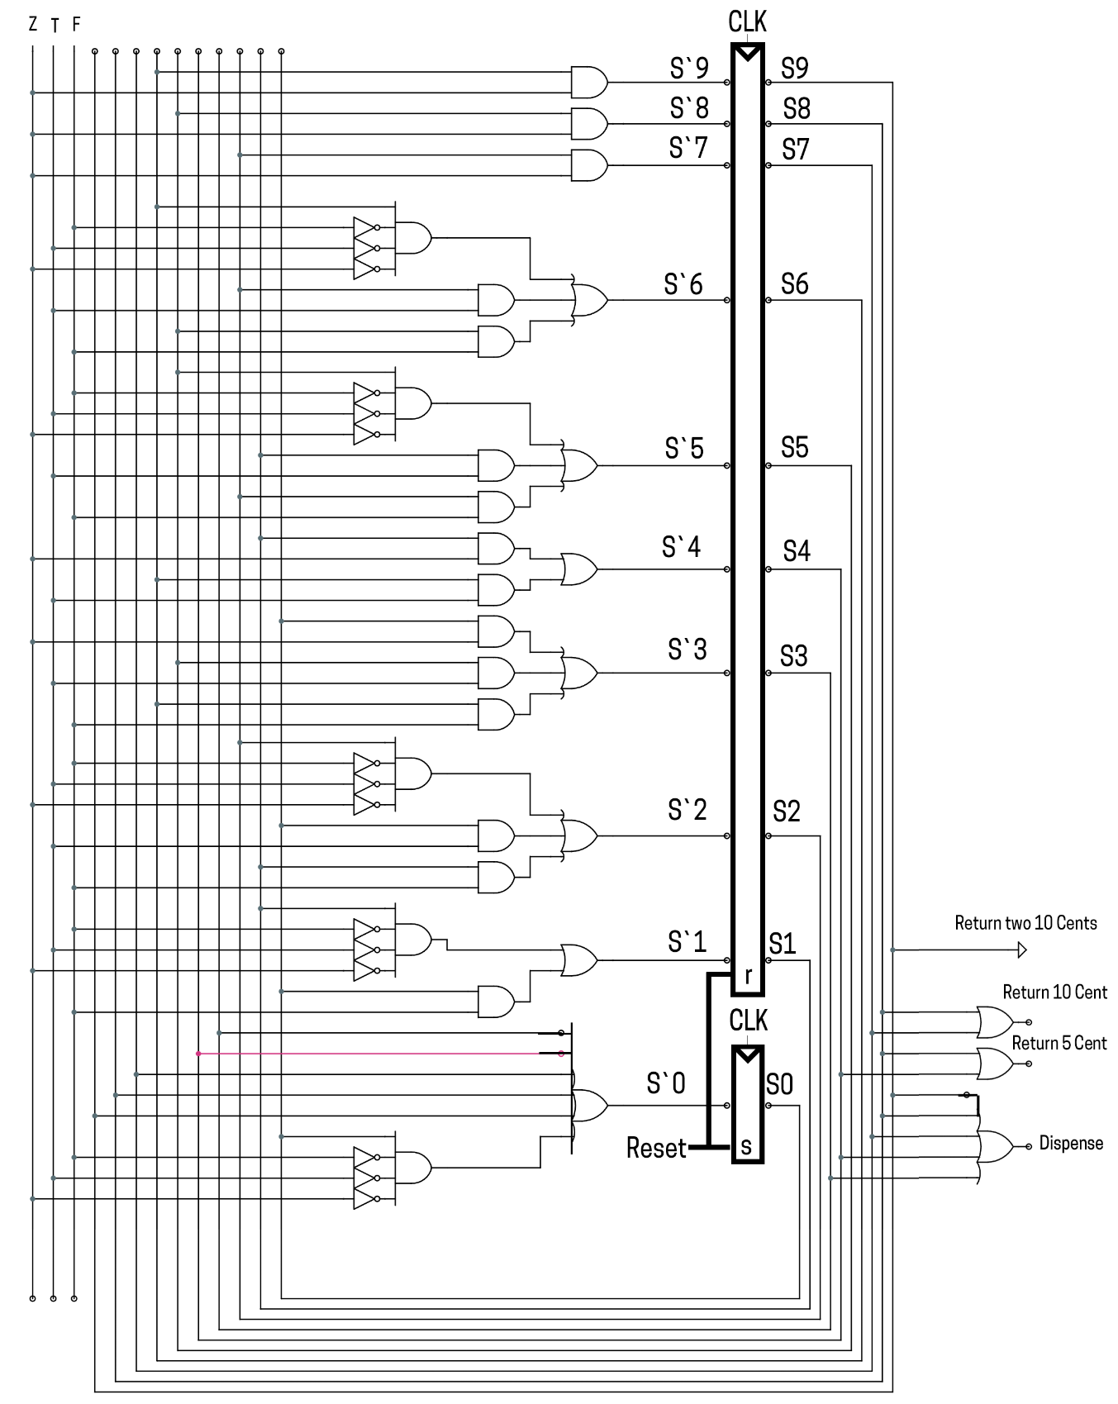**Circuit Diagram**