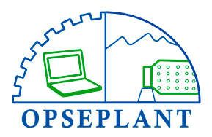


📄 REPORTE DE AVANCE DIARIO
Fecha: 2025-04-21
Supervisor: {{ supervisor }}

📌 Avance original:
{{ texto_original }}

🤖 Resumen AI:
{{ resumen_ai }}

🖼 Fotos del avance:
{{ fotos_avance }}
Fecha: 2025-04-21
Supervisor: Oscar_Ivan_Salas_Contreras
📝 Avance original:
Hola
🧠 Resumen AI:
[GPT ERROR]
You tried to access openai.ChatCompletion, but this is no longer supported in openai>=1.0.0 - see the README at https://github.com/openai/openai-python for the API.
You can run `openai migrate` to automatically upgrade your codebase to use the 1.0.0 interface.
Alternatively, you can pin your installation to the old version, e.g. `pip install openai==0.28`
A detailed migration guide is available here: https://github.com/openai/openai-python/discussions/742
📷 Fotos del avance:

