Cambridge Dream

This is a two-week study tour

7.27 8:00

We gathered at school and took a bus to Shanghai Pudong Airport. To be honest, I wanted to go home on the way, but the positive and optimistic attitude of my classmates made me not so sad.

7.28 1:00

After more than four hours of travel, we arrived at Shanghai Pudong Airport, but unfortunately our tutor did not arrange a place to stay, so we could only wait at the airport until the plane took off in the morning. This period of time was really difficult. The plane took off at nearly 12 o'clock in the morning.

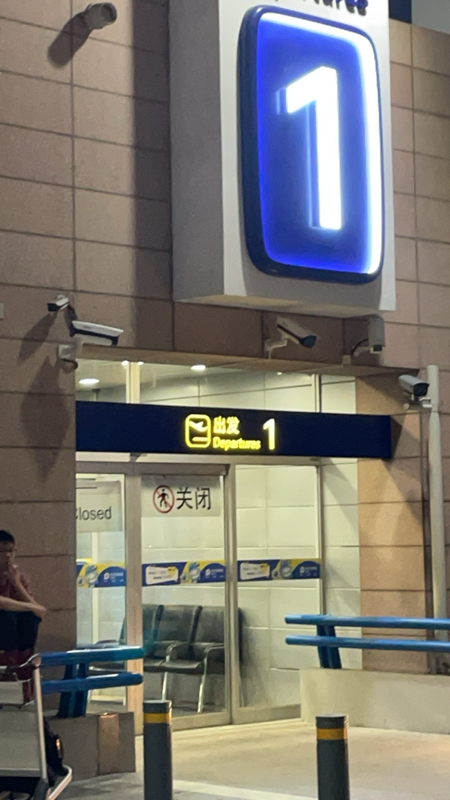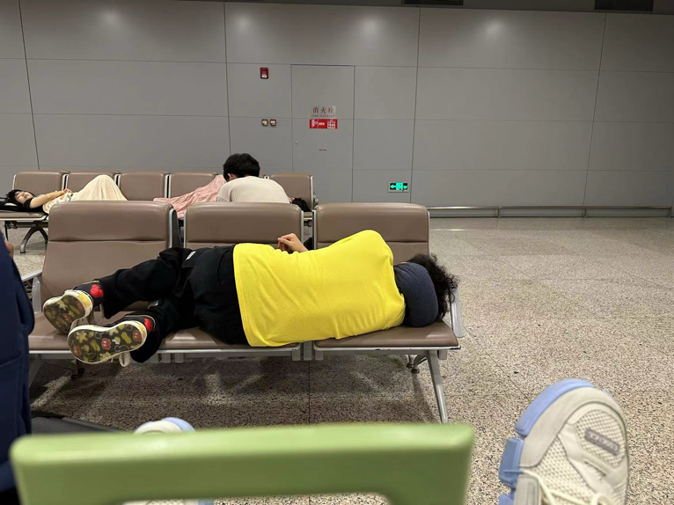

7.28 23:00

That is, at 16:00 UK time, we arrived in London, and then we were taken to Newham College of Cambridge University to rest. It should be that the climate in the UK is too different from that in China, I caught a cold as soon as I got off the plane