
COURSE: BACHELOR OF SCIENCE IN COMPUTER SCIENCE
SCHOOL: COMPUTING AND INFORMATICS
DEPARTMENT: INFORMATION TECHNOLOGY
UNIT: ADVANCED WEB DESIGN AND DEVELOPMENT.

UNIT CODE: BIT3208

LECTURER: MICHAEL NYORO

NAME: OSCAR MUNENE
ADM: BSCCS/2025/34405
PROJECT TITLE: SHOP SMART SYSTEM
TECHNOLOGIES USED:
Frontend: HTML, CSS, JavaScript
Backend: PHP
Database: MySQL
Server: Apache(XAMPP)
GITHUB LINK: https://github.com/Oscar-at-it/Shop-smart-System
ACADEMIC YEAR: YEAR III SEM II

Contents
Week 1: Local Development Environment Setup 4
Installation and testing of Local Development Environment 4
Fig 1 Installing XAMPP 4
Fig 2: Shows XAMPP control panel Apache and My SQL running 4
Fig 3 Localhost login page running in the browser 5
Fig 4: Successful connection between PHP and My SQL 5
WHAT I HAVE LEARNT 5
WEEK 2 6
FIG 1: Shows the dashboard layout of the Shop Smart System 6
Fig 2: Shows the navigation flow of Shop Smart System 6
Fig 3 : Shows the colour theme & palette design 6
Fig 4: shows the mobile mock up view of the system 7
WHAT I HAVE LEARNT 7
WEEK 3: JavaScript and PHP Basics 8
Fig 1: JavaScript Form Validation 8
Fig 2 a): Password strength checker 8
Fig 2 b) Password strength checker 9
Fig 2d) :Password Strength Checker 10
Fig 3) Dynamic User Input Handling 10
Fig 4) MySQL database connection via PHP 10
Fig 5) Fetching data from the Database 11
WHAT I HAVE LEARNT 11
WEEK 4: Task Schedule 12
Task 1: Understanding Server-Side Programming 12
Fig 1 a) Password hashing in Register form 12
Fig 2 b) : Register Form Database with hashed passwords 13
Fig 3 ) : Customer Registration Form 13
Task 3 13
Fig 4: Login Page 14
Fig 5: Session based display 14
WHAT I HAVE LEARNT 14
Week 5 15
Task 1: Introduction to Databases 15
Fig 1) Shop Database 15
Fig 2) Adding products to the database 15
Task 2: Creating Tables 16
Task 3: CRUD Operations 16
Fig 1) : Creating Tables 16
Fig 2: Inserting data 17
Fig 3: Reading data from the database 17
Fig 4: Updating data in the database 17
Fig 5: Deleting data from the database 17
WHAT I HAVE LEARNT 18

Week 1: Local Development Environment Setup

Installation and testing of Local Development Environment
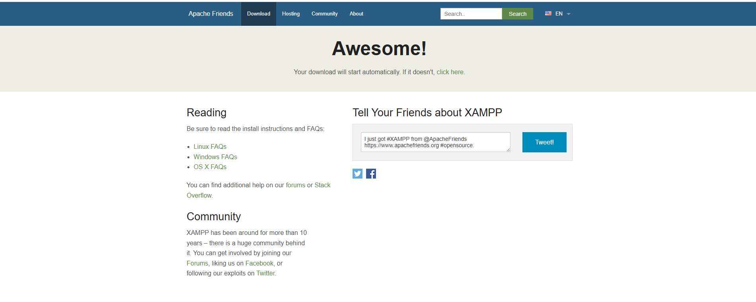

Fig 1 Installing XAMPP
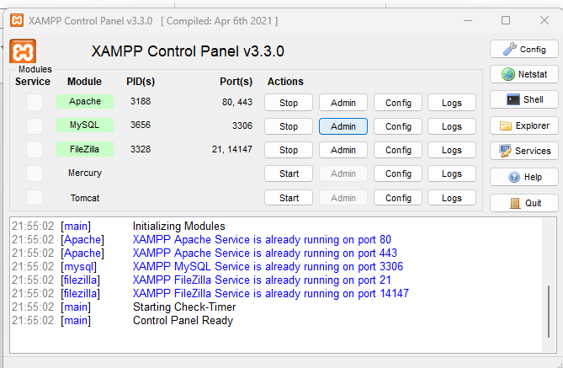

Fig 2: Shows XAMPP control panel Apache and My SQL running

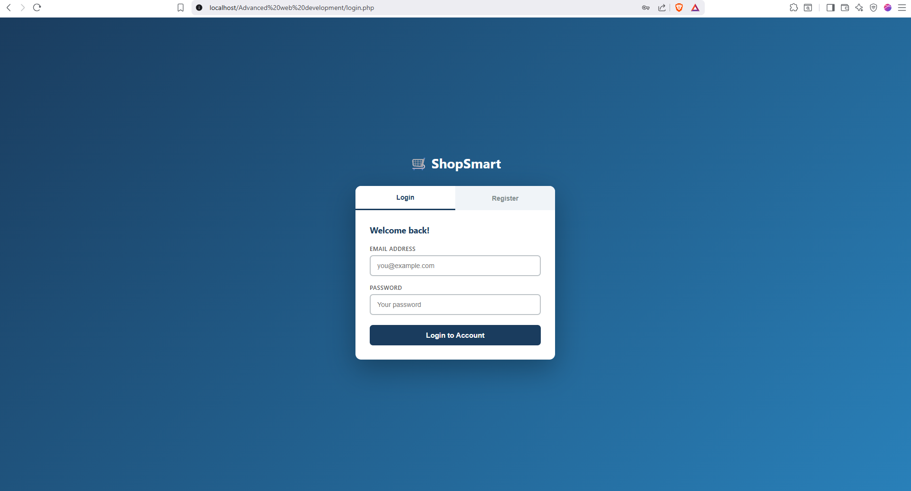

Fig 3 Localhost login page running in the browser

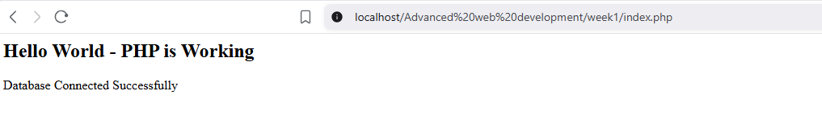

Fig 4: Successful connection between PHP and My SQL

WHAT I HAVE LEARNT
- While taking on this project, I learned how to build a Login application that validates user inputs and fetches data from the database through a PHP connection using XAMPP as the local development environment. Additionally,
I have also learnt how PHP handles API requests, My SQL commands used to create read update and delete data from the database through CRUD operations in real time scenario. Technologies used include PHP JavaScript and MySQL. Also, I have also learned that for PHP projects that are under development within the localhost are supposed to be stored in the htdocs folder found inside XAMPP folder.

WEEK 2

FIG 1: Shows the dashboard layout of the Shop Smart System
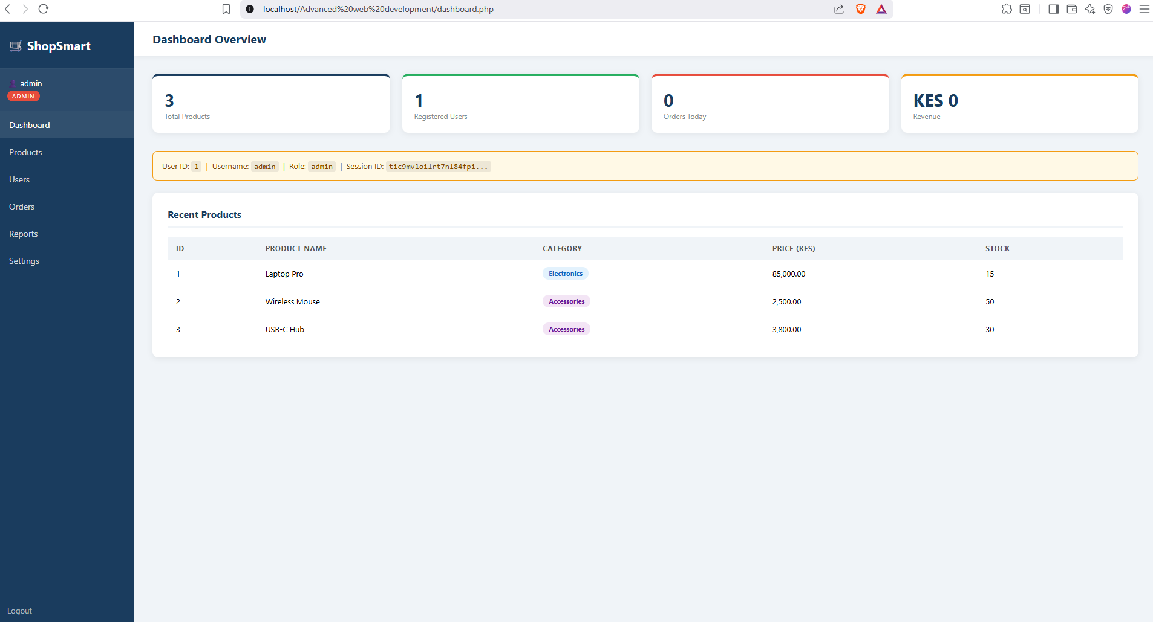

Fig 2: Shows the navigation flow of Shop Smart System
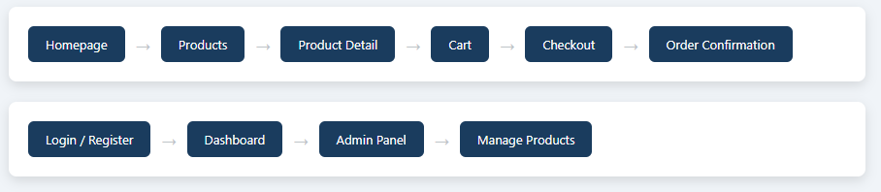

Fig 3 : Shows the colour theme & palette design
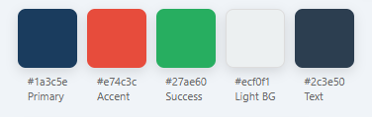

Fig 4: shows the mobile mock up view of the system
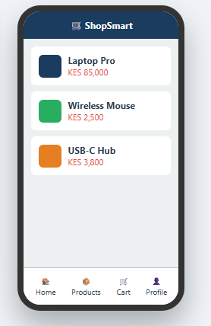

WHAT I HAVE LEARNT
- Building an intuitive dashboard that aligns the theme and colour of the system from the login page to the dashboard. In addition to that I have also gained experience in working with Figma design to come up with fully rendered Mobile mock up view with Navigation flow diagram, admin dashboard wireframes and the colour palette plan.

WEEK 3: JavaScript and PHP Basics

Fig 1: JavaScript Form Validation
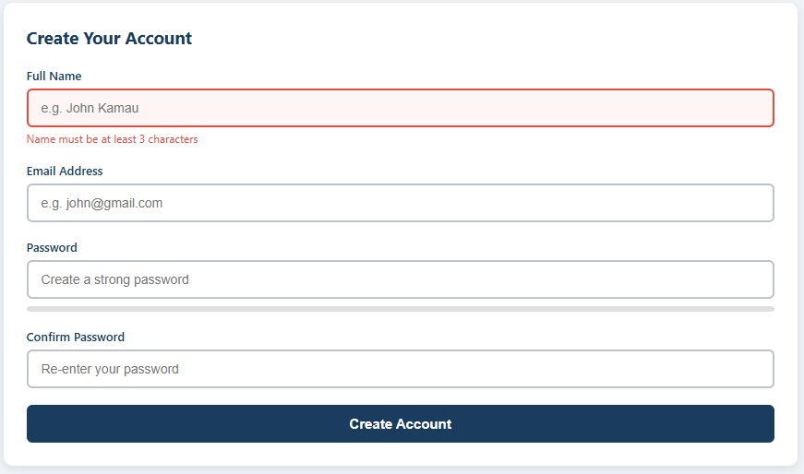

Fig 2 a): Password strength checker
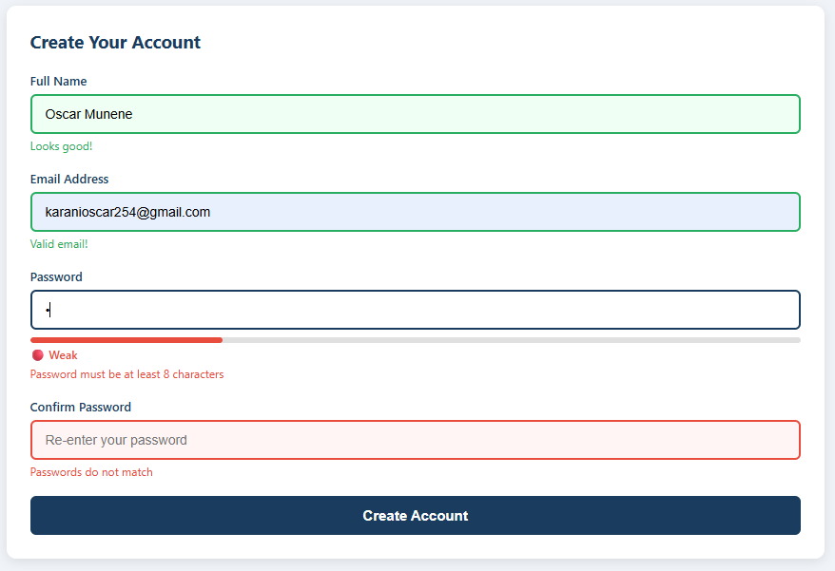

Fig 2 b) Password strength checker
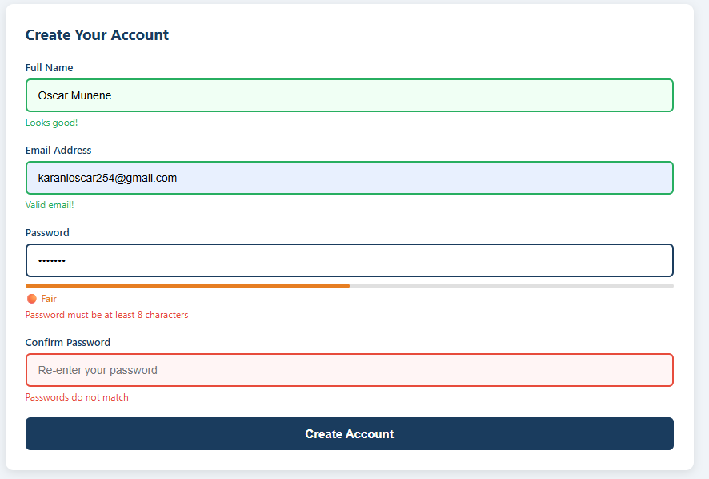Fig 2c: Password Strength Checker
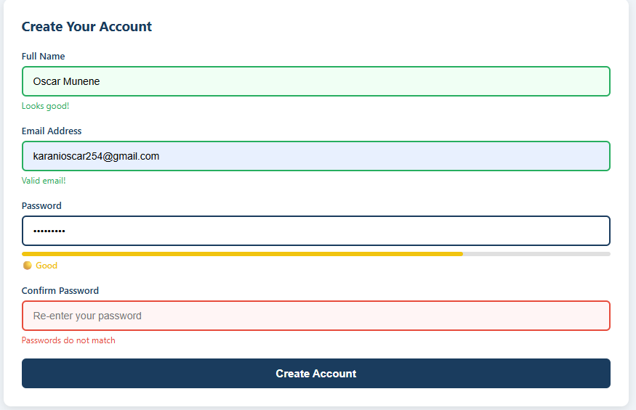

Fig 2d) :Password Strength Checker
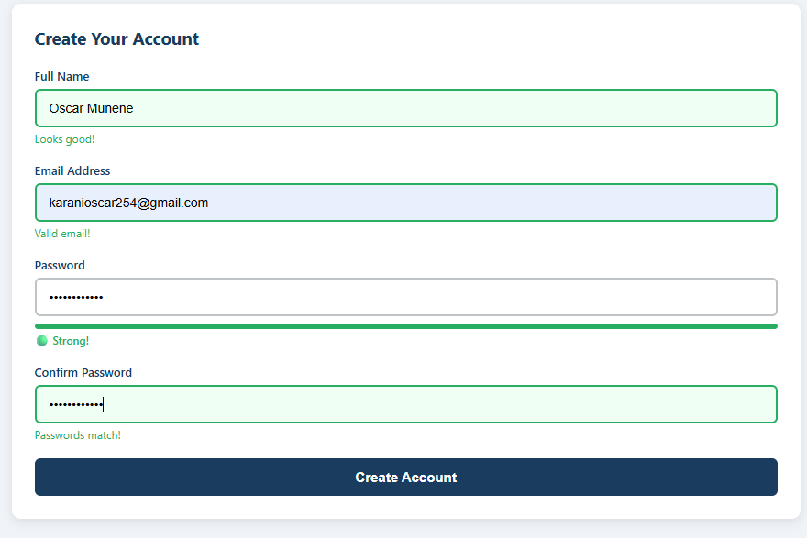

Fig 3) Dynamic User Input Handling
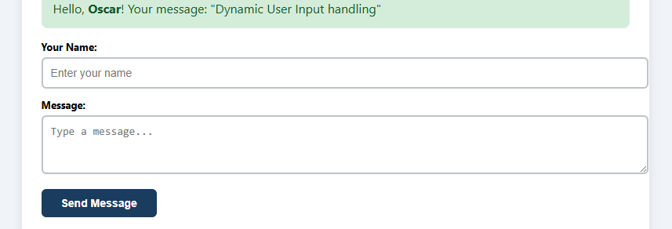

Fig 4) MySQL database connection via PHP


Fig 5) Fetching data from the Database
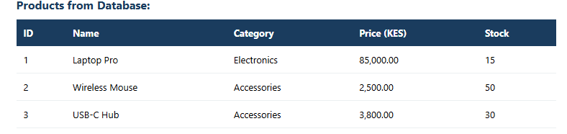

WHAT I HAVE LEARNT
Building forms that have JavaScript form validation with real-time feedback, a password strength checker(Weak/Fair/Good/Strong) and a live text preview system. In addition to that, I was able to connect a MySQL database by the use of PHP syntax and display products that are stored in the database on the dashboard of Shop Smart System.

WEEK 4: Task Schedule

Task 1: Understanding Server-Side Programming
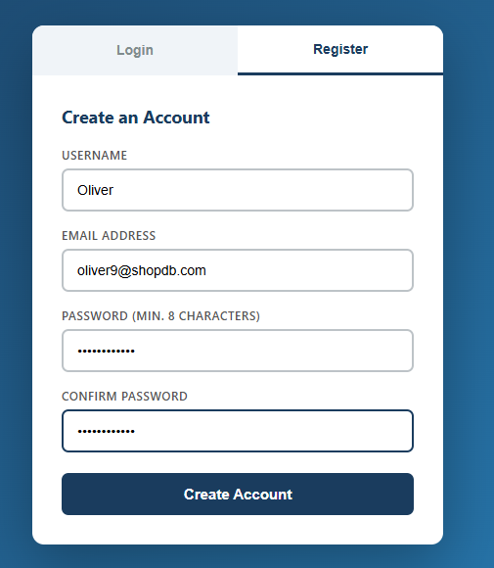

Fig 1 a) Password hashing in Register form

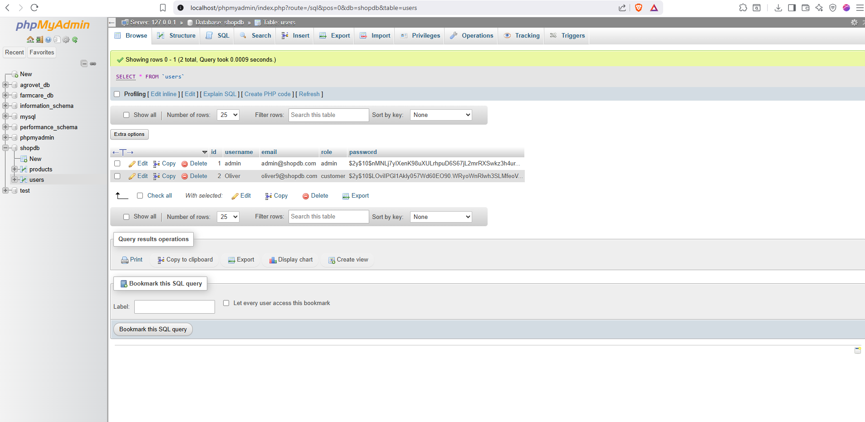

Fig 2 b) : Register Form Database with hashed passwords

Task 2


Fig 3 ) : Customer Registration Form

Task 3
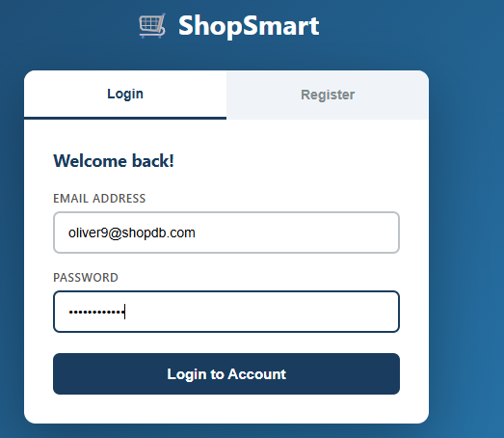

Fig 4: Login Page

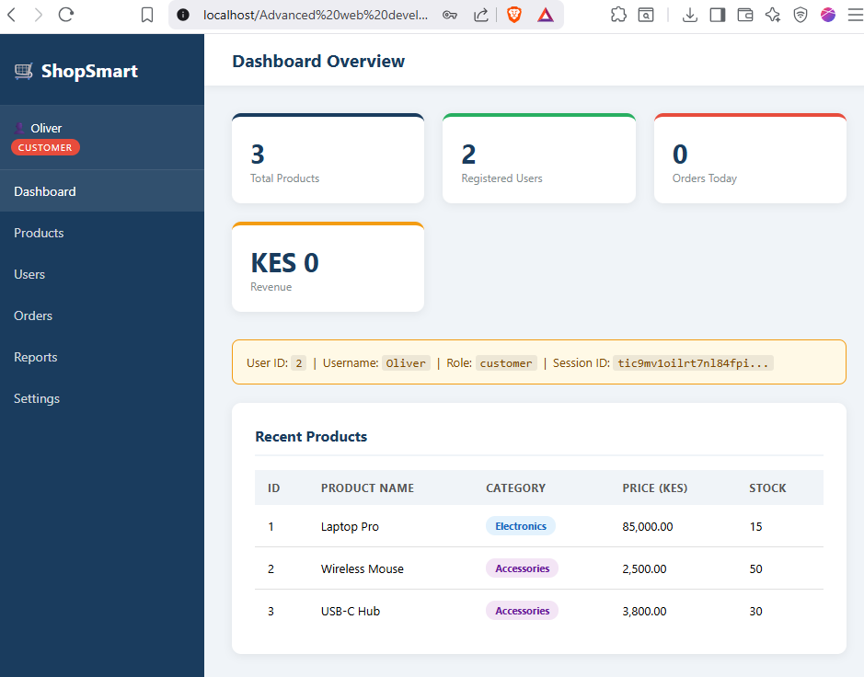

Fig 5: Session based display

WHAT I HAVE LEARNT
Using password hashing to secure the passwords and using password verify in PHP to verify passwords keyed in the login page. Blocking SQL injection by the use of prepared statements. Building a register page that lets the user enter their desired username, email and password, stores the credentials in the database immediately letting the user go back to the login page and use the credentials entered to log into the system as a customer. Additionally, I have also learnt how to use PHP in displaying the sessions data stats based on the role assigned to the currently logged in user and allocate a session id, fetching data from the database and display on the dashboard. A protected admin dashboard that redirects you the user to the login page if they are not logged in.

Week 5

Task 1: Introduction to Databases
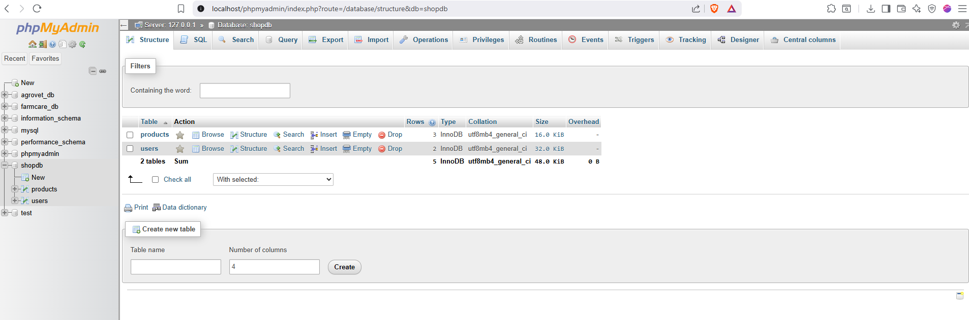

Fig 1) Shop Database
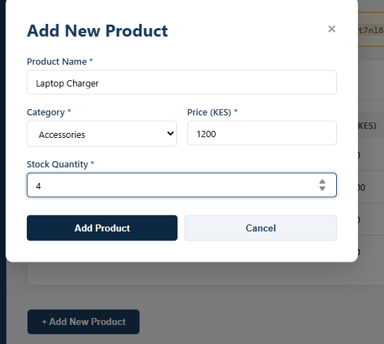

Fig 2) Adding products to the database

Task 2: Creating Tables
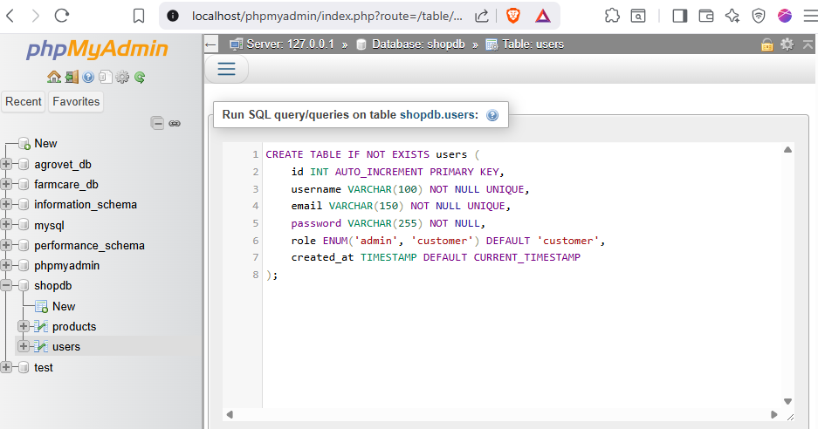

Task 3: CRUD Operations


Fig 1) : Creating Tables

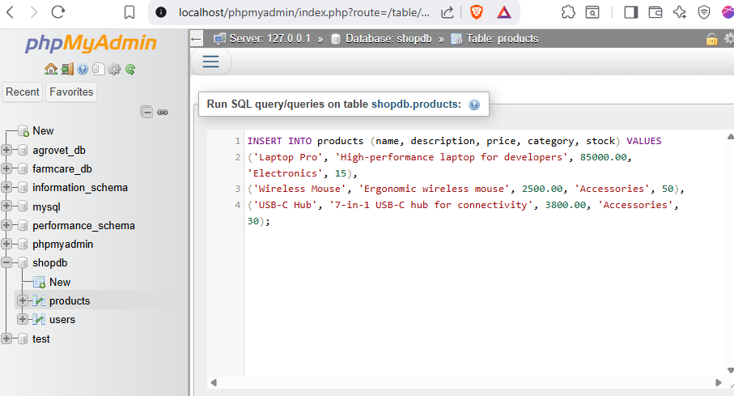

Fig 2: Inserting data

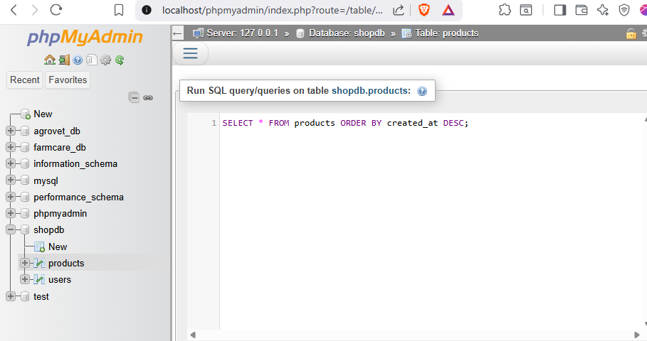

Fig 3: Reading data from the database

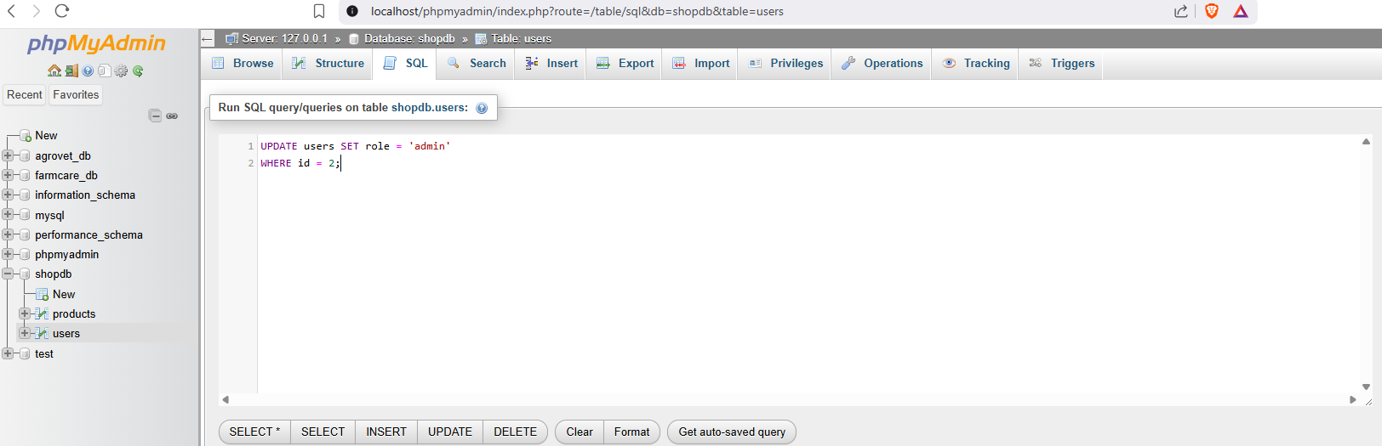

Fig 4: Updating data in the database
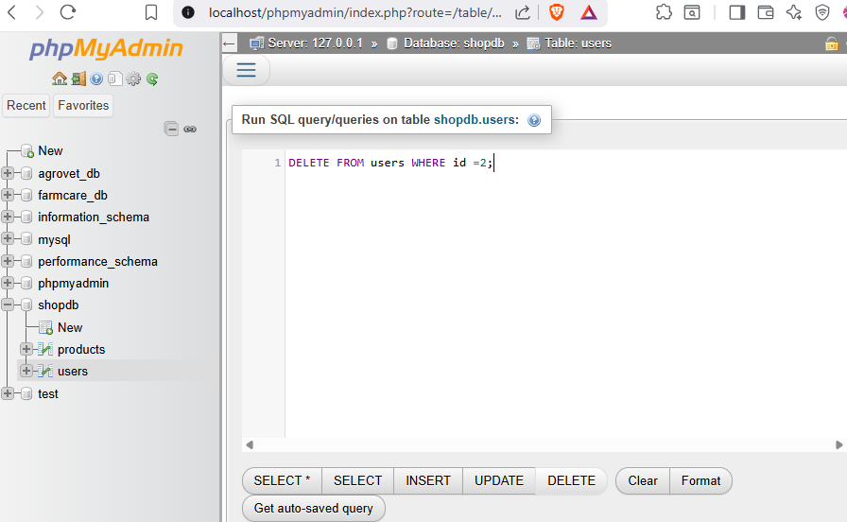

Fig 5: Deleting data from the database

WHAT I HAVE LEARNT
Creating tables inside a database and building a User input that allows the user to insert data into the database via the front end application interface, displaying the data on the dashboard as soon as it has been saved in the database and using form validations to ensure there are no conflicts in integrity of the data entered using JavaScript. I have also gained skills in reading(displaying), updating, and deleting data using CRUD operations in MySQL.

