QANC MOBILE APP INSTRUCTION MANUAL

Created by Bryan Doucette, Oscar Dias, Jon Prizby

# Section 1 – Mobile Application

**Group Page**

The use is greeted with the Group Screen, where the user can choose what group, they belong to. The user can choose more than one group and then must press “Save Role” button to save their selection. The user can press the “Reset Role” button to erase what group they selected and can then enter new groups.

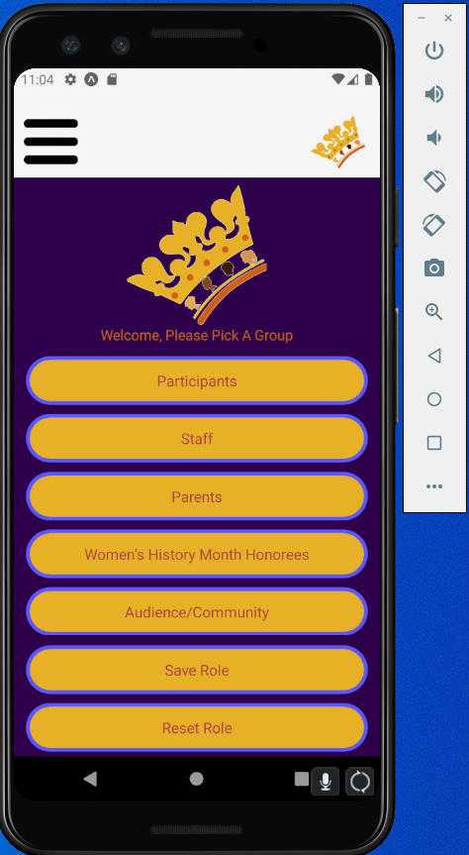

**Navigation/Home Page**

Once the the user selectes the group they belong, it will take you to the Home Page and if you swipe right you can see all of the different pages that the app has. The user can naviagte to Home page, Annoucement Page, Calander Page, and Donation Page.

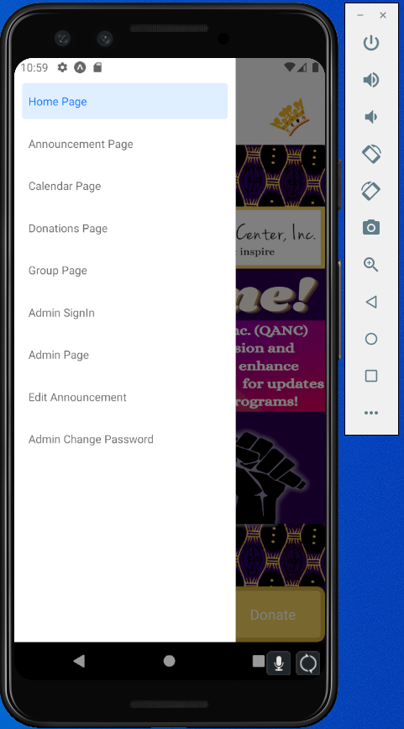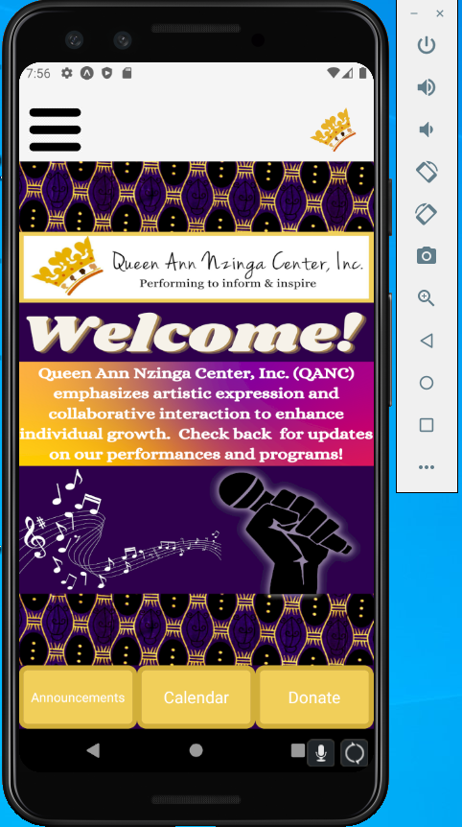

**Calander Page**

The user can see all of the events that Queen Ann Nzinga Center has posted. The Queen Ann Nzinga Center must add an event on there calander using the [qancinc@gmail.com](mailto:qancinc@gmail.com) account. Blue dots on dates mean there is an event , and the user can click it to get more information.

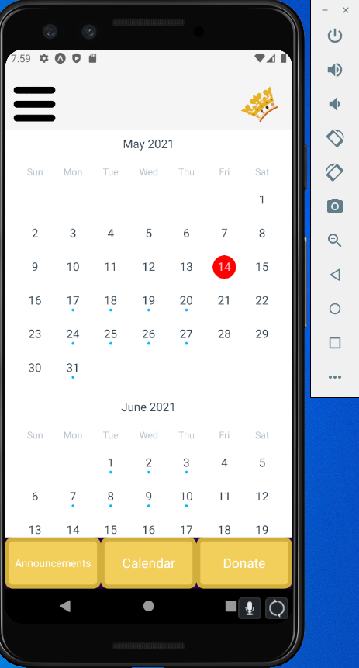

**Annoucement Page**

This page shows all of the annoucement that all users will see. Based on the group they have selected, it will highlight annoucements based on the group the admin has choosen. This means that the anncouements with a white background are not for the user.

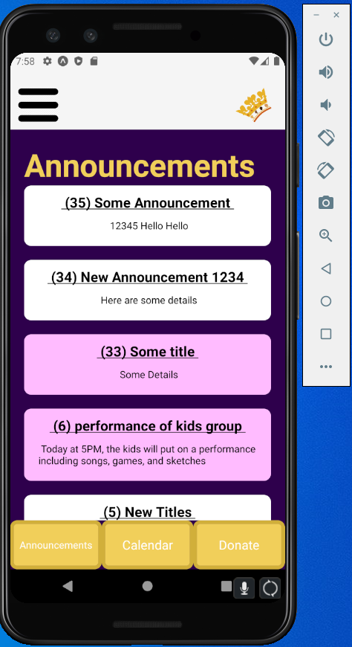

**Donate Page**

If the user clicks anywhere on the screen, then it would take you to the Queen Ann Nzinga Center donate page.

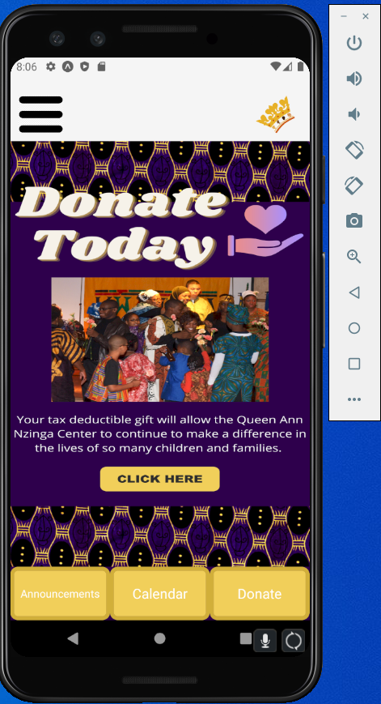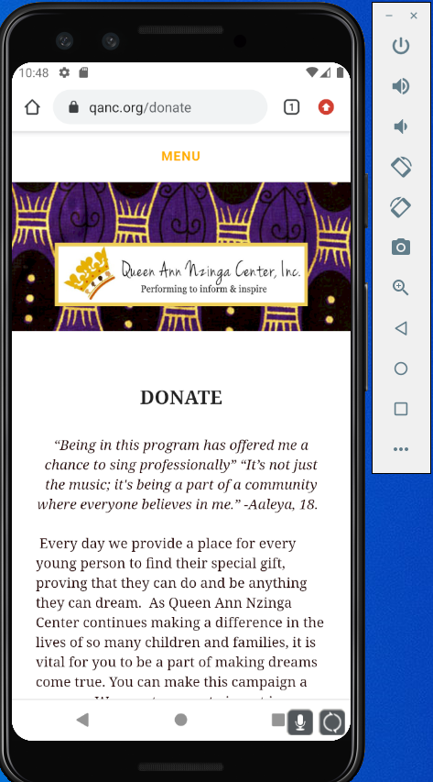

**Admin Screen**

The admin can post an annoucements in this page. In the first test box the admin enters annoucement title and in the second text box the admin write the announcement details. To select groups there is a drop down menu where the admin can select one or more groups to have the announcements highlighed.

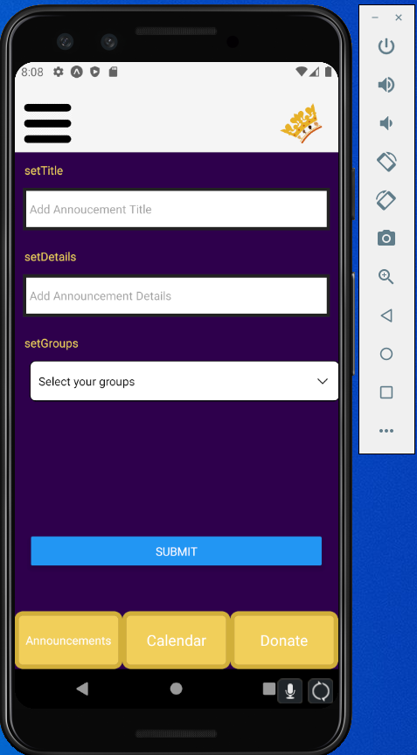.

**Edit Annoucement Page**

The admin can edit the annoucement that has already been posted. In the first test text box admin will enter the annoucement id, in the second text box adminwil enter the announcement title and in the third text box the annoucement details are entered. The admin can select which group will receive this annoucement highlighted.

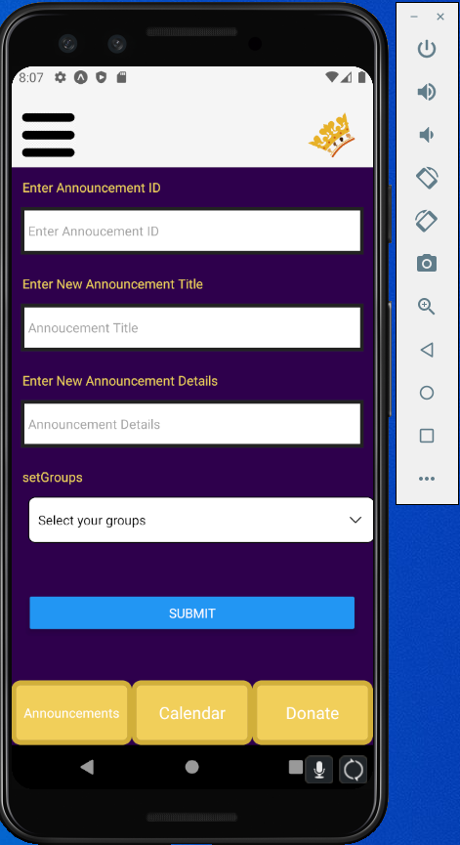

**Admin Signin and Admin Change Password**

The admin must sign in to see the admin screen. If the password is correct, you can go to Admin Page and post a annoucement. If the admin choose to change password, you can enter a new one as well.

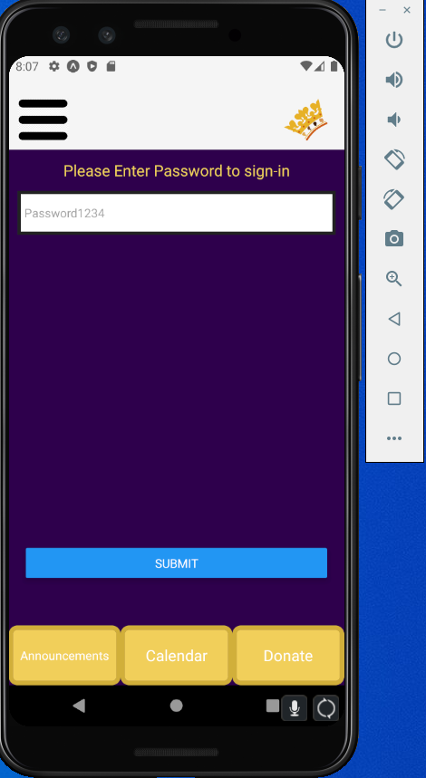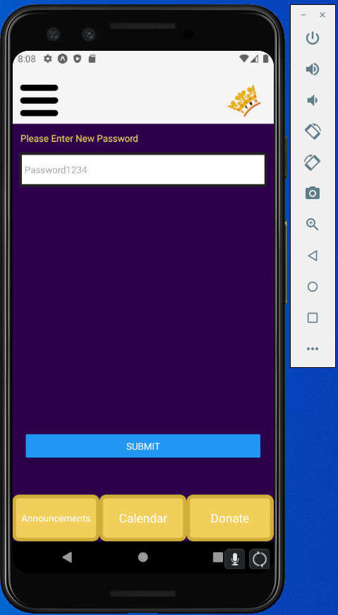

# Section 2 – Setting up AWS

In order for the mobile application is able to work, it requires an AWS account to manage and facilitate its sending and receiving of requests to access storage of information. To get started, one would need to create an AWS account, a tutorial on this can be found here: <https://aws.amazon.com/premiumsupport/knowledge-center/create-and-activate-aws-account/>

# Section 3 – Deploying AWS Components

Now that the AWS account is created, it needs to be populated with different components so that the mobile app is connected to it. This app uses three different AWS components with documentation located at their respective links

AWS Lambda – <https://docs.aws.amazon.com/lambda/?id=docs_gateway>

Amazon API Gateway – <https://docs.aws.amazon.com/apigateway/?id=docs_gateway>

Amazon Relational Database Service – <https://docs.aws.amazon.com/rds/?id=docs_gateway>

Starting with API Gateway, one would need to create an API Gateway in order to get communication going with the App and AWS. To do this, go to the API Gateway section of AWS that looks like this: 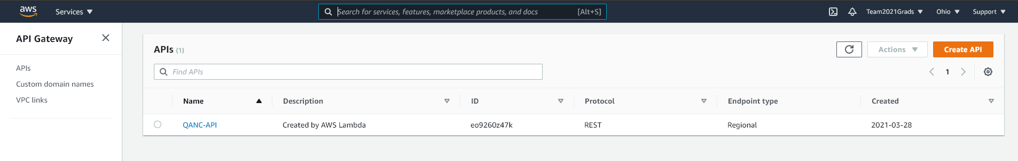

Once you are here, click on the “Create API” button on the top right. Once you do this you will see this screen, click on the REST API section and hit “build”: 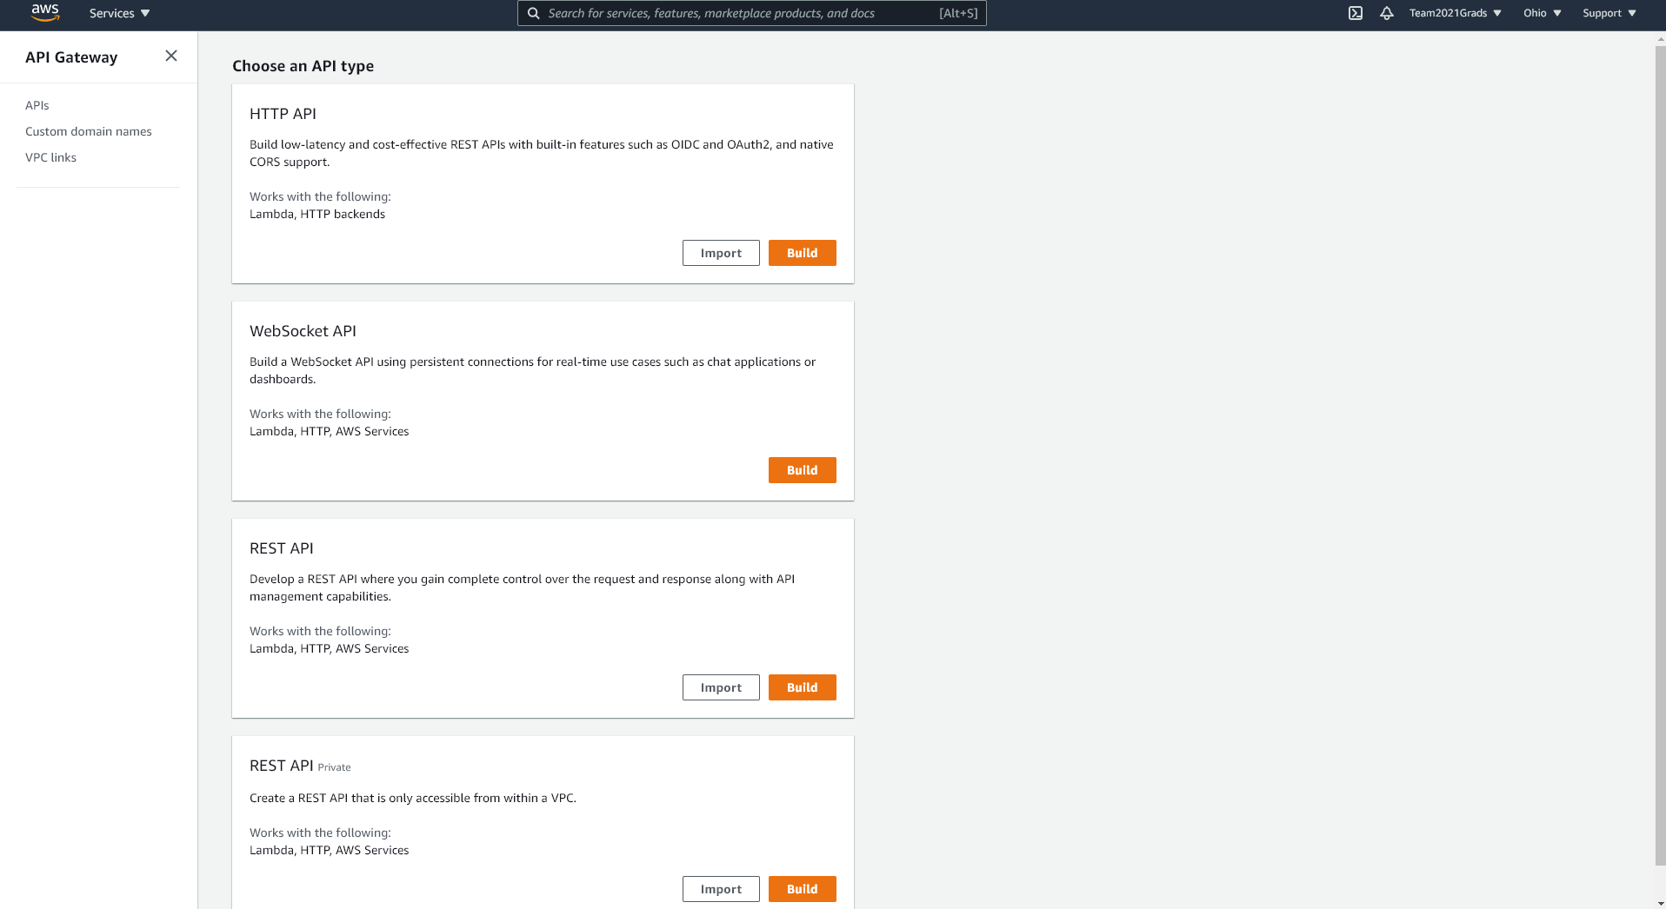

After that, you should come to a similar screen as this: 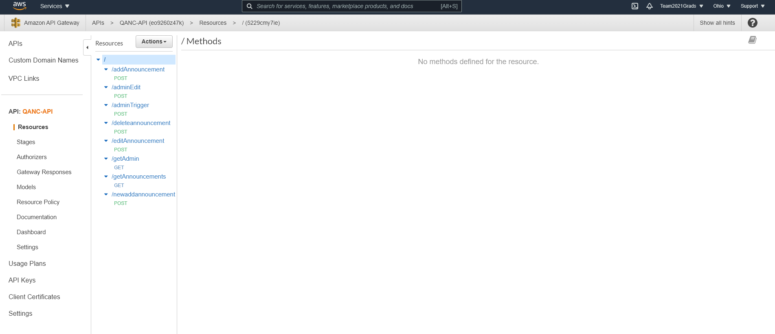

On the right-hand side, we have blue text that are API resources, each of the resources have methods assigned to them.

In order to create these resources, click on the actions button above the resources and click “create Resource” and give the resource a name. Do this for every resource listed in the image above.

Now that this is all set, head over to the AWS Lambda page.

Once you are at the AWS Lambda page, you will come to a screen like this: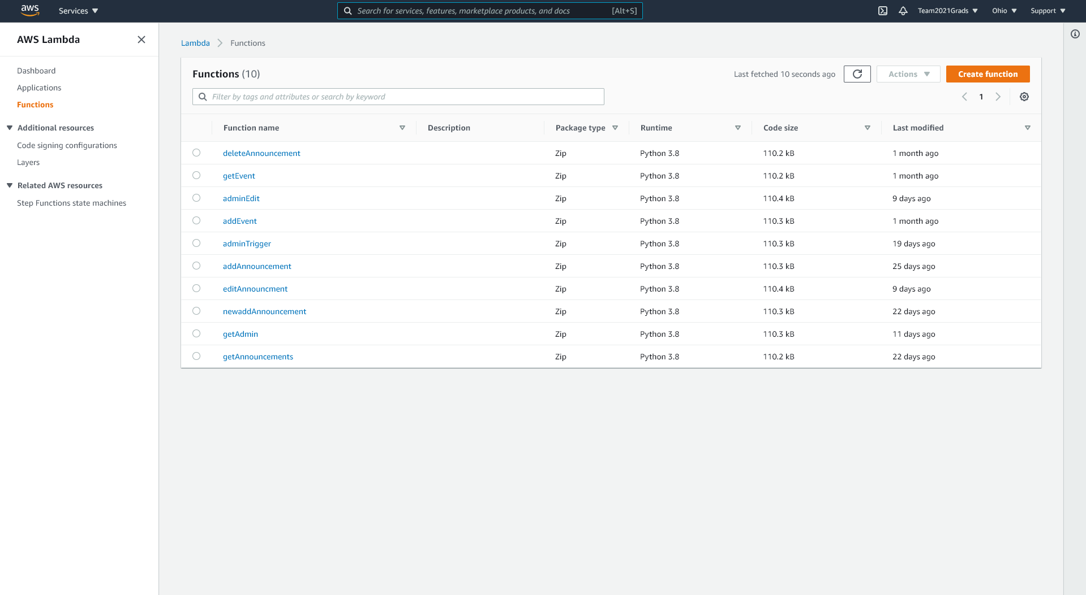

Once you are here, click on the Orange “Create Function” button on the right and you will be brought to this screen: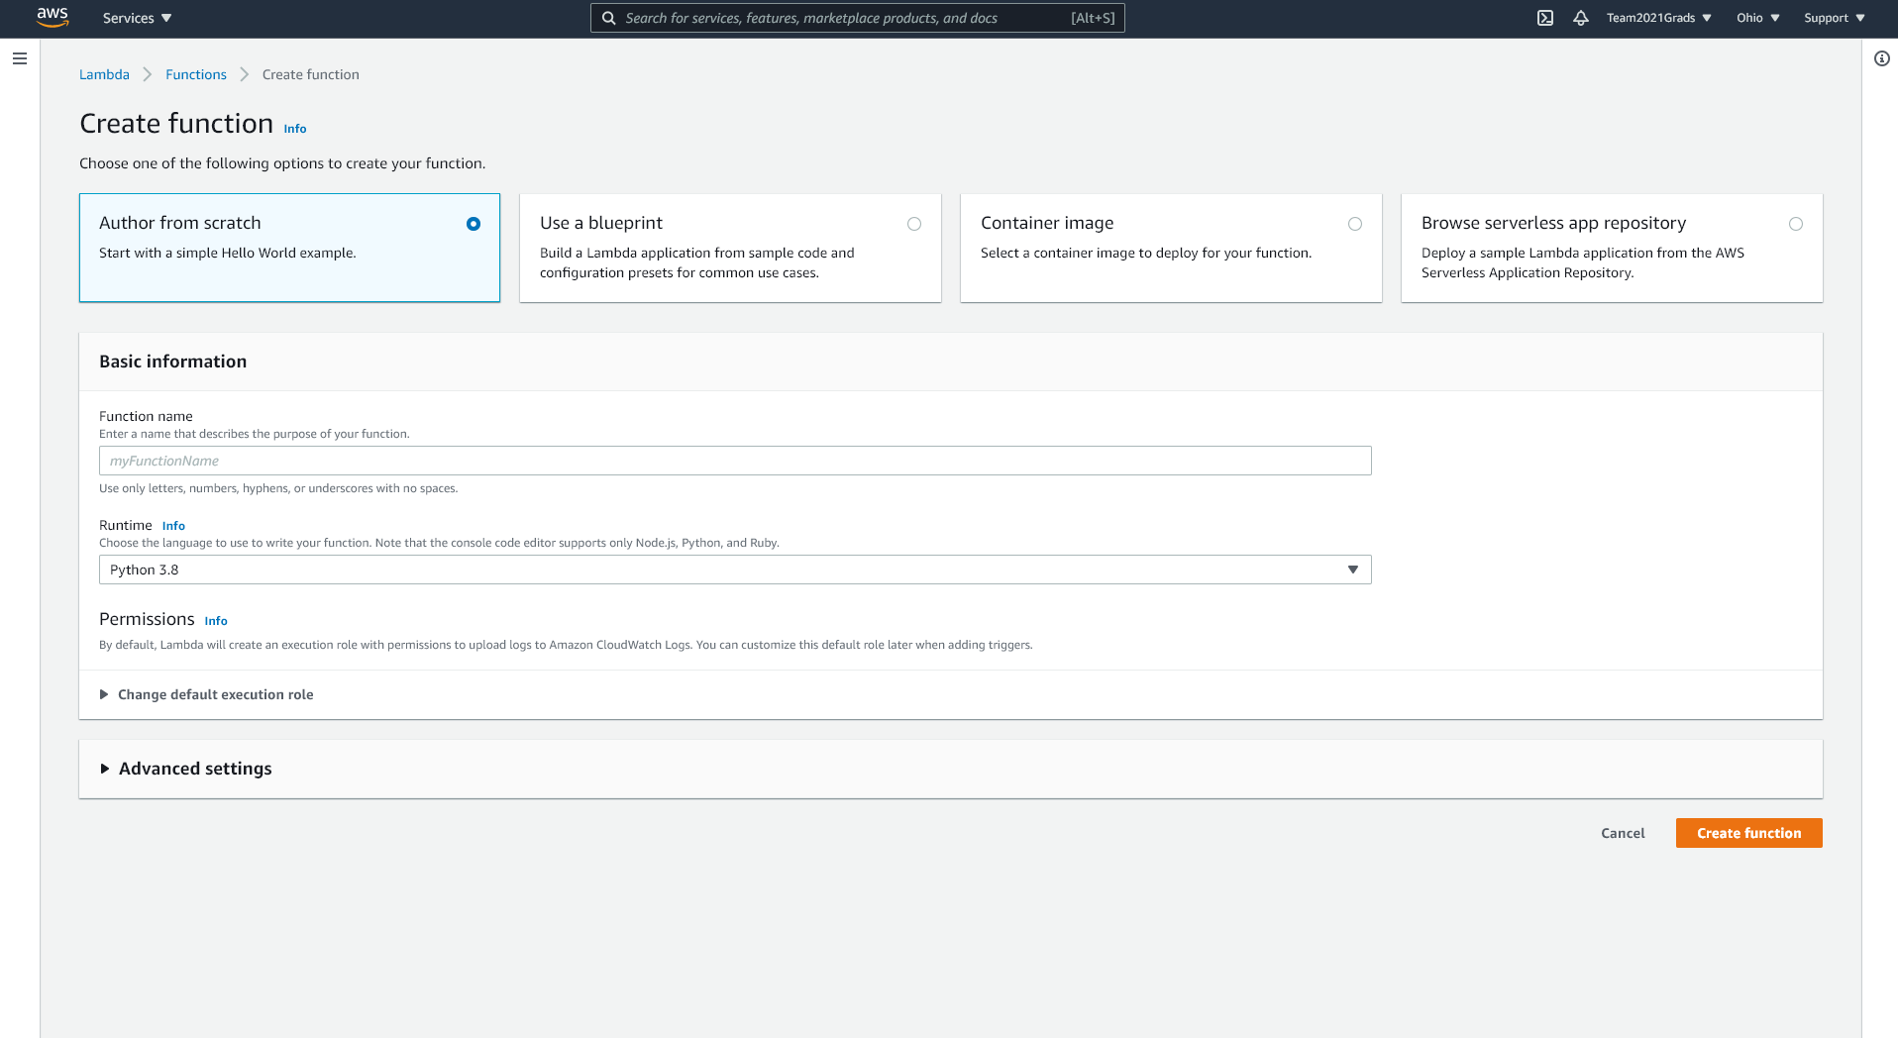

From here, select Author from scratch and enter the name of one of the Lambda functions seen in the previous image. Select Python 3.8 for the runtime and hit Create function.

Once this is complete, you should be on the Function overview page for your created function. Scroll down to the code section of the function that looks like this: 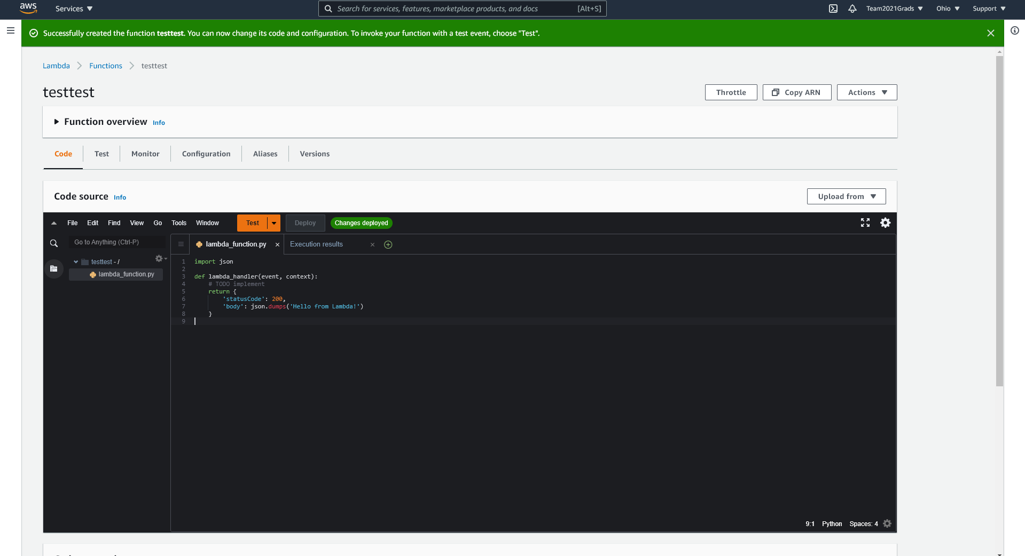

Move over to the “Upload from” drop-down and select “.zip file”. Here you will select the .zip file with the same name as the one you entered for this lambda function name.

Once this is done, head over the function overview and on the right-hand side, click on the “+ Add Trigger” button. You will be prompted to select a trigger, from here, select the API Gateway, then the API gateway you created. Also click the default deployment stage as well as “API Key” for the security option. After this, click the “add” button.

This will bring you back to the API Gateway page and you will need to click on the actions button to create a method under the desired resource. This will prompt you with a drop-down menu like this:

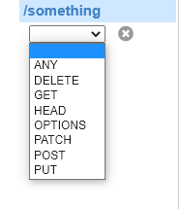

Click on either POST or GET and click the check button to the right.

You will then be prompted to fill in some information in a screen similar to this: 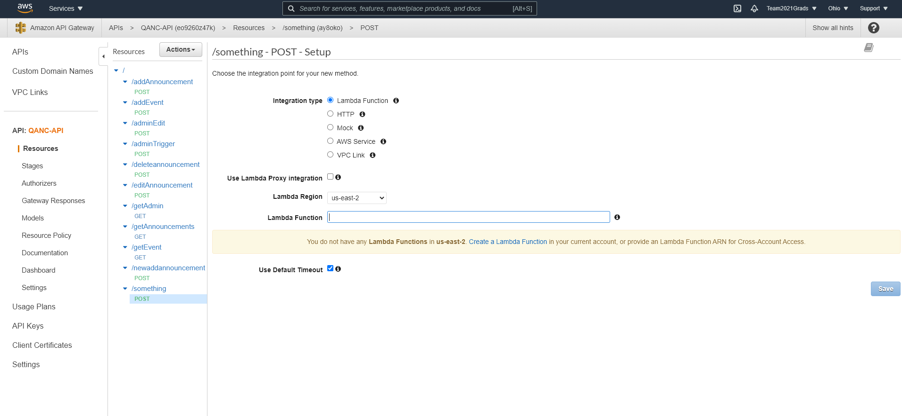

Your lambda function should already be connected to the resource but if not, enter its name in. Also be sure to click the use lambda proxy integration check box before you click Save.

Repeat this process for every lambda function as well as API Gateway resource and method.

Once this is done, go back into every lambda function, head to the Code Source, and change this code section at the top: 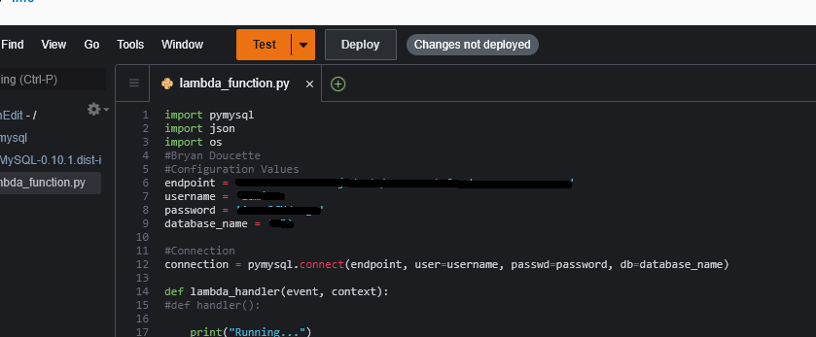

For “endpoint, username, password, and database_name” please enter your database information from the Amazon RDS section.   
After this, please head to the Configuration and then permissions section of the Lambda functions and add these policies to them: 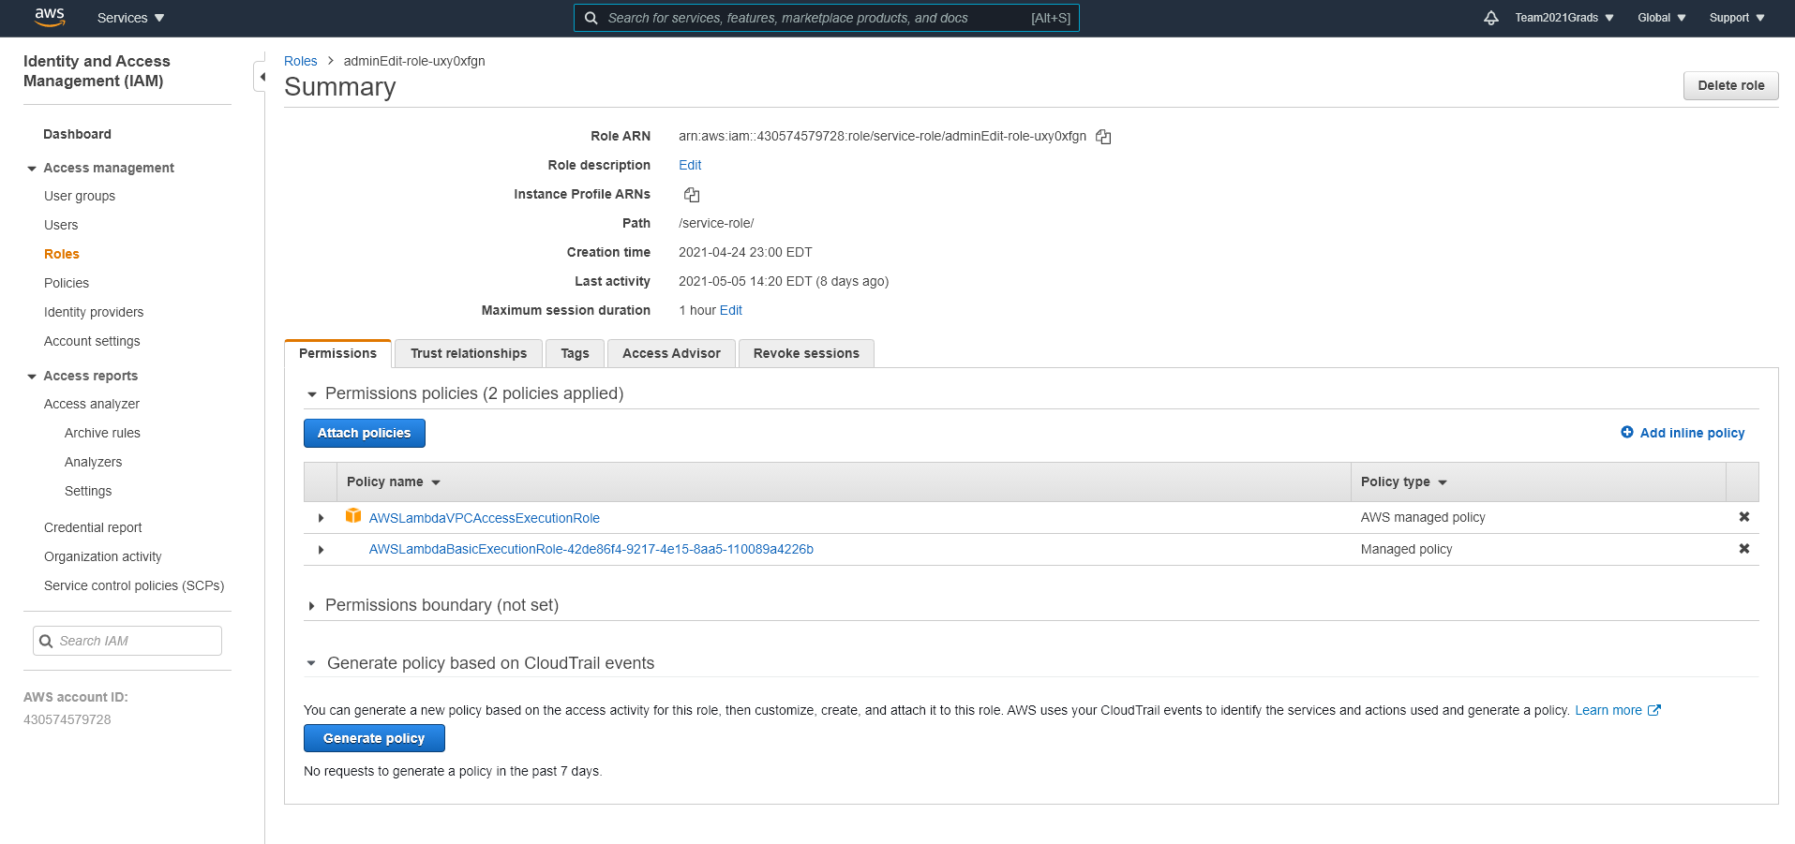

Do this for all lambda functions then head back to the Configuration tab. This time head to the VPC section and click on the edit button. From here, add the function to the VPC that you have your Aamazon RDS databse hosted on, and add two different subnets to the list (any two will do). Then add the security group of the database to the list and click “Save”. Do this for all Lambda functions.  
  
Once all of these steps are completed, you are finished with the deployment of the AWS side of the Mobile Application. Congratulations!