**CSC1200-001 / PROGRAM ONE**

**MONTHLY BUDGET PROGRAM**



**Assignment Date:** Tuesday, February 4, 2020

**Due Date:** Tuesday, February 18, 2020

**Turn in:** Upload prog1.py to the PROGRAM ONE folder on ilearn.

**Description:**

You will write a monthly financial budget program in Python.

*INPUT:*

* Monthly income
* Bills (Rent, Water & Electricity, Internet, Phone, Car Payment, Gas, Insurance, Groceries, Dining Out, Useless Stuff You Don’t Need)

*PROCESSING / CALCULATING:*

* Current Balance (the balance left over after subtracting all the bills from the monthly income)

*OUTPUT:*

* A statement at whether the user will have money left over or not.
* Amount left over.
* Advice if the user has a negative balance.

**Sample Output:**

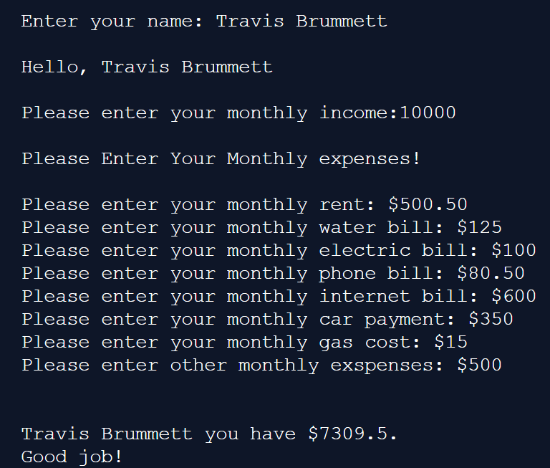

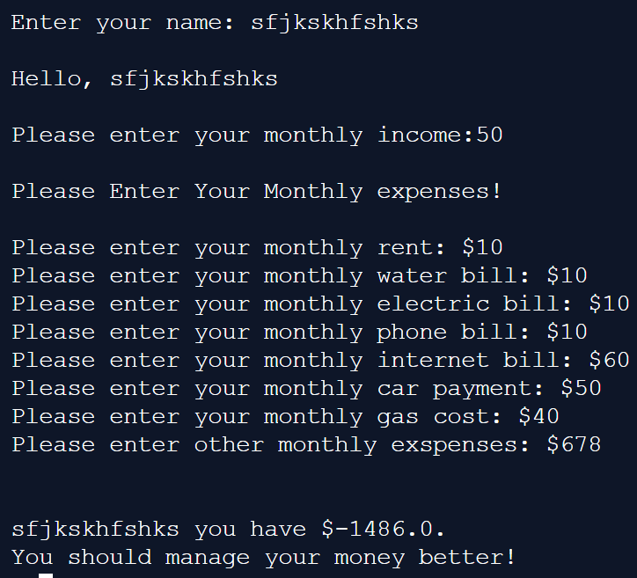

**Program One Specifications (RULES):**

1. Your program must be YOUR efforts only – not those of your classmates. Working with classmates on this program is considered cheating. Never ever share your code with anyone else.
2. You must have a comment block at the top of your code with the file name, author, major, date & purpose of the program. Comment block should be in a multi-line comment.
3. You must define your variables with good variable names.
4. Your programming code must have comments indicating the major parts of the program and should also be very easy to read.
5. Your output to the screen should contain no spelling or grammatical errors and should have plenty of white space to make sure it is readable.

