PS-2 Thunderbolt Display Port RJ-45 Jacks audio

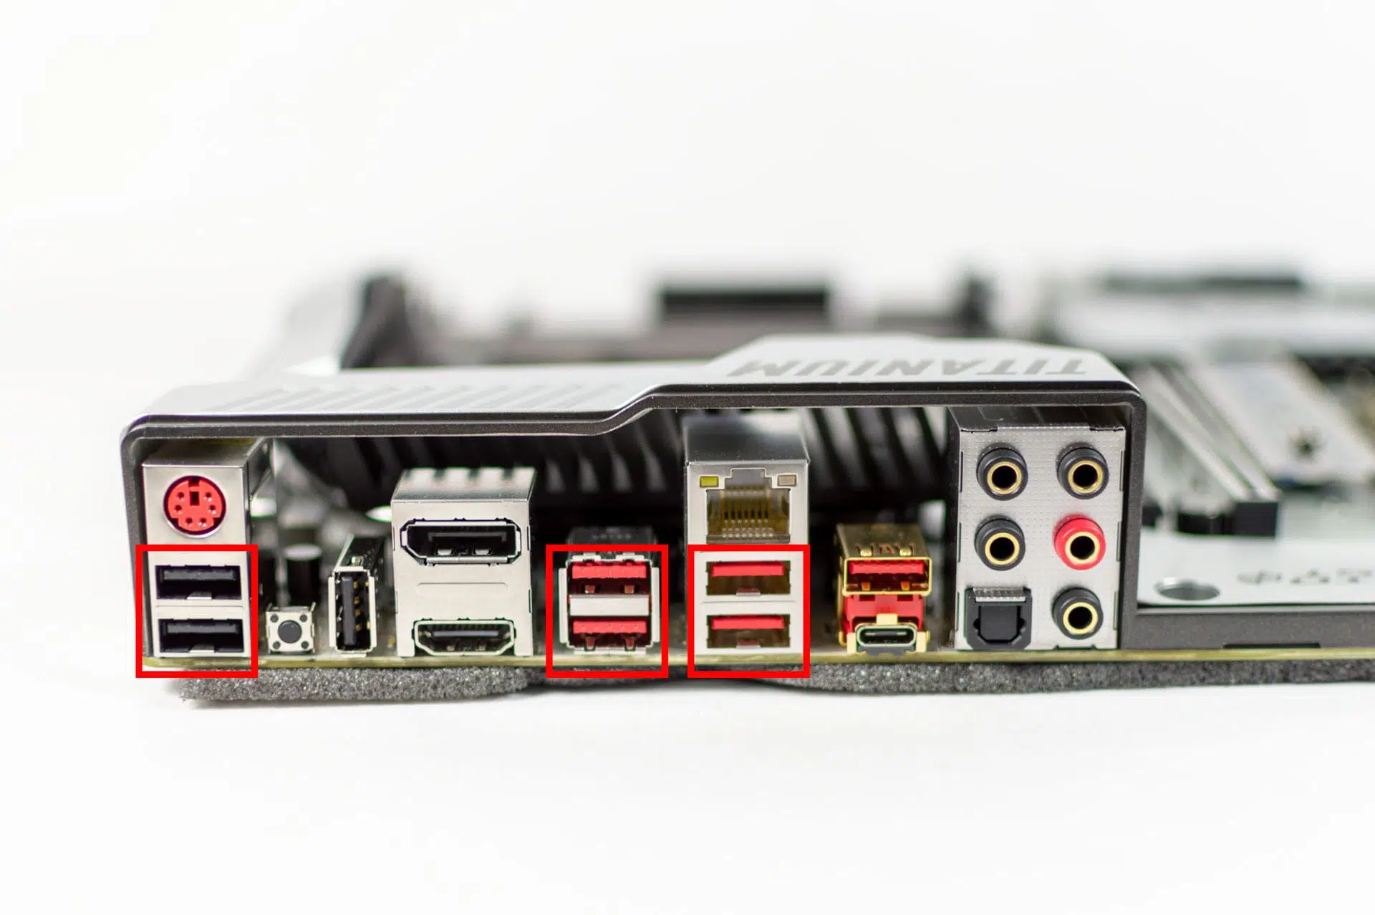

USB 2.0 HDMI USB3.2 USB-c SPDIF

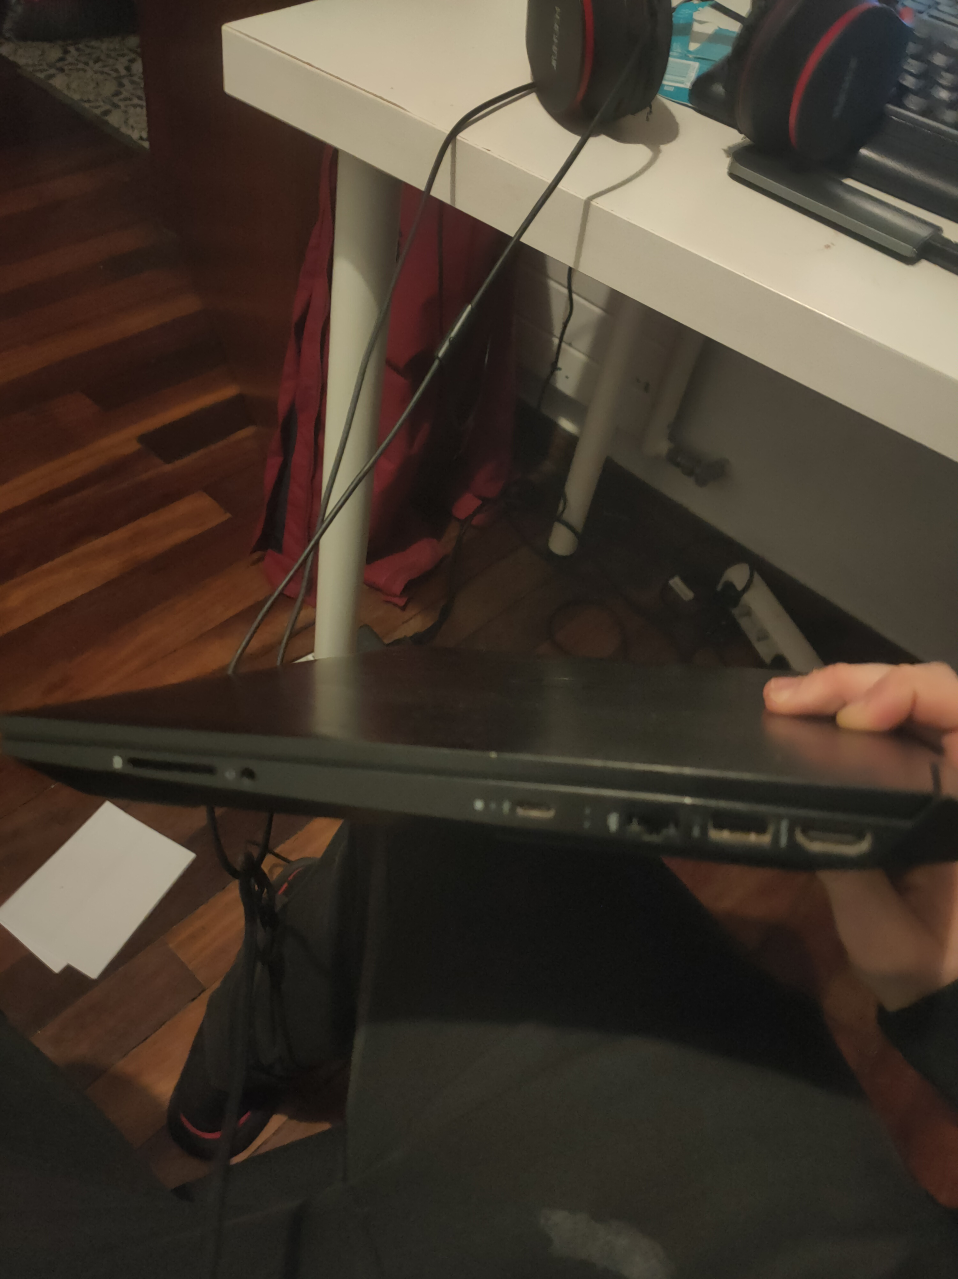
Tarjeta SD mini-jack usb-c ethernet usb hdmi
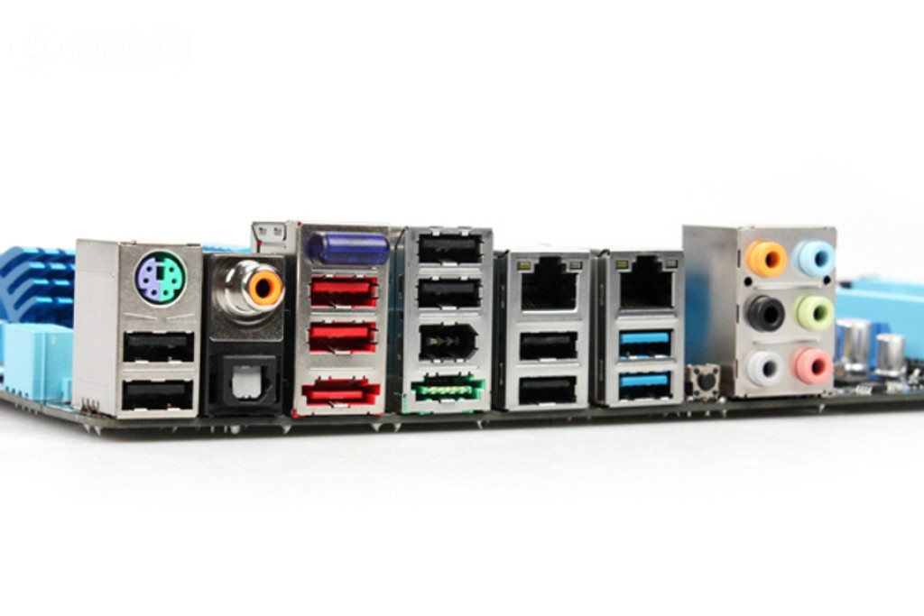
PS-2 Jack RJ-45 Mini-jack

USBA SPDIF eSATAp USB 3.2 Firewir USB3.0

conector de carga



usb

https://www.ticarte.com/contenido/conectores-externos-de-la-placa-base
https://hardwaresfera.com/articulos/conectores-pc-placa-base/
https://mestre.iessanclemente.net/mod/resource/view.php?id=16337

