VSDK – Vitral Software Development Kit
TOOLKIT LEVEL - Architecture and Design Document

Document History

Date | Autor(s) | Comments
February 16 2006 | Oscar Chavarro | Preliminary version
April 29 2006 | Oscar Chavarro | Update

Toolkit overview

The “Vitral Software Development Kit” (VSDK) toolkit is a software product, part of the computer graphics testbed of the computer graphics laboratory/research group “Takina”, of the Pontificia Universidad Javeriana (PUJ) at Bogotá Colombia. The toolkit is a current java implementation of the group´s computer graphics architecture “VITRAL”, that points forward supporting all of its defined requirements.

The VSDK toolkit is build on top of Java because this is the most popular programming language in the PUJ engineering faculty, so local community will accept it easily. This toolkit is intended to constitute the common development platform for all computer graphics teaching and research activities inside the group, and perhaps to be considered as a programming alternative outside this scope, for the developing of computer graphics applications.

The detected advantages of the VSDK toolkit as compared with current existing similar alternatives as SDL, vrjuggler, Avocado, Crystal Space and others, are the following:
- It is written in Java (this, of course, is an advantage only for the people who likes this language), so can benefit from this language´s advantages. Namely, the authors believe that Java is a very simple language, so the VSDK toolkit will be very programmer-friendly, as opposed to current C++ systems, which requires a higher programming learning curve. Other consequences could be portability, ease of maintaining and acceptance probabilities inside an ever growing Java community.
- If follows a clear software engineering process, which means well defined requirements, architecture and so on. It is expected that the VSDK toolkit be a piece of software with a fair good quality.
- It uses a clear object oriented programming schema, with standardized names and style, but over all, follows a clear correspondence between computer graphics concepts and its implementation, making it ideal for accompanying computer graphics textbooks, guides and courses.
- The authors and the Takina group members will understand it ☺ … because this kind of systems are in no way obvious or simple, the “reinvent your wheel” approach, besides its pains, will pay in some way. It is expected that the availability of this toolkit and the local proficiency on its use will help in future computer graphics research, and will ease the start of a future phase in which real contributions (in the sense of new knowledge) could be made. The VSDK toolkit is really the local testbed for the Takina research efforts.
It must be noted that the VSDK is made up of two main pieces: this toolkit and a higher level of abstraction framework. The framework is currently an experimental set of ideas and proposals, build on top of these toolkit that integrates the toolkit in a distributed computing environment, but it is outside the scope of this document.

Note that applications could be written on top of the VSDK toolkit, or on top of its framework, following in that way the full VSDK architecture specification. Inside the VSDK toolkit distribution, however, only toolkit level applications are maintained.

Toolkit distribution and file organization

The VSDK toolkit is distributed in the form of two compressed files: VSDK_<dateversion>.tar.gz and VSDK_DATA_<dateversion>.tar.gz. The distribution follows a de-facto POSIX organization, with the following directory names:
- _ide: the toolkit is independent of the IDE used, so all the IDE-specific files are enclosed inside this directory. There is a sub-directory for each IDE tool, like “Together” or “Jbuilder”. The IDE tools must be configured to put all its data inside this directory, and do no touch in any way the other directories. Most of the files here are temporary, which means that are not necessary for the software distribution, but only for the particular IDEs. This implies that in the distribution, it is common to found most files deleted, and only the main project definition files for each IDE is always kept.
- classes: this directory is meant to contain the compiled java modules (.class files). In the case of the main toolkit library, this directory is temporary, and its contents can be deleted at any time without affecting the distribution.
- doc: this directory contains the usual files found on “doc”, “html” and “man” directories in UNIX systems. This document, other toolkit related documents, development logs (Personal Software Process documents), standards, guides, bug tracks, diagrams and APIs are found inside this directory. None of these files should be deleted, as they form an integral part of the toolkit. Note that this directory also contains “source code” specs for automatic documentation generation tools like doxygen [DOXYGEN], and current results of it. In the case of automatically generated documentation, the files could be deleted, but usually, the last version is kept.
- etc: this directory contains the usual files found on “etc”, “shared” and “data” directories in UNIX systems, which means configuration files and data files. The directory is organized in subdirectories for each data type. Note that this is the bigger directory in terms of data storage size, and it is distributed broken in two distribution files. In the main VSDK compressed file are only available the smaller data files, intended for quick testsuite use. In the VSDK-DATA are distributed the larger files, intended for practical use on applications, benchmarking-type examples and specific techniques tests that uses massive information, as terrain rendering.
- lib: this is the directory meant to contain the VSDK .jar files, or java library files. Its contents could be deleted in a source-only distribution, but usually contains the current toolkit version libraries compiled in.
- src: this is the directory where the source code for the toolkit implementation lies. It is organized in a sub-directory structure related to packages / class categories, as mentioned later in this document.
- testsuite: this directory contains small programs, written using the VSDK toolkit. They are in nature catalogued in 4 groups: “Hello world” examples for underlying technologies, VSDK code examples, computer graphics techniques written using VSDK and sample VSDK functional applications. The first group of programs are identified by names with a preceding “_” (underscore) character. The other group of programs are identified by name due to a postfix of its type (for example, a Cohen-Sutherland line clipping technique example is in a directory called “CohenSutherlandClippingTechnique”). All of the subdirectories in the testsuite directory contains a program with this standard name identification, and a sub-structure of directories similar to the one of the main VSDK distribution, in other words, all this directories contains sub-directories like “src”, “classes” and so on.

Toolkit compilation and installation procedures

The toolkit depends on some underlying systems, that must be installed prior to the installation or compilation of the VSDK. These pre-requisite systems can be necessary, recommended or optional as follows:
- Necessary pre-requisites: currently, the only pre-requisite is a Java Virtual Machine for the java toolkit implementation. A JRE can be use for running applications, but a complete JSDK is recommended if application development is needed. Current VSDK implementation is meant to run on version 1.5 of the JVM, and will not function on early releases.
- Recommended pre-requisites: the only really recommended system for VSDK toolkit is JOGL. Note that JOGL is not available an all Java platforms, particularly on PDAs. On most PCs and UNIX/Linux systems can be installed, and it is recommended as VSDK toolkit rendering subsystem makes intensive use of it. Note that JOGL requires a previous OpenGL executing environment. No OpenGL development environment is needed by VSDK or JOGL.
- Optional software: any java IDE like Borland JBuilder, Borland Together, Eclipse, JCreator software can be used with VSDK. For configuring each IDE tool a procedure is recommended, in which the “_ide” directory layout is conserved. Note that the VSDK toolkit can be used without any IDE, but some users prefer to have their aid.

This ideas are expressed graphically in the UML package diagram shown in figure 1. Note that the toolkit can have various types of builds, depending of the underlying available pre-requisites. In the absence of IDE tools, there are always a set of scripts, supplied in DOS/Windows batch files (.bat) and Unix BASH shell scripts (.sh). All the user needs to testdrive the VSDK toolkit is to execute those scripts, usually the ones for compiling first, following for the ones for running.

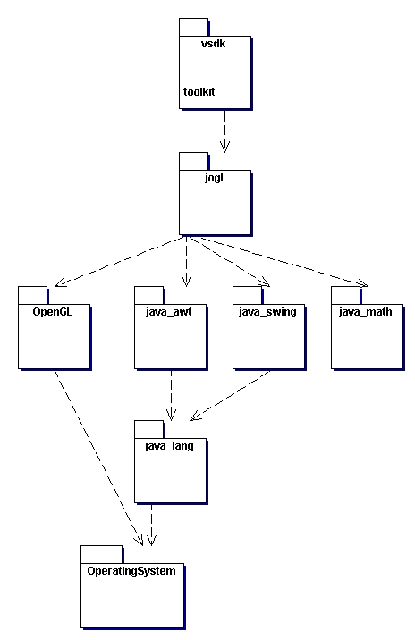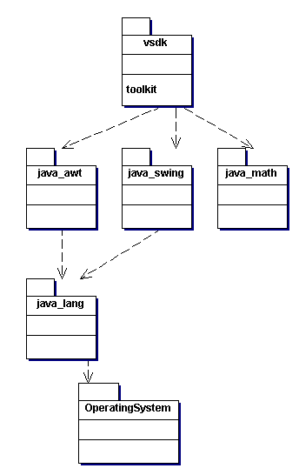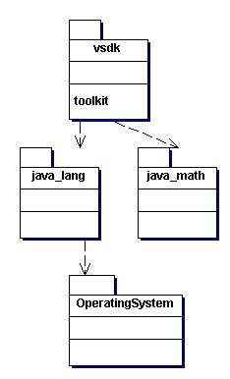
(a) (b) (c)
Figure 1. VSDK toolkit underlying packages dependencies. (a) VSDK toolkit dependencies for a platform in which JOGL is available, and Java implementation is complete. (b) VSDK toolkit dependencies in a platform configuration without JOGL, but with a complete java implementation. (c) Minimal VSDK dependencies: a JVM profile with java lang and java math packages.

As the VSDK toolkit can be configured to use or not a changing set of pre-requisites, different compilation scripts are provided for the main library build. The way in which this modularity is accomplished is by encapsulating the use of underlying systems inside specific VSDK toolkit packages. For example, only the vsdk.toolkit.render.jogl package depends on JOGL, so when JOGL is not available or enabled, all that must be done is compiling all the toolkit except this packages. Note that current version of the VSDK toolkit does not depend on swing, but only on awt (in the packages render.awt and gui).

This situation could be different at the testsuite level. The testsuite programs may need JOGL and/or Swing, or other underlying systems like JMF, but these are only needed for specific examples. Some of the examples and applications provided in testsuite can be executed using the minimal VSDK toolkit configuration.

Toolkit architecture, design patterns and organization standard

As part of the object oriented development environment in which the VSDK toolkit is built, there are some design and architectural patterns used. Other organization standards are proposed for the implementation details and coding, and these decisions affect most practical aspects in the use of the toolkit. So, as important as these are, they are briefly cover here, so the toolkit user can form an idea of the VSDK “spirit”.

Model – View - Controller

The first great design consideration taken for the organization of the toolkit, is to adapt easily to a Model View Controller schema, thus defining 3 sets of packages:
- Model related packages: common, media and environment. These contains model exclusive classes, which DO NOT depend on other Technologies than Java Virtual Machine and operating systems. These packages define all of the data structures needed to build the models. These are self container classes.
- View related packages: render.jogl, render.awt and possibly other display technology dependant classes, which constitutes observer patterns for the model.
- Controller related packages: gui and devices provides interaction technologies dependant classes which are useful for controlling the model.

Composite

The Composite pattern as presentend in [GAMMA] is commonly used for implementation of tree-like structures, as in the case of constructive solid geometry.

??? Composite? Strategy? Visitor? Other? Decoupling.

The classes inside the render packages are static, and contains methods that receives as parameter elements of the model and renders it to build a bigger rendering pipeline in a modularized way. They have in common a read-only access to the model, but a high level of coupling. They need to know most of the internal state of the model class in order to render it.

TODO: name this pattern.

Reflection / observer

All of the classes in the model packages implements a reflection or introspection mechanism which allows a higher level system to query information about its operations and information, and to query and update its internal values. This forms the way in which presentation systems can access the model in a generalized way, and eases the implementation of some forms of persistence and network distribution and control.

TODO: explain more.

Chain of responsibility

As the complex model of a computer graphics application is broken in several smaller pieces, some of them inside this VSDK toolkit model, common operations like persistence, presentation (i.e. GUI manipulation and control) and rendering / visualization could be broken in a similar fashion, leading to a set of object that together could respond to a request. This delegation schema is presented in [GAMMA] as a “chain of responsibility”. In particular, three set of classes are designed to form a part of chains of responsibilities:
- The model classes
- Classes in the render package
- Classes in the io package

TODO: Explain more and/or exemplify

Toolkit packages

The VSDK toolkit is organized in packages, which depends on each other as shown in figure 2. The environment, media and common packages contains the basic data structures used by the toolkit to construct virtual environments. The io, render and gui packages contains utility algorithms to help in building complete usuful applications. Here is a brief description of what is contained in each of these packages:
- The common package contains very basic constructs, the classes for mathematical matrix/vector manipulation needed in computer graphics algorithms and some utilities common to all the system.
- The media package contains the representation classes for multimedia material, as image, video and common computer graphics media (i.e. textures, depthmaps, palettes and so on).
- The environment package is the central package of the toolkit. This package contains most of the toolkit´s main features and is the core of the geometrical representation. This toolkit contains the entities that builds up a virtual 3D world. This package can be seen as a “model” role in the MVC architecture pattern.
- The io package contains classes intended to implement the persistence of the classes in the environment package. Note that is organized in sub-packages for each type of media.
- The GUI package contains as for now utilities for aiding the human-machine-interaction in interactive applications. Usually contains algorithms that receive notification events for common GUI devices (i.e. mouse and keyboard) and from these events affects the current state of model elements from the environment.
- The render package contains algorithms for building visualizations of the model found in environment. This package can be seen as a “view” role in the MVC architecture pattern. This package is organized in sub-packages for each underlying rendering technology. Currently implemented are JOGL (OpenGL) and AWT operations.
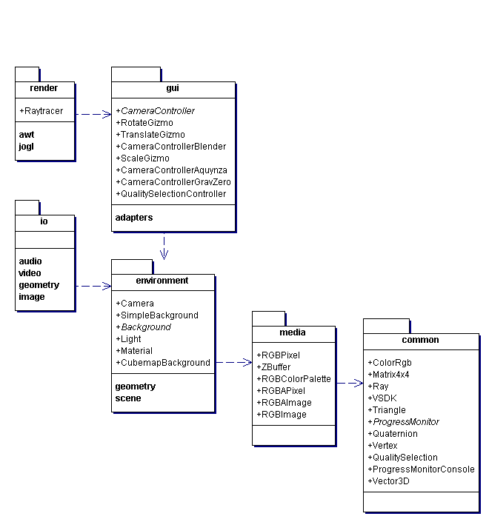

Figure 2. Toolkit packages dependency relations.

In the following sections, a detailed description of each package will be presented.

The common package

The common package classes have four main uses:
- Represent data and operations of basic mathematical entities used in computer graphics. These includes the classes Vector3D, Matrix4x4, Quaternion and Ray.
- Represent common basic data in computer graphics. There includes the classes ColorRgb, Triangle, Vertex and QualitySelection.
- Provide common utility code. This includes the interface ProgressMonitor and the class ProgressMonitorConsole.
- Establish basic foundation for the toolkit, and common structure of its model. These are the class VSDK and the Reflection/Observer/Serializaion mechanism structural class/interface Entity.

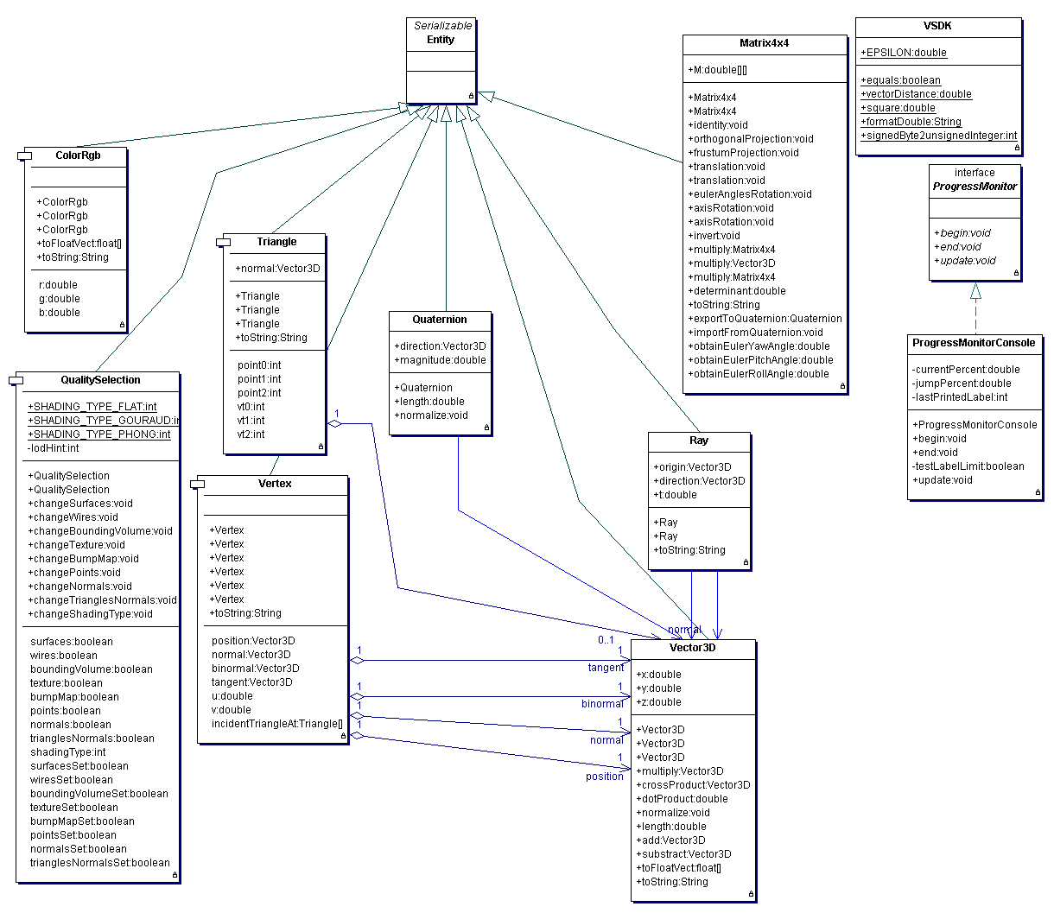
Figure 3. The vsdk.toolkit.common package classes.

This is the only package of the VSDK where classes with public attributes are allowed. Note that these classes must be considered as simple “structures” (like in C/C++), more than complete “classes” (as in strict object oriented theory). The reason for making attributes public is that these classes are so fundamental and commonly used, that the access to its attributes is usually much repeated, making a key part of efficient implementation of algorithms. Another valid argument to defend the existances of public attributes is that these are very simple entities, so they will not evolve and will not change its internal representation in the future. For example, a matrix is a matrix, period. It is not bad to have its double 2-dimensional vector exposed, will never change.

The Entity class provides the Serializable interface to all of the VSDK toolkit classes that extends Entity. Note that all the sub-classes of Entity are part of the data model in the VSDK toolkit.

The media package

The media package contains the model part and basic operations of common multimedia content like image, video and sound. Note that there is not any persistence or rendering code here. These models only have the minimum necessary for making computer graphics algorithm work in main memory, at the very common level. The most typical of these classes is the Image one. Note that images are in the heart of computer graphics. They are the result of visualization processes, they are used as textures, they are analyzed in artificial vision or image processing, and are the center, in some way, of all the current raster technologies. From an image, one can manage display hardware, one can print it, send it over the net as part of a distributed algorithm and so on. These are the kind of classes included in this package. Note that the persistence and rendering are located in the io and render packages respectively.

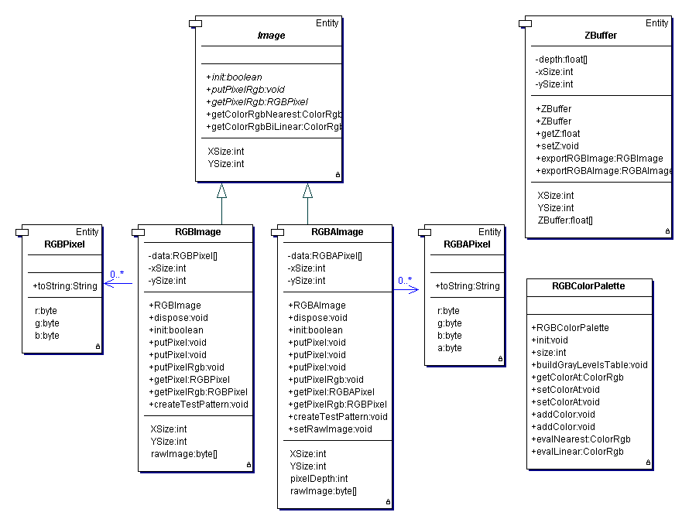
Figure 4. The vsdk.toolkit.media package classes currently implemented.

Note that in the current implementation of image models, the low cohesion alternative was chosen. That is that there is not a single complex image class representing all cases of color space alternatives, number of channels or precision. All classes for image representation have a single internal image format, based on its own pixel format class. The classes must define the abstract methods of the Image superclass, and with it will be conformant to various algorithms which uses images, like textured raytracing. Each classes defines a standard putPixel/getPixel methods for the RGB case, and additionally defines its own versions of putPixel/getPixel methods for its specific pixel formats. Note that the pixel and color classes are responsible of color model conversions, and image classes can define alternative putPixel/getPixel formats depending of the color spaces.

The ZBuffer class (DepthMap?) can be used as a depthmap in ZBuffer like algorithms, as a light buffer / light maps for multipass pixel-space shadow generation algorithms and it is very basic to most computer graphics techniques.

The palette classes are also common for computer graphics techniques, like color interpolation and scientific visualization.

The environment packages

The environment package and its sub-packages are the fundamental and central classes that constitutes the VSDK toolkit core geometric model. There are 5 groups of classes inside this packages:
- Cameras
- Backgrounds
- Lights
- Materials
- Geometries
- Scene constructs

The 5 group of classes in those packages are used to model virtual reality worlds in main memory. In current implementation this elements are not thread-safe, neither re-entrant. This implies that Threads should not be used in distributed implementation, but heavy process should be used instead. These classes are based upon the functionalities of the common and media packages, and inherits from the Entity class.

As current implementation version, Cameras, Lights and Materials are simple classes, and there is a hierarchy of Backgrounds. The most complex functionality of this package is the geometric representation of objects (which are preferred to be called “Bodies”, for not confusing them with object-oriented programming terms). The geometries are grouped in a separate sub-package called geometry. Note that the Geometry class defines some basic operations common in its sub-classes, as the doIntersection method.

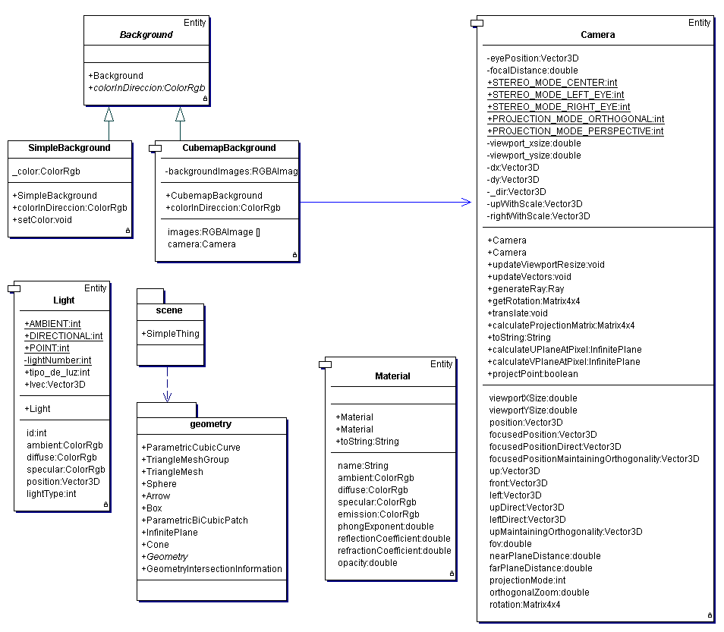
Figure 5. The vsdk.toolkit.enviroment package classes currently implemented.

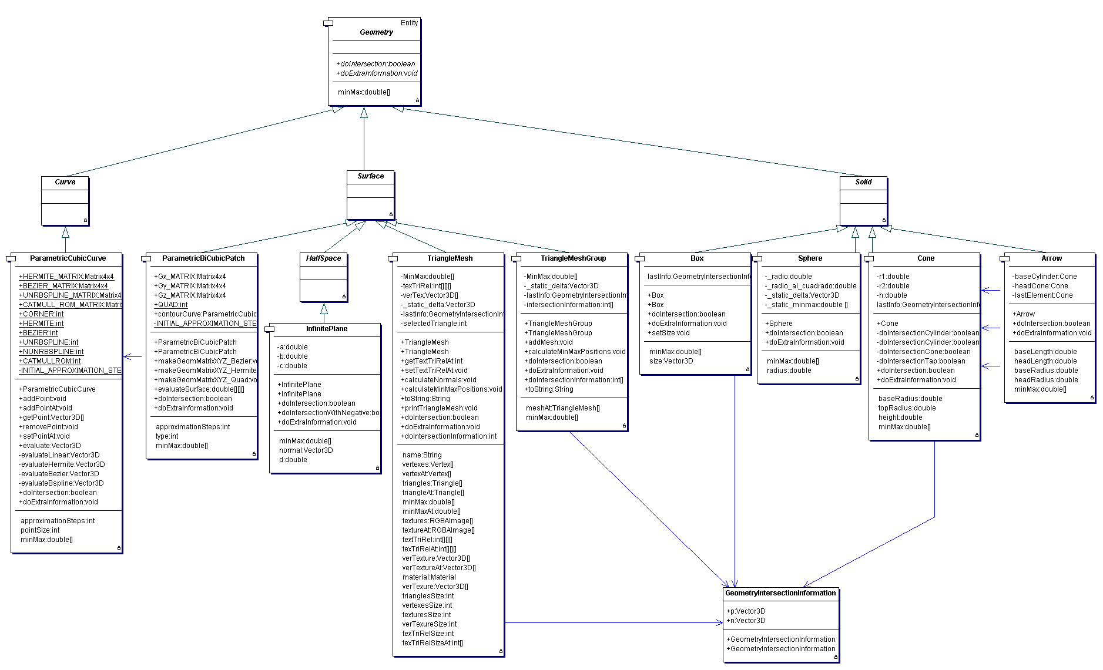
Figure 6. The vsdk.toolkit.geometry sub-package classes currently implemented.

The io packages

The classes located under some sub-package of the io package are classes that implements operations of persistence. The public methods of these classes are static, so this classes usually do not need to be instantiated. The methods usually receive as parameters a reference to an Entity (a modeling class) and some other parameter to identify the source or target for data storage.

The gui package

This is an experimental package, and its name and/or location could change.

The render packages

The render package contains static classes that receives as parameters references to model objects, and perform rendering operations on it. Usually, these rendering operations are partial, so the complete rendering pipeline should be implemented in a higher level, using these algorithms as part of a chain of responsibility.

References

[DOXYGEN]

[GAMMA]

