**Gauss-Jordan**

El método de Gauss-Jordan utiliza operaciones con matrices para resolver sistemas de ecuaciones de n número de variables. Para aplicar este método solo hay que recordar que cada operación que se realice se aplicara a toda la fila o a toda la columna en su caso. El objetivo de este método es tratar de convertir la parte de la matriz donde están los coeficientes de las variables en una matriz identidad. Esto se logra mediante simples operaciones de suma, resta y multiplicación. El procedimiento es el siguiente:

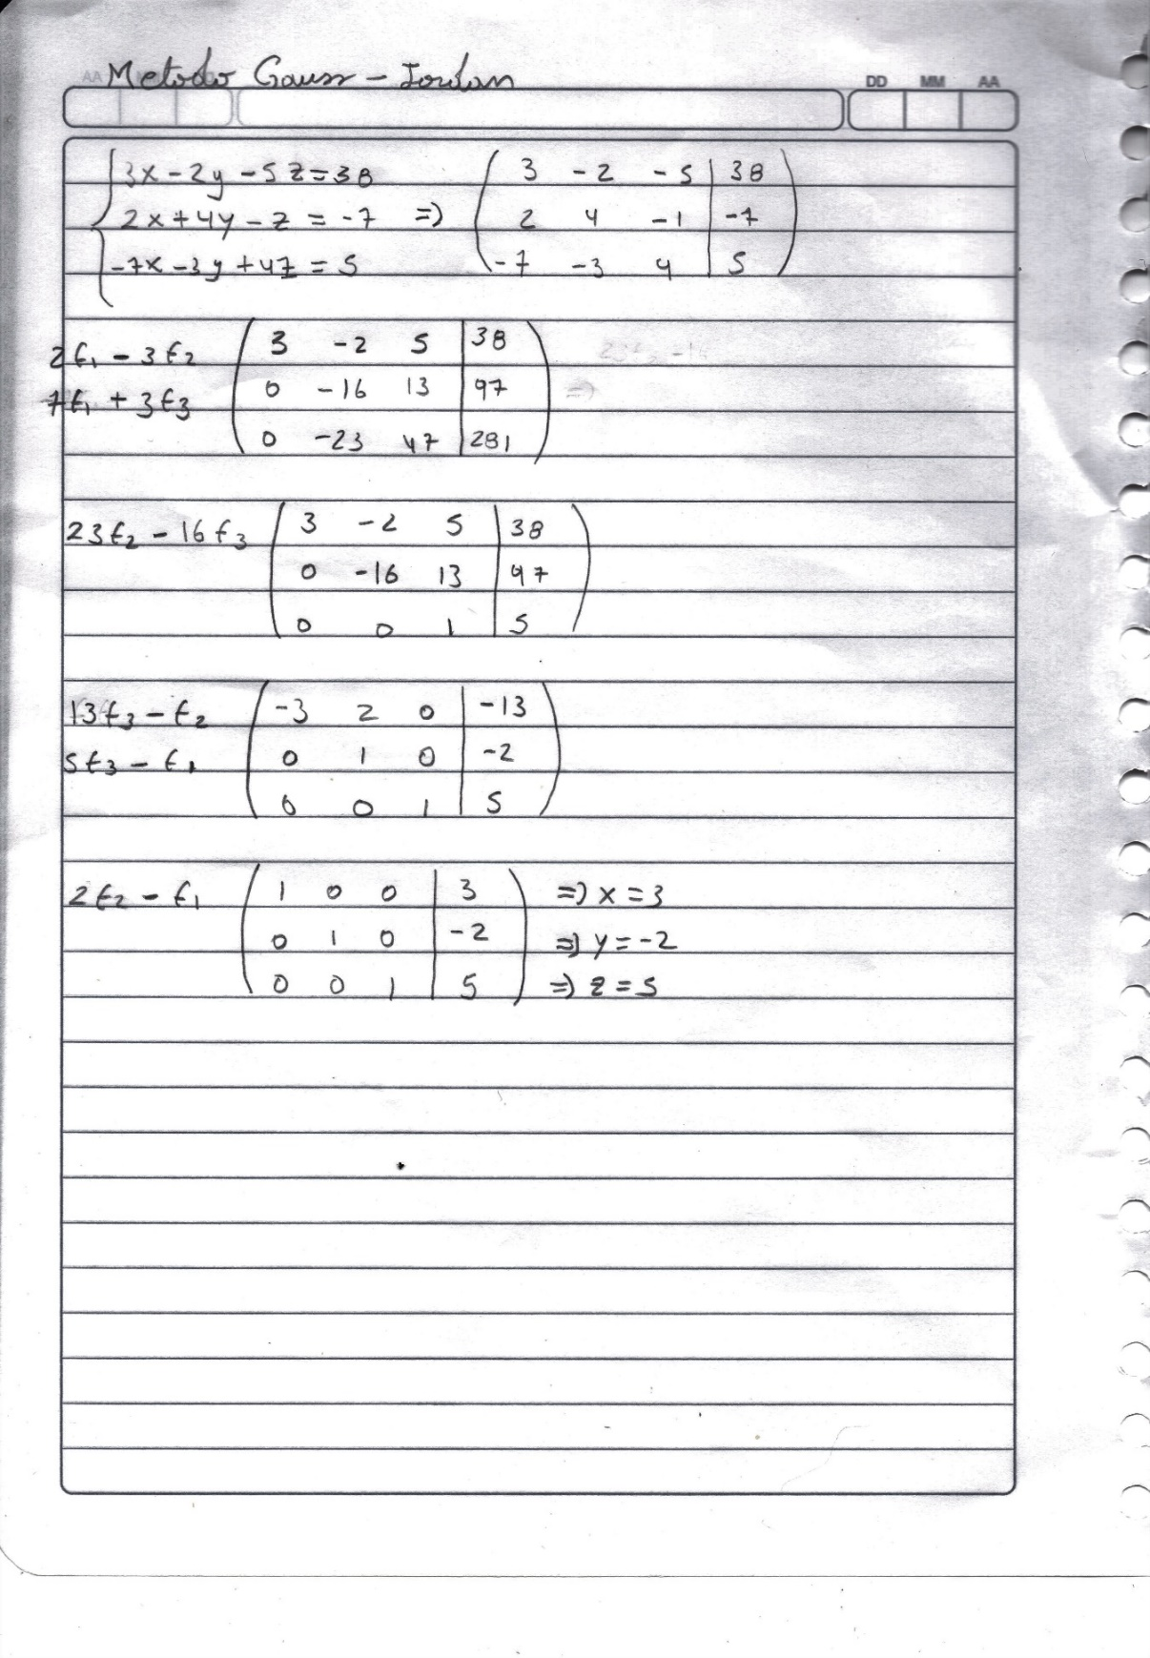

Como puede verse el método Gauss-Jordan es una herramienta útil en la resolución de este tipo de problemas y actualmente existen programas matemáticos que lo utilizan para una gran variedad de cálculos en una gran variedad de áreas, tanto científicas como socioeconómicas.

Pseudocodigo Gauss-Jordan

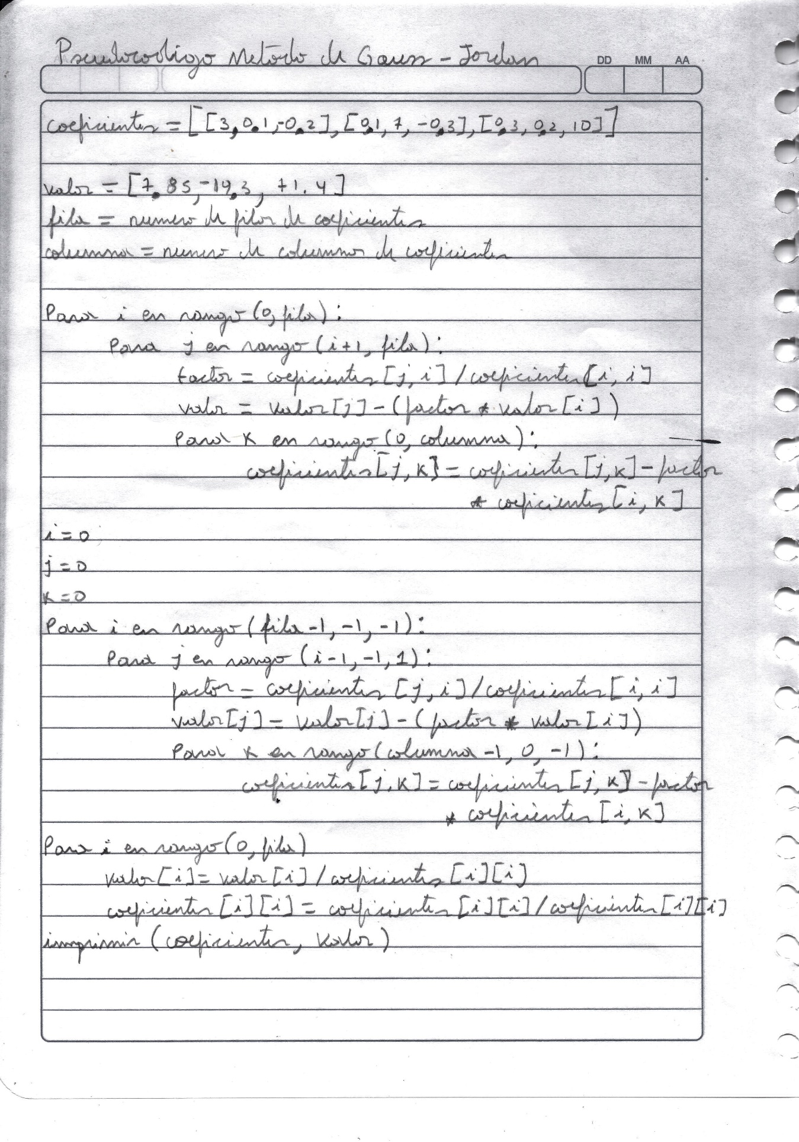

Prueba de escritorio

|  |  |
| --- | --- |
| coeficientes | [[3,-0.1,-0.2], [0.1,7,-0.3], [0.3,-0.2,10]] |
| columna | 3 |
| factor | 0 |
| fila | 3 |
| i | 0 |
| j | 0 |
| k | 0 |
| valor | [7.85,-19.3,71.4] |

|  |  |
| --- | --- |
| coeficientes | [[3,-0.1,-0.2], [0.1,7,-0.3], [0.3,-0.2,10]] |
| columna | 3 |
| factor | 0.03333333333333333 |
| fila | 3 |
| i | 0 |
| j | 1 |
| k | 0 |
| valor | [7.85,-19.561667,71.4] |

|  |  |
| --- | --- |
| coeficientes | [[3,-0.1,-0.2], [0,7,-0.3], [0.3,-0.2,10]] |
| columna | 3 |
| factor | 0.03333333333333333 |
| fila | 3 |
| i | 0 |
| j | 1 |
| k | 0 |
| valor | [7.85,-19.561667,71.4] |

|  |  |
| --- | --- |
| coeficientes | [[3,-0.1,-0.2], [0,7.00333,-0.3], [0.3,-0.2,10]] |
| columna | 3 |
| factor | 0.03333333333333333 |
| fila | 3 |
| i | 0 |
| j | 1 |
| k | 1 |
| valor | [7.85,-19.561667,71.4] |

|  |  |
| --- | --- |
| coeficientes | [[3,-0.1,-0.2], [0,7.00333,-0.29333], [0.3,-0.2,10]] |
| columna | 3 |
| factor | 0.03333333333333333 |
| fila | 3 |
| i | 0 |
| j | 1 |
| k | 2 |
| valor | [7.85,-19.561667,71.4] |

|  |  |
| --- | --- |
| coeficientes | [[3,-0.1,-0.2], [0,7.00333,-0.29333], [0.3,-0.2,10]] |
| columna | 3 |
| factor | 0.09999999999999999 |
| fila | 3 |
| i | 0 |
| j | 2 |
| k | 2 |
| valor | [7.85,-19.561667,70.615] |

|  |  |
| --- | --- |
| coeficientes | [[3,-0.1,-0.2], [0,7.00333,-0.29333], [0,-0.2,10]] |
| columna | 3 |
| factor | 0.09999999999999999 |
| fila | 3 |
| i | 0 |
| j | 2 |
| k | 0 |
| valor | [7.85,-19.561667,70.615] |

|  |  |
| --- | --- |
| coeficientes | [[3,-0.1,-0.2], [0,7.00333,-0.29333], [0,-0.19,10]] |
| columna | 3 |
| factor | 0.09999999999999999 |
| fila | 3 |
| i | 0 |
| j | 2 |
| k | 1 |
| valor | [7.85,-19.561667,70.615] |

|  |  |
| --- | --- |
| coeficientes | [[3,-0.1,-0.2], [0,7.00333,-0.29333], [0,-0.19,10.02]] |
| columna | 3 |
| factor | 0.09999999999999999 |
| fila | 3 |
| i | 0 |
| j | 2 |
| k | 2 |
| valor | [7.85,-19.561667,70.615] |

|  |  |
| --- | --- |
| coeficientes | [[3,-0.1,-0.2], [0,7.00333,-0.29333], [0,-0.19,10.02]] |
| columna | 3 |
| factor | -0.027129938124702525 |
| fila | 3 |
| i | 1 |
| j | 2 |
| k | 2 |
| valor | [7.85,-19.561667,70.08429319] |

|  |  |
| --- | --- |
| coeficientes | [[3,-0.1,-0.2], [0,7.00333,-0.29333], [0,0,10.02]] |
| columna | 3 |
| factor | -0.027129938124702525 |
| fila | 3 |
| i | 1 |
| j | 2 |
| k | 0 |
| valor | [7.85,-19.561667,70.08429319] |

|  |  |
| --- | --- |
| coeficientes | [[3,-0.1,-0.2], [0,7.00333,-0.29333], [0,0,10.12]] |
| columna | 3 |
| factor | -0.027129938124702525 |
| fila | 3 |
| i | 1 |
| j | 2 |
| k | 2 |
| valor | [7.85,-19.561667,70.08429319] |

|  |  |
| --- | --- |
| coeficientes | [[3,-0.1,-0.2], [0,7.00333,-0.29333], [0,0,10.12]] |
| columna | 3 |
| factor | -0.027129938124702525 |
| fila | 3 |
| i | 2 |
| j | 2 |
| k | 2 |
| valor | [7.85,-19.561667,70.08429319] |

|  |  |
| --- | --- |
| coeficientes | [[3,-0.1,-0.2], [0,7.00333,0], [0,0,10.12]] |
| columna | 3 |
| factor | -0.029298052955428894 |
| fila | 3 |
| i | 2 |
| j | 1 |
| k | 2 |
| valor | [7.85,-17.5083333,70.08429319] |

|  |  |
| --- | --- |
| coeficientes | [[3,-0.1,-0.2], [0,7.00333,0], [0,0,10.12]] |
| columna | 3 |
| factor | -0.029298052955428894 |
| fila | 3 |
| i | 2 |
| j | 1 |
| k | 1 |
| valor | [7.85,-17.5083333,70.08429319] |

|  |  |
| --- | --- |
| coeficientes | [[3,-0.1,-0.2], [0,7.00333,0], [0,0,10.12]] |
| columna | 3 |
| factor | -0.0199775945196883338 |
| fila | 3 |
| i | 2 |
| j | 0 |
| k | 2 |
| valor | [9.25,-17.5083333,70.08429319] |

|  |  |
| --- | --- |
| coeficientes | [[3,-0.1,0], [0,7.00333,0], [0,0,10.12]] |
| columna | 3 |
| factor | -0.0199775945196883338 |
| fila | 3 |
| i | 2 |
| j | 0 |
| k | 2 |
| valor | [9.25,-17.5083333,70.08429319] |

|  |  |
| --- | --- |
| coeficientes | [[3,-0.1,0], [0,7.00333,0], [0,0,10.12]] |
| columna | 3 |
| factor | -0.0199775945196883338 |
| fila | 3 |
| i | 2 |
| j | 0 |
| k | 1 |
| valor | [9.25,-17.5083333,70.08429319] |

|  |  |
| --- | --- |
| coeficientes | [[3,-0.1,0], [0,7.00333,0], [0,0,10.12]] |
| columna | 3 |
| factor | -0.014278914802475014 |
| fila | 3 |
| i | 1 |
| j | 0 |
| k | 2 |
| valor | [9,-17.5083333,70.08429319] |

|  |  |
| --- | --- |
| coeficientes | [[3,0,0], [0,7.00333,0], [0,0,10.12]] |
| columna | 3 |
| factor | -0.014278914802475014 |
| fila | 3 |
| i | 1 |
| j | 0 |
| k | 1 |
| valor | [9,-17.5083333,70.08429319] |

|  |  |
| --- | --- |
| coeficientes | [[3,0,0], [0,7.00333,0], [0,0,10.12]] |
| columna | 3 |
| factor | -0.014278914802475014 |
| fila | 3 |
| i | 0 |
| j | 0 |
| k | 1 |
| valor | [9,-17.5083333,70.08429319] |

|  |  |
| --- | --- |
| coeficientes | [[1,0,0], [0,7.00333,0], [0,0,10.12]] |
| columna | 3 |
| factor | -0.014278914802475014 |
| fila | 3 |
| i | 0 |
| j | 0 |
| k | 1 |
| valor | [3,-17.5083333,70.08429319] |

|  |  |
| --- | --- |
| coeficientes | [[1,0,0],[0,1,0], [0,0,10.12]] |
| columna | 3 |
| factor | -0.014278914802475014 |
| fila | 3 |
| i | 1 |
| j | 0 |
| k | 1 |
| valor | [3,-2.5,70.08429319] |
| coeficientes | [[1,0,0]  ,[0,1,0],  [0,0,1]] |
| columna | 3 |
| factor | -0.014278914802475014 |
| fila | 3 |
| i | 2 |
| j | 0 |
| k | 1 |
| valor | [3,-2.5,7] |