Comparing empirical methods measuring intra- and

inter-speci c competition coe cients

Feng-Hsun Chang

May 2018

* Introduction

[Brad, please help ll-in this section]

1. Big-picture of why MCT is the best tool we have for evaluating coexistence of species.
2. Multiple methods have been proposed for evaluating the potential for coexistence among species using empirical data. Although each of these methods is designed to evaluate Chesson's inequality criterion, it remains unclear 1) whether these methods are functionally equivalent and 2) which methods are most appropriate for a given study system.
3. We compare ve di erent methods that have been proposed for evaluating

1

* Summary of Methods For Empirically Evaluating MCT

2.1 The classic Lotka-Volterra model

In the classic Lotka-Volterra model, the per capita growth rate of species i can be described by the following equation.

|  |  |  |  |  |  |
| --- | --- | --- | --- | --- | --- |
| 1 | dNi | | X |  |  |
|  |  |  |  |  |
|  |  |  | = ri(1 iiNiijNj) | (1) |  |
| Ni | dt |  |
|  |  |  | j6=i |  |  |

In the above equation, Ni and ri are the the density and the intrinsic growth rate of species i

respectively. The ii is the intra-speci c competition coe cient, which describes the per capita

e ect of species i on the per capita growth rate of species i. The ij is the inter-speci c competition

coe cient, which describes the per capita e ect of species j on the per capita growth rate of species i. For any two species (e.g. i and j) to stably coexist, the mutual invasibility criteria must be met, which means the two species need to be able to invade the other one from rare, i.e. both species need to have positive invasion growth rate. For the two species to have positive invasion growth rate, the intra-speci c competition coe cient must be greater than the inter-speci c competition coe cient, i.e. ii > ij and jj > ji.

To use the Lotka-Volterra model to empirically predict coexistence for species i and j, one must rst estimate six di erent parameters that are used in the Lotka-Volterra model: intrinsic growth rate of each species (ri and rj) , intra-speci c competition coe cients ( ii and jj), and

inter-speci c competition coe cients ( ij and ji). In theory, this could be accomplished using

maximum likelihood method from a single co-culture time-series dataset, where both species are introduced at low density and allowed to grow to steady-state. However, in practice, it is di cult to parameterize all six variables from a single time-series. An alternative would be to use three

2

datasets for each species pair: each species as a monoculture and one co-culture of the two species (Fig. 1). An important consideration is that, the Lotka-Volterra model assumes constant intra- and inter-speci c competition coe cient with respect to population sizes and time - the rst individual and the last individual have the same per capita e ect on the growth rates.

2.2 Sensitivity method

Sensitivity method is another method proposed to measure niche di erence (ND) and relative tness di erence (RFD) without explicitly estimating the inter-speci c competition coe cients [8]. Instead, sensitivity method relies on the e ect of inter-speci c competition on the population dynamics. Sensitivity method is also based on the idea of mutual invasibility that species need to be able to invade its competitor from rare in order to coexist. When invading its competitor, if a species has low invasion growth rate, this species is more a ected by it competitor so that this species' niche should overlap with its competitor more. To quantify the e ect of the competitor on the focal species i, the sensitivity metric (Si) compares the focal species i's per capita growth rate when invading it

competitor versus the focal species i's per capita growth rate when growing alone from rare. The di erence between the two growth rates is then the proxy of the e ect of competitor on the focal species i. Speci cally, according to Carroll et al. 2011, sensitivity metric (Si) is calculated by the

following formula.

|  |  |  |  |  |
| --- | --- | --- | --- | --- |
| S | i | iij | (2) |  |
| i |  |
|  |  |  |

In equation 2, i is the per capita growth rate of species i when growing alone from rare and ij

is the per capita growth rate of species i when it competitor (species j) is at its carrying capacity. If either species has a growth rate less than or equal to zero when invading, this means that there will not be coexistence (mutual invasion criterion). The mutual invasion experiment can not only

3

be used to directly testing for mutual invasibility, but also to empirically estimate ND and RFD [8]. Speci cally, to use sensitivity (Si) to calculate niche di erence (ND) and relative tness di erence

(RFD) and predict coexistence, Carroll et al. 2011 argued that ND can be de ned as the geometric mean of sensitivity metrics and RDF can be de ned as the geometric standard deviation of the sensitivity metrics.

The sensitivity method has been argued to be a general procedure that is not restricted to a speci c competition model, and intuitively connects species competition and population dynamics

1. However, here we show that the sensitivity metric is not just an intuitive connection but actually describes the impact of the entire competitor population on the focal species i. Speci cally, in equation 2, the reduction of species i's per capita growth rate, i.e. the nominator, is actually caused by the entire population of the other species j because the invasion growth rate ( ij) is measured when the other species j is at the carrying capacity. Accordingly, the sensitivity (Si) measures the "population" impact of species j, but not the per capita impact of species j on the focal species i. To show that sensitivity is actually the population level impacts, not the per capita

level, we derive the sensitivity (Si) from the classic Lotka-Volterra competition model (equation 1).

The i is therefore ri and ij is ri(1 ijNj ). Accordingly,

|  |  |  |  |  |  |  |  |  |  |  |  |  |  |  |  |
| --- | --- | --- | --- | --- | --- | --- | --- | --- | --- | --- | --- | --- | --- | --- | --- |
|  |  | iij |  | r | i | r | (1 |  | N ) | | |  |  |  |  |
| S | i | = |  | i |  | ij | j | = | ij | N | (3) |  |
| i |  |  |  | ri | |  |  |  |
|  |  |  |  |  |  |  |  | j |  |  |

From equation 3, we see that sensitivity (Si) is the equilibrium density of species j (Nj ) times

the per capita competition coe cient ( ij). The sensitivity thus is a measurement of the overall

population e ect of species j on focal species i but not the "per capita" e ect of species j. Small tweak should be implemented when using the sensitivity method to estimate per capita inter-speci c competition coe cients ( ij).

Moreover, there is only verbal argument stating why ND and RFD can be de ned as the

4

geometric mean and standard deviation of sensitivity metrics (Si). Here we argue that de ning

ND and RFD as the geometric mean and standard deviation of sensitivity metrics is theoretically valid. We show that geometric mean and standard deviation of sensitivity metrics are theoretical valid de nitions of niche di erence (ND) and relative tness di erence (RFD). In the Lotka-Volterra

model, species' density at the equilibrium (Ni ) is actually 1 . Therefore, sensitivity (Si) can be

ii

|  |  |  |  |  |  |  |  |  |  |  |  |  |  |  |  |  |  |  |  |  |  |  |  |  |  |  |  |  |  |  |  |  |  |  |  |
| --- | --- | --- | --- | --- | --- | --- | --- | --- | --- | --- | --- | --- | --- | --- | --- | --- | --- | --- | --- | --- | --- | --- | --- | --- | --- | --- | --- | --- | --- | --- | --- | --- | --- | --- | --- |
| expressed as | ij | , which represents the inter-speci c competition scaled on intra-speci c competition | | | | | | | | | | | | | | | | | | | | | | | | | | | | | | | | |  |
|  |  |
|  | jj | | | |  |  |  |  |  |  |  |  |  |  |  |  |  |  |  |  |  |  |  |  |  |  |  |  |  |  |  |  |  |  |  |
|  |  |  |  |  |  |  |  |  |  |  |  |  |  |  |  |  |  | ij ji | | | | | | | | ij ji | | | | |  |  |  |  |  |
| coe cient. According to Chesson (1990), niche overlap ( ) is de ned as q | | | | | | | | | | | | | | | | | |  | | |  |  | . q | | |  |  |  |  |  | can then | | | |  |
| ii jj | | | | | ii jj | | | | |  |
|  |  |  |  | the geometric mean of sensitivity S | | | | | | |  | i and S | | | | | | |  | . The niche di erence | | | | | | | | | | | | | | |  |
| be expressed as pSiSj, which is | | | | |  |  |  |  |  |  |  |  |  |  |  |  |  | j |  |  |  | | | |  |  |  |  |  |  |  |  |  |  |
|  | ij ji | | |  |  | q | |  | Si | |  |  |  |  |  |  | ij ii | | | |  |  |  |  |  |  |  | ij ii | |  |
|  |  |  |  |  |  |  |  |  |  |  |  |
| (ND) is therefore 1= 1 q | | | | |  |  | = 1 pSiSj. In addition, | | | |  |  |  | = q | | | | | |  | | | | | , and | | | | q | |  |  |  |
|  | ii jj |  | Sj | | jj ji | | | | | jj ji |  |

is the de nition of the inverse of relative tness di erence of species j over species i (RFD; kj in

ki

Chesson 1990).

With the above derivation, we can also derive a coexistence criteria using the sensitivity metric. From the Lotka-Volterra model model, intra-speci c competition ( ii) must be greater than

the inter-speci c competition ( ij) to guarantee stable coexistence. Therefore we can have the

following deduction.

ij = r ij ii

jj jj ji

ii = r ij ii

ji jj ji

r ij ji = ii jj

r ii jj = ij ji

s

Si < 1, so Sj

s

Si < 1, so Sj

s

|  |  |  |  |  |
| --- | --- | --- | --- | --- |
| Si | < | 1 | (4) |  |
| Sj |  |  |
|  |  |  |

s

|  |  |  |  |
| --- | --- | --- | --- |
| Si | > | (5) |  |
| Sj |  |
|  |  |  |

Combining equation 4 and 5, we have an inequality for coexistence expressed with sensitivity metrics,

q

|  |  |  |  |  |  |
| --- | --- | --- | --- | --- | --- |
| < | Si | < | 1 | , which is in the same form as in Chesson's coexistence framework. In brief, the |  |
| Sj |  |  |
|  |  |  |  |

sensitivity metric (Si) is not equivalent to the competition coe cient ( ij in the Lotka-Volterra

model, but due to its methmatic attributes, it can be used to calculate ND and RFD directly.

5

2.3 Negative Frequency dependency (NFD) method

The negative frequency dependency (NFD) method [6, 7, 9, 10]. The NFD method is also derived from the same logic that intra-speci c competition coe cient must be greater than the inter-speci c competition coe cient for stable coexistence. The rationale is to measure how the per capita growth rate of a focal species i would be a ected by the increase of its own the frequency (%) in a community. If the intra-speci c competition coe cient is greater than the inter-speci c competition coe cient, i.e. the focal species i limits itself more than it limits its competitor, increasing relative frequency of the focal species i will decrease its own per capita growth rate. In this case, frequency dependency is negative because per capita growth rate of a focal species i negatively depends on its own frequency. Given this rationale, we argue that negative frequency is to be expected when the focal species i limits itself more than it limits its competitor, i.e. intra-speci c competition coe cient is greater than inter-speci c competition coe cient. Therefore, negative frequency should guarantee stable coexistence. However, we also argue that the magnitude of negative frequency dependency (the slope) is not equivalent to either intra- or inter-speci c competition coe cients [6]. When calculating negative frequency dependency (NFD), the per capita growth rate is being plotted against the frequency of the focal species, so it is actually the "per %" impact on the per capita growth rate. Here we show that the NFD is therefore not equivalent but related to the competition coe cients in the Lotka-Volterra model.

To show that negative frequency dependency (NFD) metrics can not be used directly to measure competition coe cients ( ij), we attempt to derive the NFD metrics from the Lotka-

Volterra model again. We found that, the NFD metrics cannot be readily derived from the Lotka-Volterra model without making further assumptions. In fact, only when the community density is xed, frequency dependency is equivalent to density dependency, which is modeled by ij in the

Lotka-Volterra model [6]. In the Lotka-Volterra model, there is no term describing the frequency

6

of species. The only way to make the per capita growth rate a function of the frequency of species i is to assume a xed total community density. Moreover, since the competition coe cients ( ij)

describe the per capita e ect, we should further assume an one-to-one conversion between the focal species i and the competing species j. By doing so, the Lotka-Volterra competition model can be rewritten as followed.

|  |  |  |  |  |  |
| --- | --- | --- | --- | --- | --- |
| 1 | dNi | | X |  |  |
|  |  |  |  |  |
|  |  |  | = ri(1 iiNiij(B Ni)) | (6) |  |
| Ni | dt |  |
|  |  |  | j6=i |  |  |

In equation 6, B is the xed community density and one unit decrease of Ni will lead to one

unit increase of Nj. Note that this B is an arbitrarily de ned constant describing a xed community

density and has nothing do to with the equilibrium of any of the species. To calculate the negative frequency dependency (NFD) metrics, we take derivative of equation 6 in terms of Ni=B.

|  |  |  |  |  |  |  |  |  |  |  |  |  |  |  |  |  |  |  |  |  |  |  |  |  |
| --- | --- | --- | --- | --- | --- | --- | --- | --- | --- | --- | --- | --- | --- | --- | --- | --- | --- | --- | --- | --- | --- | --- | --- | --- |
|  | @ | 1 |  |  | dNi | |  |  | @ | | 1 | |  | dNi |  |  | @ | 1 |  | dNi |  |  |  |  |
| N F D |  | Ni dt | | | | |  | = |  |  | Ni dt | | | |  | = B | Ni dt | | | |  | = Bri( ijii) | (7) |  |
|  | @ | Ni | | |  |  |  | 1 | | @Ni | | |  |  | @Ni | | |  |  |
|  |  |  |  |  |  | |  |  |  |  |
|  |  | | |  |  |  |  |  |  |
|  |  |  |  | B | | |  |  |  | B | | | | |  |  |  |  |  |  |  |  |  |  |

This equation 7 describe the change of species i's per capita growth rate with respective to the change of its own frequency in a community (Fig. 3). From equation 7 the NFD depends on a combination of per capita growth rate (ri) and the xed community density (B) in addition to

the intra- and inter-speci c competition coe cients. From this equation, we rst see that NFD is negative as long as the intra-speci c competition ( ii) is greater than the inter-speci c competition

( ij). Additionally, higher per capita growth rate of a species and higher community density (e.g.

in the later more mature stage of the community) would lead one to estimate stronger frequency dependency (Fig. 3). Most importantly, although NFD metrics has been used to estimate species coexistence empirically for annual plant communities (e.g. Godoy et al. 2014), NFD should be interpreted with caution as it is related but not equivalent to the competition coe cients (alphaij)

7

and thus should not be directly used to calculate ND and RFD, and to predict species coexistence.

2.4 MacArthur's consumer resource model

In 1970, MacArthur proposed a consumer resource model to describe how species compete for dif-ferent prey resources [1, 2]. This model can be reorganized into Lokta-Volterra form to more closely understand the rather phonological competition coe cients ( ij) between competing species [4, 5].

After the reorganization shown in [4], the following equation represent the linkage between the Lottka-Volterra model and the parameters of MacArthur's consumer resource model.

ij = Xcilcjl wlKl (8)

rl

l

X

fi = cilwlKl mi (9) l

Left hand side of equation 8 and 9 consists of parameters in the Lotka-Volterra model, while the right hand side consists of parameters from MacArthur's consumer resource model. On the left hand side, ij is the competition coe cient and fi is per capita growth rates of the species

i in the absence of resource limitation, which determines the winner of the competition [5]. On the right hand side, cil and cjl are the consumption of species i and j on resource l respectively, mi is

the mortality of species i, wi is the value of one unit of resource l to the species, and rl and Kl are

the per capita growth rate and carrying capacity of resource l. Through this linkage, empirically measured parameters in MacArthur's consumer resource model can be translated into parameters in Lotka-Volterra model and thus be used to calculate niche di erence (ND) and relative tness di erence (RFD).

8

The contemporary coexistence theory is Chesson's key insight toward the mutual invasi-bility criteria for stable coexistence in the classic Lokta-Volterra competition model ([4]). Chesson showed that the mutual invasibility criteria i.e. ii > ij and jj > ji, can be expressed in a

|  |  |  |  |
| --- | --- | --- | --- |
|  |  |  |  |
| di erent fashion. First, Chesson de ned the niche overlap ( ) as q | ij ji | to describe how similar |  |
| ii jj |  |

the two competing species are in terms of using resources, i.e. the similarity between cil and cjl

(Fig. 4). The niche di erence (ND) is thus 1 . Second, Chesson de ned relative tness di erence

q

|  |  |  |  |  |  |  |  |  |  |  |
| --- | --- | --- | --- | --- | --- | --- | --- | --- | --- | --- |
| (RDF; | fj | , the fi is the same as the ki in Chesson 1990) as |  | ij |  | 1 | = | ij ii | to describe which species |  |
|  | jj | | | |  |  |
|  | fi | |  | jj ji | |  |

should exclude the other one if they completely overlap their resource use. Accordingly, the product

of and RFD is the ratio of inter- speci c to intra-speci c competition coe cients, i.e. ij = fj .

jj fi

When intra-speci c competition of species j is greater than inter-speci c competition of species i

|  |  |  |  |  |  |  |  |  |  |  |  |
| --- | --- | --- | --- | --- | --- | --- | --- | --- | --- | --- | --- |
| ( jj | > ji), | ij | = | fj | < 1 so that | fj | < | 1 | | . By the same logic, when intra-speci c competition of |  |
|  |  |  |  |  |  |
| jj | fi | fi |  | |  |
|  |  |  |  |  |  |  |

species i is greater than inter-speci c competition of species j ( ii > ij), fi < 1 . Consequently,

fj

the mutual invasibility criteria for stable coexistence can be rewritten as the following inequality.

|  |  |  |  |  |  |  |  |
| --- | --- | --- | --- | --- | --- | --- | --- |
| < | f2 | < | 1 |  | : | (10) |  |
| f1 |  | |  |
|  |  |  |  |  |

2.5 Tilman's resource ratio consumer resource model

Similar to MacArthur's consumer resource model, Tilman's resource ratio consumer resource model

1. can also be translated to a Lotka-Volterra form [11]. Letten et al. 2017 reorganize Tilman's two-species consumer resource model for two essential resources to the following Lokta-Volterra form (equation 11 to 14), so that one can decipher the parameters impacting species' per capita

growth rate. According to Letten et al. the inter- and intra-speci c competition coe cients can be expressed as following,

9

|  |  |  |  |
| --- | --- | --- | --- |
| ii = | cij | (11) |  |
| D(Sj Rij) |  |

|  |  |  |  |
| --- | --- | --- | --- |
| ij = | cjj | (12) |  |
| D(Sj Rij) |  |

|  |  |  |  |
| --- | --- | --- | --- |
| jj = | cji | (13) |  |
| D(Si Rji) |  |

|  |  |  |  |
| --- | --- | --- | --- |
| ji = | cii | (14) |  |
| D(Si Rji) |  |

In the above equations, cij is the consumption term of consumer species i on resource j, so it contains

a parameter yij that representt the yield of consumer species i per resource j. D is the dilution rate,

Si is the supply rate of resource i, and Rij is the minimum resource density of resource j that still

allows the species i to have positive per capita growth rate.

Note that, in the generic consumer resource model, the above consumption term (cij) is

a function of resource density, e.g. c12 = r1R2 in Tilman's 1977 deduction. However, if the

y21(R2+K12)

consumption term is resource density dependent, competition coe cients ( ij) becomes resource

dependent as well. Although the competition coe cients ( ij) are not xed values as in the Lotka-

Volterra model, Letten et al.'s derivation can still be used to predict coexistence based on the mutual per capita e ects of each species on the other at equilibrium. To use equation 11 to 14 to calculate competition coe cients for predicting coexistence at the equilibrium, one would have to assume that the consumption of species i on resource j is evaluated at the equilibrium. For example, when at equilibrium, consumer's consumption (Cij) should be equal to the dilution rate (D) divided by the

yield of consumer (yij). In another words, the ij describes impact of species j on the per capita

10

growth rate of species i when the resource that limits species j is at the equilibrium, i.e. at the R* level. This assumption is the same as the sensitivity method since both method are based on the mutual invasibility criteria for stable coexistence. This assumption is also valid because the mutual invasibility criteria is the logical basis for coexistence.

11

References

1. Robert MacArthur. \Species packing, and what competition minimizes." In: Proceedings of the National Academy of Sciences of the United States of America 64.4 (Dec. 1969), pp. 1369{71. issn: 0027-8424. doi: 10.1073/PNAS.64.4.1369. url: http://www.ncbi.nlm.nih.gov/ pubmed/16591810%20http://www.pubmedcentral.nih.gov/articlerender.fcgi?artid= PMC223294.
2. Robert MacArthur. \Species packing and competitive equilibrium for many species". In: The-

oretical Population Biology 1.1 (May 1970), pp. 1{11. issn: 0040-5809. doi: 10.1016/0040-

5809(70 ) 90039 - 0. url: https : / / www . sciencedirect . com / science / article / pii / 0040580970900390.

1. David Tilman. \Resource competition between plankton algae: An experimental and theoret-

ical approach". In: EcologyEcology 58.2 (1977), pp. 338{348.

1. Peter Chesson. \MacArthur's consumer-resource model". In: Theoretical Population Biology

37.1 (1990), pp. 26{38. issn: 10960325. doi: 10.1016/0040-5809(90)90025-Q.

1. Peter Chesson. \Mechanisms of maintenance of species diversity". In: Annual Review of Ecology

and Systematics 31 (2000), pp. 343{66. issn: 0066-4162. doi: 10.1146/annurev.ecolsys.31. 1.343.

1. Peter B. Adler, Janneke HilleRislambers, and Jonathan M. Levine. \A niche for neutrality". In: Ecology Letters 10.2 (2007), pp. 95{104. issn: 1461023X. doi: 10.1111/j.1461- 0248. 2006.00996.x.

12

1. Jonathan M Levine and Janneke HilleRisLambers. \The importance of niches for the main-tenance of species diversity." In: Nature 461.7261 (2009), pp. 254{7. issn: 1476-4687. doi: 10.1038/nature08251. url: http://www.ncbi.nlm.nih.gov/pubmed/19675568.
2. Ian T Carroll, Bradley J Cardinale, and Roger M Nisbet. \Niche and tness di erences re-late the maintenance of diversity to ecosystem function of diversity relate the maintenance di erences Niche and tness to ecosystem function". In: Ecology 92.5 (2011), pp. 1157{1165. issn: 0012-9658. doi: 10.1890/10-0302.1. arXiv: arXiv:1011.1669v3. url: http://www. esajournals.org/doi/abs/10.1890/10-0302.1.
3. J Hillerislambers et al. \Rethinking Community Assembly through the Lens of Coexistence Theory". In: Annu. Rev. Ecol. Evol. Syst 43 (2012), pp. 227{48. issn: 1543-592X. doi: 10. 1146/annurev-ecolsys-110411-160411.
4. Oscar Godoy, Nathan J B Kraft, and Jonathan M. Levine. \Phylogenetic relatedness and the determinants of competitive outcomes". In: Ecology Letters 17.7 (2014), pp. 836{844. issn: 14610248. doi: 10.1111/ele.12289. arXiv: 2072.
5. Andrew D. Letten, Po Ju Ke, and Tadashi Fukami. \Linking modern coexistence theory and contemporary niche theory". In: Ecological Monographs 87.2 (2017), pp. 161{177. issn: 15577015. doi: 10.1002/ecm.1242. arXiv: 1106.4388.

13

Figures

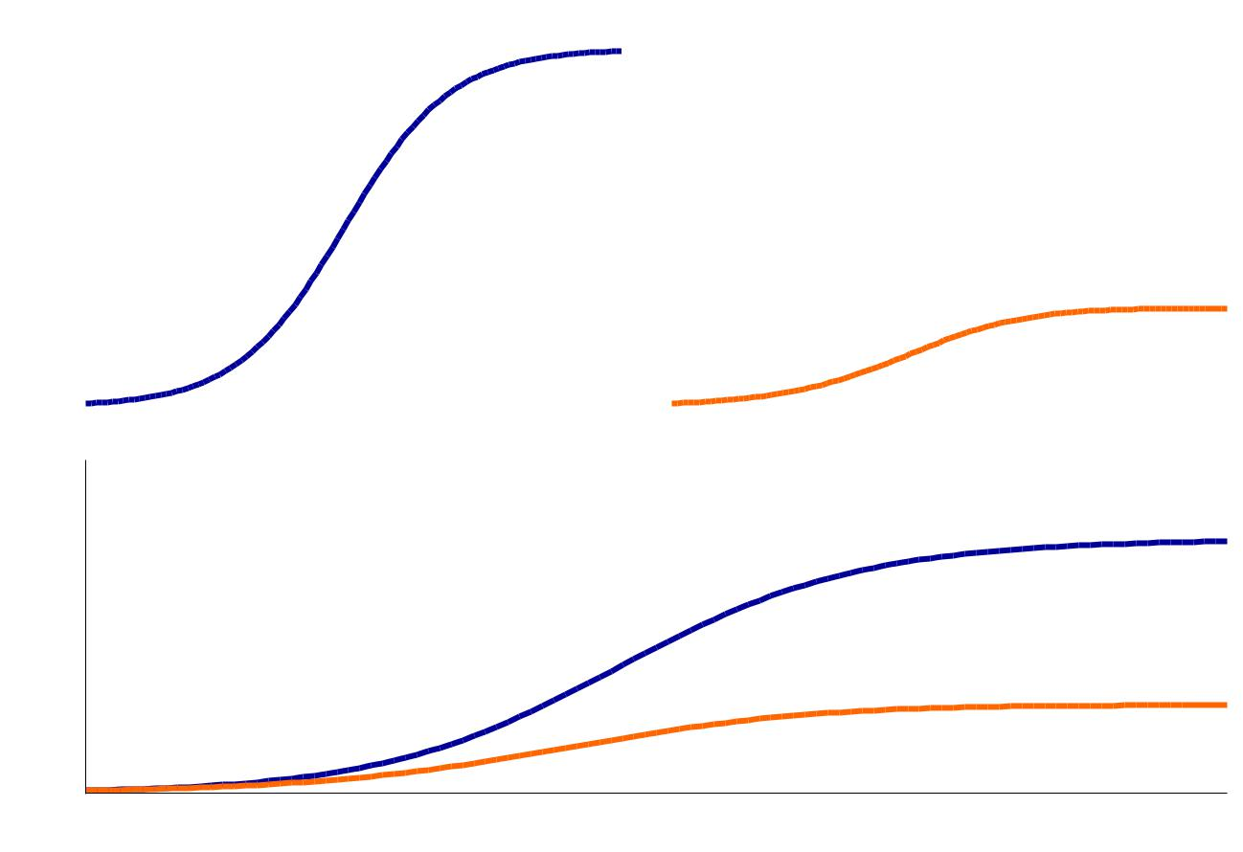

**A.**

|  |  |
| --- | --- |
|  | density |
| **C.** | Population |

|  |  |  |  |
| --- | --- | --- | --- |
| Species *i* monoculture | **B.** | Species *j* monoculture | |
|  |  |  |  |
|  |  |  |  |
|  |  |  |  |

Species *i* and *j* biculture

Time

Figure 1: An example plot showing the estimation of ij from tting Lotka-Volterra model to time

series. The points represent the density of species i (open circles) and j (solid dots) respectively. The dashed lines are the two tted growth curve. The species densities were generated by a Lotka-Volterra model and added some random noise. The parameters used in the Lotka-Volterra model are that r1 = 0.1, r1 = 0.05, 11 = 0.8, 12 = 21 = 0.6, 22 = 1.5. The random noise are from a normal

distribution with mean equals to 0 and standard deviation equals to 0.05. The tted parameters are that r1 = 0.099, r1 = 0.043, 11 = 0.808, 12 = 0.577, 21 = 0.720, 22 = 0.974.

14

**A.**

|  |  |
| --- | --- |
|  | density |
| **B.** | Population |

Species *i* invading species *j*

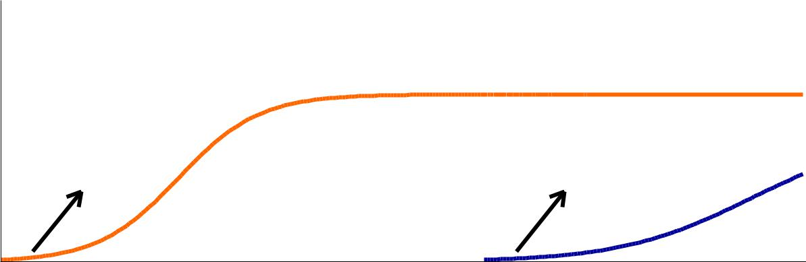

Growth rate of species Growth rate of species

*j* growing alone (µj) *i* invading species (µj)

Species *j* invading species *i*

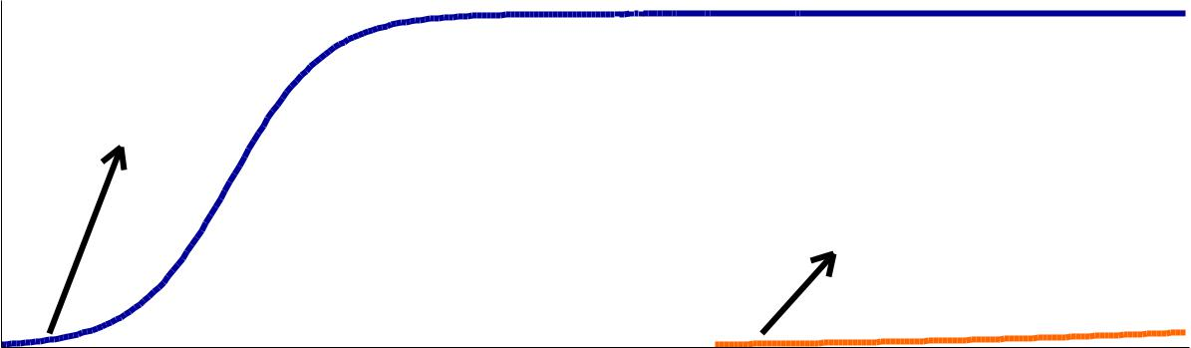

Growth rate of species

1. growing alone (µi)

Growth rate of species

*j* invading species (µi)

Time

Figure 2: An example plot showing the estimation of sensitivity (Sij) of species i invading species

j (panel a.) or the reverse (panel b.). In both panels, solid dots are the growth curve species when growing alone and the open circles are the growth curve of species when invading the carrying capacity of the other species. These data is generated from the same Lotka-Volterra model as in gure 1. To estimate the sensitivity of the focal species (e.g. s species i), the competing species (species j) is xed at the equilibrium and invade the focus species to estimate the invading growth rate of the focal species. Using the sensitivity method, the 12 is estimated to be 0.686 and 21

is estimated to be 0.652, which is close to the predetermined inter-speci c competition coe cients ( 12 = 21 = 0:6).

15

**A.**

|  |
| --- |
| *per capita* growth rate of species *i* |

**B.**



0.08

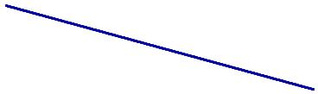

0.06

0.04

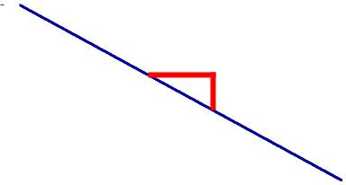

Slope = NFD ≠ α

0.02

0.00 0.25 0.50 0.75 1.00

Frequency (%) of species *i*

|  |
| --- |
| *per capita* growth rate of species *j* |

0.075

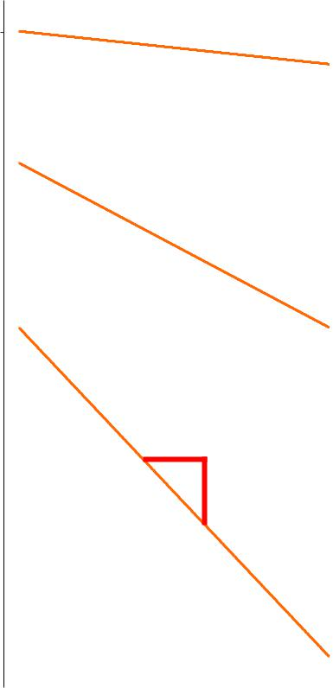

|  |  |
| --- | --- |
| 0.050 |  |
|  | Community |
|  | biomass (B) |
|  | 0.1 |
|  | 0.5 |
| 0.025 | 1 |
|  | Slope = NFD ≠ α |
| 0.000 |  |



0.00 0.25 0.50 0.75 1.00

Frequency (%) of species *j*

Figure 3: An example plot showing the negative frequency dependency (NFD) of species i (panel a.) and species j (panel b.). To calculate NFD, we rst determined an arbitrary community biomass (B) and gradually increased the frequency of the focal species (species i in panel a. and species j in panel b.) to calculate the per capita growth rate of the focal species. Note that we directly calculated the per capita growth rate from equations of the Lotka-Volterra model not from numerical simulations. As the gure shows, the NFD depends on the arbitrarily community biomass (B). The resulting NFDs (slopes) match that are expected by equation 7. For example, when community biomass is 1 (dashed line in the middle), NFD of species i is -0.02 and NFD of species j is -0.045. This slope is far away from the predetermined s ( 12=0.8, 12 = 21 = 0.6, and 22 = 1.5).

16

|  |  |  |  |
| --- | --- | --- | --- |
| ) | 14 |  |  |
|  |  |  |
| *j l* |  |  |  |
| (*C* | 13 |  |  |
| *l* |  |  |  |
| onresource | 12 |  |  |
|  |  |  |
| *j* |  |  |  |
| ofspecies | 11 |  |  |
|  |  |  |
| Consumption | 10 |  |  |
| 9 |  |  |
|  |  |  |
|  | 88 | |  |

|  |  |  |  |  |  |  |  |  |  |  |  |
| --- | --- | --- | --- | --- | --- | --- | --- | --- | --- | --- | --- |
| eaten | pertime | 6 |  |  |  |  |  |  |  | 1:1 line |  |
|  |  |  |  |  |  |  |  |  |  |
|  |  | 5 |  |  |  |  |  |  |  |  |
|  |  |  |  |  |  |  |  |  |  |  |
| *li* | | 4 |  |  |  |  |  |  |  |  |  |
| Resource | perspecies | 3 |  |  |  |  |  |  |  |  |  |
|  |  |  |  |  |  |  |  |  |  |  |
|  |  | 2 |  |  |  |  |  |  |  |  |  |
|  |  | 1 |  |  |  |  |  |  |  |  |  |
|  |  | 0 0 | | 5 | 10 | 15 | 20 |  |  |  |  |
|  |  |  |  | Density of resource *l* | | | |  |  |  |  |
|  |  |  |  |  |  |  |  |  |  |  |  |
|  |  |  |  |  |  |  |  |  |  |  |  |
|  |  |  |  |  |  |  |  |  |  |  |  |

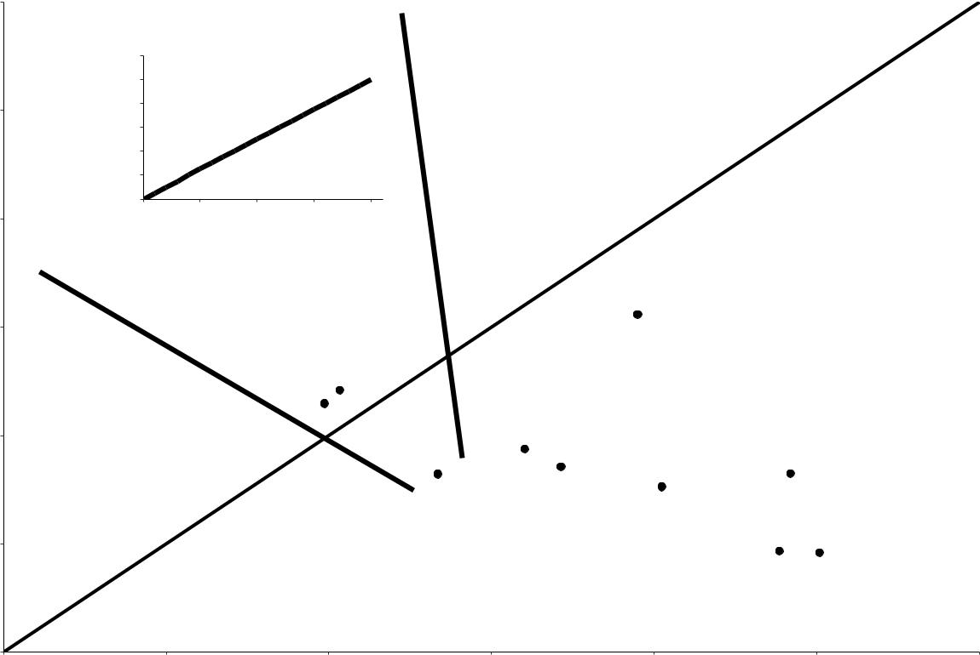

9 10 11 12 13 14

Consumption of species *i* on resource *l* (*C* *i l* )

Figure 4: An example plot demonstrating the idea of niche di erence (ND; ) in MacArthur's con-sumer resource model. Consumption of species j on resource l (cjl) are plotted against consumption

of species i on resource l (cil). The closeness between cjl and cjl are the closeness between these

points to the 1:1 line and is expressed as . For example, if all cjl are equal to cil, which means all

points are on the 1:1 line, is 1 and ND between species i and species j is 1 = 0. The inset plot is an example plot showing the data required to measure consumption of species j on resource

* (cjl).

17

**A.**

|  |  |
| --- | --- |
|  | rate of species *i* |
| **C.** | growth |
|  | *per capita* |

1. *i* − D

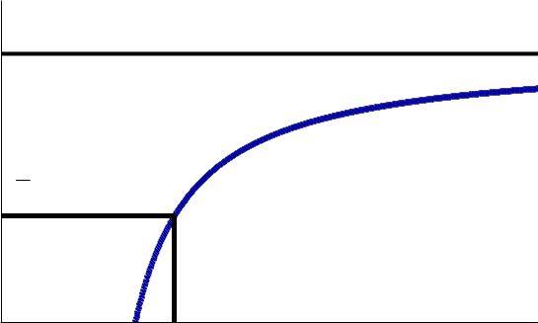

1

2 *r i* − D

*R i*i* *K i i*

Density of resource *i*

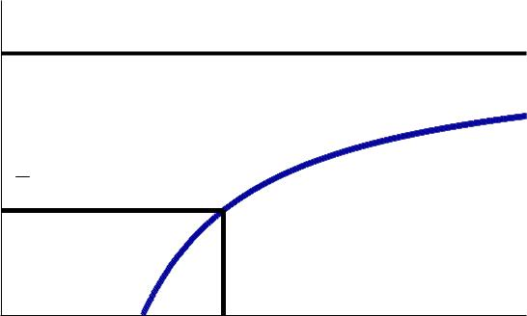

1. *i* − D

1

2 *r i* − D

|  |  |  |
| --- | --- | --- |
| *R* | *\** | *K i j* |
|  | *i j* |  |

Density of resource *j*

**B.**

|  |  |
| --- | --- |
|  | rate of species *j* |
| **D.** | growth |
|  | *per capita* |

1. *j* − D

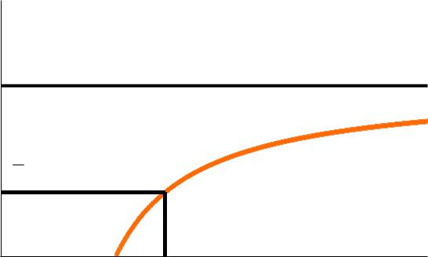

1

2 *r j* − D

|  |  |  |
| --- | --- | --- |
| *R* | *\** | *K j i* |
|  | *j i* |  |

Density of resource *i*

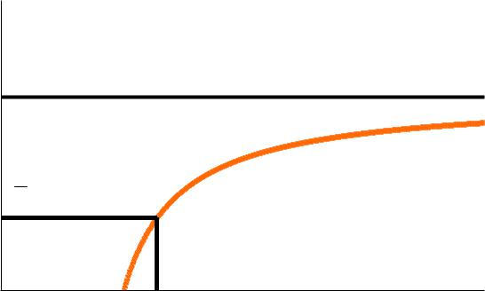

1. *j* − D

1

2 *r j* − D

*R j*j* *K j j*

Density of resource *j*

Figure 5: Example plots showing the empirical data resource model for species i and j on resource i and

required to estimate R in Tilman's consumer j. Rij means the minimum level of resource j

that still allows species i to have positive per capita growth rate. In this example scenario, species i

(j) is limited by resource j (i), so that the Rij (Rji) is greater than Rii (Rjj). The Rij (Rji) is the

one being used to calculate ii and ij ( jj and ji) because it determine how sensitivity species i

will be a ected by the resource (resoruce j) that limits the growth rate of species i

18