Priority questions:

Do you need 6 peristaltic pumps? (more info need for the pump and tubes for the pump).

The 6 required include 2 for bacteria sampling, 2 for the modified dilution experiment and 2 as the spare.

=> We can cut it down to 4, including 2 for bacteria sampling, 1 for modified sampling and 1 as the spare, if necessary.

As to the model of the pump, we currently use the one equipped with Masterflex L/S® Easy-Load® Pump Head (<https://tg.pe/1Up>) and/or Masterflex E/S® Portable Sampler, 115 VAC (<https://tg.pe/ij7>), which is compatible with the L/S 15 or L/S 24 tubes (<https://tg.pe/RKu>. Also see the following pictures).

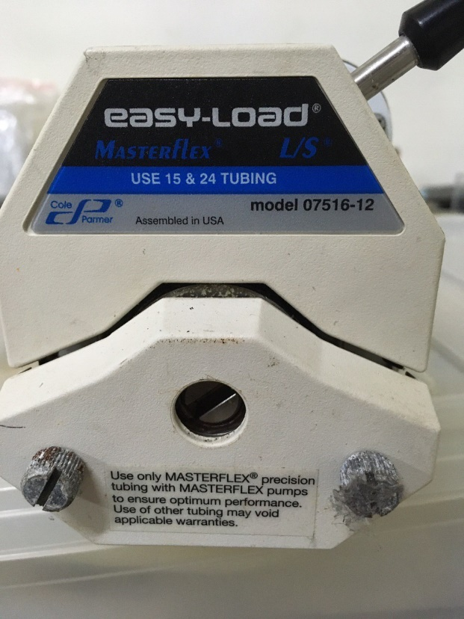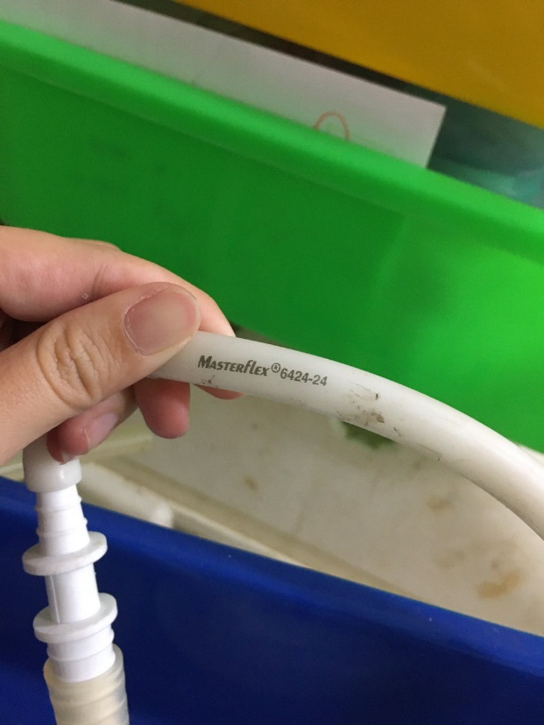

The inner diameter of the L/S 15 and L/S 24 tube are 3/16 in (4.7625 mm) and 1/4 in (6.35 mm). The outer diameter of the L/S 15 and L/S 24 tube are 3/8 in (9.525 mm) and 7/16 in (11.1125 mm).

=> Other alternatives along with their compatible tubes are acceptable as long as they can be used to pump the water.

Filter holders for 142 mm. I need to check availability but not sure I can prepare for 5 sets.....

=> We should be able to bring some if it’s hard for you to prepare them all.

Silicon tube: need inner and outer diameter.

The silicon tube 2 is for the peristaltic pump. The current one we are using is as stated above (L/S 15 or L/S 24 tubes; inner diameter is 3/16 in or 4.8 mm/outer diameter is 5/16 in or 7.9 mm). We accept other peristaltic pump models along with their compatible tubes.

The silicon tube 3 will be used to connect the silicon tube 2 to carboys (sometimes the silicon tube 2 is not long enough) or connect the filter holder to carboys. The inner/outer diameter of the tube we are using currently is 10mm/16mm.

=> Depending on the peristaltic pump we finally agreed on, we could help preparing them if you are not able to find compatible ones.

8-sets of 100-liter dark incubation tanks: It is not easy to imagine. Do you have any photos?

On deck incubator I have is attached. We can put 24 liter or 2 liter bottles. We usually wrap bottles by black plastic or aluminum foil for dark incubation.

Please see the following pictures showing the tanks we used as incubators for in situ incubation (100 L in volume). Besides dark incubation, we would like to circulate ambient seawater to maintain temperature. We can work with any incubator that can (1) keep the incubation bottles (14 2L bottles)/containers (3 20L containers) in dark and (2) circulate seawater are also acceptable.

Besides dark incubation, we would like to circulate ambient seawater to maintain temperature. Therefore, there must be a water inlet on the incubator for seawater circulation. We can work with any incubator that can (1) keep the incubation carboys (14\*2L carboys) and cubitainers (3\*20L containers) in dark and (2) circulate seawater.

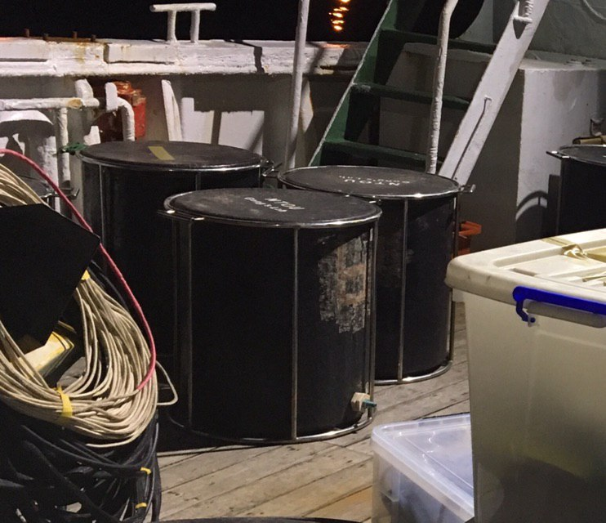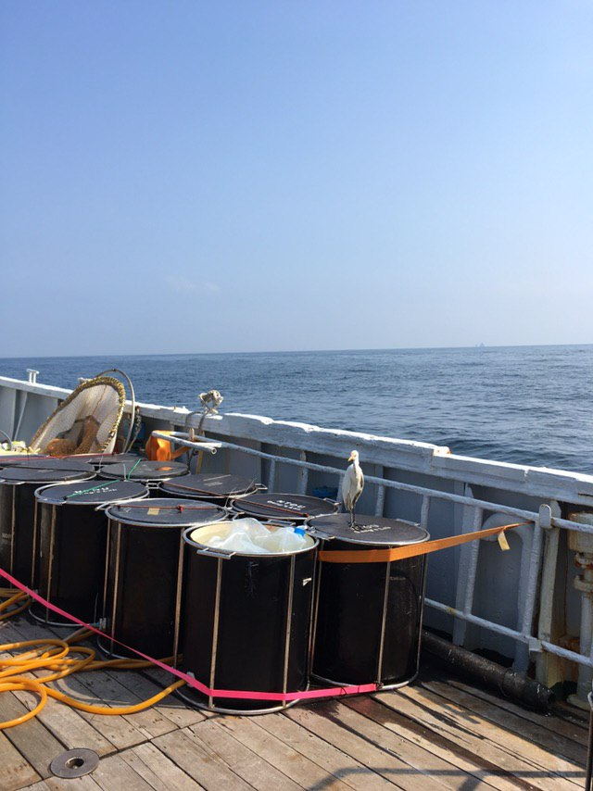=> Does our incubator meet the above two needs?

What are difference of 10-20 liter carboy (I have 9 liter and 20 liter polycarbonate containers) and 20 l carboy. I need to check I have 11 20-lier carboys (sure 8 but not sure 11).

The 10-20 liter carboy means that any carboy ranging from 10 to 20 L is acceptable. Usually we use 20 L carboys to collect the water from X-Niskin, but if the number of 20 L carboy is not enough we can use 10 L carboys as alternatives.

=> We should be able to do with 8 20 L carboys (at least 4 for Exp I and 3 for Exp II plus 1 as the spare), since the 20 L carboys should be pretty sturdy.

2-liter carboy: I’m sure I have 30 2-liter carboy but not sure 50....

We usually reuse

We plan for 50 (8 as spares) because we would like to prepare for the situation that 3 sets of incubation are taking place at the same time. Each incubation requires at least 14 bottles and will take at least 12 hours. If we plan to conduct incubation at 3 stations (the most offshore and inshore and the middle one in between) in each transect, we think it might be possible that 3 sets of incubation will take place at the same time. However, if the ship time between stations is long enough and given the facts that we only incubate for 12 hours, 2 sets may be enough. It is hard to say anything before knowing the ship time.

=> (1) Would you please give us an approximation of the ship time between stations, especially between the most inshore station to the most offshore one? If the ship time between the most inshore station to the most offshore one is longer than 14 hours (12 hours for incubation and 2 hours for clean/preaping equpiment), we should be able to downsize our plan.

(2) If 50 is not realistic, we will consider downsizing our plan to 2 station per transect (the most offshore and inshore) so that 30 should be sufficient (28 bottles plus 2 spares).

Plastic bucket: do you want to take water from surface (not 5 m by X-Niskin.)

No, the bucket is not for taking water from the surface. The bucket will be filled with 5m water taken by X-Niskin and be used to re-suspend the nauplii and copepodites collected by towing.

=> It can be any bucket that can hold at least 20 L of seawater.

Norpac net 50 um (We usually use 100 um. mesh Norpac. Do you have 50 um net?  I don’t understand you need 15 nets....

We will use 50 um nets to collect nauplii, which is difficult to retain by 100 um net. According to our experience, the 50 um nets are easily broken especially when it’s windy. That’s why we are planning for 15 of them.

=> If you do not have 50 um nets, we will ship them.

You need many bottles. I believe you need to wash them before exp. Can you send some before the cruise (before loading, loading is usually 1-week before the cruise in most cases, so, some may come enough before the cruise to wash and prepare staff).

=> I guess the answer needs to be yes and one of us needs to be there one week earlier just to wash bottles.