第八次作业
一、选择题
1、设网(带权的图)有n个顶点和e条边，则采用邻接表存储时，求最小生成树的Prim算法的时间复杂度为 B 。
A. O(n) B. O(n+e) C. O(n²) D. O(n³)
//当用邻接矩阵存储时，时间复杂度为O(n²)
2、设图有n个顶点和e条边，求解最短路径的Floyd算法的时间复杂度为 D 。
A. O(n) B. O(n+e) C. O(n²) D. O(n³)
3、最小生成树是指 C 。
A. 由连通网所得到的边数最少的生成树。
B. 由连通网所得到的顶点数相对较少的生成树。
C. 连通网中所有生成树中权值之和为最小的生成树。
D. 连通网的极小连通子图。
4、下面关于工程计划的AOE网的叙述中，不正确的是 B 。
A. 关键活动不按期完成就会影响整个工程的完成时间。
B. 任何一个关键活动提前完成，那么整个工程将会提前完成。
//（除非该关键活动在所有的关键路径上）
C. 所有关键活动都提前完成，那么整个工程将会提前完成。
D. 某些关键活动若提前完成，那么整个工程将会提前完成。
5、在AOE网中，始点和汇点的个数为 C 。
A. 1个始点，若干个汇点 B. 若干个始点，若干个汇点
C. 若干个始点，1个汇点 C. 1个始点，1个汇点
6、在下图所示的无向图中，从顶点v1开始采用Prim算法生成最小生成树，算法过程中产生的顶点次序为 B 。
A. v1, v3, v4, v2, v5, v6 B. v1, v3, v6, v2, v5, v4
C. v1, v2, v3, v4, v5, v6 D. v1, v3, v6, v4, v2, v5
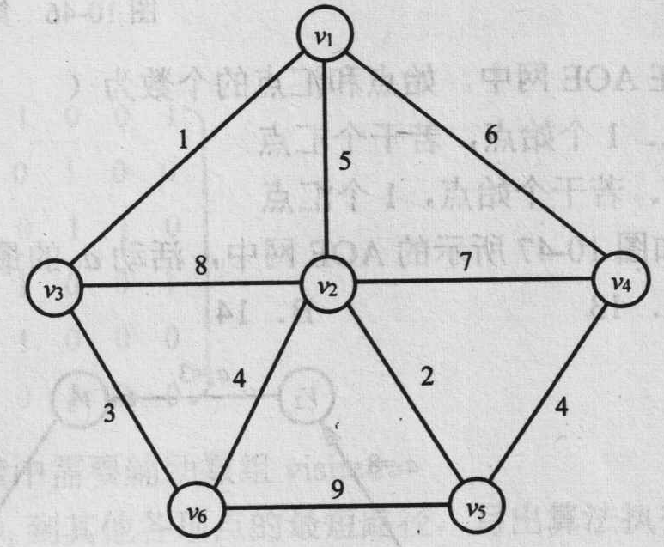
7、在上图所示的途中，采用Cruskal算法生成最小生成树，过程中产生的边的次序是 C 。
A. (v1, v2), (v2, v3), (v5, v6), (v1, v5) B. (v1, v3), (v2, v6), (v2, v5), (v1, v4)
C. (v1, v3), (v2, v5), (v3, v6), (v4, v5) D. (v2, v5), (v1, v3), (v5, v6), (v4, v5)
10、如下图所示的图中，其中一个拓扑排序的结果是 A 。
A. v1→v2→v3→v6→v4→v5→v7→v8
B. v1→v2→v3→v4→v5→v6→v7→v8
C. v1→v6→v4→v5→v2→v3→v7→v8
D. v1→v6→v2→v3→v7→v8→v4→v5
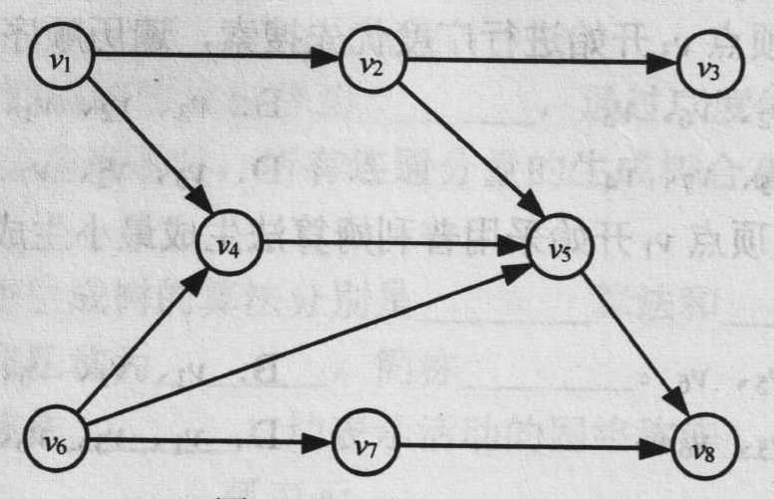
8、在下图所示的AOE网中，活动a9的最早开始时间为 B 。
A. 13 B. 14 C. 15 D. 16
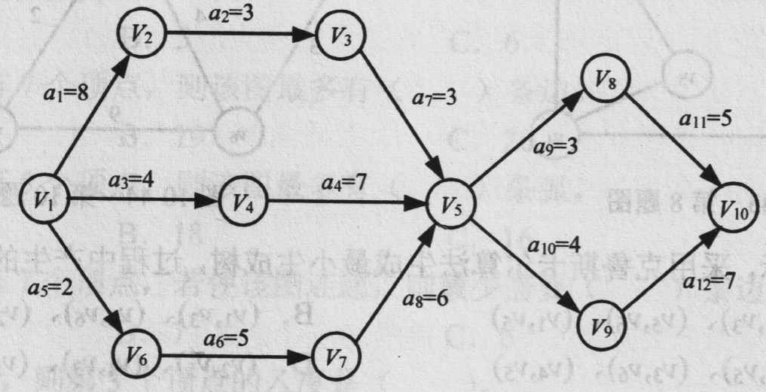
9、在上图所示的AOE网中，活动a4的最迟开始时间为 D
A. 4 B. 5 C. 6 D. 7

二、填空题
1、连通而且无环路的无向图称为 开放树 。
//指的应该是邻接矩阵表示：
- 对于含有n个顶点e条边的连通图，利用Prim算法求其最小生成树的时间复杂度为 O(n²) ，利用Kruscal算法求最小生成树的时间复杂度是 O（eloge）。
3、顶点表示活动的网简称为 AOV ；边表示活动的网简称为 AOE 。
4、一个含有n个顶点的无向连通图，其每条边的权重都是a(a>0)，则其最小生成树的权重等于 (n-1)*a 。
//最小生成树是一棵开放树，有n-1条边，每条边的权值为a，所以最小生成树的的权值为（n-1）*a

三、网络G的邻接矩阵如下，试画出该图，并画出它的一棵最小生成树。
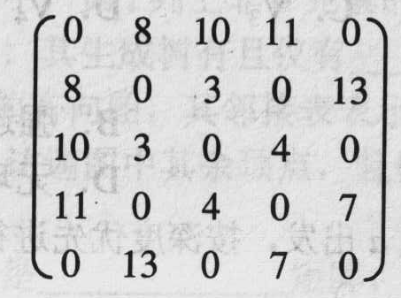
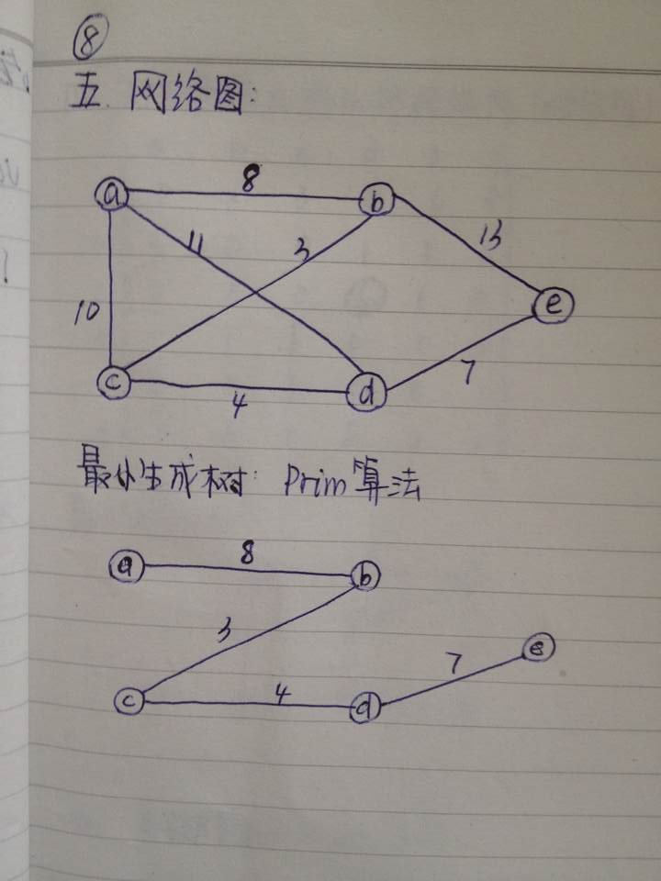

四、下图是一个无向带权图，请给出该图的邻接矩阵，并分别按Prim算法和Kruskal算法求最小生成树（包括算法代码和画图）。
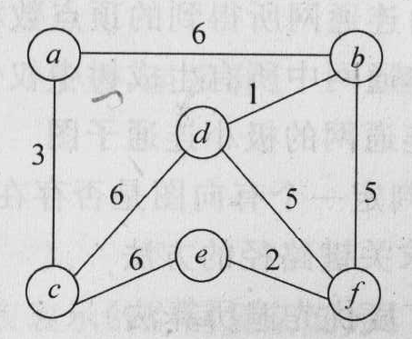
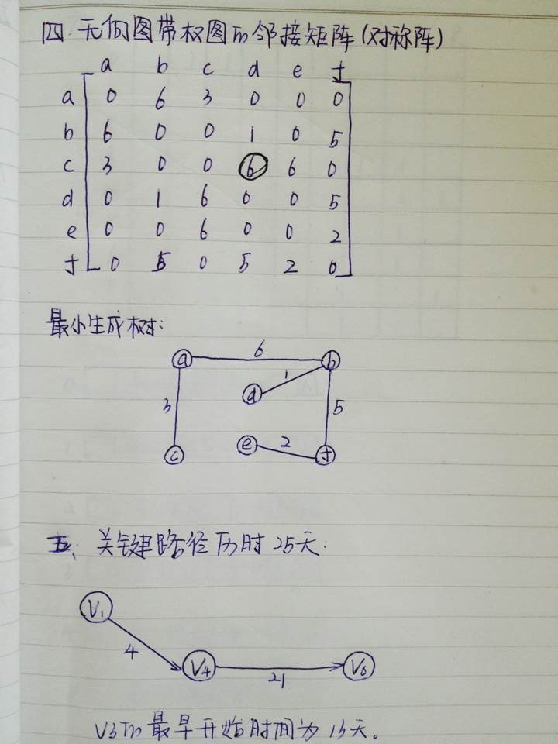
//Prim算法
void Prim(MTGraph G, TREE_ARRAY T)
{
int i, j, k;
EdgeData min;//存储最小边长
EdgeData LOWCOST[NumVertices]; // 如果第i个顶点未加入U，则LOWCOST[i]表示第i个顶点与U中距离最近的顶点之间的距离
int CLOSSET[NumVertices]; // 如果第i个顶点未加入U，则LOWCOST[i]表示第i个顶点与U中距离最近的顶点
//初始化
int n=G.n;
for( i=1; i<n; i++ )
{
LOWCOST[i] = G.edge[0][i]; //其他顶点与顶点i之间的距离
CLOSSET[i] = 0;
T[i+1].data=G.vexlist[i];
T[i+1].parent=0;
}
T[1].data=G.vexlist[0];//单独初始化第一个顶点
T[1].parent=0;
//找出最近的点
for( i = 1; i < n; i++ )
{
min = LOWCOST[i];
k = i;
for( j = 1; j < n; j++ )
if ( LOWCOST[j] < min )
{
min = LOWCOST[j] ;
k=j;
}

cout << "第"<<i<<"个顶点的父亲："<< G.vexlist[CLOSSET[k]] <<'\t'<< "最近的顶点："<<G.vexlist[k] <<"最近距离为："<<G.edge[CLOSSET[k]][k]<< endl;

T[k].parent=CLOSSET[k]; //构建树：新加入结点为已有结点的孩子结点

LOWCOST[k] = INT_MAX ; // 标识第k个顶点已放入U中

for ( j = 1; j < n; j++ )
if ( G.edge[k][j] < LOWCOST[j] && LOWCOST[j]!=INT_MAX)
{
LOWCOST[j]=G.edge[k][j];
CLOSSET[j]=k;
}
}
}
void main()
{
MTGraph G;
IniMGraph(&G);
VertexData v[6]={ 'a', 'b', 'c', 'd', 'e', 'f'};
EdgeData e[6][6] = {{0,6,3,0,0,0},{6,0,0,1,0,5},{3,0,0,6,6,0},{0,1,6,0,0,5},{0,0,6,0,0,2},{0,5,0,5,2,0}};
CreateMGraph(&G, v, e, 6);
TREE_ARRAY T;
Prim(G, T);

PreOrder(T, 1);
cout<<endl;
}

struct node_tmp{
int i;
int j;
EdgeData v;
};

int Find(TREE_ARRAY T, int n)
{
if(T[n].parent==n)
return n;
else
Find(T, T[n].parent);
}
//Kruskal算法
//将结点n的父节点设置为m
void Union(TREE_ARRAY T, int m, int n)
{
if(Find(T, m)!=Find(T, n))
T[n].parent=m;
}

void Kruskal(MTGraph G, TREE_ARRAY T)
{
int i, j, k;
// 对树进行初始化，每一个结点构成一棵树，其父节点为它本身
for(i=0; i<G.n; i++)
{
T[i+1].data=G.vexlist[i];
T[i+1].parent=i+1;
}

node_tmp tmp[NumVertices*NumVertices], t1;
k=0;
for(i=0; i<G.n; i++)
for(j=i+1; j<G.n; j++)
{
if(G.edge[i][j]!=INT_MAX-1)
{
tmp[k].i=i;
tmp[k].j=j;
tmp[k].v=G.edge[i][j];
k++;
}
}

// 按权值进行排序
for(i=0; i<k-1; i++)
for(j=i+1; j<k; j++)
{
if(tmp[i].v>tmp[j].v)
t1=tmp[i], tmp[i]=tmp[j], tmp[j]=t1;
}

for(i=0; i<k; i++)
{
Union(T, tmp[i].i+1, tmp[i].j+1);
}

j=Find(T, 1);
T[j].parent=0;
}

void main()
{
MTGraph G;
IniMGraph(&G);
VertexData v[6]={ 'a', 'b', 'c', 'd', 'e', 'f'};
EdgeData e[6][NumVertices]={{INT_MAX-1,1,6, INT_MAX-1,INT_MAX-1,5},{1,INT_MAX-1,5,6,4,5}，{6,5,INT_MAX-1,3,INT_MAX-1, INT_MAX-1},
{INT_MAX-1,6,3,INT_MAX-1,6,INT_MAX-1},{INT_MAX-1,4, INT_MAX-1,6, INT_MAX-1,2},{5,5,INT_MAX-1,INT_MAX-1,2,INT_MAX-1}};
CreateMGraph(&G, v, e, 6);

int CLOSSET[NumVertices];
TREE_ARRAY T;
Kruskal(G, T);
PreOrder(T, Root(T));
cout<<endl;
}
五、已知如下图所示的AOE网，顶点表示事件，弧及权重表示活动的时间(单位为天)。找出关键路径，并求出事件v3的最早开始时间，然后编程实现。
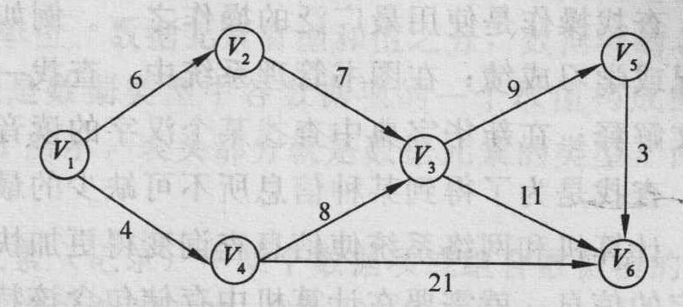
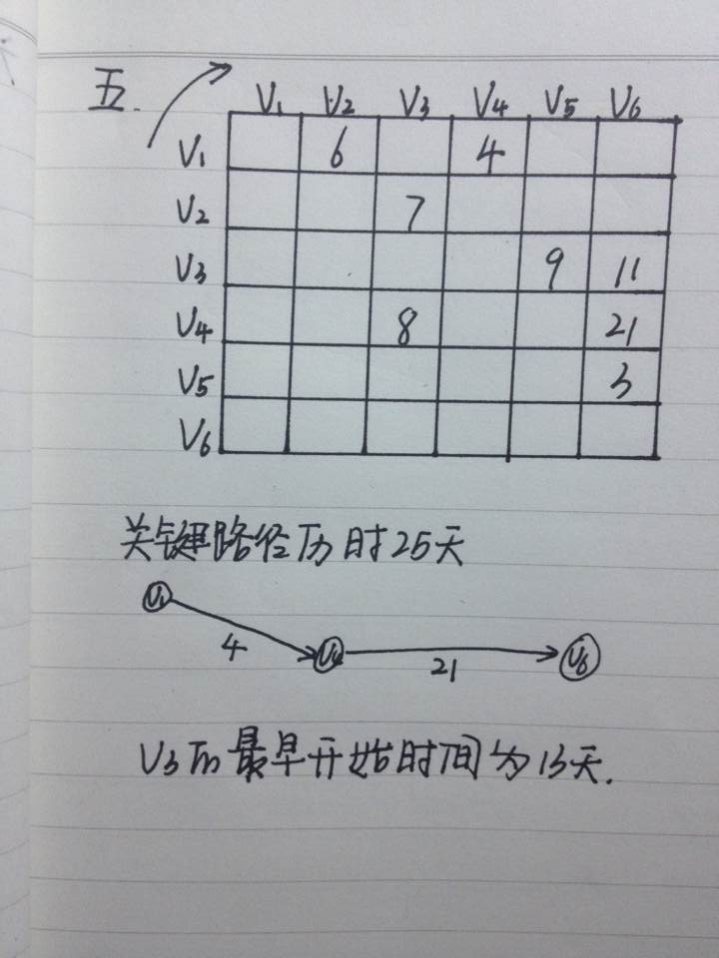
//还有一条关键路径：v1—>v2—>v3—>v5—>v6
//AOE关于边的活动网，求关键路径（活动的最早发生时间，最迟发生时间）
void aoe(AdjGraph G, int start)// 参数start为起始点的下标
{
int i, j;
EdgeData E[NumVertices][NumVertices], VE[NumVertices], L[NumVertices][NumVertices], VL[NumVertices];
int aov[NumVertices];
EdgeNode *tmp;

//对所有事件进行拓扑排序，排序结果放置在数组aov中
Topologicalsort( G, aov);

for(i=0; i<G.n; i++)
for(j=0; j<G.n; j++)
{
E[i][j]=-1;
L[i][j]=-1;
}

// 求VE[i]事件i的最早发生时间
VE[aov[0]-1]=0;//起点
for(i=1; i<G.n; i++) // 对拓扑排序后的顶点aov[i]按序处理
{
VE[aov[i]-1]=0;
for(j=0; j<i; j++) // 搜索顶点aov[i]的所有前驱顶点
{
tmp=G.vexlist[aov[j]].firstedge; // 邻接表表示的图的顶点的下标是从1开始的
while(1)
{
if(tmp==NULL)
break;
else if(tmp->adjvex==aov[i])
{
if(tmp->cost+VE[aov[j]-1]>VE[aov[i]-1]) // 根据搜索到的前驱顶点求当前顶点的VE
VE[aov[i]-1]=tmp->cost+VE[aov[j]-1];
}
tmp=tmp->next;
}
}
}
cout<<"v3的最早发生时间："<<VE[3]<<endl;
// 求E[i][j]
for(i=0; i<G.n; i++)
{
tmp=G.vexlist[i+1].firstedge; //搜索第i+1个顶点的出边
while(1)
{
if(tmp==NULL)
break;
else
{
E[i][tmp->adjvex-1]=VE[aov[i]-1];
}
tmp=tmp->next;
}
}
//求VL[i]事件i的最迟发生时间，转化为求最早发生时间问题
VL[aov[G.n-1]-1]=VE[aov[G.n-1]-1];
for(i=G.n-2; i>=0; i--) // 对拓扑排序后的顶点aov[i]按逆序处理
{
VL[aov[i]-1]=VE[aov[G.n-1]-1];
tmp=G.vexlist[aov[i]].firstedge; // 邻接表表示的图的顶点的下标是从1开始的
while(1) // 搜索顶点aov[i]的所有后继节点
{
if(tmp==NULL)
break;
else
{
if(VL[aov[i]-1]>VL[tmp->adjvex -1]-tmp->cost)
VL[aov[i]-1]=VL[tmp->adjvex -1]-tmp->cost;
}
tmp=tmp->next;
}

}
// 求L[i][j]
for(i=0; i<G.n; i++)
{
tmp=G.vexlist[i+1].firstedge; // 搜索第i+1个顶点的出边
while(1)
{
if(tmp==NULL)
break;
else
{
L[i][tmp->adjvex-1]=VL[aov[tmp->adjvex-1]-1]-tmp->cost;
}
tmp=tmp->next;
}
}

//输出关键活动
cout<<"关键活动为: "<<endl;
for(i=0; i<G.n; i++)
for(j=0; j<G.n; j++)
{
if(E[i][j]!=-1 && L[i][j]!=-1 && E[i][j]==L[i][j])
cout<<i+1<<"->"<<j+1<<endl;
}
}

void main()
{
AdjGraph G1;
IniADJGraph(&G1);
// 创建一个有向图
VertexData v1[9]={'v1', 'v2', 'v3', 'v4', 'v5','v6'};
EdgeData e1[9][NumVertices]={{0, 6, 0, 4, 0, 0},
{0, 0, 7, 0, 0, 0},
{0, 0, 0, 0, 9, 11},
{0, 0, 8, 0, 0, 21},
{0, 0, 0, 0, 0, 3},
{0, 0, 0, 0, 0, 0}};
CreateADJGraph_directed(&G1, v1, e1, 6);

aoe(G1, 0);
}
六、已知一个图的顶点集V和边集G分别为V={0, 1, 2, 3, 4, 5, 6, 7, 8}，E={<0, 1>, <0, 2>, <1, 3>, <1, 4>, <2, 4>, <2, 5>, <3, 6>, <3, 7>, <4, 7>, <4, 8>, <5, 7>, < 6, 7>, <7, 8>}，若采用邻接表存储，并且每个顶点邻接表中的边结点都是按照终点序号从大到小的次序连接的，则按照拓扑排序算法，写出得到的拓扑序列，并编程实现。
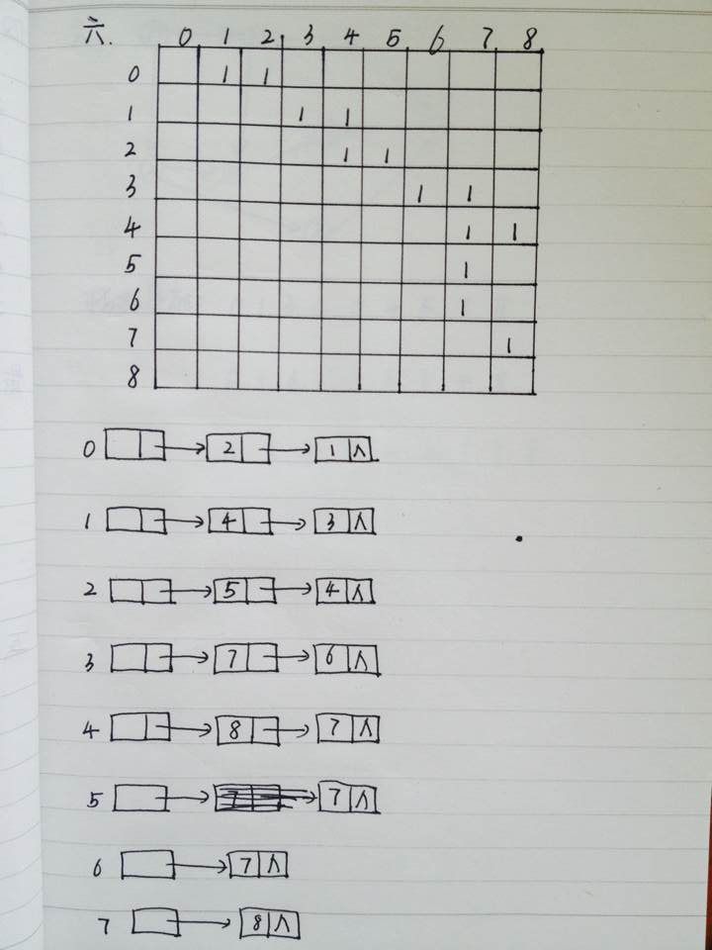
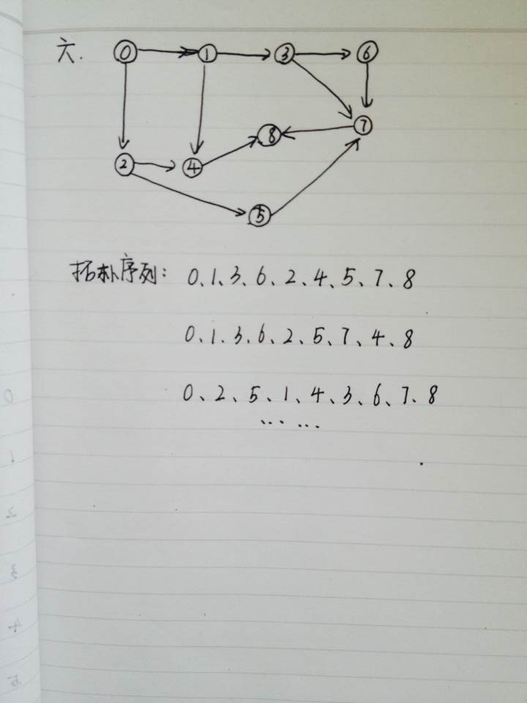
//拓扑排序
void topoOrder(AdjGraph *G)
{
celltype *t;
int v,w;
int nodeCount=0;//计数拓扑节点
QUEUE Q;
MAKENULL(Q);
for(v=1;v<=G->n;v++)//将所有入度为0的顶点入队
{
if(G->indegree[v]==0)
ENQUEUE(v,Q);
}

while(!EMPTY(Q))
{
t = FRONT(Q);//队首出队并删除
v=t->element;
DEQUEUE(Q);
cout<<v<<'\t';//拓扑过程依次输出排序的顶点
nodeCount++;
//搜索邻接于v的其他顶点，同样入度为零的入队
for(w=1;w<=G->n;w++)
{
if(IsEdge(G,v,w))
{
G->indegree[w]--;
if(G->indegree[w] == 0)
ENQUEUE(w,Q);
}

}
}
if(nodeCount<G->n)
cout<<"这个有向图有环路！"<<endl;

}
void main()
{
AdjGraph G;
IniADJGraph(&G);
VertexData v[9]={'v1', 'v2', 'v3', 'v4', 'v5','v6','v7', 'v8','v9'};//顶点
EdgeData e[9][NumVertices]={{0,1,1,0,0,0,0,0,0},{0,0,0,1,1,0,0,0,0},{0,0,0,0,1,1,0,0,0},{0,0,0,0,0,0,1,1,0},{0,0,0,0,0,0,0,1,1},{0,0,0,0,0,0,0,1,0},{0,0,0,0,0,0,0,1,0},{0,0,0,0,0,0,0,0,1},{0,0,0,0,0,0,0,0,0}};
CreateADJGraph(&G, v, e, 9);//创建无向图
cout<<"拓扑排序："<<endl;
topoOrder(&G);
}
思考题1：
POJ1789 要求用Prim算法实现
Truck History
Time Limit: 2000MS |  | Memory Limit: 65536K
Description
Advanced Cargo Movement, Ltd. uses trucks of different types. Some trucks are used for vegetable delivery, other for furniture, or for bricks. The company has its own code describing each type of a truck. The code is simply a string of exactly seven lowercase letters (each letter on each position has a very special meaning but that is unimportant for this task). At the beginning of company's history, just a single truck type was used but later other types were derived from it, then from the new types another types were derived, and so on.
Today, ACM is rich enough to pay historians to study its history. One thing historians tried to find out is so called derivation plan -- i.e. how the truck types were derived. They defined the distance of truck types as the number of positions with different letters in truck type codes. They also assumed that each truck type was derived from exactly one other truck type (except for the first truck type which was not derived from any other type). The quality of a derivation plan was then defined as
1/Σ_{(to,td)}d(t_{o},t_{d})
where the sum goes over all pairs of types in the derivation plan such that t_{o} is the original type and t_{d} the type derived from it and d(t_{o},t_{d}) is the distance of the types.
Since historians failed, you are to write a program to help them. Given the codes of truck types, your program should find the highest possible quality of a derivation plan.
Input
The input consists of several test cases. Each test case begins with a line containing the number of truck types, N, 2 <= N <= 2 000. Each of the following N lines of input contains one truck type code (a string of seven lowercase letters). You may assume that the codes uniquely describe the trucks, i.e., no two of these N lines are the same. The input is terminated with zero at the place of number of truck types.
Output
For each test case, your program should output the text "The highest possible quality is 1/Q.", where 1/Q is the quality of the best derivation plan.
Sample Input
4
aaaaaaa
baaaaaa
abaaaaa
aabaaaa
0
Sample Output
The highest possible quality is 1/3.

思考题2
POJ2485 要求用Kruskal算法实现
Highways
Time Limit: 1000MS |  | Memory Limit: 65536K
Total Submissions: 18145 |  | Accepted: 8433
Description
The island nation of Flatopia is perfectly flat. Unfortunately, Flatopia has no public highways. So the traffic is difficult in Flatopia. The Flatopian government is aware of this problem. They're planning to build some highways so that it will be possible to drive between any pair of towns without leaving the highway system.
Flatopian towns are numbered from 1 to N. Each highway connects exactly two towns. All highways follow straight lines. All highways can be used in both directions. Highways can freely cross each other, but a driver can only switch between highways at a town that is located at the end of both highways.
The Flatopian government wants to minimize the length of the longest highway to be built. However, they want to guarantee that every town is highway-reachable from every other town.
Input
The first line of input is an integer T, which tells how many test cases followed.
The first line of each case is an integer N (3 <= N <= 500), which is the number of villages. Then come N lines, the i-th of which contains N integers, and the j-th of these N integers is the distance (the distance should be an integer within [1, 65536]) between village i and village j. There is an empty line after each test case.
Output
For each test case, you should output a line contains an integer, which is the length of the longest road to be built such that all the villages are connected, and this value is minimum.
Sample Input
1

3
0 990 692
990 0 179
692 179 0
Sample Output
692

思考题3

POJ1094 拓扑排序
Sorting It All Out
Time Limit: 1000MS |  | Memory Limit: 10000K
Description
An ascending sorted sequence of distinct values is one in which some form of a less-than operator is used to order the elements from smallest to largest. For example, the sorted sequence A, B, C, D implies that A < B, B < C and C < D. in this problem, we will give you a set of relations of the form A < B and ask you to determine whether a sorted order has been specified or not.
Input
Input consists of multiple problem instances. Each instance starts with a line containing two positive integers n and m. the first value indicated the number of objects to sort, where 2 <= n <= 26. The objects to be sorted will be the first n characters of the uppercase alphabet. The second value m indicates the number of relations of the form A < B which will be given in this problem instance. Next will be m lines, each containing one such relation consisting of three characters: an uppercase letter, the character "<" and a second uppercase letter. No letter will be outside the range of the first n letters of the alphabet. Values of n = m = 0 indicate end of input.
Output
For each problem instance, output consists of one line. This line should be one of the following three:
Sorted sequence determined after xxx relations: yyy...y.
Sorted sequence cannot be determined.
Inconsistency found after xxx relations.
where xxx is the number of relations processed at the time either a sorted sequence is determined or an inconsistency is found, whichever comes first, and yyy...y is the sorted, ascending sequence.
Sample Input
4 6
A<B
A<C
B<C
C<D
B<D
A<B
3 2
A<B
B<A
26 1
A<Z
0 0
Sample Output
Sorted sequence determined after 4 relations: ABCD.
Inconsistency found after 2 relations.
Sorted sequence cannot be determined.

要求：

1、上述作业要求在单独完成；
2、完成后，于规定期限内提交到教学辅助系统中，注意，在提交时将所编写的程序统一拷贝到一个Word文件中。

