第九次作业
一、选择题
1、设图有n个顶点和e条边，当用邻接矩阵表示该图时，则求解最短路径的Floyd算法的时间复杂度为 D 。
A. O(n) B. O(n+e) C. O(n²) D. O(n³)
2、分别以下列序列构造二叉排序数（二叉查找树），与用其他3个序列所构造的结果不同的是 C ：
A. (100, 80, 90, 60, 120, 110, 130) B. (100, 120, 110, 130, 80, 60, 90)
C. (100, 60, 80, 90, 120, 110, 130) D. (100, 80, 60, 90, 120, 130, 110)
3、在二叉平衡树中插入一个结点造成了不平衡，设最低的不平衡点为A，并已知A的左孩子的平衡因子为0，右孩子的平衡因子为1，则应作 C 型调整使其平衡。
A. LL B. LR C. RL D. RR

二、填空题
1、具有n个顶点的有向图，如果采用邻接矩阵表示该图，则求某顶点到其他各顶点的最短路径的Dijkstra算法的时间复杂度是 O(n^2) ；如果采用邻接表表示该图，则时间复杂度为 O（e） 。
2、在用Dijkstra算法求单源最短路径的过程中，将顶点集合V划分为两个集合S和V-S，其中S中的点为 最短路径已经确定的顶点集合 ，V-S中的点为 最短路径尚未确定的顶点集合 。
3、求每一对顶点之间的最短路径，可以用两种方法，一种是分别对每个顶点采用 Dijkstra 算法，另一种方法是 Floyd算法 。
4、假设有向图的邻接矩阵C的传递闭包为A，A[i][j]=1表示有且仅有一条路径从i到j 。
5、有向图的中心点是指 具有最小偏心度的顶点 。
6、一个无序序列可以通过构造一棵 二叉查找 树而变为一个有序序列，构造树的过程即对无序序列进行排序的过程。
7、对于一棵二叉排序树，按 中根遍历 方法遍历得出的结点序列是从小到大排列的。

三、如下图所示的有向网络，利用Dijkstra算法求从顶点v1到其他各顶点的最短路径(要求写出如教材P155表4-2所示的Dijkstra算法的执行过程)，并编程验证。
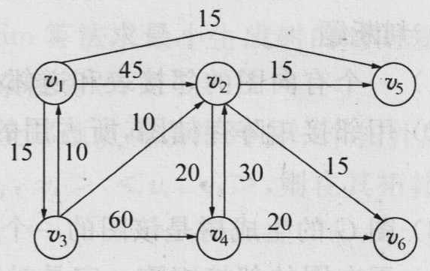
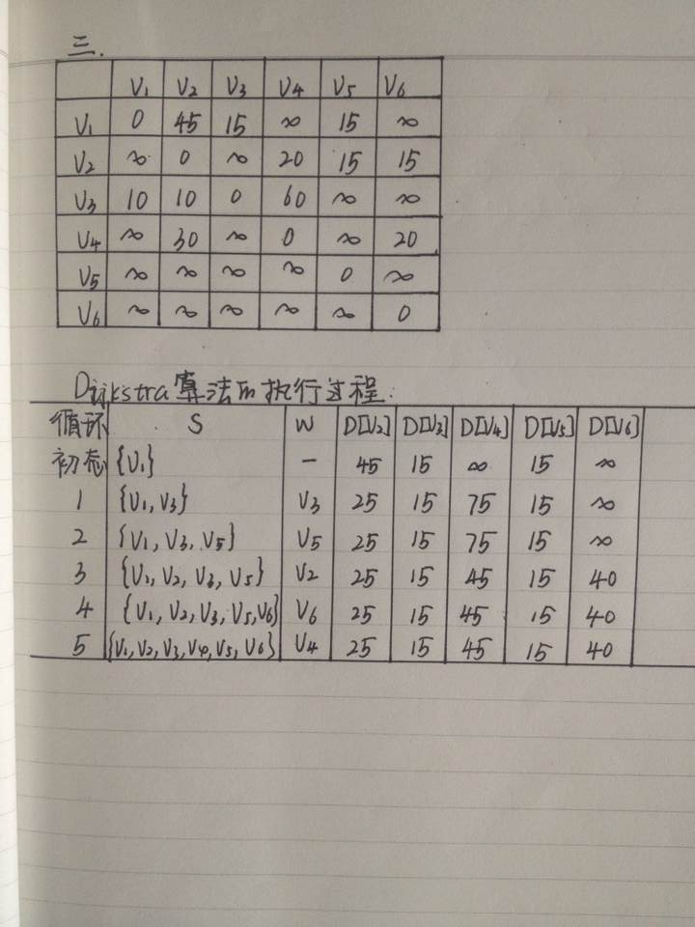

#include<iostream>
#include<string>
using namespace std;
#define MaxValue 100
enum BOOLEAN{FALSE, TRUE};
#define NumEdges 50 //边数
#define NumVertices 6 //顶点个数
typedef char VertexData; //顶点数据类型
typedef int EdgeData; //边上权值类型

typedef struct{
VertexData vexlist[NumVertices]; //顶点表
EdgeData edge[NumVertices][NumVertices];
//邻接矩阵—边表, 可视为边之间的关系
int n; //图中当前的顶点个数
int e; //图中当前的边数
} MTGraph;

void IniMGraph_directed(MTGraph *G)
{
for(int i=0; i<NumVertices; i++)
for(int j=0; j<NumVertices; j++)
G->edge[i][j]=MaxValue;
G->n=0;
G->e=0;
}

void CreateMGraph_directed(MTGraph *G, VertexData V[], EdgeData E[][NumVertices], int n)
{
int i, j;
G->n=n;

for (i=0; i<n; i++) //2.读入顶点信息，建立顶点表
G->vexlist[i]=V[i];

for (i=0; i<G->n; i++)
for (j=0;j<G->n;j++)
G->edge[i][j]=MaxValue; //3.邻接矩阵初始化

for(i=0; i<n; i++) //4.读入e条边建立邻接矩阵
for(j=0; j<n; j++)
{
if(E[i][j]!=0)
{
G-> edge[i][j]=E[i][j];
G->e++;
}
}
}

void PrintMT(MTGraph *G)
{
cout<<'\t';
for(int i=0; i<G->n; i++)
{
cout<<G->vexlist[i]<<'\t';
}
cout<<endl;
for(i=0; i<G->n; i++)
{
cout<<G->vexlist[i]<<'\t';
for(int j=0; j<G->n; j++)
cout<<G->edge[i][j]<<'\t';
cout<<endl;
}
}
//求V-S中使D[w]最小的w值
int mincost(EdgeData D[NumVertices], BOOLEAN S[NumVertices], int n)
{
int w;
EdgeData temp =MaxValue ; //用MaxValue表示无穷大
w=0;
for (int i=1 ; i<n ; i++ )
if (!S[i] && D[i]<temp)//搜索D[]中最小且未放入S中的顶点的权
{
temp = D[i] ;
w = i ;
}
return w ;
}

// 单源最短路径
void Dijkstra(MTGraph G, EdgeData D[NumVertices], int P[NumVertices])
{
BOOLEAN S[NumVertices]={FALSE};
int i, v, w;
EdgeData sum;

D[0]=MaxValue;
//初始化为初态
for ( i=1 ; i<G.n; i++ )
{
D[i]=G.edge[0][i] ;
S[i]=FALSE ;
}

S[0]= TRUE;//初态将起点放入S中

for(i=1; i<G.n; i++)
{
w=mincost ( D, S, G.n );
S[w]=TRUE ;//将w放入S中
for ( v=1 ; v<G.n ; v++ )
if ( S[v]!=TRUE && G.edge[w][v]!=MaxValue)
{
sum=D[w] + G.edge[w][v] ;
if (sum < D[v] )
D[v] = sum ;
P[v]=w; //存储加入s的顶点
}
}
}

void main()
{
MTGraph G;
IniMGraph_directed(&G);
VertexData v[6]={'v1', 'v2', 'v3', 'v4', 'v5' , 'v6'};
EdgeData e[6][NumVertices]={{0,45,15,MaxValue,15,MaxValue},{MaxValue,0,MaxValue,20,15,15},{10,10,0,60,MaxValue,MaxValue},{MaxValue,30,MaxValue,0,MaxValue,20},{MaxValue,MaxValue,MaxValue,MaxValue,0,MaxValue},{MaxValue,MaxValue,MaxValue,MaxValue,MaxValue,0}};
CreateMGraph_directed(&G, v, e, 6);
cout<<"有向图的邻接矩阵："<<endl;
PrintMT(&G);
cout<<endl;
EdgeData D[6];
int P[6]={0};
Dijkstra(G, D, P);
cout<<"单源最短路径长度：";
for(int i=1; i<6; i++)
cout<<D[i]<<'\t';
cout<<endl;
cout<<"随着算法的进行D[w]变动时所得D[w]的路线变动情况："<<endl;
for(i=1; i<6; i++)
cout<<G.vexlist[P[i]]<<"->"<<G.vexlist[i]<<endl;
cout<<endl;
}
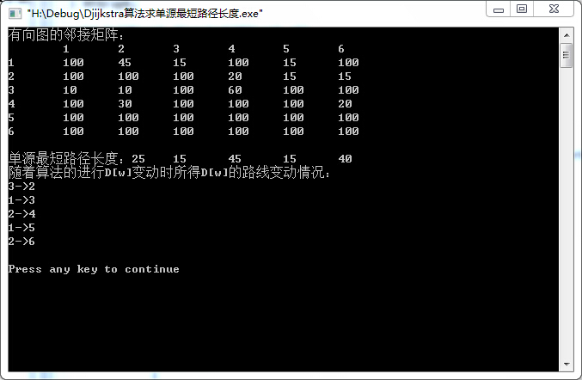

四、应用Floyd算法，编程求下图所示有向图的每对顶点之间的最短路径(写出相应的矩阵)，并求该图的中心点。并利用Warshall算法，编程求该图的传递闭包(矩阵)。
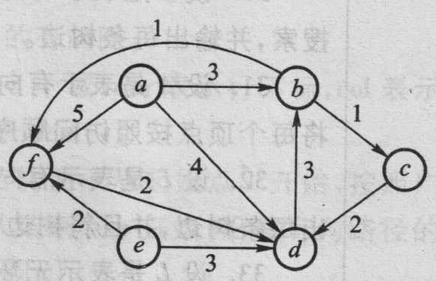
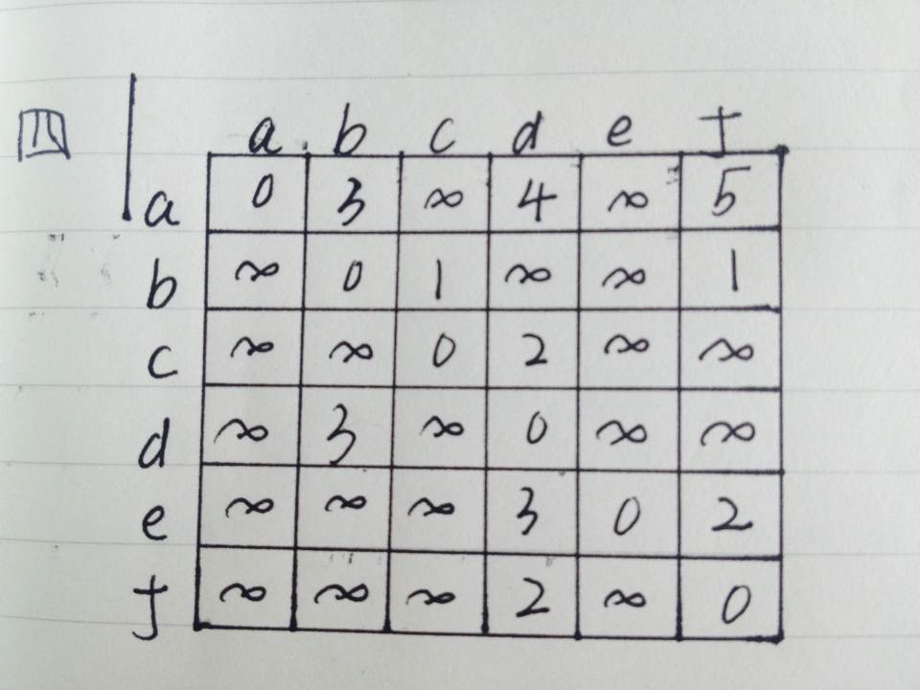
#include<iostream.h>

#define MaxValue 1000
#define NumEdges 50 //边数
#define NumVertices 6 //顶点个数

typedef char VertexData; //顶点数据类型
typedef int EdgeData; //边上权值类型

typedef struct{
VertexData vexlist[NumVertices]; //顶点表
EdgeData edge[NumVertices][NumVertices];
//邻接矩阵—边表, 可视为边之间的关系
int n; //图中当前的顶点个数
int e; //图中当前的边数
} MTGraph;

// 有向图
void IniMGraph_directed(MTGraph *G)
{
for(int i=0; i<NumVertices; i++)
for(int j=0; j<NumVertices; j++)
G->edge[i][j]=MaxValue;
G->n=0;
G->e=0;
}

void CreateMGraph_directed(MTGraph *G, VertexData V[], EdgeData E[][NumVertices], int n)
{
int i, j;
G->n=n;

for (i=0; i<n; i++) //2.读入顶点信息，建立顶点表
G->vexlist[i]=V[i];

for (i=0; i<G->n; i++)
for (j=0;j<G->n;j++)
G->edge[i][j]=MaxValue; //3.邻接矩阵初始化

for(i=0; i<n; i++) //4.读入e条边建立邻接矩阵
for(j=0; j<n; j++)
{
if(E[i][j]!=0)
{
G-> edge[i][j]=E[i][j];
G->e++;
}
}
}
//Floyd算法求每对顶点之间的最短路径
void Floyd(int A[NumVertices][NumVertices],MTGraph C,int P[NumVertices][NumVertices],int n)
{
int i, j, k;
for ( i = 0; i < n; i++ )
for ( j = 0; j<n; j++ )
{
A[i][j] = C.edge[i][j] ;
P[i][j] = -1;
}

for ( k = 0; k < n; k++ )
for ( i = 0; i < n; i++ )
for ( j = 0; j <n; j++ )
if ( A[i][k] + A[k][j] < A[i][j] )
{
A[i][j] = A[i][k] + A[k][j] ;
P[i][j] = k;
}
} /* 时间复杂性O(n3) */

void Path(int P[NumVertices][NumVertices], int i, int j)
{
int k=P[i][j];
if(k!=-1)
{
Path(P, i, k);
cout<<k+1<<endl;
Path(P, k, j);
}

}

//Warllshall算法求邻接矩阵的传递闭包
void Warshall(int A[NumVertices][NumVertices],MTGraph C,int n)
{
int i, j, k;
for ( i = 0; i < n; i++ )
for ( j = 0; j<n; j++ )
{
if(C.edge[i][j]!=MaxValue)
A[i][j] =1 ;
else
A[i][j]=0;

}
for ( k = 0; k < n; k++ )
for ( i = 0; i < n; i++ )
for ( j = 0; j <n; j++ )
if ( A[i][k] && A[k][j] )
{
A[i][j] =A[i][j] || ( A[i][k] && A[k][j]) ;
}
} /* 时间复杂性O(n3) */

//求中心点
void CenterPoint(EdgeData A[NumVertices][NumVertices], int n, int &cp)
{
EdgeData E[NumVertices]={0};
int min=MaxValue;
for(int j=0; j<n; j++)
{
for(int i=0; i<n; i++)
if(A[i][j]<MaxValue)
E[j]+=A[i][j];
if(E[j]==0)
E[j]=MaxValue;
if(E[j]<min)
{
min=E[j];
cp=j;
}
}
}

void main()
{
int i, j, cp;
MTGraph G;
IniMGraph_directed(&G);
VertexData v[]={'a', 'b', 'c', 'd', 'e','f'};//顶点集
EdgeData e[NumVertices][NumVertices]={
{0,3,MaxValue,4,MaxValue,5},
{MaxValue,0,1, MaxValue, MaxValue,1},
{MaxValue, MaxValue,0,2,MaxValue,MaxValue},
{MaxValue,3,MaxValue,0,MaxValue,MaxValue},
{MaxValue, MaxValue, MaxValue,3,0,2},
{MaxValue,MaxValue,MaxValue,2,MaxValue,0}
};//边集，邻接矩阵
CreateMGraph_directed(&G, v, e, 6);

EdgeData A[NumVertices][NumVertices]={0};
int A1[NumVertices][NumVertices]={0};
int P[NumVertices][NumVertices];

Floyd(A, G, P, G.n);
cout<<"每一对顶点之间的最短路径:"<<endl;
for(i=0; i<G.n; i++)
{
for(int j=0; j<G.n; j++)
cout<<A[i][j]<<'\t';
cout<<endl;
}
cout<<"相通节点之间的路径长以及中间节点: "<<endl;
for(i=0; i<G.n; i++)
for(j=0; j<G.n; j++)
{
if(A[i][j]<MaxValue)
{
cout<<G.vexlist[i]<<"->"<<G.vexlist[j]<<", 最短路径长度: "<<A[i][j]<<", 中间结点"<<':'<<endl;;
Path(P, i, j);
}
}
//求传递闭包
Warshall(A1, G, G.n);
cout<<"\n传递闭包为:"<<endl;
for(i=0; i<G.n; i++)
{
for(int j=0; j<G.n; j++)
cout<<A1[i][j]<<'\t';
cout<<endl;
}
//求中心节点
CenterPoint(A, G.n, cp);
cout<<"\n\n中心点为: "<<G.vexlist[cp+1]<<endl;
}
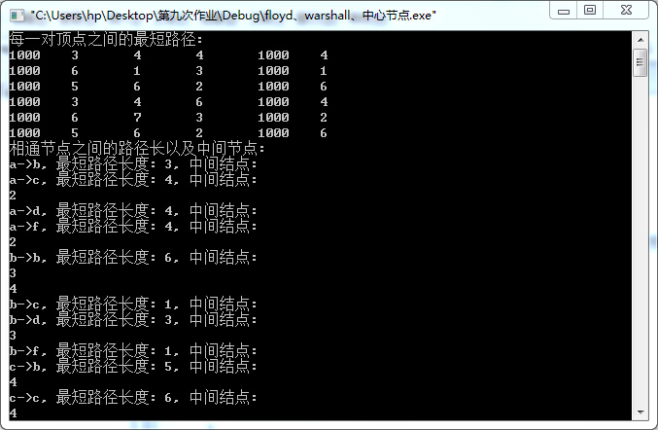
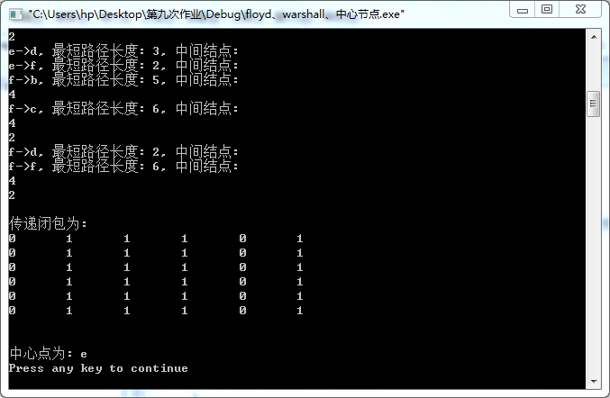

五、依次输入表(30, 15, 28, 20, 24, 10, 12, 68, 35, 50, 46, 55)中的元素，生成一棵二叉排序数，要求：
1、试画出生成之后的二叉排序树。
2、对该二叉排序数作中根遍历，写出遍历序列。
3、编程构建一个二叉排序数，并中根遍历验证上述结果。
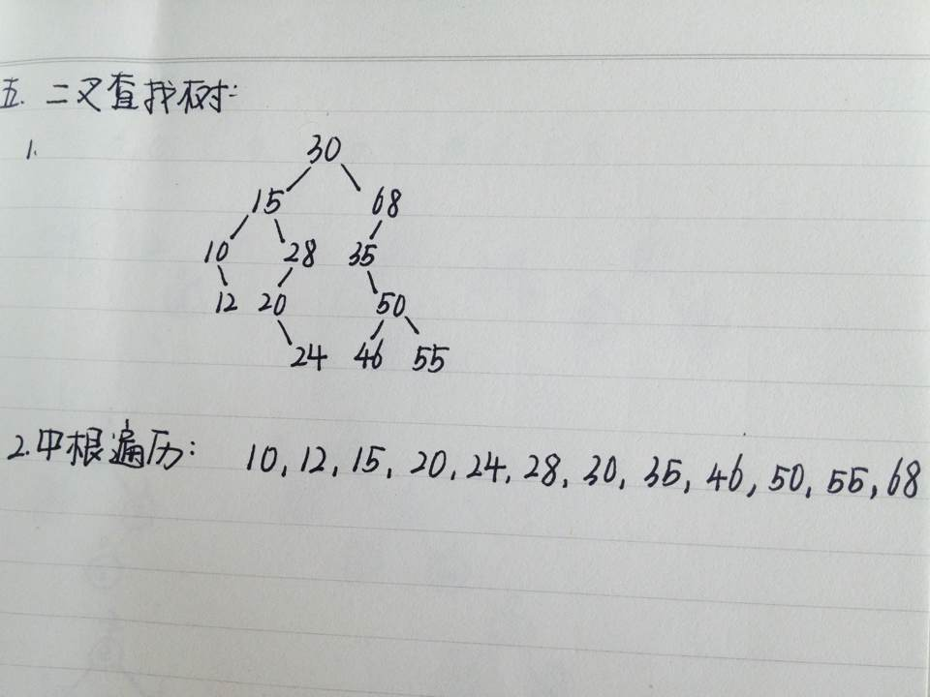
#include<iostream>
using namespace std;

typedef int records;
//二叉查找树节点类型
struct celltype{
records data;
celltype *rchild,*lchild;
};

typedef celltype *BST;

//在F所指的二叉查找树中插入新记录R
void insert(records R, BST &F)
{
if(F == NULL)
{
F=new celltype;
F->data = R;
F->lchild = NULL;
F->rchild = NULL;
}
else if(R<F->data)
insert(R,F->lchild);
else if(R>F->data)
insert(R,F->rchild);
else return;
}

//中根遍历二叉查找树
void inOrder(BST F)
{
if(F!=NULL)
{
inOrder(F->lchild);
cout<<F->data<<'\t';
inOrder(F->rchild);
}
}
//判断F是不是二叉排序树
void isBST(BST F,bool &is)
{
if(F->lchild && F->rchild)//左右子树都不为空
{
if(F->data>F->lchild->data && F->data<F->rchild->data)
{
isBST(F->lchild,is);
isBST(F->rchild,is);
}
else
is=false;
}
else if(F->lchild && !F->rchild)//左子树不为空，右子树为空
{
if(F->data>F->lchild->data)
isBST(F->lchild,is);
else
is = false;
}
else if(!F->lchild && F->rchild)//左子树为空，右子树不为空
{
if(F->data<F->rchild->data)
isBST(F->rchild,is);
else
is = false;
}
}
void main()
{
cout<<"建立空二叉查找树F："<<endl;
BST F=NULL;
cout<<"插入记录：30"<<endl;
insert(30,F);
cout<<"插入记录：15"<<endl;
insert(15,F);
cout<<"插入记录：28"<<endl;
insert(28,F);
cout<<"插入记录：20"<<endl;
insert(20,F);
cout<<"插入记录：24"<<endl;
insert(24,F);
cout<<"插入记录：10"<<endl;
insert(10,F);
cout<<"插入记录：12"<<endl;
insert(12,F);
cout<<"插入记录：68"<<endl;
insert(68,F);
cout<<"插入记录：35"<<endl;
insert(35,F);
cout<<"插入记录：50"<<endl;
insert(50,F);
cout<<"插入记录：46"<<endl;
insert(46,F);
cout<<"插入记录：55"<<endl;
insert(55,F);
cout<<"中根遍历二叉查找树："<<endl;
inOrder(F);
cout<<endl;
bool is = true;
isBST(F,is);
if(is)
cout<<"F是二叉排序树!"<<endl;
else
cout<<"F不是二叉排序树!"<<endl;
}
六、编写一个判别给定二叉树是否为二叉排序树的算法，假设二叉树是用左右链方式存储。
算法思路：根据二叉排序树的定义和特点，从根节点开始，判断是否左子树根节点的值小于父节点的值，并且右子树根节点的值大于父节点的值，如果不是返回false，如果是则继续在左右子树根节点处递归判断，直到递归到叶子节点（左右子树都为空）结束，然后返回true。
//判断F是不是二叉排序树
void isBST(BST F,bool &is)
{
if(F->lchild && F->rchild)//左右子树都不为空
{
if(F->data>F->lchild->data && F->data<F->rchild->data)
{
isBST(F->lchild,is);
isBST(F->rchild,is);
}
else
is=false;
}
else if(F->lchild && !F->rchild)//左子树不为空，右子树为空
{
if(F->data>F->lchild->data)
isBST(F->lchild,is);
else
is = false;
}
else if(!F->lchild && F->rchild)//左子树为空，右子树不为空
{
if(F->data<F->rchild->data)
isBST(F->rchild,is);
else
is = false;
}
}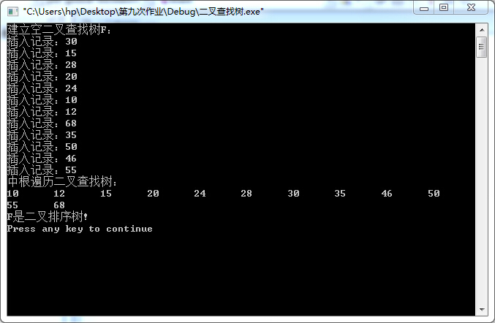

七、试画出从空树开始，有字符序列(t, d, e, s, u, g, b, j, a, k, r, i)构成的二叉平衡树，并为每一次平衡处理指明旋转类型。
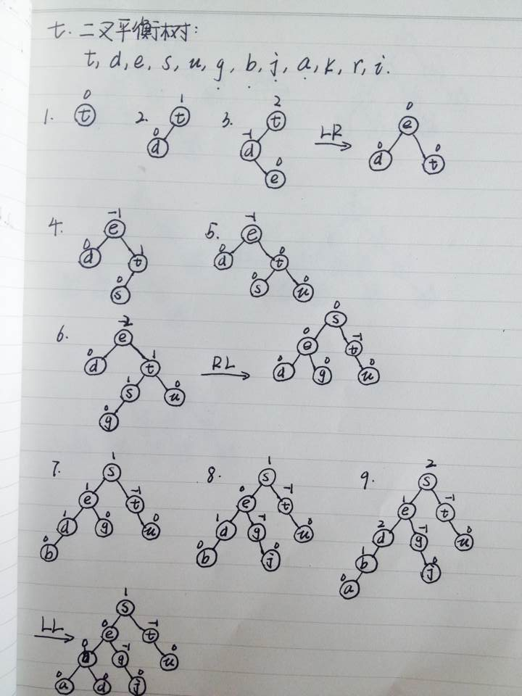
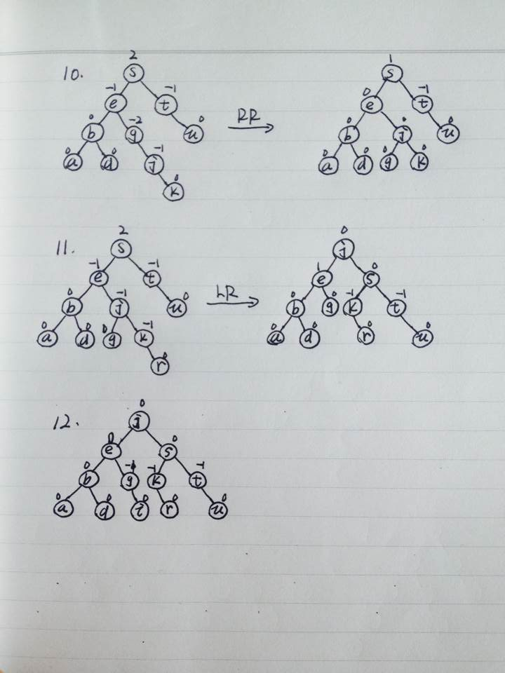

- 假设一棵平衡二叉树的每个结点都标明了平衡因子b，试设计一个算法，利用平衡因子求平衡二叉树的高度。
算法思路：从根节点开始，平衡因子为正则移动到左子树的根，为负则移动到右子树的根，为0的时候（并且左右子树不都为空）可以移动到左子树或右子树的根，每次移动高度加1，直到移动到某个节点平衡因子为0并且左右子树都为空则结束，输出平衡二叉树的高度。

//以下程序中左右旋转函数有问题
#include<iostream>
using namespace std;

typedef int records;
//AVL树节点类型
struct celltype{
int bf;//AVL的平衡因子
records data;
celltype *rchild,*lchild;
};

typedef celltype *AVL;
//旋转函数有问题！
void leftRotation(AVL &F,bool &unbalanced)
{
AVL gc,lc;
lc = F->lchild;
if(lc->lchild->bf==1)//LL
{
F->lchild = lc->rchild;
lc->rchild = F;
F->bf = 0;
F = lc;
}
else//LR
{
gc = lc->rchild;
lc->rchild = gc->lchild;
gc->lchild = lc;
F->lchild = gc->rchild;
gc->rchild = F;
switch(gc->bf){
case 1:
F->bf = -1;
lc->bf = 0;
break;
case 0:
F->bf=lc->bf = 0;
break;
case -1:
F->bf = 0;
lc->bf = 1;
}
F = gc;
}
F->bf = 0;
unbalanced = false;
}

void rightRotation(AVL &F,bool &unbalanced)
{
AVL gc,rc;
rc = F->rchild;
if(rc->lchild->bf==-1)//RR
{
F->rchild = rc->lchild;
rc->lchild = F;
F->bf = 0;
F = rc;
}
else//RL
{
gc = rc->lchild;
rc->lchild = gc->rchild;
gc->rchild = rc;
F->rchild = gc->lchild;
gc->lchild = F;
switch(gc->bf){
case 1:
F->bf = 1;
rc->bf = 0;
break;
case 0:
F->bf=rc->bf = 0;
break;
case -1:
F->bf = 0;
rc->bf = -1;
}
F = gc;
}
F->bf = 0;
unbalanced = false;
}
//在F所指的二叉查找树中插入新记录R
void insert(AVL &F,records R,bool &unbalanced)
{
if(F == NULL)//向空二叉树中插入新元素
{
unbalanced = true;
F=new celltype;
F->data = R;
F->lchild = NULL;
F->rchild = NULL;
F->bf = 0;
}
else if(R<F->data)//在左子树上插入
{
insert(F->lchild,R,unbalanced);
if(unbalanced)
switch(F->bf){
case -1:F->bf = 0;
unbalanced = false;
break;
case 0:F->bf = 1;
break;
case 1:leftRotation(F,unbalanced);
}
}
else if(R>F->data)//在右子树上插入
{
insert(F->rchild,R,unbalanced);
if(unbalanced)
switch(F->bf){
case -1:F->bf = 0;
unbalanced = false;
break;
case 0:F->bf = -1;
break;
case 1:rightRotation(F,unbalanced);
}
}
else
unbalanced = false;
}

//中根遍历二叉查找树
void inOrder(AVL F)
{
if(F!=NULL)
{
inOrder(F->lchild);
cout<<F->data<<'\t';
inOrder(F->rchild);
}
}

//利用平衡因子求二叉树的高度
void height(AVL F,int &h)
{
if(F){
++h;
if(F->bf>0)//如果bf大于0跳到左子树中递归
height(F->lchild,h);
else if(F->bf<0)//如果bf小于0跳到右子树中递归
height(F->rchild,h);
else if(F->bf == 0 && F->lchild)
height(F->lchild,h);//或者isBST(F->rchild);
else
return;
}
}
void main()
{
bool unbalanced =false;
cout<<"建立空二叉查找树F："<<endl;
AVL F=NULL;
cout<<"插入记录：30"<<endl;
insert(F,30,unbalanced);
cout<<"插入记录：15"<<endl;
insert(F,15,unbalanced);
cout<<"插入记录：28"<<endl;
insert(F,28,unbalanced);
cout<<"插入记录：20"<<endl;
insert(F,20,unbalanced);
cout<<"插入记录：24"<<endl;
insert(F,24,unbalanced);
cout<<"插入记录：10"<<endl;
insert(F,10,unbalanced);
cout<<"插入记录：12"<<endl;
insert(F,12,unbalanced);
cout<<"插入记录：68"<<endl;
insert(F,68,unbalanced);
cout<<"插入记录：35"<<endl;
insert(F,35,unbalanced);
cout<<"插入记录：50"<<endl;
insert(F,50,unbalanced);
cout<<"插入记录：46"<<endl;
insert(F,46,unbalanced);
cout<<"插入记录：55"<<endl;
insert(F,55,unbalanced);
cout<<"中根遍历二叉查找树："<<endl;
inOrder(F);
cout<<endl;
int h=0;
height(F,h);
cout<<"树的高度为："<<h<<endl;
}
思考题1：
Poj1125 Floyd算法
Stockbroker Grapevine
Description
Stockbrokers are known to overreact to rumours. You have been contracted to develop a method of spreading disinformation amongst the stockbrokers to give your employer the tactical edge in the stock market. For maximum effect, you have to spread the rumours in the fastest possible way.
Unfortunately for you, stockbrokers only trust information coming from their "Trusted sources" This means you have to take into account the structure of their contacts when starting a rumour. It takes a certain amount of time for a specific stockbroker to pass the rumour on to each of his colleagues. Your task will be to write a program that tells you which stockbroker to choose as your starting point for the rumour, as well as the time it will take for the rumour to spread throughout the stockbroker community. This duration is measured as the time needed for the last person to receive the information.
Input
Your program will input data for different sets of stockbrokers. Each set starts with a line with the number of stockbrokers. Following this is a line for each stockbroker which contains the number of people who they have contact with, who these people are, and the time taken for them to pass the message to each person. The format of each stockbroker line is as follows: The line starts with the number of contacts (n), followed by n pairs of integers, one pair for each contact. Each pair lists first a number referring to the contact (e.g. a '1' means person number one in the set), followed by the time in minutes taken to pass a message to that person. There are no special punctuation symbols or spacing rules.
Each person is numbered 1 through to the number of stockbrokers. The time taken to pass the message on will be between 1 and 10 minutes (inclusive), and the number of contacts will range between 0 and one less than the number of stockbrokers. The number of stockbrokers will range from 1 to 100. The input is terminated by a set of stockbrokers containing 0 (zero) people.
Output
For each set of data, your program must output a single line containing the person who results in the fastest message transmission, and how long before the last person will receive any given message after you give it to this person, measured in integer minutes.
It is possible that your program will receive a network of connections that excludes some persons, i.e. some people may be unreachable. If your program detects such a broken network, simply output the message "disjoint". Note that the time taken to pass the message from person A to person B is not necessarily the same as the time taken to pass it from B to A, if such transmission is possible at all.
Sample Input
3
2 2 4 3 5
2 1 2 3 6
2 1 2 2 2
5
3 4 4 2 8 5 3
1 5 8
4 1 6 4 10 2 7 5 2
0
2 2 5 1 5
0
Sample Output
3 2
3 10

思考题2
1203 dijkstra算法
Timetable
Description
You are the owner of a railway system between n cities, numbered by integers from 1 to n. Each train travels from the start station to the end station according to a very specific timetable (always on time), not stopping anywhere between. On each station a departure timetable is available. Unfortunately each timetable contains only direct connections. A passenger that wants to travel from city p to city q is not limited to direct connections however -- he or she can change trains. Each change takes zero time, but a passenger cannot change from one train to the other if it departs before the first one arrives. People would like to have a timetable of all optimal connections. A connection departing from city p at A o'clock and arriving in city q at B o'clock is called optimal if there is no connection that begins in p not sooner than at A and ends in q not later than at B. We are only interested in connections that can be completed during same day.
Write a program that:
reads the number n and departure timetable for each of n cities from the standard input,
creates a timetable of optimal connections from city 1 to city n,
writes the answer to the standard output.
Input
The first line of the input contains an integer n (2 <= n <= 100000). The following lines contain n timetables for cities 1, 2, ..., n respectively.
The first line of the timetable description contains only one integer m. Each of the following m lines corresponds to one position in the timetable and contains: departure time A, arrival time B (A < B) and destination city number t (1 <= t <= n) separated by single spaces. Departure time A and arrival time B are written in format hh:mm, where hh are two digits representing full hours (00 <= hh <= 23) and mm are two digits representing minutes (00 <= mm <= 59). Positions in the timetable are given in non-decreasing order according to the departure times. The number of all positions in all timetables does not exceed 1000000.
Output
The first line of the output contains an integer r -- the number of positions in the timetable being the solution. Each of the following r lines contains a departure time A and an arrival time B separated by single space. The time format should be like in the input and positions in the timetable should be ordered increasingly according to the departure times. If there is more then one optimal connection with the same departure and arrival time, your program should output just one.
Sample Input
3
3
09:00 15:00 3
10:00 12:00 2
11:00 20:00 3
2
11:30 13:00 3
12:30 14:00 3
0
Sample Output
2
10:00 14:00
11:00 20:00

要求：

1、上述作业要求在单独完成；
2、完成后，于规定期限内提交到教学辅助系统中，注意，在提交时将所编写的程序统一拷贝到一个Word文件中。

