**SCHOOL OF ELECTRICAL ENGINEERING**

**FACULTY OF ENGINEERING**

**UNIVERSITI TEKNOLOGI MALAYSIA**

**MKEL 1173**

**Advanced Digital System Design**

**Semester 1 Session Academic 2023/2024**

**Milestone 4**

|  |  |  |
| --- | --- | --- |
| **Student Name** | **Matrix No.** |  |
| Ho Jun Kin | MKE231021 |  |
| Kevin Ng Zhi Hao | MKE231018 |  |
| Yip Wen Xin | MKE231013 |  |

**Step 1: Dataset Training**

In this project, we planned to use Cifar-10 dataset for the image recognition at first.

Cifar10 Dataset is obtained from GitHub and directly link to STM32CubeIDE. Cifar10 Dataset consists of 60000 images with 32x32 pixel each. It consists of the following.

1. airplane
2. cars
3. birds
4. cats
5. deer
6. dogs
7. frogs
8. horses
9. ships
10. trucks

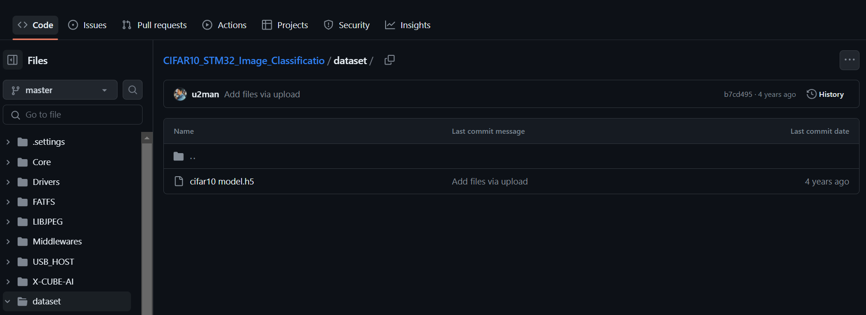

Figure 1: Pretrained cifar10 dataset

However, STM32Nucleo-F446RE board is having limited flash, which unable to use the Cifar-10 dataset that required more flash. Hence, we decided to change the dataset to MNIST dataset.

MNIST Dataset is obtain from github and directly link to STM32CubeIDE. MNIST Dataset we used is a database of handwritten digits that having a training set of 60,000 examples and a test set of 10,000 examples.

Figure 2: Pretrained MNIST dataset

**Step 2: Tool Setup**

In this project, we are using ST32CubeIDE (STM32 X-CUBE-AI tools) to train and validate the dataset into the board.

STM32 X-CUBE-AI is a set of libraries and plugins in the IDE. It supports model trained with TensorFlow, Keras, etc. With the tools, we will be able to load the trained model into the microcontroller and proceed with coding to perform inference, which is our image recognition for digit numbers.

Figure 3: STM32CubeIDE

In this project, STM32F446RET6 which is Nucleo-64 STM board is used. Target MCU board is point towards the STM board.

Next, to compile the machine learning model for training, STM32CubeAI is installed and compile.

Figure 4: STMicroelectronics.X-CUBE-AI

Artificial Intelligence X-CUBE-AI is pointed towards the Core while the Device Application is pointed towards Validation. Both installed versions are 8.1.0 which is the latest version.

After the installation, a new project is created, and our targeted board will be chosen as shown in Figure 3.

Figure 5: COM Port Selection (USART2)

The STM32 board is connected to the laptop via USB cable which is USART. The selection is shows in Figure 5.

**Step 3: Model Configuration and Code Generation**

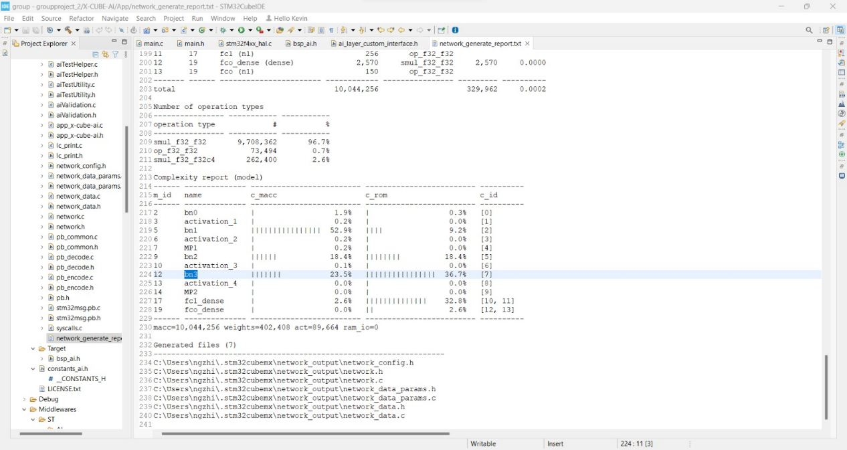

Figure 6: MNIST database generated

By applying the MNIST model into CubeAI, after configuring the model, we will be able to generate a code with the model framework and the MNIST database has been generated to the project. For the further process, we will need to amend the main.c with the function we need for the digit recognition.

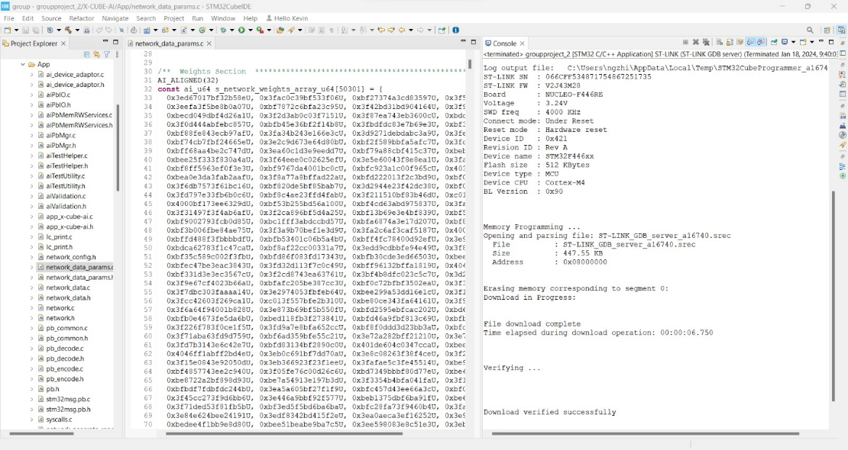

Figure 7: MNIST model (on the left) and configuration report (on the right)

Before adding the code to perform the recognition, we did run a simple LED blinking by using the code generated, and the LED is able to blink.

Besides, in order to work on the generated code, CMSIS library is included to the path.

Figure 6: CMSIS library

the included CMSIS library is as follow:

1. arm_nn_math_types.h
2. arm_nn_tables.h
3. arm_nn_types.h
4. arm_nnfunctions.h
5. arm_nnsupportfuntions.h

**Step 4: Digit Recognition Code Implementation**

We are working on this step by amending the main.c.

**Reference:**

[1] Ioan Lucan Orășan and Cătălin Daniel Căleanu, “ARM Embedded Low Cost Solution for Implementing Deep Learning Paradigms,” Nov. 2020, doi: <https://doi.org/10.1109/isetc50328.2020.9301130>.

[2] u2man, “CIFAR10_STM32_Image_Classificatio/dataset/cifar10 model.h5 at master · u2man/CIFAR10_STM32_Image_Classificatio,” *GitHub*, 2020. <https://github.com/u2man/CIFAR10_STM32_Image_Classificatio/blob/master/dataset/cifar10%20model.h5>.

[3] Nima, “nimaaghli/STM32AI_MNIST,” *GitHub*, Aug. 20, 2023. <https://github.com/nimaaghli/STM32AI_MNIST>.

‌

‌