1. Tener un email

[php.cecomp.2018@gmail.com](mailto:php.cecomp.2018@gmail.com)

1. Entrar a github.com

<https://github.com/join?source=login>

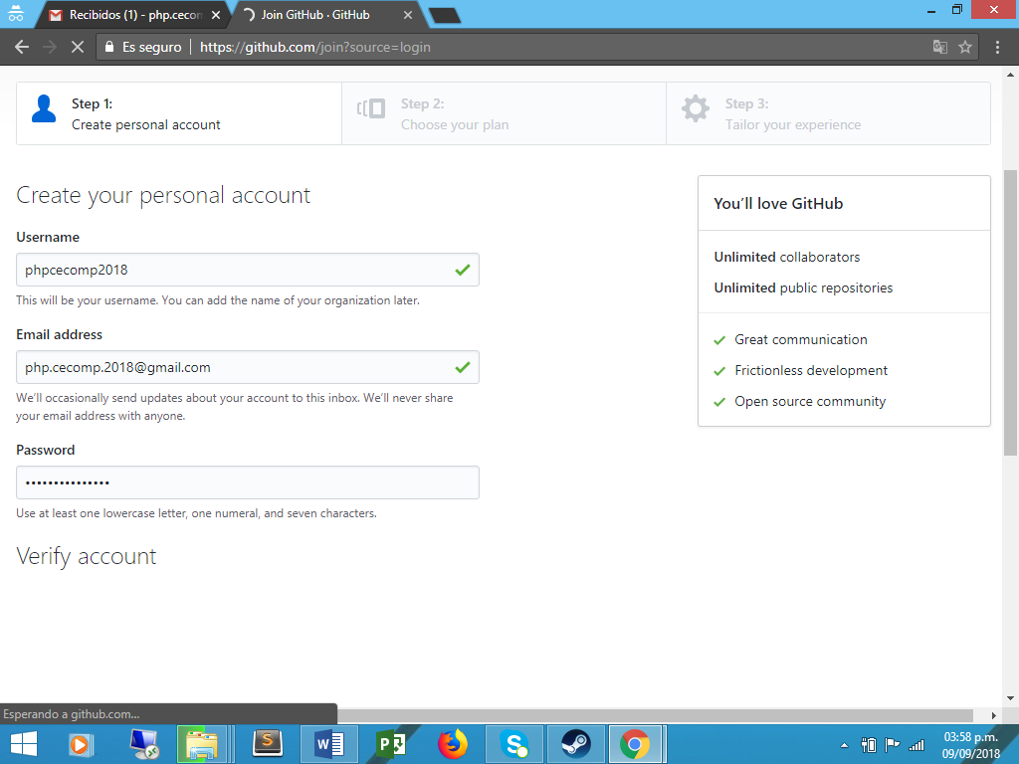

1. <https://github.com/phpcecomp2018>