Team Number: 4

# Team Name: Docker Dudes

# Team Members:

* Oscar Mikus - osmi3783/GH:OscarMikus
* Dominik Krotzer- dokr2508/GH:dokr2508
* Matthew Recksiedler - mare8229/GH:mare8229
* Noah Schotthoefer - nosc7618/GH:nosc7618
* Zach Cook - zaco6003/GH:zaco6003

# Application Name:

Climbing Buddy

# Application Description

Project Description:

* Climbing buddy - App to find nearby climbers in need of a partner
* Database contains username/login table in addition to rock-climbing ‘trail’ information (incl location) table and tables to store user connections (social media)

# Vision Statement

For climbers who are in need of a climbing buddy. The Climbing Buddy is a social app that will allow climbers to interact with one another to determine if they want to climb with one another.

# Development Methodology

Agile

Scrum Master - Matthew Recksiedler

# Communication Plan

We intend on communicating through SnapChat Messages, which should be an effective means of getting in touch with everyone simultaneously.

We are going to meet from 3-5 on tuesdays

# Meeting Plan

Group meeting: Tuesdays 3-5PM at Engineering Center

Weekly Meeting with TA: Fridays @ 12:45 with everyone present. Modality: Zoom

# Use Case Diagram

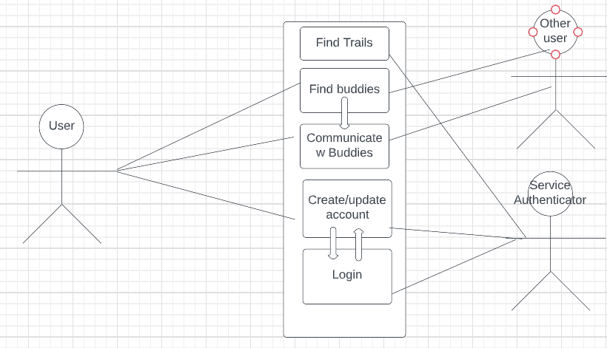

<https://lucid.app/lucidchart/23a23a7b-9d8a-41ad-96e6-e35f6efb3faa/edit?viewport_loc=-191%2C-31%2C2048%2C862%2C0_0&invitationId=inv_62b2e0fd-a7d2-4478-b515-ced4367b0bfa>

# Wireframes

