Workshop 1 — Software Engineering II
Universidad Nacional de Colombia Semester 2026-II Instructor: Eng. Liliana Marcela Olarte, M.Sc. Project: Web and mobile academic tutoring platform Submission deadline: September 30, 2026, 11:00 PM
Team members:
- Camilo Alejandro Lagos Malaver — Backend Developer
- Oscar Javier Saavedra Montero — Frontend Developer
- Angel Palacio Suarez — UX/UI Designer
- Brahian Camilo Gomez Carvajal — Frontend / Mobile Developer
- Sergio David Motta Romero — Project Manager / QA

1. System Overview
The system is a web and mobile application that connects students who need academic or artistic support with specialized human tutors. The platform centralizes the process of searching for, requesting and managing tutoring sessions: students look up available tutors according to the subject they need, review their experience and availability, request sessions and rate the tutoring they received. Tutors register the subjects they master, make posts, define their availability and manage the requests they receive.
The platform also incorporates a review and rating mechanism and a tutor recommendation service using artificial intelligence, which analyzes the academic need described by the student in order to suggest related tutors. Administrators supervise the registered information and manage users, subjects and content.

2. Problem and Objectives
Problem: students have difficulty finding available tutors, learning about their experience and coordinating tutoring sessions in an organized way, which leads to lost time and lost learning opportunities, even in unconventional areas.
General objective: develop a web and mobile platform that centralizes the search, request, scheduling and evaluation of academic tutoring between students and tutors.
Specific objectives:
- Allow students to find tutors by subject, availability and rating.
- Allow tutors to manage their academic offering and availability.
- Automate the flow of requesting, accepting/rejecting and confirming tutoring sessions.
- Record ratings and reviews that support each tutor's reputation.
- Incorporate an artificial intelligence service that recommends tutors based on the need described by the student.
- Provide administrators with supervision and moderation tools.

3. Scope
Included in the project scope:
- Registration and management of accounts with a student or tutor role.
- Management of the tutor's profile, subjects and availability.
- Search and filtering of tutors by subject, schedule and rating.
- Request, acceptance, rejection and tracking of tutoring sessions.
- Cancellation and completion of tutoring sessions.
- Ratings and reviews of completed tutoring sessions.
- Tutor recommendation through artificial intelligence (OpenRouter).
- Administration panel for users, subjects, tutoring sessions and reviews.
Out of scope (for now):
- Payment or subscription processing.
- Built-in video calls within the platform (the use of external links is assumed).
- Full instant messaging between student and tutor.
- Integrations with external calendars (Google Calendar, Outlook).
- Any functionality not covered in the project's general proposal.
Methodological note: following the course guidelines, login (and the corresponding logout) is not treated as a core business functionality or as an independent user story, since it is a cross-cutting access condition and does not provide differentiating value to the academic tutoring domain. It is documented as part of account registration (FR-01), through FR-02 and FR-03, and as a precondition of all other functionalities.

4. System Actors
- Student: user who looks for academic support, consults tutors, requests and attends tutoring sessions, and rates them once they are finished.
- Tutor: user who offers tutoring on the subjects they master, manages their availability and responds to requests.
- Academic administrator: user in charge of supervising the accounts, subjects, tutoring sessions and reviews registered on the platform.
- Recommendation service (AI / OpenRouter): support actor that analyzes the student's academic need and suggests related tutors.

5. Functional Requirements

5.1 Account and Profile Management
- FR-01. The system must allow the interested person to register an account, indicating the student or tutor role.
- FR-02. The system must allow the user to log in using their credentials.
- FR-03. The system must allow the user to log out.
- FR-04. The system must allow the user to view their profile information.
- FR-05. The system must allow the user to edit their profile information.

5.2 Tutor Management
- FR-06. The system must allow the tutor to register the topics they can teach.
- FR-07. The system must allow the tutor to register descriptive information about their experience.
- FR-08. The system must allow the tutor to register their schedule availability for giving tutoring sessions.
- FR-09. The system must allow the tutor to modify their schedule availability for giving tutoring sessions.

5.3 Tutor Search and Selection
- FR-10. The system must allow the student to search for tutors by filtering by a specific subject or topic and/or by available schedule.
- FR-11. The system must show the student the tutors that match the applied search criteria.
- FR-12. The system must show the student the relevant profile information of the selected tutor (subjects, experience, availability and rating).

5.4 Tutoring Request and Management
- FR-13. The system must allow the student to request a tutoring session with a selected tutor, proposing a date and time within the tutor's availability.
- FR-14. The system must notify the tutor of pending tutoring requests.
- FR-15. The system must allow the tutor to accept or reject a tutoring request.
- FR-16. The system must update the request status after the tutor's response.
- FR-17. The system must allow users to view the status and schedule of their tutoring sessions (pending, confirmed, rejected, canceled, completed).
- FR-18. The system must allow users to cancel a previously confirmed tutoring session.
- FR-19. The system must update the status of a tutoring session when it is canceled or finished.
- FR-20. The system must send a notification of the status of a tutoring session when it is canceled or finished.

5.5 Reviews and Ratings
- FR-21. The system must allow the student to rate a tutoring session after it is finished.
- FR-22. The system must allow the student to write a review associated with the tutoring session and the corresponding tutor.
- FR-23. The system must display the available ratings and reviews on the tutor's profile.
- FR-24. The system must calculate each tutor's average rating from the recorded ratings.
- FR-25. The system must prevent the student from submitting more than one review for the same tutoring session.
- FR-26. The system must allow the administrator to moderate reviews that violate the platform's usage rules.

5.6 Artificial Intelligence Recommendation
- FR-27. The system must analyze the description of the student's academic need through an artificial intelligence service (OpenRouter).
- FR-28. The system must recommend to the student tutors related to the identified academic need.

5.7 Administration
- FR-29. The administrator must be able to manage the accounts registered on the platform.
- FR-30. The administrator must be able to manage the topics available on the platform.
- FR-31. The administrator must be able to view the tutoring sessions registered in the system.
- FR-32. The administrator must be able to view the reviews submitted by students.
- FR-33. The system must log the relevant administrative actions performed on the platform (audit).
- FR-34. The administrator must be able to ban user accounts from the application when they repeatedly fail to show up to tutoring sessions in the agreed time slots.

5.8 Schedule Compatibility
- FR-35. The system must allow multiple tutoring requests in the same time slot; however, it only schedules the first one to be accepted and invalidates the others.
- FR-36. The system must allow multiple tutoring requests to the same tutor as long as the time slot changes; these will be scheduled once the tutor accepts them.

6. Non-Functional Requirements
- NFR-01 (Performance). The system must respond to tutor searches within a maximum of 2 seconds.
- NFR-02 (Concurrency). The system must support up to 500 concurrent users.
- NFR-03 (Security). All communication between client and server must be carried out over HTTPS, and passwords must be stored encrypted.
- NFR-04 (Data protection). The processing of students' and tutors' personal data must comply with Colombian data protection regulations (Habeas Data, Law 1581 of 2012).
- NFR-05 (Informed consent). The system must request informed consent during registration when the account is created.
- NFR-06 (Usability). A student must be able to complete a tutoring request in a maximum of 3 steps from the tutor's profile screen.
- NFR-07 (Availability). The system must guarantee a minimum availability across the different platforms (web and mobile app).
- NFR-08 (Cross-platform compatibility). Availability and request data must be kept synchronized between the web application (React) and the mobile application (Expo) within no more than 5 seconds.
- NFR-09 (Scalability). The system must support growth in the number of users without response time degrading by more than 20%.
- NFR-10 (Maintainability). The backend must be implemented with a modular, domain-based architecture (Django apps) and have automated test coverage of at least 70% of the business logic.
- NFR-11 (Reliability). The system must not lose information about requests or confirmed tutoring sessions in the event of temporary server failures.
- NFR-12 (Auditing). All relevant administrative actions must be recorded with a timestamp and the responsible user.
- NFR-13 (AI service performance). The recommendation service using OpenRouter must respond within a maximum of 3 seconds, showing a loading indicator while the request is being processed.

7. User Stories
Each user story includes the role, the story, related requirements, priority, assigned release and acceptance criteria in Given/When/Then format.

Epic 1 — Account and Profile Management
US-01 — Account Registration As a person interested in using the platform, I want to register indicating whether I am a student or a tutor, so that I can access the functionalities corresponding to my role. Related requirements: FR-01. Priority: High. Release: 1.
Acceptance Criteria
- Given that I am a visitor on the registration screen, when I complete my information and select the role "student" or "tutor", then the system creates my account and redirects me to my dashboard according to the chosen role.
- Given that I enter an email that is already registered, when I try to create the account, then the system shows an error message and does not create a duplicate account.
US-02 — Profile Management As a registered user, I want to view and edit my profile information, so that I can keep my data up to date. Related requirements: FR-04, FR-05. Priority: Medium. Release: 1.
Acceptance Criteria
- Given that I have an active session, when I edit my profile data and save the changes, then the system updates the information and shows a confirmation message.
- Given that as a tutor I also want to use the platform, the system allows me to schedule tutoring sessions in which I am the student, despite my active role as a tutor.

Epic 2 — Tutor Management
US-03 — Tutor Subject Registration As a tutor, I want to register the subjects or topics I can teach, so that students can find me according to their academic need. Related requirements: FR-06. Priority: High. Release: 1.

Acceptance Criteria
- Given that I have an active tutor account, when I add a subject to the catalog and save, then the system associates it with my profile and displays it on my public profile.
- Given that I want people to find me, my profile must be promoted in some way, through AI recommendation or an announcement board.

US-04 — Experience Registration As a tutor, I want to register descriptive information about my experience, so that students can learn about my background before requesting a tutoring session. Related requirements: FR-07. Priority: Medium. Release: 1.
- Given that I have an active tutor account, when I enter the descriptive information about my experience and save, then the system associates it with my profile and displays it on my public profile.
US-05 — Availability Management As a tutor, I want to define the time blocks in which I am available, so that students can only request tutoring sessions from me in those slots. Related requirements: FR-08, FR-09. Priority: High. Release: 1.
- Given that I am in the availability section, when I mark the time blocks in which I can give tutoring sessions, then the system saves them and shows them on my public profile.
- Given that a time block already has a confirmed tutoring session, when I try to delete it, then the system warns me about the conflict and asks for confirmation before releasing it.

Epic 3 — Tutor Search and Selection
US-06 — Tutor Search As a student, I want to search for tutors by filtering by subject and/or available schedule, so that I can quickly find an option that fits my need. Related requirements: FR-10, FR-11. Priority: High. Release: 1.
- Given that I am on the search screen, when I select a subject and a time range, then the system shows the tutors that meet both criteria.
- Given that no tutor meets the selected criteria, when I run the search, then the system shows a message indicating that there are no results and suggests broadening the filters.
US-07 — Tutor Profile View As a student, I want to view a tutor's detailed profile, so that I can review their experience, availability and ratings before requesting a tutoring session. Related requirements: FR-12. Priority: High. Release: 1.
- Given that I am on the search results list, when I select a tutor, then the system shows their full profile with subjects, experience, availability and average rating.

Epic 4 — Tutoring Request and Scheduling
US-08 — Tutoring Request As a student, I want to request a tutoring session by proposing a date and time within the tutor's availability, so that I can coordinate the session. Related requirements: FR-13, FR-36. Priority: High. Release: 1.
- Given that I select a tutor and an available time block, when I confirm the request, then the system registers it with "pending" status and notifies the tutor.
- Given that I select a tutor and an unavailable time block, the system prevents me from selecting that time slot, but collects the information in order to recommend a tutor who is available in that time slot.
US-09 — Pending Request Notification As a tutor, I want to receive a notification of pending tutoring requests, so that I can respond to them in a timely manner. Related requirements: FR-14. Priority: Medium. Release: 1.
- Given that a student requests a tutoring session with me, when the request is registered, then the system immediately notifies me within the platform.
- Given that the system depends on my authorization, no tutoring session will be accepted or rejected without my confirmation.
US-10 — Accepting or Rejecting Requests As a tutor, I want to accept or reject the tutoring requests I receive, so that I can manage my availability and workload. Related requirements: FR-15, FR-16. Priority: High. Release: 1.
- Given that I have a pending request, when I accept it, then the system changes its status to "confirmed" and notifies the student.
- Given that I have a pending request, when I reject it, then the system changes its status to "rejected", releases the time block and notifies the student.
US-11 — Request Status View As a platform user, I want to check the status of my tutoring requests, so that I know whether they were accepted, rejected or are still pending. Related requirements: FR-17, FR-35. Priority: Medium. Release: 1.
- Given that I have registered requests, when I enter the "My tutoring sessions" section, then the system shows the updated status of each one.
- Given that two tutoring sessions requested for the same time slot are accepted, the system only accepts the first request to be answered by the tutor, and notifies me of an incompatibility regarding the second.

Epic 5 — Tutoring Execution and Follow-up
US-12 — Scheduled Tutoring View As a user with confirmed tutoring sessions, I want to view my scheduled and completed tutoring sessions, so that I can organize my academic time. Related requirements: FR-17. Priority: Medium. Release: 1.
- Given that I have confirmed or completed tutoring sessions, when I enter my tutoring dashboard, then the system shows them organized by date and status.
US-13 — Tutoring Cancellation As a platform user, I want to cancel a previously confirmed tutoring session, so that I can free up the slot when I cannot attend. Related requirements: FR-18, FR-19, FR-20. Priority: Medium. Release: 2.
- Given that I have a confirmed tutoring session, when I cancel it before it starts, then the system updates its status to "canceled" and notifies the other party.

Epic 6 — Evaluation and Reviews
US-14 — Tutoring Rating As a student, I want to rate a tutoring session after it is finished, so that I can reflect the quality of the service received. Related requirements: FR-21, FR-22, FR-25. Priority: High. Release: 2.
- Given that I attended a tutoring session marked as finished, when I rate it from 1 to 5 stars and add a comment, then the system records the review associated with the tutor and the tutoring session.
- Given that I have already rated a specific tutoring session, when I try to rate it again, then the system prevents a second review from being registered for the same tutoring session.
US-15 — Tutor Ratings View As a student, I want to see a tutor's ratings and reviews, so that I can decide whether they are a good option before requesting a tutoring session. Related requirements: FR-23, FR-24. Priority: Medium. Release: 2.
- Given that I view the profile of a tutor with registered reviews, when I check their ratings section, then the system shows the average rating and the associated comments.
- Given that as a user I want fair reviews, the system allows me to flag for review the reviews that violate the usage rules.
US-16 — Review Moderation As an administrator, I want to moderate the registered reviews, so that I can remove content that violates the platform's usage rules. Related requirements: FR-26. Priority: Low. Release: 2.
- Given that I identify a review that violates the usage rules, when I flag it for review and confirm its removal, then the system removes it from the tutor's profile.
- Given that reviews must be justified, the system only allows reviews from users whose tutoring session is marked as completed by both parties.

Epic 7 — Intelligent Recommendation
US-17 — Tutor Recommendation Using AI As a student, I want to describe my academic need in natural language, so that I receive automatic recommendations of related tutors. Related requirements: FR-27, FR-28. Priority: Medium. Release: 3.
- Given that I write a description of my academic need, when I request recommendations, then the system analyzes the text through the artificial intelligence service and shows tutors related to the identified subject.
- Given that the artificial intelligence service is unavailable, when I request recommendations, then the system reports the error and lets me continue with a manual search by subject or by time slot.

Epic 8 — Platform Administration
US-18 — Account Management As an administrator, I want to manage the accounts registered on the platform, so that I can keep the system working correctly. Related requirements: FR-29, FR-34. Priority: Low. Release: 3.
- Given that I review the account list, when I change the status of an account (active/inactive), then the system applies the change and restricts access if applicable.
US-19 — Subject Management As an administrator, I want to manage the subjects and topics available on the platform, so that I can keep up to date the catalog used by tutors and students. Related requirements: FR-30. Priority: Low. Release: 3.
- Given that I review the subject catalog, when I add, edit or delete a subject, then the system reflects the change in the options available to tutors and students.
US-20 — Tutoring and Review Oversight As an administrator, I want to view the tutoring sessions and reviews registered in the system, so that I can oversee the general operation of the platform. Related requirements: FR-31, FR-32, FR-33. Priority: Low. Release: 3.
- Given that I enter the administration panel, when I view the list of tutoring sessions or reviews, then the system shows the information together with the corresponding audit log.

Epic 9 — Constraints
US-21 — Tutoring Confirmation As a user, I want the platform to protect me in case the other party does not show up. Related requirements: FR-19. Priority: Medium. Release: 2.
- Given that the system seeks to validate that tutoring sessions take place, the user must be able to confirm whether the other party showed up; when the current time matches the time scheduled for the tutoring session, the user will not be able to continue scheduling tutoring sessions until they confirm the status of the current one.
- Given that the other party could respond fraudulently to the attendance confirmation, the system will penalize the reputation of the party responsible when absences occur repeatedly.

8. User Story Mapping

The following diagram represents the project's user story map. On the horizontal axis (backbone) are the eight main user activities in the natural order of use of the platform; on the vertical axis are the user stories of each activity, ordered from highest to lowest priority and separated by cut lines according to the release they belong to (Release 1 in green, Release 2 in yellow and Release 3 in red).
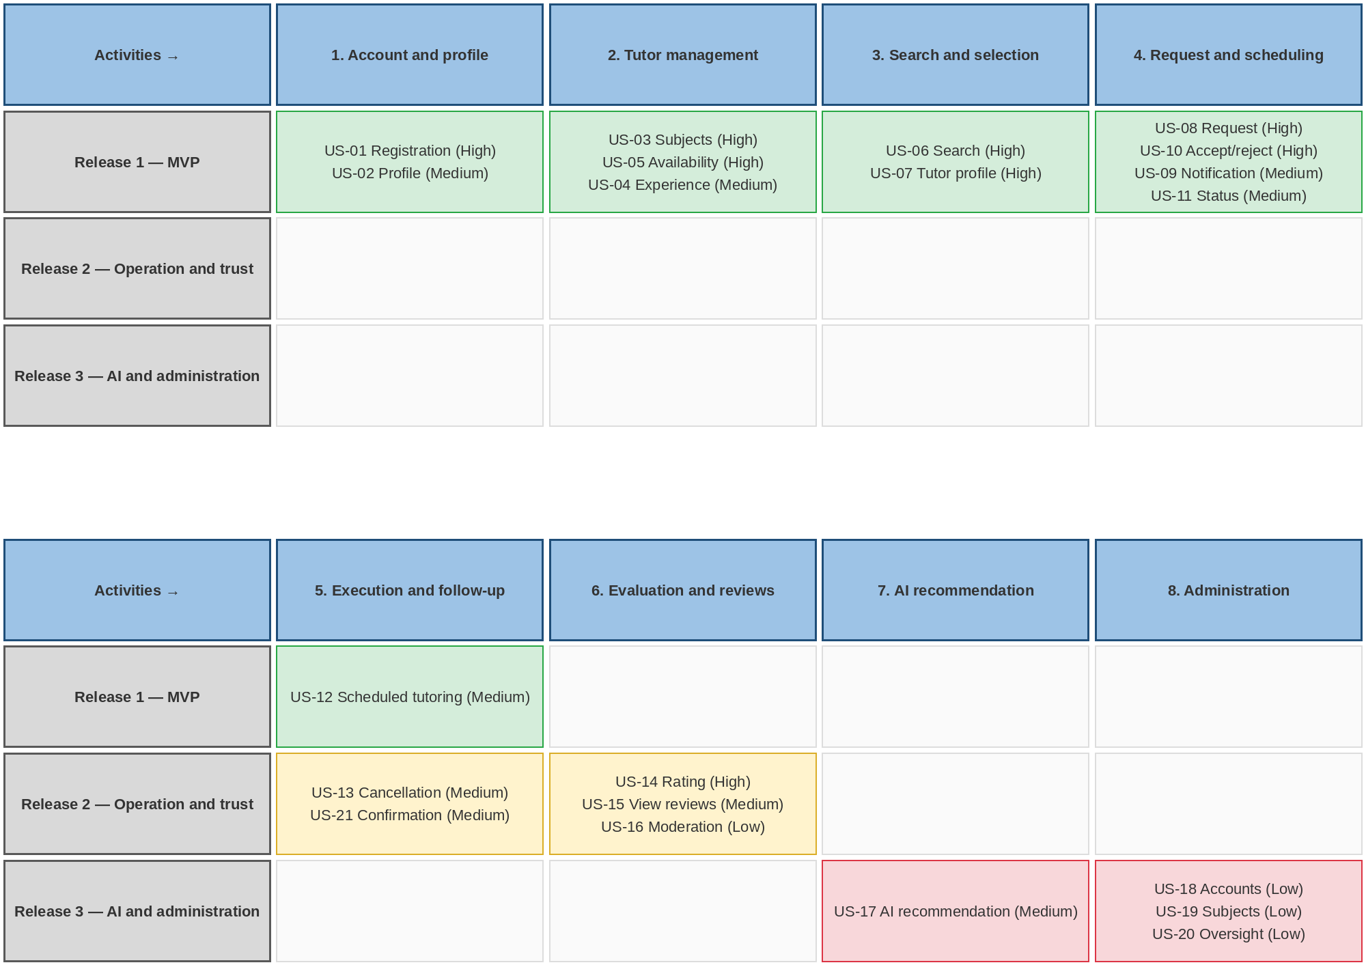

Figure 1. User story map of the academic tutoring platform (created with Mermaid).

Each row of the map corresponds to a cut line that defines the minimum set of stories needed for each functional version of the product (see section 9). Release 1 covers the main flow end to end (registration, tutor offering, search, request and follow-up), while Releases 2 and 3 complete the evaluation cycle, the intelligent recommendation and the administration.

9. Prioritization and Releases
Release 1 — MVP (Minimum Viable Product): enables the complete flow of registration, tutoring offering, search, request and scheduling. US-01, US-02, US-03, US-04, US-05, US-06, US-07, US-08, US-09, US-10, US-11, US-12.
Release 2 — Operation and Trust: incorporates the closing of the tutoring cycle and the reputation system. US-13, US-14, US-15, US-16, US-21.
Release 3 — Intelligence and Advanced Administration: incorporates AI recommendation and administrative supervision tools. US-17, US-18, US-19, US-20.

10. Requirements Traceability

Functional requirement → User story → Release
FR-01 → US-01 → Release 1
FR-02, FR-03 → (cross-cutting precondition, see section 3)
FR-04, FR-05 → US-02 → Release 1
FR-06 → US-03 → Release 1
FR-07 → US-04 → Release 1
FR-08, FR-09 → US-05 → Release 1
FR-10, FR-11 → US-06 → Release 1
FR-12 → US-07 → Release 1
FR-13, FR-36 → US-08 → Release 1
FR-14 → US-09 → Release 1
FR-15, FR-16 → US-10 → Release 1
FR-17 → US-11, US-12 → Release 1
FR-35 → US-11 → Release 1
FR-18, FR-19, FR-20 → US-13 → Release 2
FR-19 → US-21 → Release 2
FR-21, FR-22, FR-25 → US-14 → Release 2
FR-23, FR-24 → US-15 → Release 2
FR-26 → US-16 → Release 2
FR-27, FR-28 → US-17 → Release 3
FR-29, FR-34 → US-18 → Release 3
FR-30 → US-19 → Release 3
FR-31, FR-32, FR-33 → US-20 → Release 3

All the functional requirements of the proposal are represented in at least one user story and in one release, except the cross-cutting access requirements FR-02 and FR-03 (see section 3).

11. Technology Stack
- Web frontend: React.
- Mobile application: Expo.
- Backend: Django.
- Database: MySQL.
- Artificial intelligence: OpenRouter, for request analysis and tutor recommendation.
- Communication: HTTPS between client and server, and REST API between frontend/mobile and backend.

12. References
- Cohn, M. (2004). User Stories Applied: For Agile Software Development. Addison-Wesley.
- Patton, J. (2014). User Story Mapping: Discover the Whole Story, Build the Right Product. O'Reilly Media.
- Plan.io Blog. User Story Mapping. https://plan.io/blog/user-story-mapping/
- Congress of the Republic of Colombia. Law 1581 of 2012 (Habeas Data).
- W3C. Web Content Accessibility Guidelines (WCAG) 2.1.
- AI tools used as support for structuring the workshop along with the design of the user story maps (Claude Cowork with Mermaid, Drive and NotebookLM MCPs)
- Class material — Software Engineering II, Eng. Liliana Marcela Olarte, M.Sc., Universidad Nacional de Colombia (2026-II).
- General final project proposal — Academic tutoring platform (internal team document).

