CMS22301 · INTELLIGENT SYSTEMS AND EMERGING TECHNOLOGIES · SMART VITALS
Design plan
Hand this in before your Week 8 session. Short answers are fine: your tutor checks that your plan covers the brief before you build. R1 to R11 are the brief's requirements; the same questions are in your repository as docs/design-plan.md.
Name
Student ID

Question | Your plan
1 · Two approaches to compare  Output 1. Two model types, or edge versus cloud? How will you judge them? | Model: a random forest vs logistic regression, both against an 'always Normal' baseline. Judged on recall for Critical, balanced accuracy and macro F1, tested on patients the model has never seen.  Architecture: cloud decides everything (Week 6 design A) vs an edge/cloud split (design C). Judged on whether the clinician is still alerted during an internet outage, how many messages are sent, and how much raw data leaves the home.
2 · Data  R2, R7, R9. Simulator or open dataset; how readings and labels are made; how you will create dropouts, delays, glitches and duplicates. | Simulated data only, never real (R7). I will extend the module simulator: each patient has conditions (hypertension, diabetes, arrhythmia) that set their risk group, Low, Medium or High (R1).  One reading a minute: heart rate, SpO2, blood pressure, temperature, and glucose for diabetic patients only (R2). Labels come from a points rule based on NEWS2 (RCP, 2017); I will document how it differs.  For R9 I inject faults on purpose and keep a hidden answer key: sensor dropouts, impossible values, readings 5 minutes late, duplicate resends and frozen sensors.
3 · Your model  R3, Output 4. Inputs; models to try; main measure and target, e.g. recall for Critical of at least 0.90. | Inputs: risk level, diabetic yes/no and the vitals (later: rolling averages over recent readings to catch slow deterioration).  Models: baseline, logistic regression, random forest in a pipeline that fills gaps from missing readings.  Main measure: recall for Critical, because a missed Critical is a missed alert. Target: at least 0.90 on unseen patients (the demo data currently gives 0.81).
4 · Architecture  R11. Edge/cloud split, API, containers: what runs where, and why. | Edge (patient's phone, simulated): range check, an urgent low-SpO2 rule so the alarm works offline, a buffer while the internet is down, retry with backoff and jitter.  Cloud: a Flask API in Docker validates each reading, ignores duplicates by reading_id, classifies it with the saved model (loaded once), stores it and raises alerts. The dashboard is a second container; Docker Compose starts everything.  Why: in Week 6 the cloud-only design never alerted the carer during an outage; the split design did. Containers make it run the same on any machine.
5 · Alerts, history, dashboard  R4, R6, R8, R10. How a Critical becomes an alert; where history is kept; what the clinician sees; thresholds per patient. | A Critical reading creates an alert with patient ID, assigned clinician, vitals and timestamp (R4). Alerts jump the queue ahead of routine readings, and one alert per episode limits alarm fatigue.  Readings and alerts are stored per patient in SQLite on a Docker volume, so history survives restarts (R6).  Dashboard: trend charts per vital, alert list and data health (R8). Clinicians set each patient's thresholds through PUT /patients/{id}/thresholds (R10).
6 · Security and privacy  R5, R7. How you control access and protect the data. | Clinicians log in and can only see their own patients; anything else gets 403 (R5). This is the OWASP API 'broken object level authorisation' risk, and a typed header alone is not enough.  Only simulated data, pseudonymous patient IDs, only the vitals that are needed (UK GDPR data minimisation). Secrets stay in a .env file outside the repository and images (R7).
7 · The tension  Output 3. The ethical, privacy or sustainability trade-off you will argue. | Missed alerts vs false alarms. Too sensitive and clinicians start ignoring alerts; too strict and a deteriorating patient is missed. In Week 8, validation threw away a real heart rate of 28. I will argue where the line should be, and that unusual readings should be flagged for a clinician, not silently deleted.

8 · Architecture sketch
Where readings come from, where the model runs, what crosses each arrow, and which parts run as containers. Draw it here, or attach docs/architecture.png.
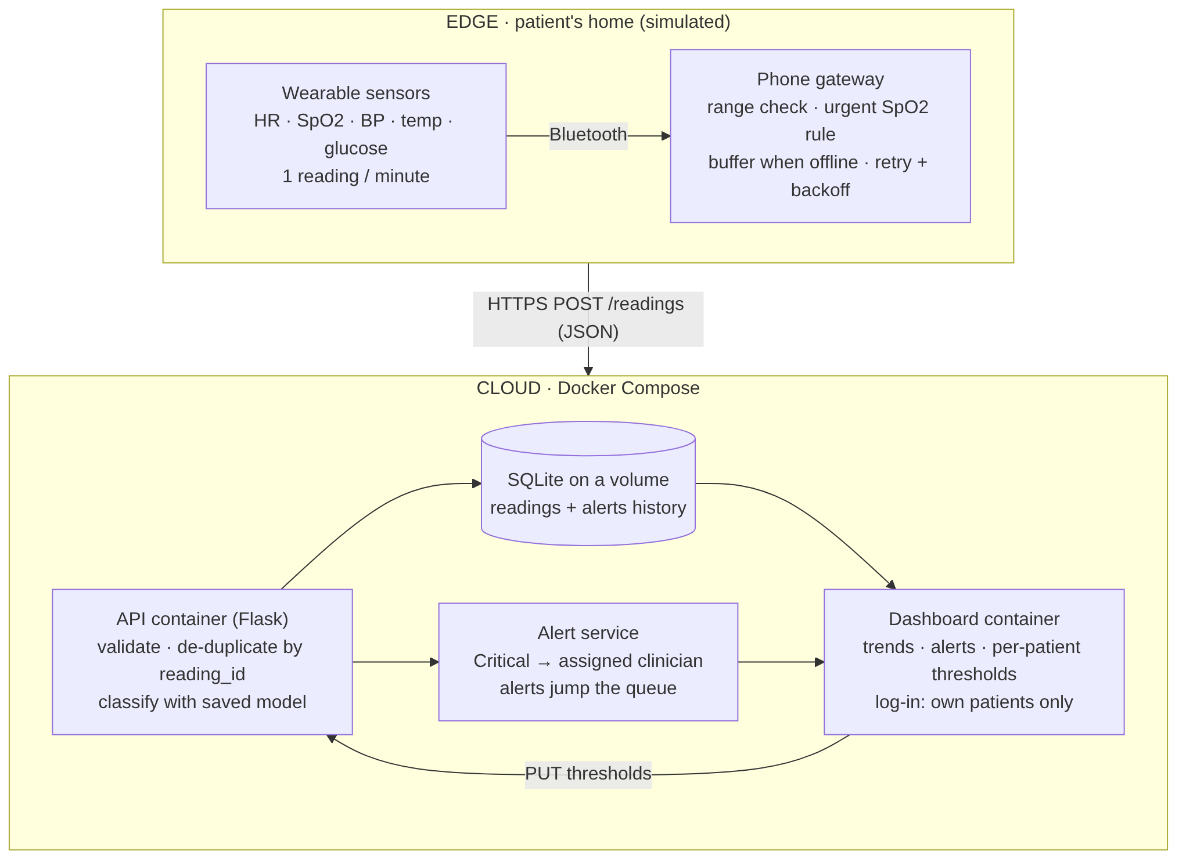
The edge (top) sends JSON readings over HTTPS to the cloud (bottom). The API, database volume and dashboard run as containers; the model runs inside the API container. Also saved as docs/architecture.png.

9 · Key assumptions, biggest risk and plan B
Assumptions: each patient has one assigned clinician; one reading a minute; risk group comes from conditions and history; all data is simulated. All assumptions are logged in docs/assumptions.md.
Biggest risk: running out of time on integration, especially Docker on Windows.
Plan B: run the API and simulator locally without Docker (the brief allows it) and use a lab PC for the container steps; keep a working end-to-end version tagged at each milestone.

Tutor feedback
☐ Green: ready to build ☐ Amber: start, but fix one thing first ☐ Red: book a tutorial this week
Requirements not yet covered (R1–R11):
Comments:
One action before Week 9:
Tutor and date:

