COMP4680 A2 – Flow Matching
Basic Experimental setup

Task 1.1: Data visualization
Below are the three raw datasets, visualized directly from 2d embedding (top row) and projected from 32d embedding (bottom row).
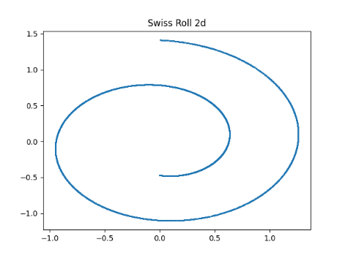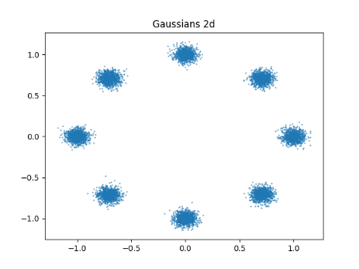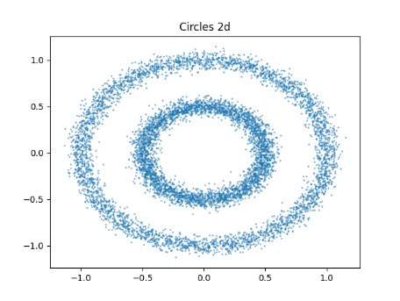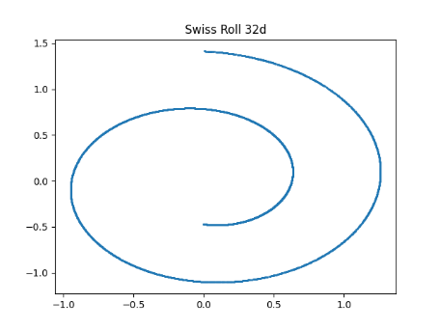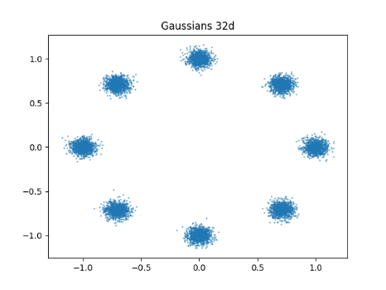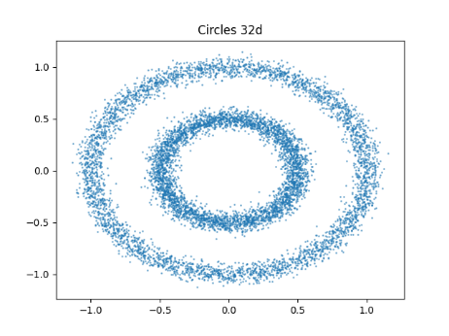
Task 1.2: v-prediction flow matching
Hyperparameters: v-prediction flow matching was implemented as per the assignment specification (25000 steps, 1024 batch size, Adam optimizer, Cosine Annealing Learning Rate schedule starting at 0.001 with a minimum learning rate of 0.0001.
The following datasets were sampled in 2d (raw data below for comparison):
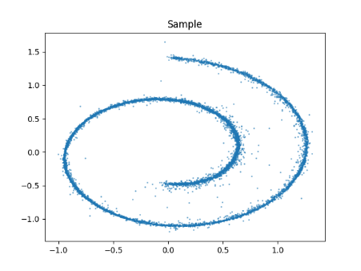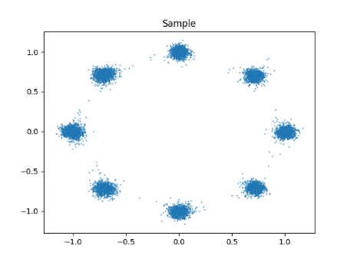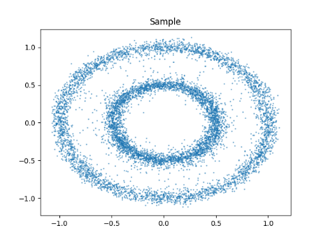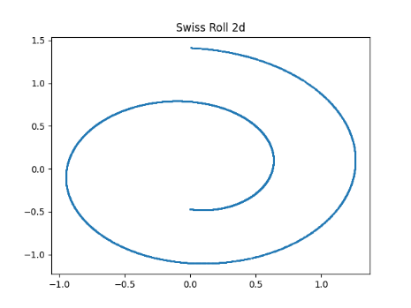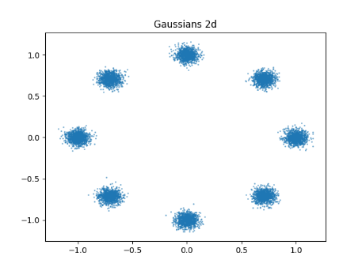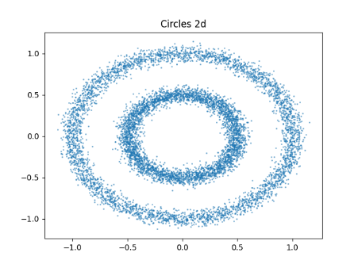
As we observe, the v-prediction flow matching generates a clearly recognizable but slightly noisy version of each of the training datasets.

Task 2.1: Flow matching parameterization
The forward process for flow matching is:
z_{t} = (1-t)x + tϵ (1)
Where v is defined as:
v = ϵ - x (2)
If we eliminate ϵ from (1) and (2) we get:
z_{t} = (1-t)x + t(v+x) (3)
Be rearranging (3), we get the following conversion formulae:
- If we have v-prediction and x-loss we compute the loss term:
Loss(θ) = mse(x, x_{θ}) where x_{θ} = z_{t}-tv_{θ}
- And if we have x-prediction with v-loss we compute the loss term:
Loss(θ) = mse(ϵ-x, v_{θ}) where v_{θ} = (z_{t}- x_{θ})/t
Task 2.2: Comparing parameterizations across 2d, 8d, 32d
Flow matching was implemented with the four different prediction/loss configurations for each dataset in 2d, 8d and 32d. The only change to the training configuration was restricting the sampled values of t to t ∈ [0.0001, 1] to avoid dividing by t ≈ 0 as this would cause numerical instability in the loss terms. The sampled results for each dataset, prediction quantity, loss quantity and dimension are shown on the following page.
Questions:
- As we observe, x-prediction scales more successfully to higher dimensions than v-prediction. The v-prediction generates good samples at D=2 with both loss types, however it generates visibly noisier samples at D=8 (particularly on the circles dataset and swiss roll dataset with x-loss), and fails altogether at D=32, where the sampled datasets are all unrecognizable. Conversely, x-prediction performs just as well at D=32 as it does at D=8 and D=2.
- Yes, the choice of loss space matters, especially for x-prediction. x-prediction performs significantly better with x-loss than v-loss across all dimensions, because the division by t in the v-loss calculation results in much larger loss gradients for t values close to 0, which creates a loss weighting where the model tries to hyper-optimize over late diffusion steps (t≈0) at the expense of important earlier diffusion steps. Thus, we observe much noisier generation samples when using v-loss with x-prediction across all dimensions. With v-prediction, the opposite effect applies – the multiplication by t when computing x-loss creates a loss weighting toward early diffusion steps (t≈1) at the expense of later diffusion steps. Thus, for v-prediction, we observe that the samples generated with x-loss have similar overall structure to those with v-loss but are always a bit noisier.
- At D=8 or D=32, the dataset is projected from 2d onto a 2d manifold in a higher dimensional space. If we use the raw data as the prediction target (x-prediction) the rank of the prediction target is 2 (the rank of x), regardless of the ambient dimension. This means that in training, the model learns to only ever predict points on a 2d manifold within D-dimensional space – concretely, all model weights corresponding to the rest of the D-dimensional space will be ≈0 after training. Thus, x-prediction scales well to higher dimensions because the rank of the underlying dataset is preserved.
The same does not apply to v-prediction. This is because the loss, ϵ, is sampled from the full D-dimensional space. This means that the prediction target, v = ϵ - x, is not confined to a 2d manifold in D-dimensional space. Indeed, the rank of v is D since this is the rank of ϵ. This means that the model has to optimize exponentially more nonzero weights in higher dimensions compared to D=2, which is a fundamentally harder problem. This is why x-prediction works at scale, while v-prediction fails.

2d results:
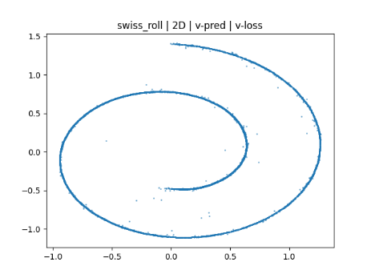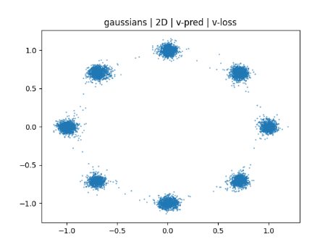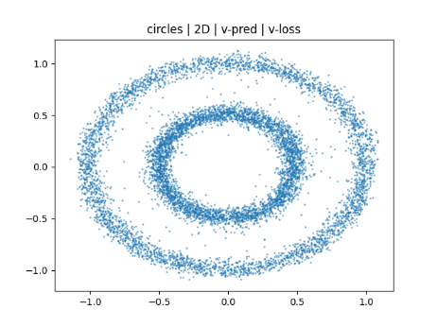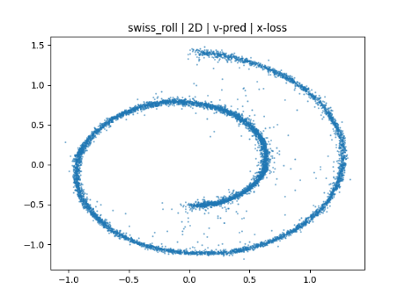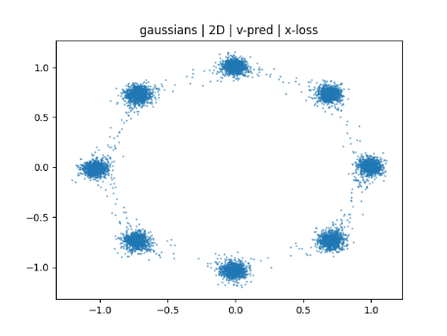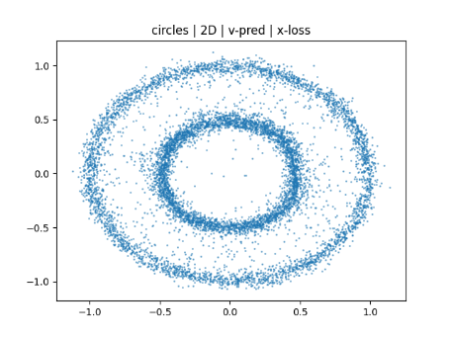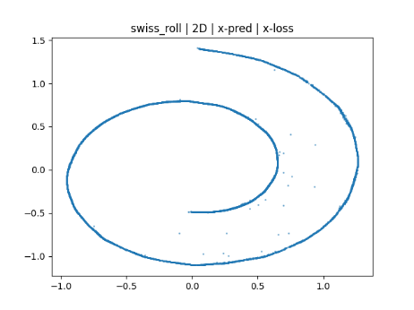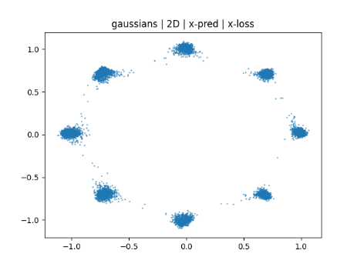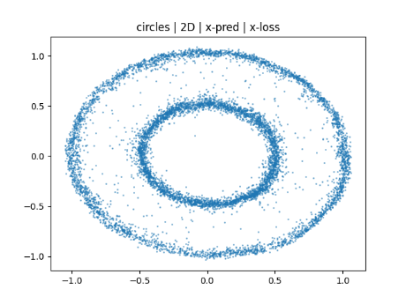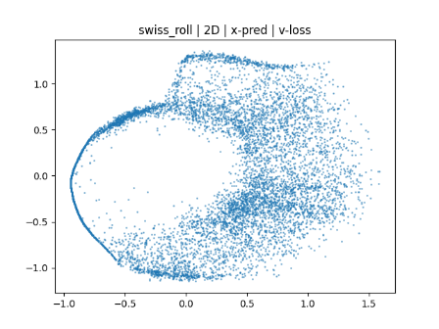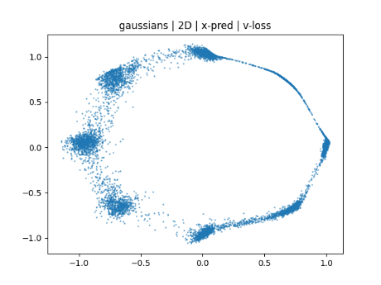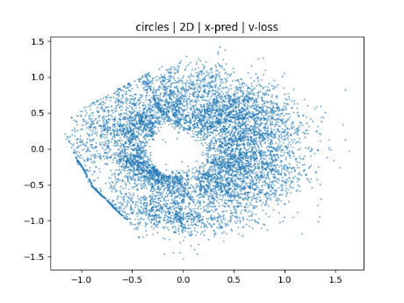

8d results:
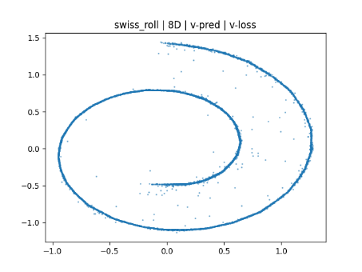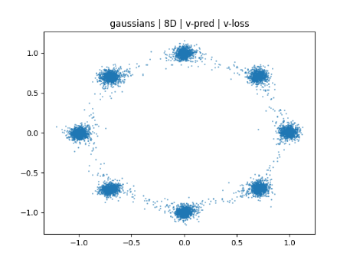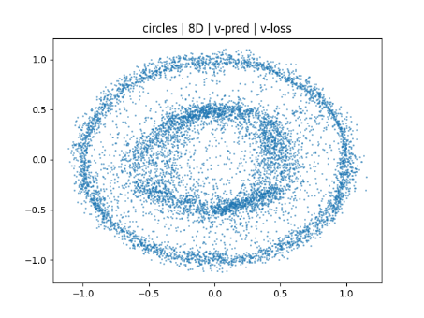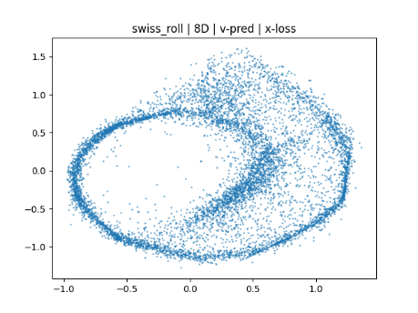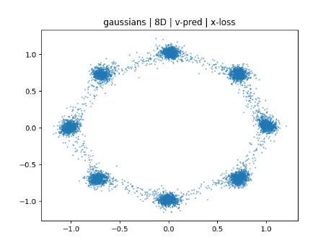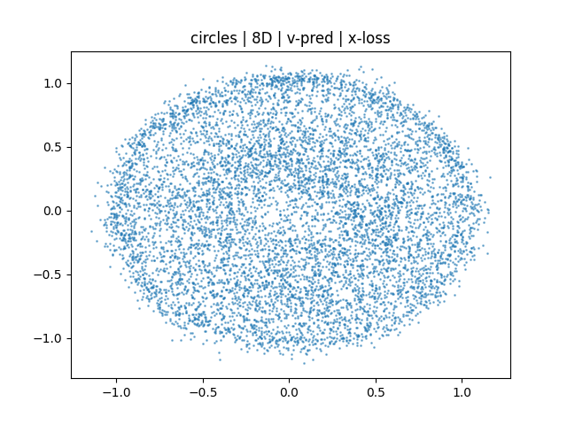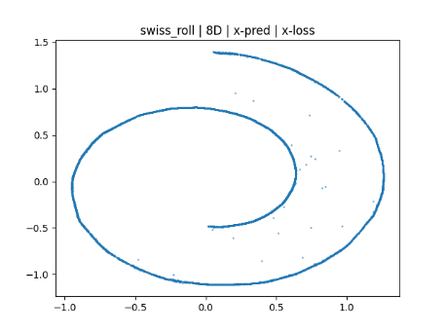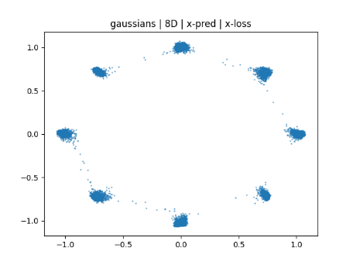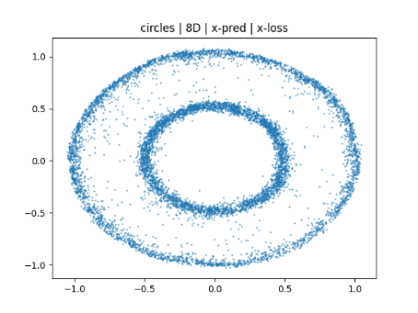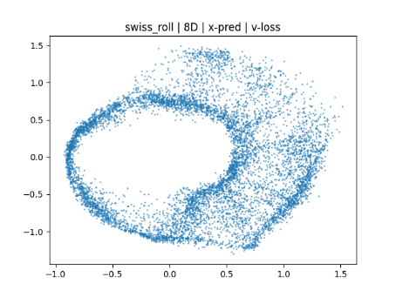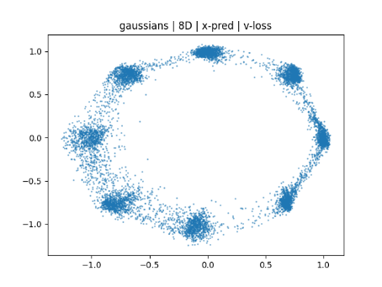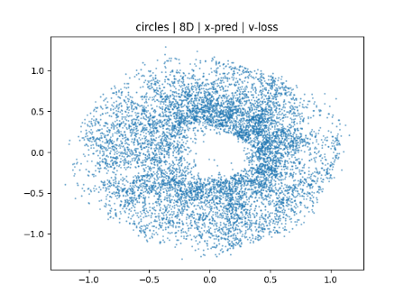

32d results:
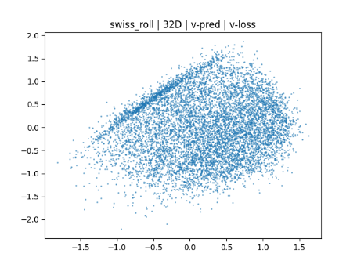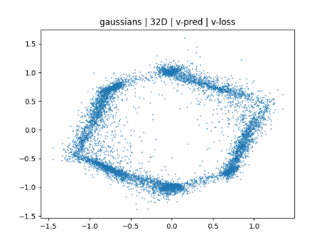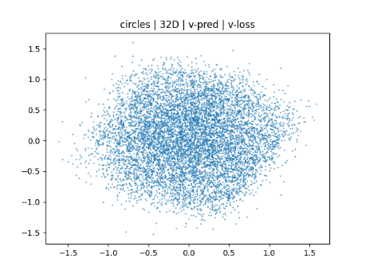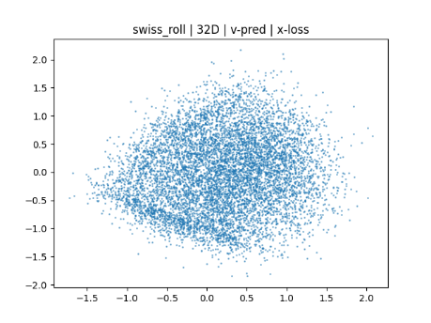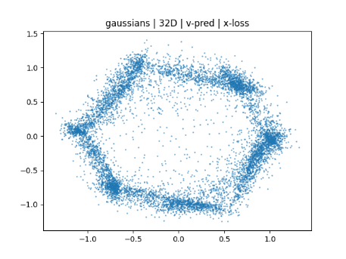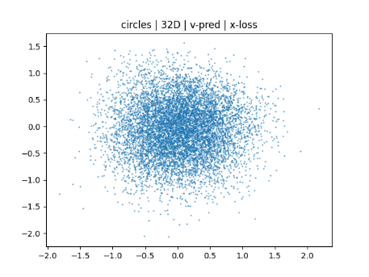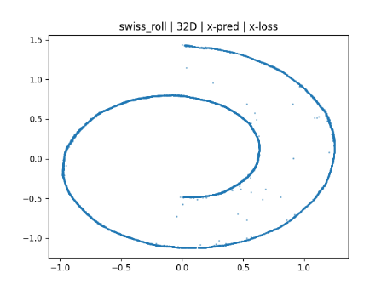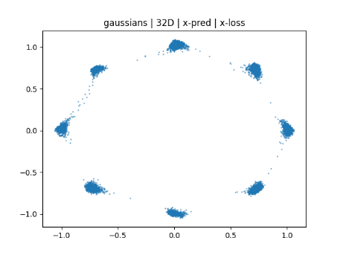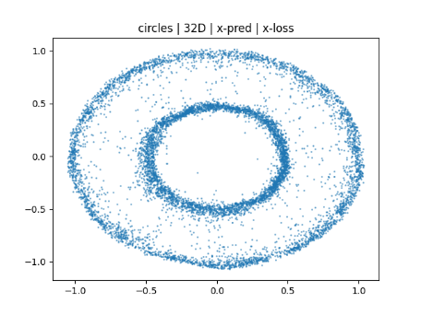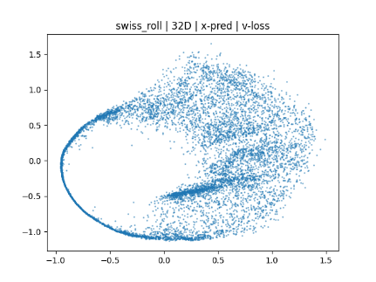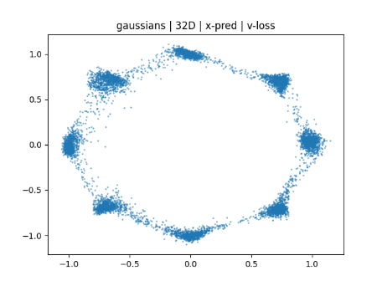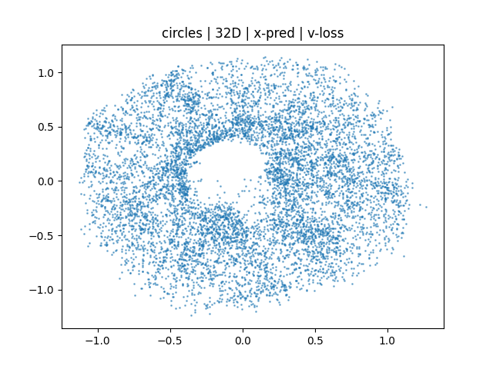

Task 3.1: Recovering v-prediction at D=32
The RAE paper suggests implementing a dimension-dependent noise scheduling to improve v-prediction training at higher dimensions. This was implemented exactly as per the paper with m=32 (embedding dimension) and n=2 (base dimension). That is: in the training loop, after sampling t uniformly from [0, 1] I applied the t-shift:
t_shifted = α*t / (1+(α-1)*t) where α=sqrt(m/n)
And then calculated z_t using t_shifted rather than the sampled t. The reason for this is that when the 2d data is projected into 32d and noise is sampled in 32d, most of the sampled noise falls off the 2d projection manifold, and so the model learns to ignore it. Therefore, in 32d it is better to train the model primarily on more heavily noised samples, so it learns to predict the underlying distribution within the projection manifold.
The following shows of a comparison of the default training configuration with t-shifting (left) versus without (right):
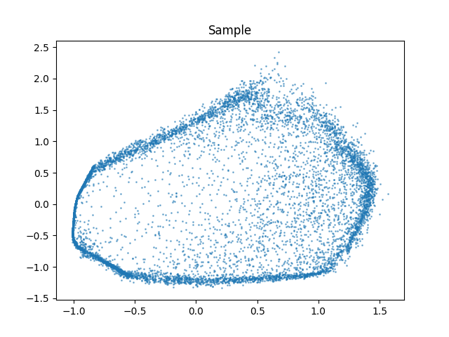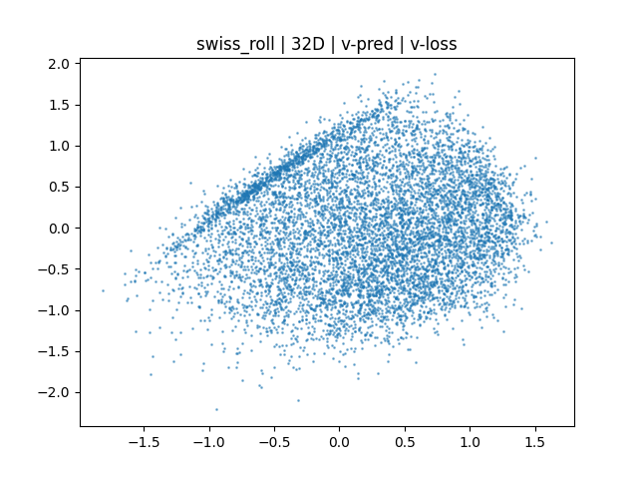
T-shifting improved the sampling performance, but it is still a far cry from the performance of x-prediction at D=32. In the next experiment, the number of training steps was increased from 25000 to 100000 (with t-shifting implemented), with a Cosine Annealing Learning Rate schedule between 1e-3 and 1e-5. The following sample was generated with this configuration:
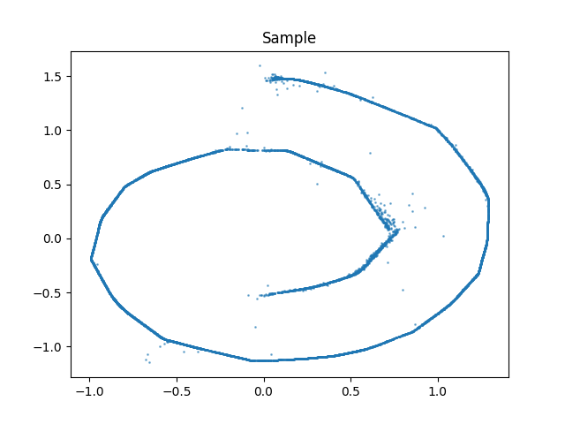
With setup, v-prediction performed comparably to x-prediction (although the generated sample has a few sharp corners which should be smooth curves). As a separate experiment, the learning rate was set lower to a Cosine Annealing schedule between 5e-4 and 5e-6. However, this caused sample generation quality to drop noticeably:
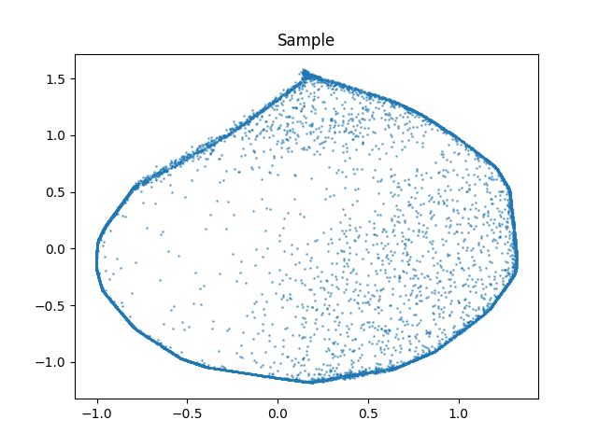
Increasing the number of Euler steps in sampling was tried and found to have no noticeable effect on sample quality.
Questions:
- V-prediction’s failure is not fundamental with this setup, since the model width of 256 exceeds the embedding dimension of 32. As demonstrated above, by implementing t-shifting and increasing number of training steps, v-prediction was able to produce a reasonable quality generation sample at D=32.
- I tried implementing t-shifting, increasing the number of training steps, decreasing the learning rate and increasing the number of Euler steps in sampling. My approach which achieves good sample quality is significantly more computationally expensive than the default setup with x-prediction, as it takes 4 times as many training steps, and also calls the (inexpensive) t-shifting function every training step.
- Below is a comparison of the generated samples using x-prediction (left) vs v-prediction (right) with t-shifting and 10000 training steps:
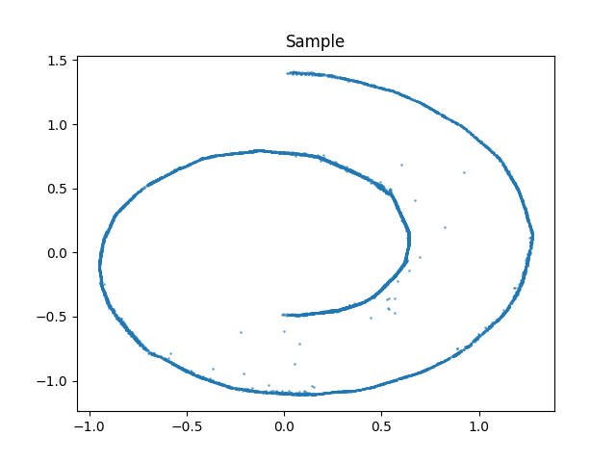 
As we can see, applying t-shifting and increasing the training steps did not improve performance with x-prediction like it does with v-prediction. This is because x-prediction only every learns points on a 2d manifold in 32d x-space, whereas v-prediction is not confined to a subspace of 32d v-space, and thus v-prediction requires longer training. T-shifting is also ineffective for x-prediction since the prediction targets (x) are independent of noise.
- V-prediction works in practice for image generation models such as Stable Diffusion 3 and FLUX, because real image data usually has an intrinsic dimension close to its ambient dimension, unlike our toy case where we have an intrinsic dimension of 2 and ambient dimension of 32. This means the problem we have of most of the noise falling off manifold doesn’t apply in real image generation. Furthermore, we demonstrated that it is still possible to recover v-prediction by optimizing the training configuration, as would be done in practice. Thus with appropriate model size and training configuration, v-prediction is successful in real image generation models.

Task 4.1: Sampling efficiency
Using the default training setup with x-prediction and x-loss on the swiss_roll dataset (D=32), the following samples were generated using 1, 2, 5, 10, 20, 50, 100 and 200 Euler steps:
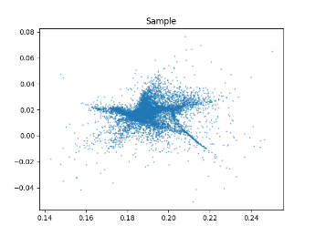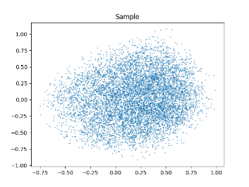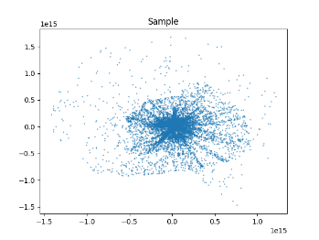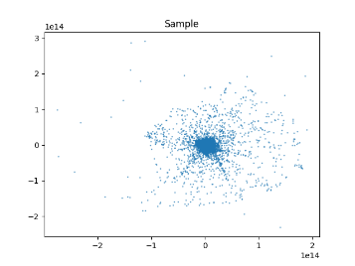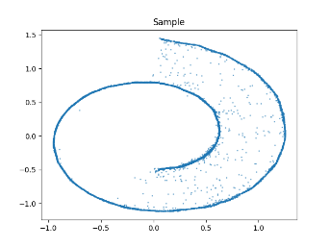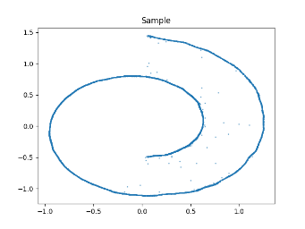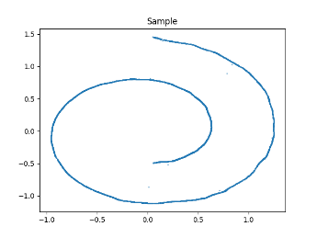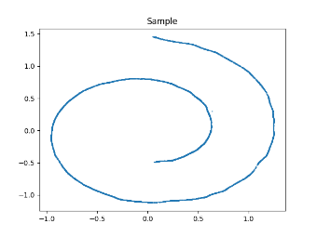
As we can see, sampling fails catastrophically with fewer than 20 steps but performs very well with more than 20 steps. The greater the number of Euler steps, the cleaner the sample generated, to the point where at 200 steps there is only one single visible point not on the spiral.
Task 4.2: Mean flow

