**Name: Oscar Ynoa**

**Student Id: 00308560**

**Course: Linux Administration (CIS-245-O1A)**

**Subject: Containers Ubuntu**

**Professor: Adrianna Holden-Gouveia**

**Date: 12/02/2021**

**How to install Docker on Ubuntu**

**Before doing anything always remember to become root in the server**

**The command for performing this action is sudo -i + the password**

**We start by updating the existing package first.**

**sudo apt update**

**It takes a while so leave it there**

**Then we install some packages that allow the apt to use packages over HTTPS sudo apt install apt-transport-https ca-certificates curl software-properties-common**

**We type Y and it is completed**

**Then we use the command to add a key curl -fsSL https://download.docker.com/linux/ubuntu/gpg | sudo apt-key add -**

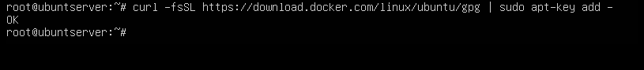

**Later we add the Docker Repository to APT sources with sudo add-apt-repository "deb [arch = amd64] https://download.docker.com/linux/ubuntu focal stable"**

**Then we realize another update because of the new added package.**

**sudo apt update**

**Now we realize the installation from the docker directory instead of the default in Ubuntu**

**apt-cache policy docker-ce**

**Now we just need to install docker with the next command**

**sudo apt install docker-ce**

**We type Y and it is finally over.**

**With this docker is installed and we just need to check.**

**sudo systemctl status docker**

**How to install Kubernetes on Ubuntu**

**We start writing the following command sudo apt-get install -y apt-transport-https**

**Then we install the curl command with sudo apt-get install curl**

**Then we proceed with sudo curl -s** [**https://packages.cloud.google.com/apt/doc/apt-key.gpg**](https://packages.cloud.google.com/apt/doc/apt-key.gpg) **| sudo apt-key add**

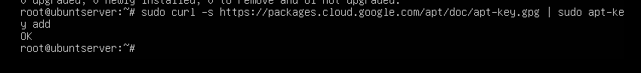

**We grant some permission to the kubernet with sudo chmod 777 /etc/apt/sources.list.d/**

**Then we have to add the repository url to our source file with deb http://apt.kubernetes.io/ kubernetes-xenial main**

**Now we can finally install Kubernetes with sudo apt install kubeadm kubelet kubectl kubernetes-cni**

**Then we need to turn off swap sudo swapoff -a and also do sudo kubeadm init. With that Kubernetes is finally installed**

**MiniKube on Ubuntu**

**To begin we must update the system:**

**sudo apt-get update -y**

**And then again do the same sudo apt-get upgrade -y**

**We need to install VirtualBox using:**

**sudo apt install virtualbox virtualbox-ext-pack**

**Press Y**

**Then we just accept the license agreement and we will be able to proceed.**

**Then we download minikube binary and set it to our desire path, then give it execution permission and install it. We use the following commands for this.**

**wget** [**https://storage.googleapis.com/minikube/releases/latest/minikube-linux-amd64**](https://storage.googleapis.com/minikube/releases/latest/minikube-linux-amd64)

**sudo cp minikube-linux-amd64 /usr/local/bin/minikube**

**To verify the version, type the following command :**

**minikube version**

**We just finished.**

**Overall, everything works. Minikube was not a problem. I did the ansible installation on my CentOs so I did not make it here. I think the worst by default was the kubernet because it had so many things for the installation and configuration, but everything went fine at the end. The only thing that could mess me a little was the thing of how many pages it was supposed to be. I cut a lot of stuff but ended up with this many.**

**References**

[**https://www.digitalocean.com/community/tutorials/how-to-install-and-use-docker-on-ubuntu-20-04-es**](https://www.digitalocean.com/community/tutorials/how-to-install-and-use-docker-on-ubuntu-20-04-es)

[**https://computingforgeeks.com/deploy-kubernetes-cluster-on-ubuntu-with-kubeadm/**](https://computingforgeeks.com/deploy-kubernetes-cluster-on-ubuntu-with-kubeadm/)

[**https://www.youtube.com/watch?v=MyNnVurtSf0&ab_channel=Simplilearn**](https://www.youtube.com/watch?v=MyNnVurtSf0&ab_channel=Simplilearn)

[**https://phoenixnap.com/kb/install-minikube-on-ubuntu**](https://phoenixnap.com/kb/install-minikube-on-ubuntu)