How to Implement 2.5D Graphics
Oscar Lara | A01781855

Introduction
2.5D graphics refers to a visual style that creates the illusion of three-dimensional depth using two-dimensional techniques. This document covers the three main approaches used in game development, and explains how our engine implements them for the Racing Roguelike project.

Sources
Wikipedia — 2.5D: https://en.wikipedia.org/wiki/2.5D
Wikipedia — Mode 7: https://en.wikipedia.org/wiki/Mode_7
Wikipedia — Ray Casting: https://en.wikipedia.org/wiki/Ray_casting
GitHub — Cubified/mode7: https://github.com/Cubified/mode7

2.5D Techniques

Skyboxes and Skydomes
Skyboxes and skydomes are methods used to create immersive backgrounds that make a game level appear larger than it actually is. If the level is enclosed in a cube, distant elements such as the sky, mountains, and buildings are rendered onto the cube's faces using a technique called cube mapping, creating the illusion of three-dimensional surroundings. A skydome employs the same concept using a sphere or hemisphere instead of a cube.

Scaling Along the Z Axis
In some games, sprites are scaled larger or smaller depending on their distance to the player, producing the illusion of motion along the Z (forward) axis. This technique is at the core of billboard-based sprite rendering, and is the method we use for rendering karts and objects in our engine.

Mode 7
Mode 7 is a graphics mode from the Super Nintendo Entertainment System (SNES) that allows a background layer to be rotated and scaled on a scanline-by-scanline basis to create depth effects. The most well-known application is the perspective effect on a background layer, which transforms it into a two-dimensional horizontal texture-mapped plane that trades height for depth, achieving an impression of three-dimensional graphics.
Mode 7 graphics are generated for each pixel by mapping screen coordinates to background coordinates using an affine transformation:
r' = M(r − r₀) + r₀
Where M is a 2x2 transformation matrix, r is the screen coordinate, and r0 is the origin. This maps every pixel on screen to a corresponding point in the 2D map texture.
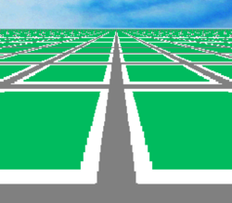

Ray Casting
Ray casting is a first-person pseudo-3D technique in which a ray is sent from the camera position for every vertical slice of the screen. These rays travel until they hit an object or wall, and that portion of the wall is rendered in the corresponding screen slice. Due to the limited camera movement and internally 2D playing field, this is considered a 2.5D technique.

Our Implementation
Our engine combines all three techniques described above. The canvas is divided by a horizontal Horizon Line at y = canvasHeight / 2. Everything above this line is the sky, and everything below is the floor rendered with Mode 7-style perspective.
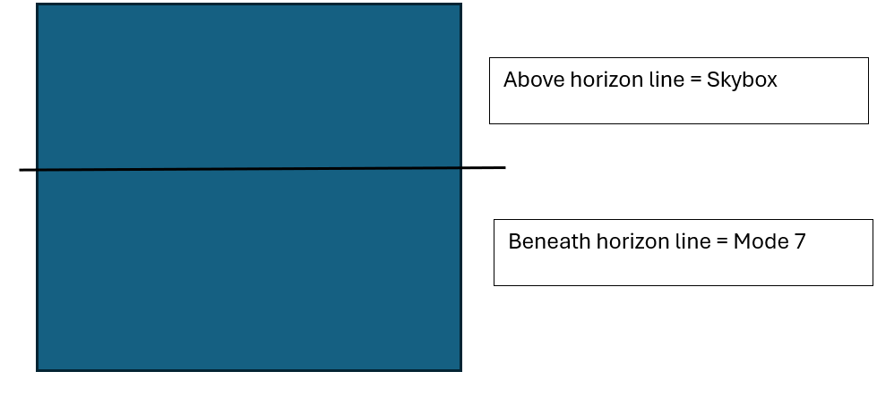

The Horizon Line and Row Distance
For every row of pixels below the horizon, we calculate how far that row is from the camera using the following equation:
rowDist = camera.posZ / (y − horizon)
camera.posZ is the virtual height of the camera above the floor. The denominator (y − horizon) is small for rows near the horizon (far away) and large for rows near the bottom of the screen (close to the camera). This gives us correct perspective scaling automatically.
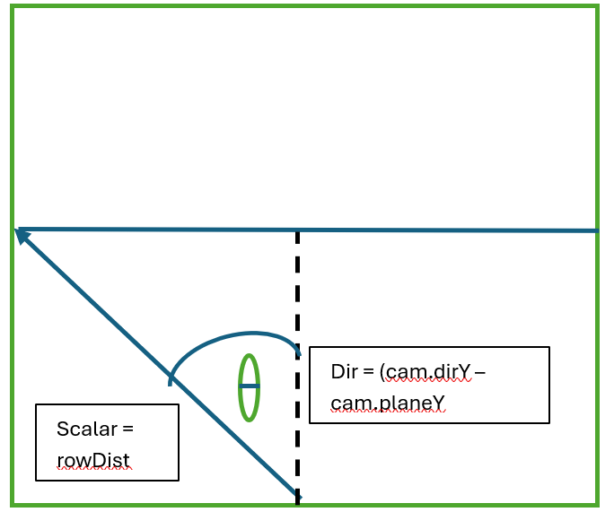

Finding the Left Edge of Each Row
For each row, we find the map coordinate that corresponds to the leftmost pixel using vector scaling:
floorX_step = rowDist × (camera.dirX − camera.planeX)
floorY_step = rowDist × (camera.dirY − camera.planeY)
The expression (dirX − planeX) is the vector pointing to the left corner of the camera's field of view. Multiplying by rowDist scales it to the correct distance in the map, giving us the starting map coordinate for that row.
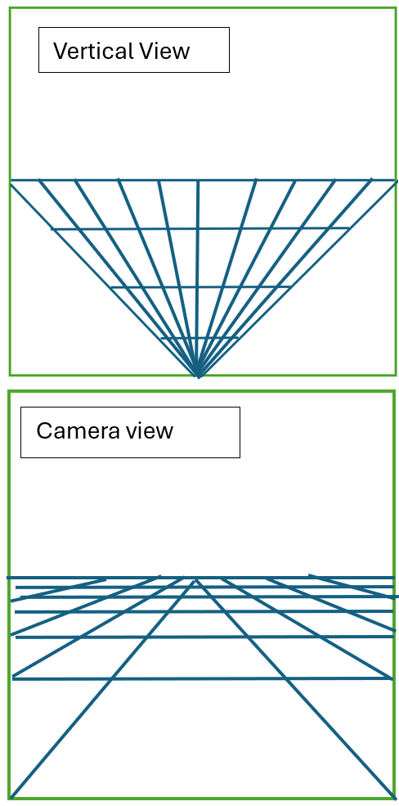

Advancing Across Each Row (Discrete Derivative)
To find the map coordinate for every subsequent pixel in the row, we use a discrete derivative — how much the map coordinate changes per pixel advance:
stepX = rowDist × (2 × camera.planeX) / screenWidth
stepY = rowDist × (2 × camera.planeY) / screenWidth
2 × planeX represents the total width of the camera plane from left edge to right edge. Dividing by screenWidth gives the map distance per pixel. Rows closer to the horizon have a larger rowDist, meaning each pixel covers more map distance — which produces the compression of distant elements seen in perspective rendering.
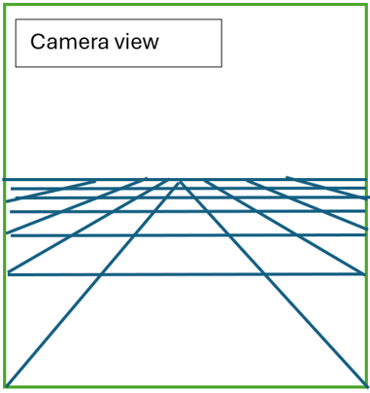

Mapping Floor Coordinates
The final map coordinate for pixel (x, y) is calculated by adding the camera position to the step offsets:
floorX = camera.posX + floorX_step
floorY = camera.posY + floorY_step
This translation from origin to camera position is essential — without it, the perspective would be calculated from the world origin (0, 0) rather than from the camera's actual position in the map.

Rendering the Pixel Buffer
With the map coordinate known for each pixel, we sample the texture or grid at that position and write the result directly into the pixel buffer:
for (let x = 0; x < this.width; x++) {
const i = (y * this.width + x) * 4;
pixels[i] = r; // Red
pixels[i+1] = g; // Green
pixels[i+2] = b; // Blue
pixels[i+3] = 255; // Alpha
floorX += stepX;
floorY += stepY;
}
Each pixel occupies 4 consecutive positions in the buffer (RGBA). The index formula (y × width + x) × 4 maps 2D canvas coordinates to a flat array index.
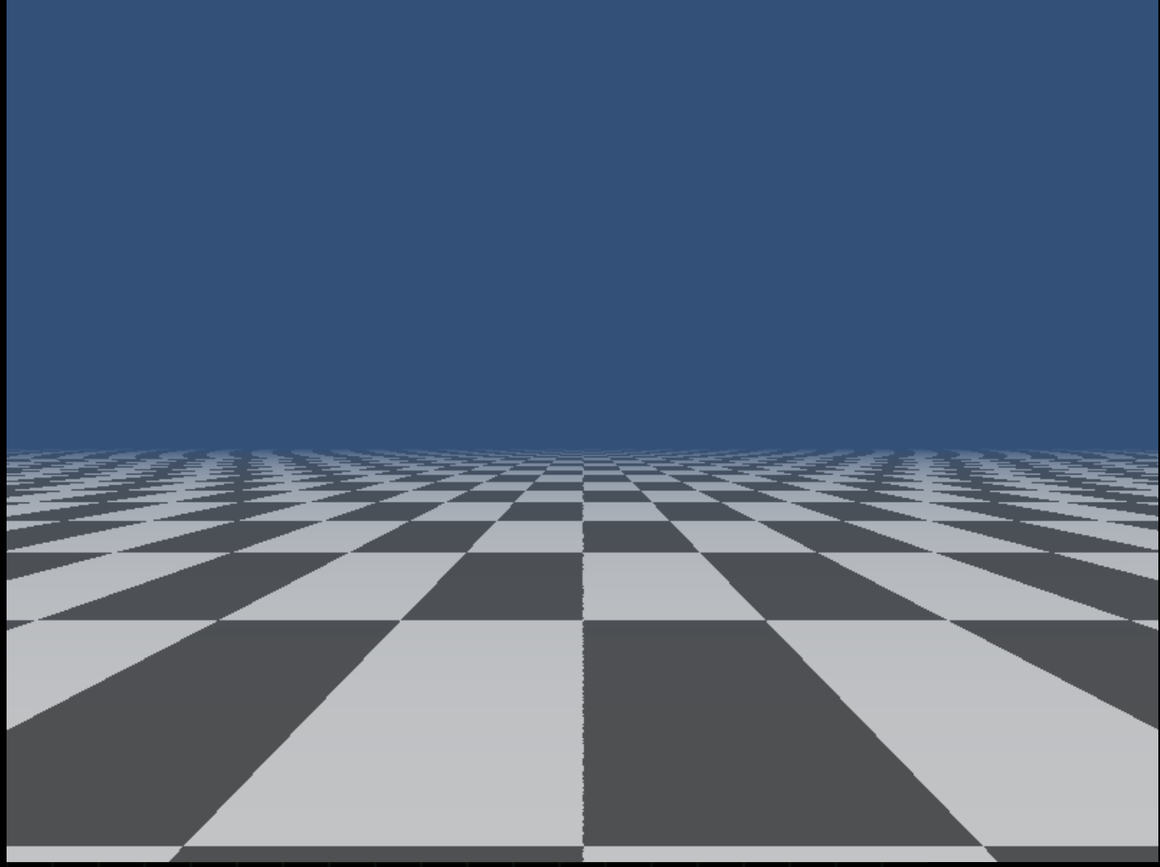

Conclusion
Our 2.5D implementation combines Mode 7-style floor projection, Z-axis sprite scaling, and a sky fill into a unified rendering pipeline. The result is a perspective-correct view of a 2D map that runs efficiently in the browser using the Canvas API pixel buffer.
The key insight is that perspective arises naturally from the equation rowDist = posZ / (y − horizon) — the same mathematical relationship that governs how parallel lines appear to converge in real-world perspective. Every other calculation in the renderer follows directly from this single formula.

