**Background on the Addressed Thermodynamic Problem**

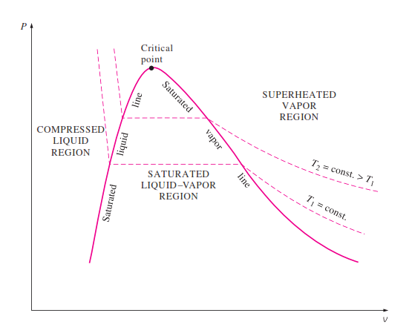Basically, the project is based on the subject of the phases of pure substances, more specifically, with the properties of pure substances during the process of vaporizing the substance (transforming the substance from the liquid state to the vapor one). This specific situation has three sub-states itself. 1- the substance being in the liquid state, 2- the substance being in the vapor state, 3- the state in between where the substance is in an inseparable state between both being liquid and vapor. The problem in hand is more concerned with the bridge between the 2nd and 3rd state. In other words, about the properties of a certain pure substance, which is water, during the transition from being in the inseparable state to being in the vapor state. Thermodynamics provides a diagram for describing both the pressure and volume of the substance during all of these states. This diagram is the *p-v diagram for pure substance (figure 1)*, which provides information about the relation between both the pressure and the volume of the substance during its transitions between the liquid and vapor states. Another useful information that can be extracted from this relation are; the boundary work and the bulk modulus of the substance, which are the work exerted by the substance on its surroundings while expanding during the transition (Boundary Work), and a constant which represents how resistant to compression the substance is (Bulk modulus), respectively. The goal of the project is to get these two pieces of information for water from the data that represents the p-v relation using analytical and numerical methods of interpolating, integration and differentiation on these data.

Figure

**Algorithms background:**

**Cubic splines:**

In many engineering problems, we normally have measured values for a specific value collected from precise experiments. However, as shown in this problem, we might need to evaluate the function on a value other than the ones used in the experiment. In order to do this, we use splines and for accurate results we use cubic spline. The method is based on cutting the measured value to intervals. Each interval has its own equation based on coefficients and their second derivatives. The main advantage of this method is that it provides high accuracy for the values within each interval.

**Thomas algorithm:**

**Numerical integration:**

Usually, analytical integration can be used for simple problems. However, there are problems where integrating the given problem’s function analytically would be time consuming and might be too difficult. Therefore, using numerical integration would be more time efficient and easier to work with. In order to evaluate the numerical integration, there are 3 known methods for doing so, trapezoidal rule, 1/3 Simpson and 3/8 Simpson. In this project, we chose to use the trapezoidal method for its efficiency in data given as points.

**Numerical differentiation:**

Similar to the numerical integration, evaluating the derivative at a certain value can be complex and difficult especially if the values are given in tabular form without knowing the function beforehand. In this case, using numerical differentiation methods can make the process much easier with accurate results depending on the error type of the equation used. The main method for evaluating the derivative is through the absolute difference between the value of the function at two points surrounding the wanted value divided by the difference between the two points. For higher derivatives, the expression of the result is obtained from the Taylor expansion of the function.

**Code functionality:**

numerical_int( x, y):

The function takes the values of the volumes as x and the corresponding pressures as y, with the first and last value being calculated from the splines equations. Afterwards, it calculated the values of the integral using the trapezoidal method by calculating the partitioning the values into segments and calculating each one of them separately and add them up in the end to get the integral.

numerical_spline_int( splines,values,x1, x2):

The function takes the coefficients of each spline interval, the values of the volume, and the two point between which we want to calculate the integral and a value representing the integration of the pressure along the value v1 and v2. The function uses the trapezoidal method since it gives accurate and efficient results.

numerical_diff(splines,values):

The function takes the coefficients of each spline interval, the values of the volume and returns a vector containing the derivatives of the given points. The function uses a difference of 1e-12 and handles three cases. The first case is if the given point is the last in the dataset, in this case it uses the backward difference. The second case is if the given point is the first in the dataset, in this case it uses the forward difference. Otherwise, it uses the centered difference method.

compute_2nd_deriv(Vg, P):

the function take the values of both the volume and their corresponding pressures and returns a vector containing the second derivative of each point. This is using the cubic splines assumption that the first and last points’ derivatives are both zero. The function uses another Thomas function to solve the acquired equations.

linear_spline(Vg, P):

The function takes as input the values of both the volume and their corresponding pressures and returns a matrix in which each row represents the coefficients of the corresponding linear spline. the function directly calculate the coefficients using the slope between every two points.

quadratic_splines(Vg, P):

The function takes as input the values of both the volume and their corresponding pressures and returns a matrix in which each row represents the coefficients of the corresponding quadratic splines. The function uses gauss method to solve the generated system of equations

cubic_spline(Vg, P, d2y):

The function takes as input the values of both the volume and their corresponding pressures in addition to the value of the second derivative at each given volume. It then returns a matrix in which each row represents the coefficients of the corresponding cubic splines.

valid_range(v1, v2, data_start, data_end):

A Boolean function which takes as input the two inputted values, the start of the data , and the end of it. It returns 1 if both values are within the given dataset obtained from the table.

F(f, x):

This function takes as input the coefficients of the spline containing the value x, along with x which we want to compute the function’s value for it.

analyt_int_sliced(inner_splines, X):

the function takes a matrix containing the coefficients of the splines and the vector of the given volumes X. It then loops over the given values and coefficients and computes the analytical integration of each segment.

analyt_int(f(i), X(i), X(i+1)):

The function take a vector containing the coefficients of the spline containing the other two inputs, x(i) and x(i+1) representing the volumes at the end of each segment.

analyt_diff_sliced(inner_splines, X):

the function takes a matrix containing the coefficients of the splines and the vector of the given volumes X. It then loops over the given values and coefficients and computes the analytical differentiation of each segment.

analyt_diff_sliced(f, X):

The function take a vector containing the coefficients of the spline containing the other input, X representing the volumes at which we want to get the derivative.

**Code FlowChart:**

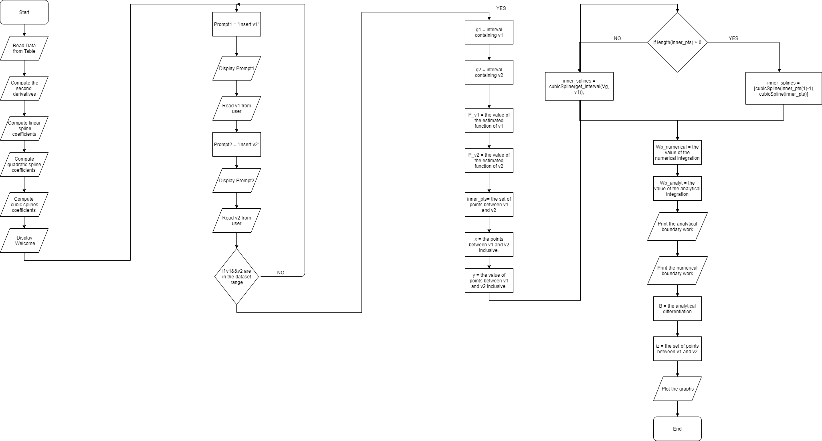

**Results:**

Requirements:

1. Calculate the values of p1 and p2:

Using the cubic spline functions we managed to calculate the pressures corresponding to both v1 and v2, respectively and output them to the user

1. Calculate the boundary work using the equation $\int_{v2}^{v1}{Pdv}$

Using the splines’ equations we managed to calculate the boundary work, both analytically and numerically.

The results were surprisingly close which shows how efficient numerical methods are.

Below are the computed values for v1=1 and v2=15



1. Calculate the bulk modulus using the equation $B= -v\frac{dP}{dV}$

Using the splines’ equations we managed to calculate the derivative of the pressure with respect to the volume, both numerically and analytically.

For the numerical differentiation, we chose to use an h equal to 1e-12 to guarantee high accuracy after trying several other values. The results were indeed accurate and almost the same as the analytical ones.

Below are the computed values for v1=1 and v2=15

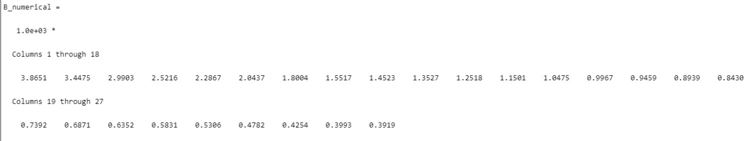

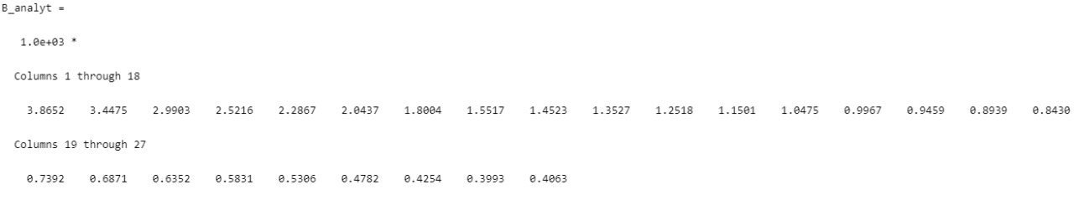

1. Plots:
   1. 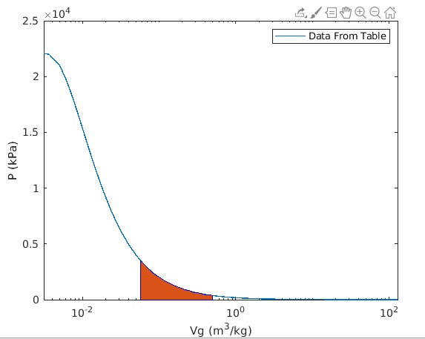

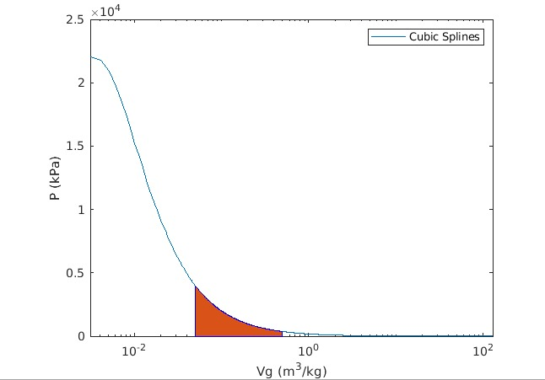

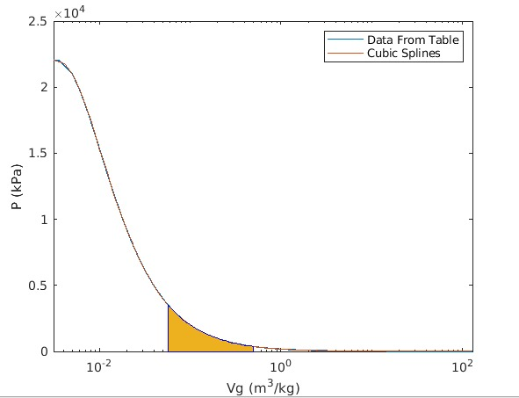

As shown, the cubic splines manage to fit the dataset smoothly allowing for accurate predictions of the pressure.

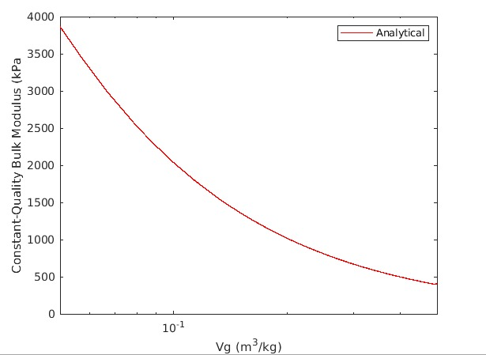

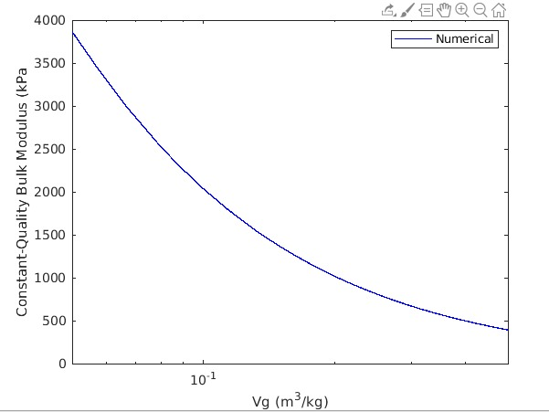

As shown, the results are very accurate and close the analytical figures.

**Conclusion and Future Work**

The conclusion of the project is our software that is capable of extracting both the boundary work and the bulk modulus of water based on two points that are in the range of the data provided. Possible future work might include performing extrapolation on the given data to be able to take any possible values for v even if it is not in the given data’s range. Also, we could import the data for different substances to be able to get the same information for several substances other than water.

**References**

Boundary Work. (n.d.). Retrieved from <http://www.mhhe.com/engcs/mech/cengel/notes/BoundaryWork.html>.

Bulk modulus. (2019, November 11). Retrieved from <https://en.wikipedia.org/wiki/Bulk_modulus>.