|  |  |
| --- | --- |
| Name(s): | Jeremy Richard-Ikediashi, Kamsiyochukwu Uwah |
|  |  |

**Do not remove the table below. It should be present when you submit your work**

**Due at the end of the starting Lab period**

**Include images of your results below:** These images should be clipped so that they show only the desired results as shown in the lab manual. Insert as much space as you need but keep all text present in this lab sheet intact. Feel free to insert any comments you would like, especially if you did something above and beyond the requirements that you think should be considered for extra credit.

Be sure to check for anything that might generate penalty points as indicated on the submission site.

1. Place a screen shot of your initial GUI as it appears before any button is clicked.

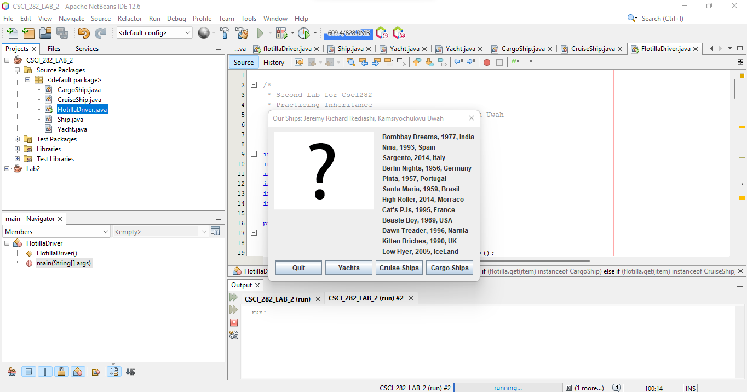

2. Place a screen shot of your GUI after the Yacht Button is clicked.

3. Place a screen shot of your GUI after the Cruise Ship Button is clicked.

4. Place a screen shot of your GUI after the Cargo Ship Button is clicked.

