Image Source: www.rbnz.govt.nz

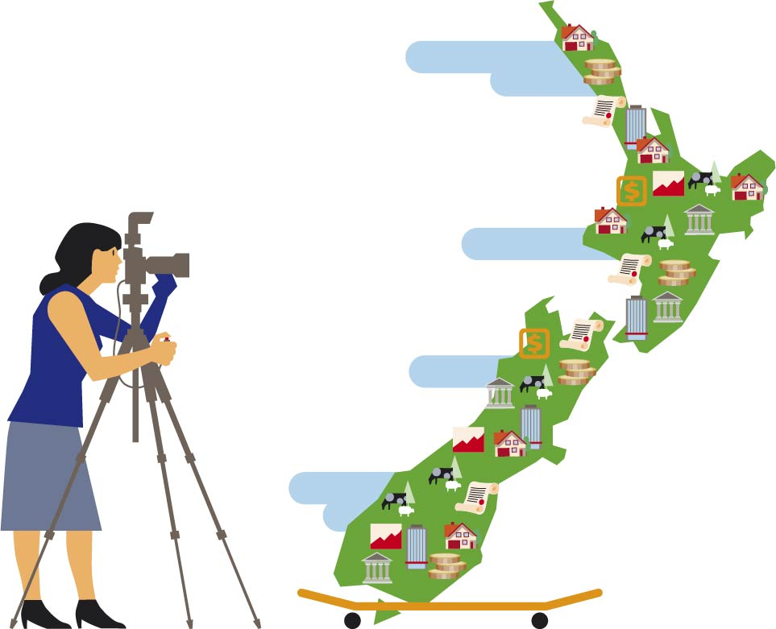

**Group Project Report**

# **Kiwi Budget : A Database of New Zealand Economic Activities (1996 ~ 2022)**

Jinze(Jerry) Zhou, Ali Ansar, Mingqiu(Jeffery) Chi

DATA-422

# Abstract

# This data set contains data covering major economic activities and a key monetary policy indicator (OCR) of New Zealand, from 1999 to 2022. Our analysis of this dataset verifies some correlations between OCR, CPI, HPI and other economic data. All data are scraped from online sources which are publicly available. The reuse potential includes training machine learning algorithms that do the forecasting. This data set is available through publishing API.

# Purpose

Our aim is to collect a data set that contains a small but limited number of the most critical economic data indicators, such as monetary policy indicators (OCR only), house price indices (HPI), CPI, unemployment rate, tourism data and import/export data, with the expectation of seeing correlations between the data, which may provide a reference for financial planning for companies or individuals. The reuse potential includes training machine learning algorithms that do the forecasting.

# Methodology

Our data collection, processing and analysis process basically follows the following steps as shown in following diagram:

Image Source: monkeylearn.com

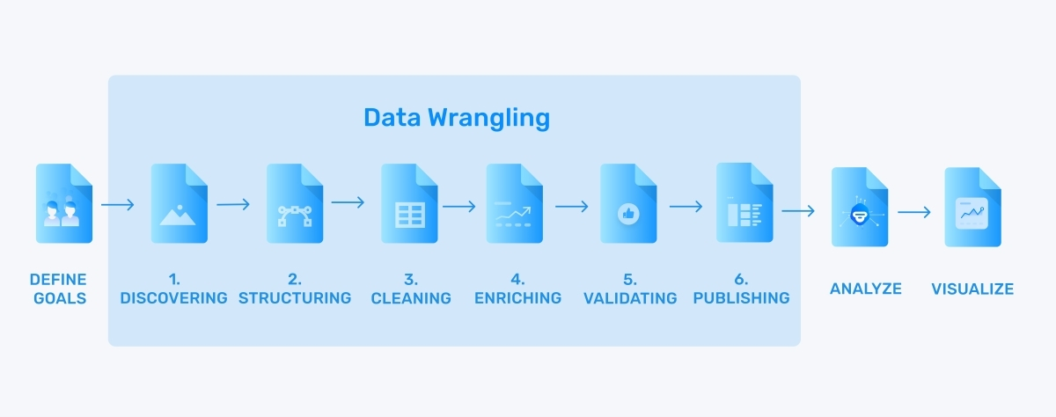

Figure 1 Data Process Pipeline

We have summarized them into the following modules:

* Goals & Model
* Data Collection
* Data Wrangling
* Data Visualize & Analyze

## Model

The goals have been described in the previous section and we briefly describe the economic and financial rationale underlying the data.

Monetary policy that are measures employed by governments to influence economic activity, specifically by manipulating the supplies of money and credit and by altering official cash rate (OCR). The usual objectives of monetary policy are to control inflation, maintain full employment and achieve high economic growth rates, but these objectives are in conflict. Inflation control is the RBNZ's only objective under the Banking (Prudential Regulation) Act 1989, but the conflicting objective of guaranteeing employment was planned for 2018 and added to the Reserve Bank of New Zealand Act 2021 (RBNZ, 2022). We believe we would see this conflict in the data. High CPI trends in recent years, caused New Zealand Reserved Bank to adopt measures to reduce inflation by restricting growth in the money supply and increasing the interest rate.

Based on economic principles, as New Zealand Reserve Bank sets its interest rate up, businesses will have difficulty getting cheap loans for further development, it is anticipated that business development will be reduced, hence in terms of cargo statistics, housing prices, and tourism counts, we are anticipating dropping in these activities as well as leads to increase of unemployment. On the other hand, an increase in the Reserve Bank interest rate will attract oversea hot money for a short-term investment, therefore it is anticipated that the exchange rate of New Zealand dollars VS. Other currency will go up.

We will collecting online public data to verify economic principles and examine relationship between data. We collected the following data to test the correlation:

* Official cash rate
* CPI
* Unemployment rate
* HPI (Housing price index)
* Exchange rate(NZDUSD/NZDRMB)
* Tourism
* Exports and Imports data.

The data is collected separately and wrangled into a table, the overall structure is shown in the figure below:



Data collection, wrangling, visualize and analyze will be describe in the following section.

# Data Collection

## Data Source

As all data is publicly available on the RBNZ, it is in principle more reliable to collect data from the source where it was originally published, which is the RBNZ website. However, due to the redesign of the RBNZ website, which uses Cloudflare as the CDN and refuses to automatically crawl content, we failed to scrape data from RBNZ although we tried various methods of disguise. As time constraints, we had to choose other crawler-friendly sites to get the data. After much searching and searching we finally settled on three crawler friendly sites to get the data:

* infoshare.stats.govt.nz
  + Labour force status data (Unemployment rate)
  + Tourism visitor data
  + Import & Exports data
* [www.interest.co.nz](http://www.interest.co.nz)
  + Official Cash Rate
  + CPI & HPI
  + NZD-USD Exchange Rate
* api.ofx.com
  + NZD-RMB Exchange Rate

Infoshare is a free service provided by Statistics New Zealand to allow the viewing of survey data. The website “interest.co.nz” is partnered with Calculate.co.nz which has created New Zealand's largest collection of calculators. While “ofx.com” is a currency exchange platform regulated by over 50 regulators globally. The backgrounds of these data sources give them high creditability.

## Crawler, Scraping & API

# Data Wrangling

# Data Visualization and Analyses

# Summary

**Reference**

RBNZ (2022). *Our legislation*. https://www.rbnz.govt.nz/about-us/responsibility-and-accountability/our-legislation.

Total word counts excluding the tables, reference and appendix are xxxx.