SUBJECT: Web Development (INTRODUCTION) (WEDE5020)
NAME: Osego
SURNAME: Seeti
STUDENT NUMBER: ST10536642
GROUP 2
ORGANISATION OVERVIEW ....................................................................................... 2
WEBSITES GOALS & OBJECTIVES ............................................................................... 2
WEBSITE ANALYSIS ................................................................................................... 3
WEBSITE FEATURES AND FUNCTIONALITY..................................................................... 4
DESIGN AND USER EXPERIENCE ................................................................................... 4
TECHNICAL REQUIRMENTS .......................................................................................... 6
TIMELINE AND MILESTONES ......................................................................................... 6
BUDGET ...................................................................................................................... 7
REFERENCES ............................................................................................................... 7
ORGANISATION OVERVIEW ....................................................................................... 8
WEBSITES GOALS & OBJECTIVES ............................................................................... 8
WEBSITE ANALYSIS ................................................................................................... 8
WEBSITE FEATURES AND FUNCTIONALITY..................................................................... 8
DESIGN AND USER EXPERIENCE ................................................................................... 9
TECHNICAL REQUIRMENTS ........................................................................................ 11
TIMELINE AND MILESTONES ....................................................................................... 11
BUDGET .................................................................................................................... 11
REFERENCES ............................................................................................................. 12

PROPOSAL A
ORGANISATION OVERVIEW
- NAME: Stanceinsa
- HISTORY: Car enthusiasts, stanced car drivers, and modified car drivers are the primary customers of Stanceinsa, a customs online business. In South Africa, where the stance culture began to expand quickly in the early 2010s, Stanceinsa filled a much-needed market need in 2018. Stanced automobiles have been the norm throughout the world. automobile shampoos, body waxes and interior scents, automobile accessories, air suspension kits, and coilovers are just a few of the car care products available in the online store.
MISSION STATEMENT: Stanceinsa's Vision and Mission is to let customers express their love for cars through the high quality of products in their catalogue. To provide high-quality automotive performance and styling products at affordable prices while helping customers express their individuality through their vehicles and building a strong automotive community
VISION STATEMENT: To become South Africa's leading online provider of automotive performance and style, renowned for their excellent goods, first-rate customer support, and community participation.

TARGET AUDIENCE
- Car enthusiasts
- Car detailers
- Vehicle owners wanting to modify car suspension
WEBSITES GOALS & OBJECTIVES
- SELL PRODUCTS ONLINE: Car shampoos, waxes, ceramic coatings, detailing equipment, suspension kits and coilovers.
- GENERATE LEADS: Allow customers to book appointments for suspension installation online.
- Present key performance indicators (KPI) to measure success.

WEBSITE ANALYSIS
STRENGTHS
- Customers instantly know what the website is about as the home page has images of coilovers, air suspension kits, car care products front and center.
- The product category is quick to access, making it easy to navigate between products that are being sold.
- Selling both car care detailing products and car parts is advantageous as customers want to take care of their cars, especially car enthusiasts.
- Both contact number and email address are provided for any inquiries that customers may have the contact number provided ensures faster and reliable communication.
WEAKNESSES
- The homepage is clustered with the showcase of products they provide which are already done in the product catalogue.
- The website does not have customer reviews of the products sold, which could lead to customers not trusting the website.
- Lots of products are marked "sold out” and there is no information about when stocks will be available which results in loss of customers.
- The website has more texts than it has images of what they sell.
Areas of Improvement
- Add a customer review to create trust for other customers interested in purchasing products.
- Improve homepage content to explain what the business is all about to customers.
- Highlight featured products and promotions.
- Improve SEO to get stanceinsa.co.za be a recommendation when customers search “Car modification stores in South Africa”

WEBSITE FEATURES AND FUNCTIONALITY

Improved website should include:
- Homepage
- AboutUs
- Products Catalogue
- Product Search
- Shopping Cart
- ContactUs
- Gallery
- Customer Reviews
- Social Media Links

DESIGN AND USER EXPERIENCE

Colour scheme
- Black
- White
- Gray
- Red
- Blue (Buttons and links)
Typography
- Montserrat Bold

Layout and Design
- Easy to use navigation menu
- Featured product selection
- Responsive design for computers and mobiles

User experience considerations
- Fast loading pages
- Simple navigation
- Mobile responsiveness
- Clear product description
- Contact option
Wireframes:
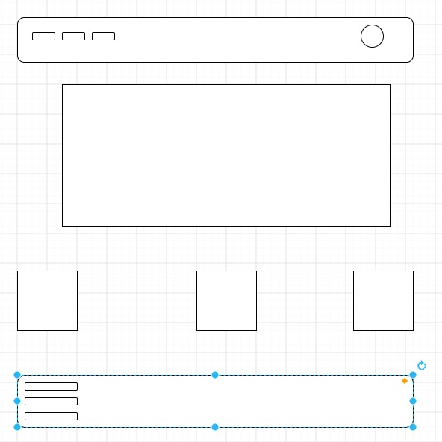
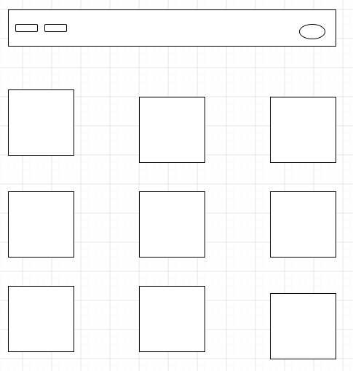
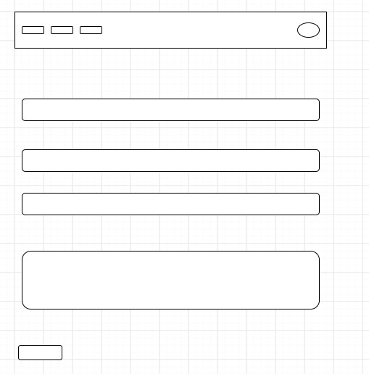

TECHNICAL REQUIRMENTS
- HTML
- CSS
- JAVA SCRIPT
TIMELINE AND MILESTONES
WEEK 1: Project Proposal
WEEK 2: Project planning and gathering requirements
WEEK 3: Wireframe design
WEEK 4: Website development
WEEK 5: Website development
WEEK 6: Product and images uploading & testing quality

BUDGET
Website Planning: R1,500
UI/UX Website Design: R2.500
Website Development: R5,000
Product upload: R1,500
Testing: R1,000
SEO : R2,750
Hosting: R3,000
Domain: R500
REFERENCES

References
Berry, S., 2026. www.seo.com. [Online]
Available at: https://www.seo.com/basics/glossary/seo/
[Accessed 23 July 2026].
Malsam, W., 2025. www.projectmanager.com. [Online]
Available at: https://www.projectmanager.com/blog/how-to-create-a-project-proposal
[Accessed 22 July 2026].
Paeds In a Pod, 2018. www.paedsinapod.biz. [Online]
Available at: https://www.bing.com/ck/a?!&&p=94d15219afa11b76bf1b3bb5fc2b77a28bdeaa45413d5f364d88d1365eba23c0JmltdHM9MTc4NjY2NTYwMA&ptn=3&ver=2&hsh=4&fclid=1092f9d3-21ee-6245-16a8-ee6620e2637b&u=a1aHR0cHM6Ly93d3cuYmluZy5jb20vYWxpbmsvbGluaz91cmw9aHR0cHMlM2ElMmYlMmZ3d3cu
[Accessed 20 July 2026].
Stanceinsa, 2026. stanceinsa.co.za. [Online]
Available at: https://stanceinsa.co.za/
[Accessed 20 July 2026].

PROPOSAL B
ORGANISATION OVERVIEW
- NAME: Paeds in a Pod Wellness Centre
- HISTORY: Paeds in a Pod Wellness Centre was set up in 2018 by Dr Isaru Riberio with the aim of setting up a multi-disciplinary children's wellness Centre where paediatric medical treatments and developmental services will be provided together.
MISSION STATEMENT: Providing compassionate, holistic healthcare that supports every child's physical, emotional, and mental wellbeing.
VISION STATEMENT: Becoming South Africa's leading wellness center

TARGET AUDIENCE
- Parents
- Children and adolescents
- Schools
- Healthcare professionals
WEBSITES GOALS & OBJECTIVES
- Increase online visibility
- Improve accessibility for enquiries and bookings
- Build trust with potential patients
- Increase patient engagement through educational resources
- Present KPI

WEBSITE ANALYSIS STRENGTHS
- Easy to navigate
- Good overview of services
- Staff profile builds trust

WEAKNESSES
- Website requires new design
- Interaction with website is limited
- Navigation could be simpler
- Limited educational resources
- Seo optimisation
Areas of Improvement
- Modern design
- Faster loading pages
- Better navigation
- Educational blog
- Improved accessibility

WEBSITE FEATURES AND FUNCTIONALITY Improved website should include:
- Banner
- Introduction to Paeds in a Pod
- Featured services
- Emergency contact information
- About Us
- Services
- Meat team
- Resources
- Contact Page

DESIGN AND USER EXPERIENCE
Colour scheme
Soft Blue, gray, white
Typography
Poppins Bold, Open sans

Layout and Design
- Clear navigation menu
- Responsive layout
- Readable font sizes
- Large images

User experience considerations
- Easy navigation
- Fast loading pages
- Accessible on computers and mobiles devices
- Accessible design for all users
Wireframes:

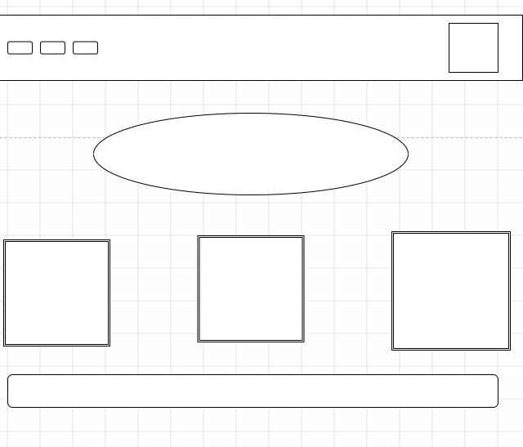
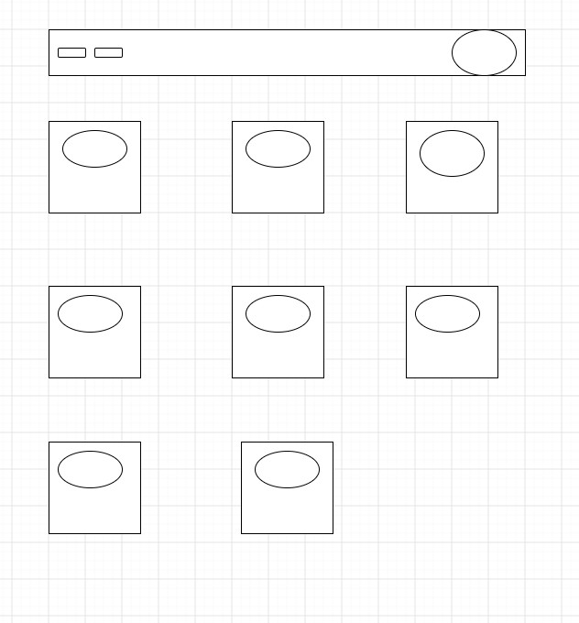
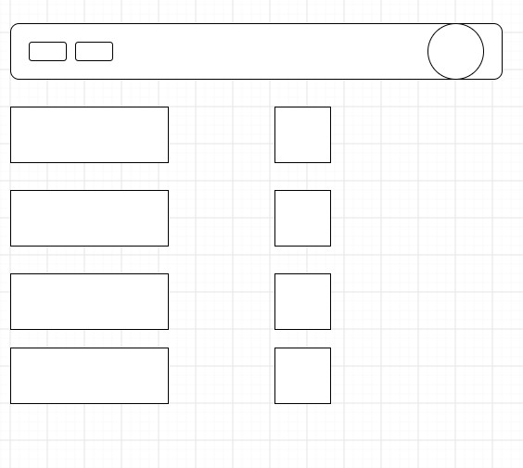
TECHNICAL REQUIRMENTS
- HTML
- CSS
- JAVA SCRIPT
TIMELINE AND MILESTONES WEEK 1: Project Proposal
WEEK 2: Project planning and gathering requirements
WEEK 3: Wireframe design
WEEK 4: Website development
WEEK 5: Website development
WEEK 6: Product and images uploading testing quality BUDGET
Website Planning: R1,500
UI/UX Website Design: R2.500
Website Development: R5,000
Product upload: R1,500
Testing: R1,000
SEO : R2,750
Hosting: R3,000
Domain: R500
REFERENCES

References
Berry, S., 2026. www.seo.com. [Online]
Available at: https://www.seo.com/basics/glossary/seo/
[Accessed 23 July 2026].
Malsam, W., 2025. www.projectmanager.com. [Online]
Available at: https://www.projectmanager.com/blog/how-to-create-a-project-proposal
[Accessed 22 July 2026].
Paeds In a Pod, 2018. www.paedsinapod.biz. [Online]
Available at: https://www.bing.com/ck/a?!&&p=94d15219afa11b76bf1b3bb5fc2b77a28bdeaa45413d5f364d88d1365eba23c0JmltdHM9MTc4NjY2NTYwMA&ptn=3&ver=2&hsh=4&fclid=1092f9d3-21ee-6245-16a8-ee6620e2637b&u=a1aHR0cHM6Ly93d3cuYmluZy5jb20vYWxpbmsvbGluaz91cmw9aHR0cHMlM2ElMmYlMmZ3d3cu
[Accessed 20 July 2026].
Stanceinsa, 2026. stanceinsa.co.za. [Online]
Available at: https://stanceinsa.co.za/
[Accessed 20 July 2026].

