**Question 1**

A noun

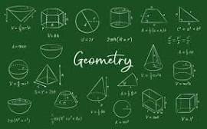

A.palindrome B.D-Day invasion C.Invasion of Poland D.ssss E.20

**Question 2**

What is a noun?



A.An action word B.A word C.A doing thing D.A doing word E.A name of an animal place or thing

**Question 3**

what is an adjective?

A.a doing word B.A figure of speech C.a word that qualifies a noun D.an action E.a word used instaed of a noun