**Question 1**

A noun

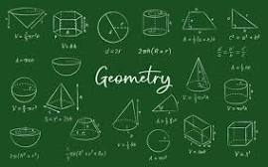

A.20 B.D-Day invasion C.palindrome D.Invasion of Poland E.ssss

**Question 2**

What is a noun?



A.A word B.A doing word C.A name of an animal place or thing D.A doing thing E.An action word

**Question 3**

what is an adjective?

A.a doing word B.A figure of speech C.an action D.a word used instaed of a noun E.a word that qualifies a noun