**Question 1**

What is the capital of France?

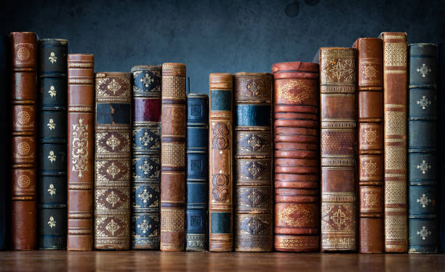

A London B Paris C Madrid D Berlin E Rome

**Question 2**

Who wrote "To Kill a Mockingbird

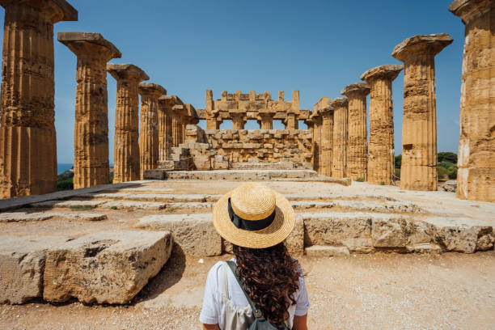

A J.K. Rowling B Stephen King C Ernest Hemingway D Harper Lee E George Orwell

**Question 3**

Which planet is closest to the Sun

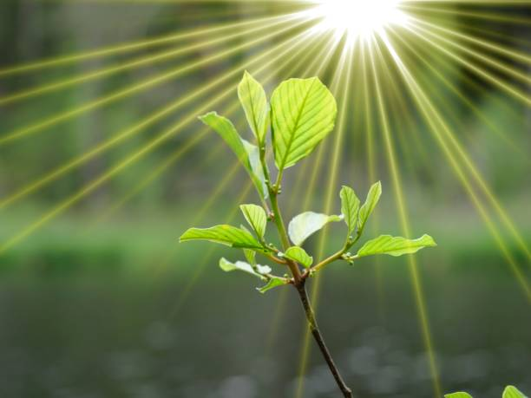

A Jupiter B Earth C Venus D Mercury E Mars

**Question 4**

What is the chemical symbol for water

A CO2 B NaCl C O2 D H2O E C6H12O6

**Question 5**

Who painted the Mona Lisa?

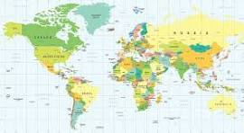

A Leonardo da Vinci B Pablo Picasso C Vincent van Gogh D Rembrandt E Michelangelo