**Question 1**

Which planet is closest to the Sun

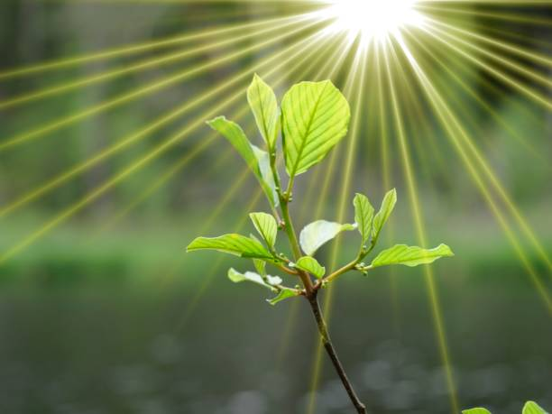

A.Mars B.Earth C.Venus D.Mercury E. Jupiter

**Question 2**

Who painted the Mona Lisa?

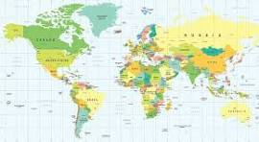

A.Michelangelo B.Rembrandt C. Leonardo da Vinci D.Vincent van Gogh E.Pablo Picasso

**Question 3**

What is the capital of France?

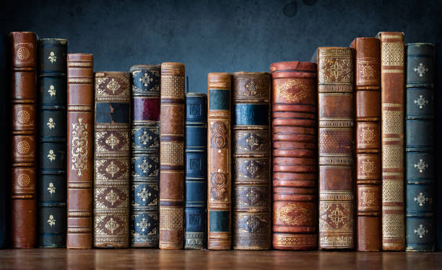

A.Paris B.Madrid C.London D.Berlin E.Rome

**Question 4**

What is the chemical symbol for water

A.O2 B. NaCl C.H2O D. CO2 E.C6H12O6

**Question 5**

Who wrote "To Kill a Mockingbird

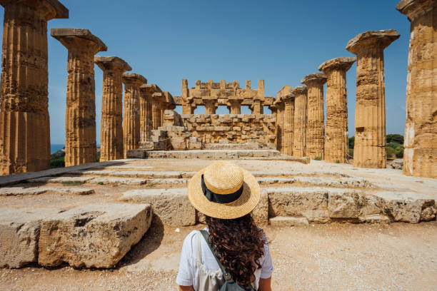

A.J.K. Rowling B.Ernest Hemingway C.Stephen King D.George Orwell E. Harper Lee