**Question 1**

Which planet is closest to the Sun

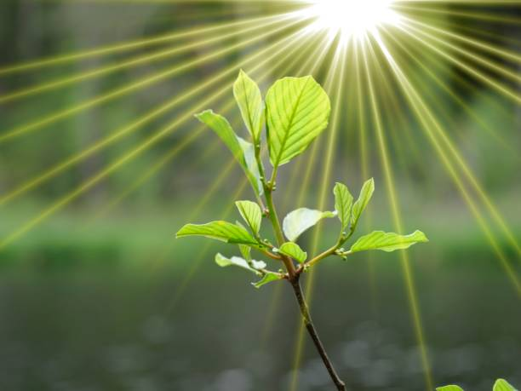

A.Mercury B. Jupiter C.Earth D.Venus E.Mars

**Question 2**

Who painted the Mona Lisa?

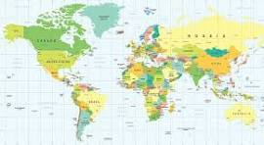

A.Pablo Picasso B.Rembrandt C.Michelangelo D.Vincent van Gogh E. Leonardo da Vinci

**Question 3**

What is the capital of France?

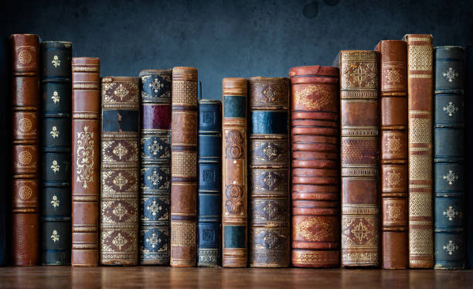

A.Berlin B.Rome C.Madrid D.Paris E.London

**Question 4**

What is the chemical symbol for water

A.O2 B.C6H12O6 C. CO2 D. NaCl E.H2O

**Question 5**

Who wrote "To Kill a Mockingbird

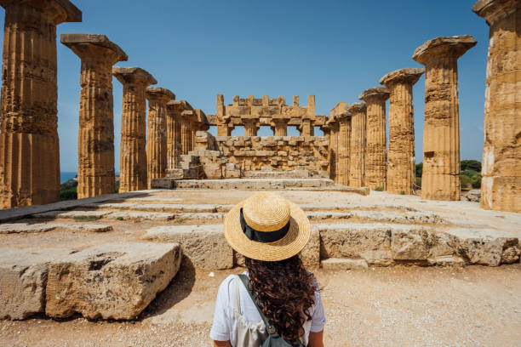

A.Stephen King B.George Orwell C.J.K. Rowling D. Harper Lee E.Ernest Hemingway