**Question 1**

Which planet is closest to the Sun

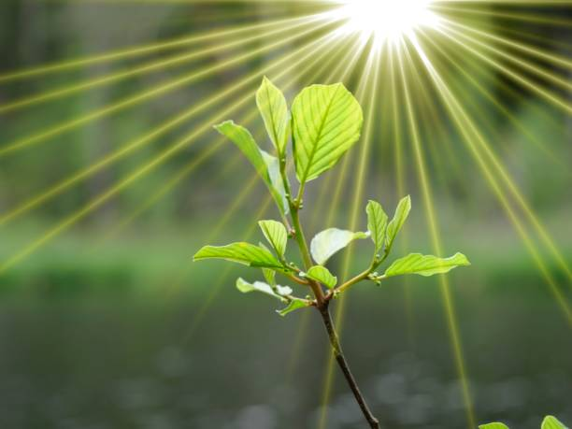

A.Mercury B.Mars C.Earth D. Jupiter E.Venus

**Question 2**

Who painted the Mona Lisa?

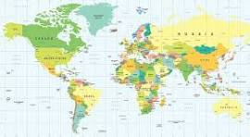

A.Pablo Picasso B.Vincent van Gogh C.Michelangelo D. Leonardo da Vinci E.Rembrandt

**Question 3**

What is the capital of France?

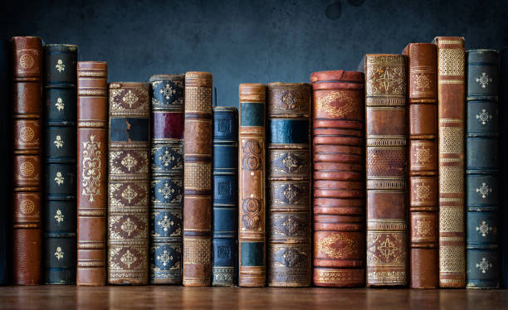

A.Rome B.London C.Madrid D.Paris E.Berlin

**Question 4**

What is the chemical symbol for water

A.H2O B.O2 C.C6H12O6 D. CO2 E. NaCl

**Question 5**

Who wrote "To Kill a Mockingbird

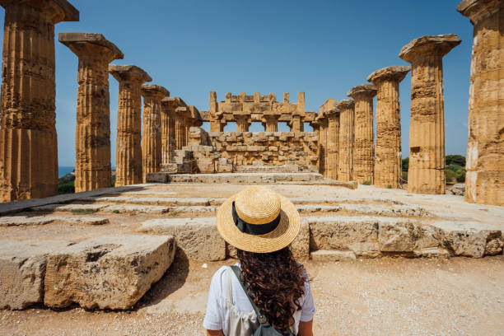

A.Ernest Hemingway B.Stephen King C.J.K. Rowling D.George Orwell E. Harper Lee