**Question 1**

A noun

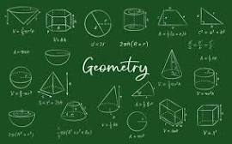

A.Invasion of Poland B.20 C.D-Day invasion D.ssss E.palindrome

**Question 2**

What is a noun?



A.A word B.A doing thing C.A doing word D.A name of an animal place or thing E.An action word

**Question 3**

what is an adjective?

A.an action B.a word that qualifies a noun C.a word used instaed of a noun D.A figure of speech E.a doing word