**Question 1**

A noun

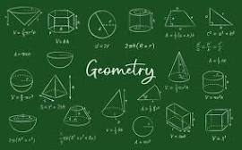

A.20 B.palindrome C.Invasion of Poland D.D-Day invasion E.ssss

**Question 2**

What is a noun?



A.A doing word B.A doing thing C.A word D.An action word E.A name of an animal place or thing

**Question 3**

what is an adjective?

A.a word used instaed of a noun B.A figure of speech C.a word that qualifies a noun D.an action E.a doing word