**Question 1**

A noun

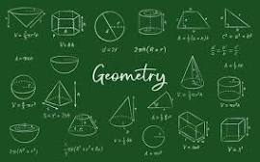

A.Invasion of Poland B.D-Day invasion C.palindrome D.ssss E.20

**Question 2**

What is a noun?



A.A word B.A doing word C.An action word D.A doing thing E.A name of an animal place or thing

**Question 3**

what is an adjective?

A.A figure of speech B.an action C.a word used instaed of a noun D.a word that qualifies a noun E.a doing word