**Question 1**

A noun

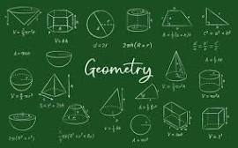

A.D-Day invasion B.palindrome C.ssss D.Invasion of Poland E.20

**Question 2**

What is a noun?



A.A name of an animal place or thing B.A doing word C.A word D.An action word E.A doing thing

**Question 3**

what is an adjective?

A.a doing word B.A figure of speech C.a word used instaed of a noun D.a word that qualifies a noun E.an action