**Question 1**

Which planet is closest to the Sun

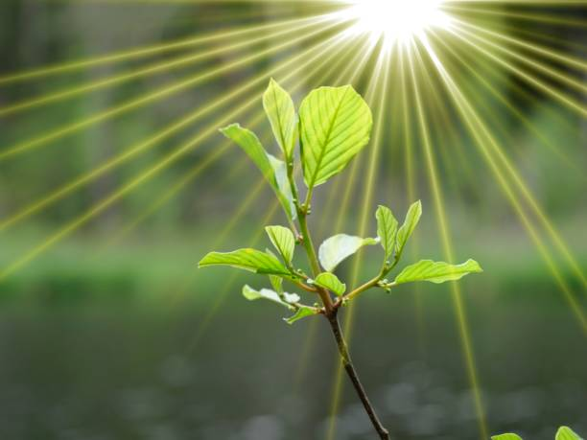

A.Earth B. Jupiter C.Mercury D.Venus E.Mars

**Question 2**

Who painted the Mona Lisa?

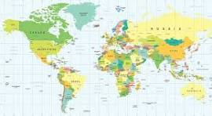

A.Pablo Picasso B. Leonardo da Vinci C.Michelangelo D.Rembrandt E.Vincent van Gogh

**Question 3**

What is the capital of France?

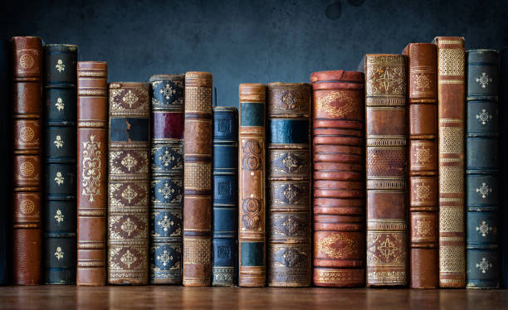

A.Madrid B.Berlin C.London D.Rome E.Paris

**Question 4**

What is the chemical symbol for water

A. CO2 B. NaCl C.O2 D.C6H12O6 E.H2O

**Question 5**

Who wrote "To Kill a Mockingbird

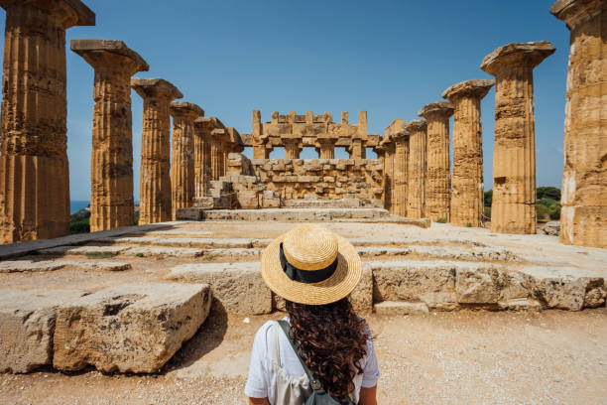

A.J.K. Rowling B. Harper Lee C.George Orwell D.Ernest Hemingway E.Stephen King