**Question 1**

what is a noun?

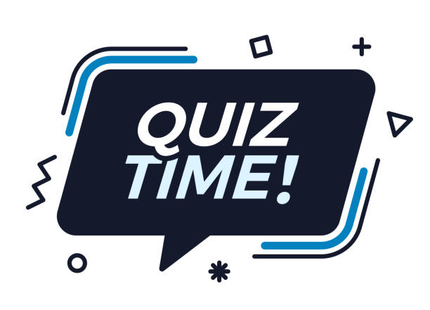

A A word used instead of noun B A verb C an adjective D A name of animal place or thing E an action word