**Question 1**

A noun

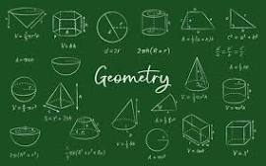

A.20 B.Invasion of Poland C.ssss D.D-Day invasion E.palindrome

**Question 2**

What is a noun?



A.An action word B.A doing word C.A word D.A doing thing E.A name of an animal place or thing

**Question 3**

what is an adjective?

A.A figure of speech B.a word that qualifies a noun C.a doing word D.a word used instaed of a noun E.an action