**Question 1**

A noun

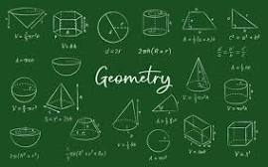

A.20 B.palindrome C.ssss D.D-Day invasion E.Invasion of Poland

**Question 2**

What is a noun?



A.A word B.A doing thing C.A name of an animal place or thing D.A doing word E.An action word

**Question 3**

what is an adjective?

A.a word used instaed of a noun B.a word that qualifies a noun C.A figure of speech D.an action E.a doing word