**Question 1**

A noun

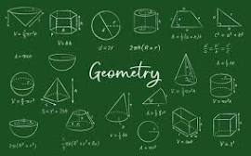

A.20 B.Invasion of Poland C.D-Day invasion D.palindrome E.ssss

**Question 2**

What is a noun?



A.A doing word B.A name of an animal place or thing C.A word D.A doing thing E.An action word

**Question 3**

what is an adjective?

A.A figure of speech B.a word used instaed of a noun C.a word that qualifies a noun D.an action E.a doing word