**Question 1**

A noun

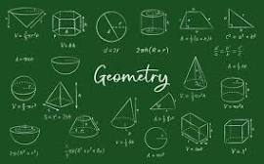

A.ssss B.Invasion of Poland C.D-Day invasion D.20 E.palindrome

**Question 2**

What is a noun?



A.An action word B.A word C.A name of an animal place or thing D.A doing thing E.A doing word

**Question 3**

what is an adjective?

A.A figure of speech B.an action C.a word used instaed of a noun D.a word that qualifies a noun E.a doing word