**Question 1**

Which planet is closest to the Sun

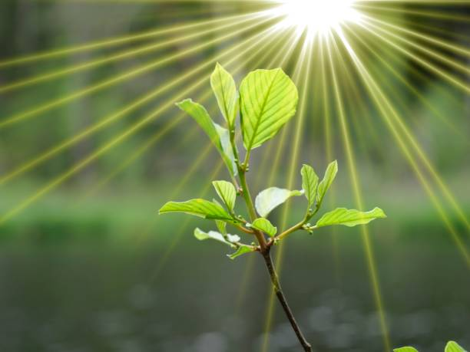

A. Jupiter B.Mars C.Earth D.Venus E.Mercury

**Question 2**

Who painted the Mona Lisa?

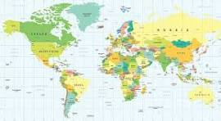

A.Michelangelo B.Pablo Picasso C.Vincent van Gogh D.Rembrandt E. Leonardo da Vinci

**Question 3**

What is the capital of France?

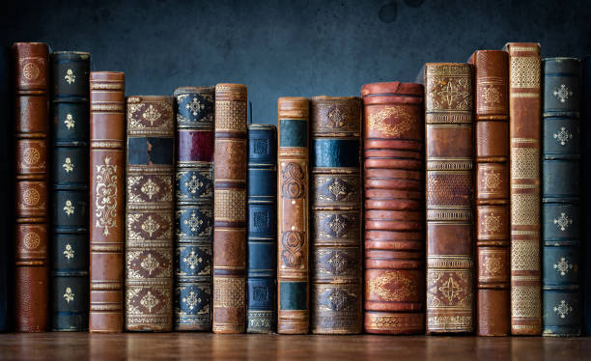

A.Rome B.Madrid C.Berlin D.London E.Paris

**Question 4**

What is the chemical symbol for water

A. NaCl B.H2O C.C6H12O6 D.O2 E. CO2

**Question 5**

Who wrote "To Kill a Mockingbird

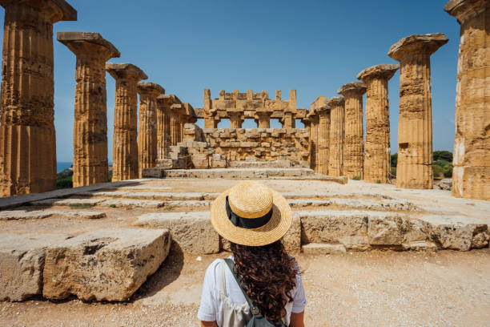

A. Harper Lee B.Stephen King C.J.K. Rowling D.George Orwell E.Ernest Hemingway