**Question 1**

What is 2 + 2

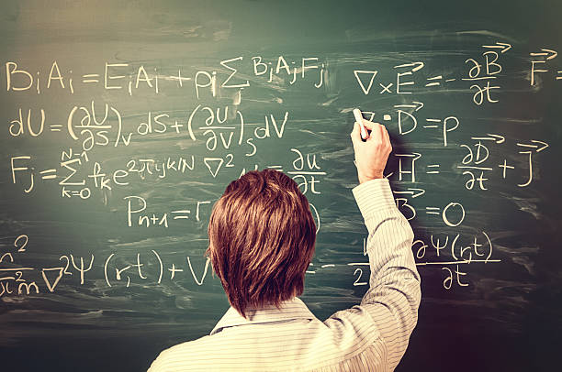

A 2 B 12 C 22 D 4 E 44