**Question 1**

Which planet is closest to the Sun

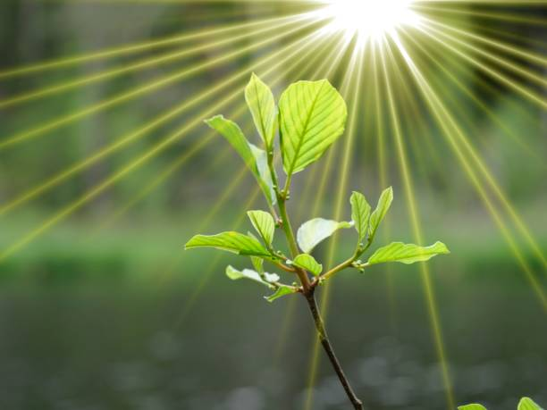

A.Mercury B.Venus C. Jupiter D.Earth E.Mars

**Question 2**

Who painted the Mona Lisa?

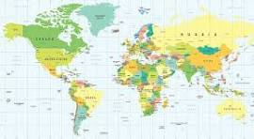

A.Michelangelo B.Pablo Picasso C.Rembrandt D. Leonardo da Vinci E.Vincent van Gogh

**Question 3**

What is the capital of France?

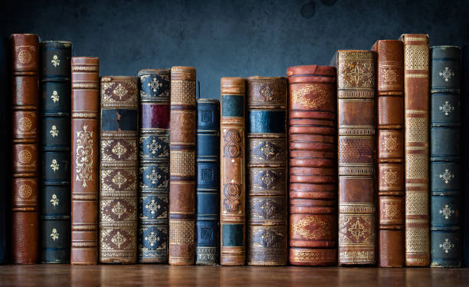

A.Rome B.London C.Madrid D.Paris E.Berlin

**Question 4**

What is the chemical symbol for water

A.C6H12O6 B. CO2 C. NaCl D.O2 E.H2O

**Question 5**

Who wrote "To Kill a Mockingbird

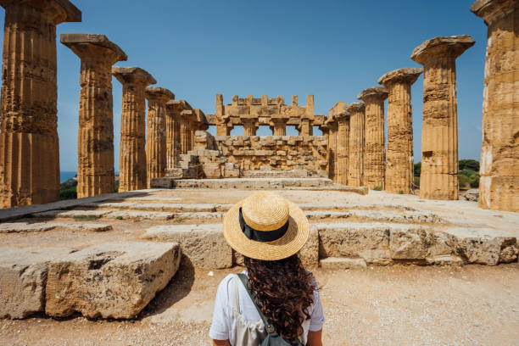

A.George Orwell B. Harper Lee C.J.K. Rowling D.Ernest Hemingway E.Stephen King