**Question 1**

A noun

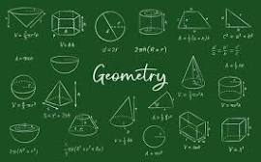

A.D-Day invasion B.Invasion of Poland C.ssss D.20 E.palindrome

**Question 2**

What is a noun?



A.A doing word B.A name of an animal place or thing C.An action word D.A word E.A doing thing

**Question 3**

what is an adjective?

A.an action B.a word used instaed of a noun C.a word that qualifies a noun D.a doing word E.A figure of speech